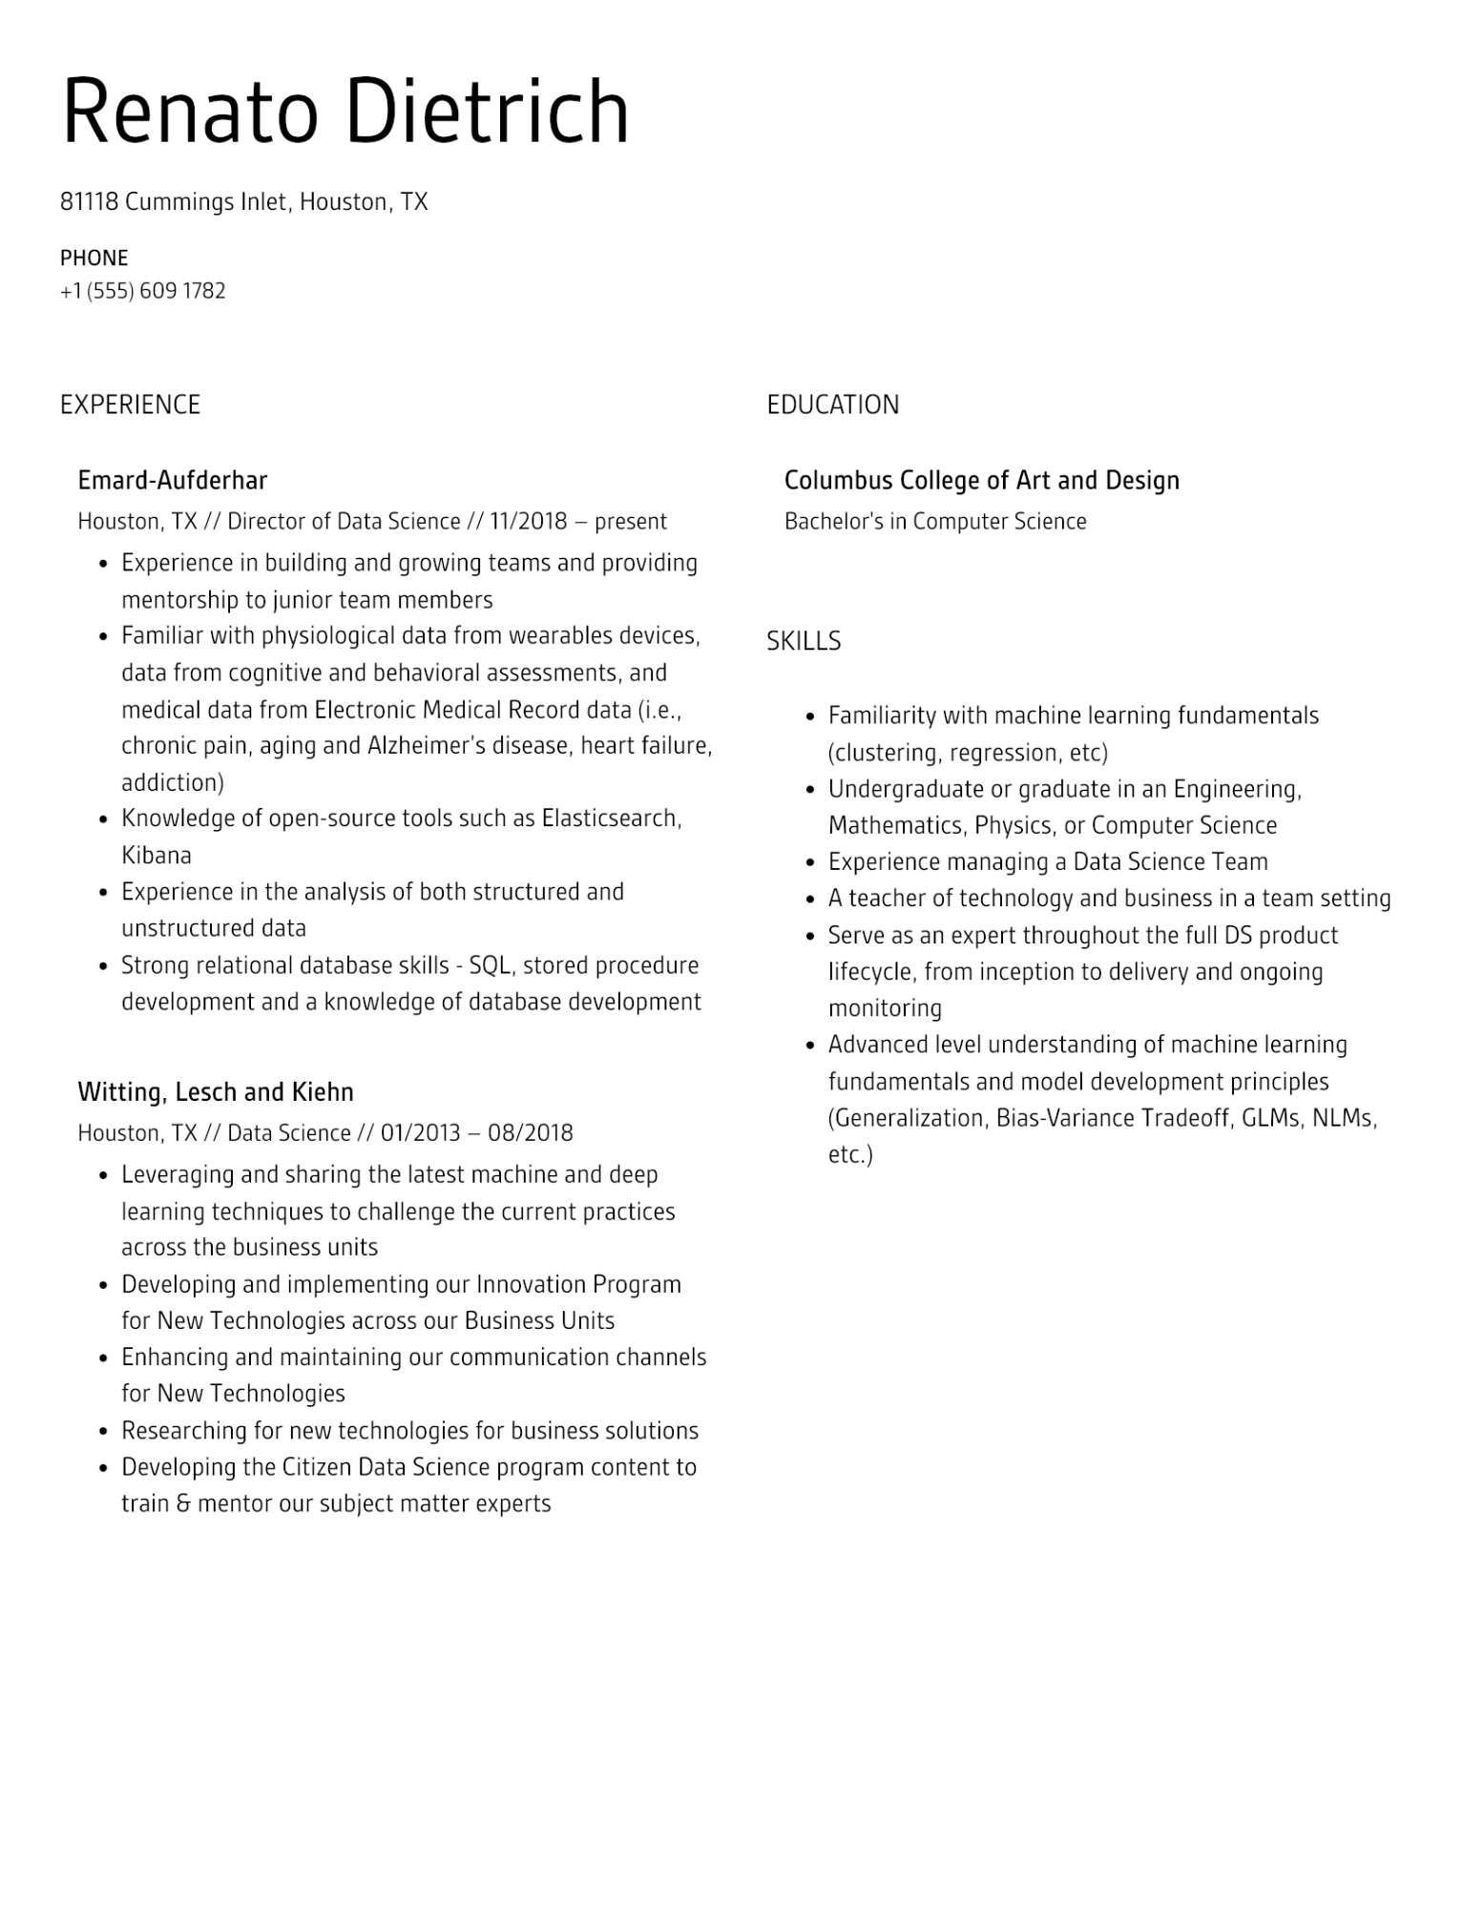

Renato Dietrich

81118 Cummings Inlet, Houston, TX

PHONE

+1 (555) 609 1782

EXPERIENCE

Emard-Aufderhar

Houston, TX // Director of Data Science // 11/2018 - present

•

Experience in building and growing teams and providing mentorship to junior team members

• Familiar with physiological data from wearables devices, data from cognitive and behavioral assessments, and medical data from Electronic Medical Record data (i.e., chronic pain, aging and Alzheimer's disease, heart failure, addiction)

•

•

•

Knowledge of open-source tools such as Elasticsearch, Kibana

Experience in the analysis of both structured and unstructured data

-

Strong relational database skills - SQL, stored procedure development and a knowledge of database development

Witting, Lesch and Kiehn

Houston, TX // Data Science // 01/2013 - 08/2018

•

·

•

•

•

Leveraging and sharing the latest machine and deep

learning techniques to challenge the current practices across the business units

Developing and implementing our Innovation Program

for New Technologies across our Business Units

Enhancing and maintaining our communication channels for New Technologies

Researching for new technologies for business solutions

Developing the Citizen Data Science program content to

train & mentor our subject matter experts

EDUCATION

Columbus College of Art and Design

Bachelor's in Computer Science

SKILLS

·

•

Familiarity with machine learning fundamentals (clustering, regression, etc)

Undergraduate or graduate in an Engineering, Mathematics, Physics, or Computer Science

Experience managing a Data Science Team

•

A teacher of technology and business in a team setting

•

• Serve as an expert throughout the full DS product

•

lifecycle, from inception to delivery and ongoing monitoring

Advanced level understanding of machine learning fundamentals and model development principles (Generalization, Bias-Variance Tradeoff, GLMs, NLMs,

etc.)