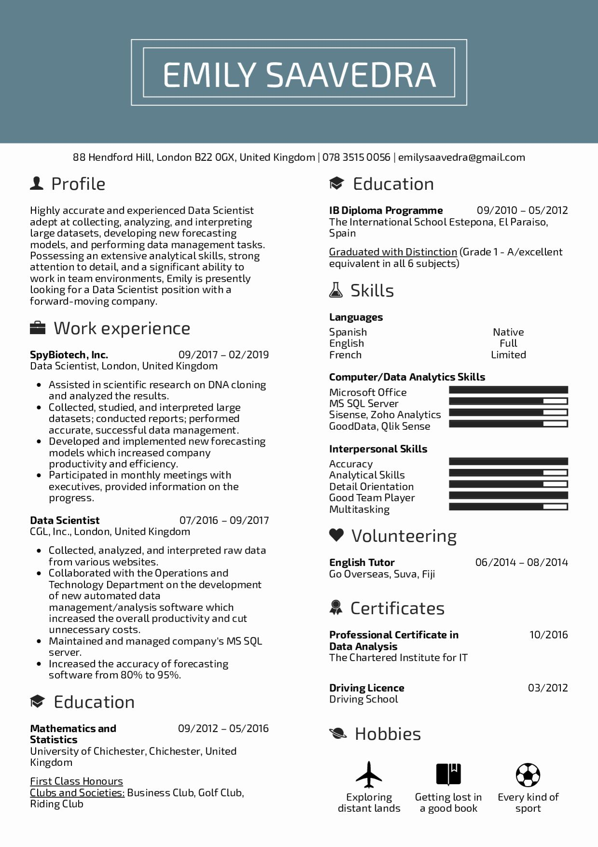

EMILY SAAVEDRA

88 Hendford Hill, London B22 OGX, United Kingdom | 078 3515 0056 | emilysaavedra@gmail.com

Profile

Highly accurate and experienced Data Scientist adept at collecting, analyzing, and interpreting large datasets, developing new forecasting models, and performing data management tasks. Possessing an extensive analytical skills, strong attention to detail, and a significant ability to work in team environments, Emily is presently looking for a Data Scientist position with a forward-moving company.

Work experience

**SpyBiotech, Inc.**

Education

IB Diploma Programme

09/2010 05/2012

The International School Estepona, El Paraiso, Spain

Graduated with Distinction (Grade 1 - A/excellent equivalent in all 6 subjects)

Skills

**Languages**

Spanish

Native

English

Full

09/2017 02/2019

French

Limited

**Computer/Data Analytics Skills**

Data Scientist, London, United Kingdom

• Assisted in scientific research on DNA cloning and analyzed the results.

• Collected, studied, and interpreted large

datasets; conducted reports; performed accurate, successful data management.

• Developed and implemented new forecasting models which increased company productivity and efficiency.

Participated in monthly meetings with executives, provided information on the progress.

**Data Scientist**

07/2016-09/2017

CGL, Inc., London, United Kingdom

• Collected, analyzed, and interpreted raw data from various websites.

• Collaborated with the Operations and Technology Department on the development of new automated data

management/analysis software which increased the overall productivity and cut unnecessary costs.

• Maintained and managed company's MS SQL

server.

• Increased the accuracy of forecasting

software from 80% to 95%.

Education

**Mathematics and**

**Statistics**

09/2012-05/2016

University of Chichester, Chichester, United Kingdom

First Class Honours

Clubs and Societies: Business Club, Golf Club, Riding Club

Microsoft Office

MS SQL Server

Sisense, Zoho Analytics

GoodData, Qlik Sense

**Interpersonal Skills**

Accuracy Analytical Skills Detail Orientation Good Team Player Multitasking

❤ Volunteering

**English Tutor**

Go Overseas, Suva, Fiji

Certificates

**Professional Certificate in Data Analysis**

The Chartered Institute for IT

**Driving Licence**

Driving School

Hobbies

Exploring

distant lands

06/2014 08/2014

10/2016

03/2012

Getting lost in a good book

Every kind of sport