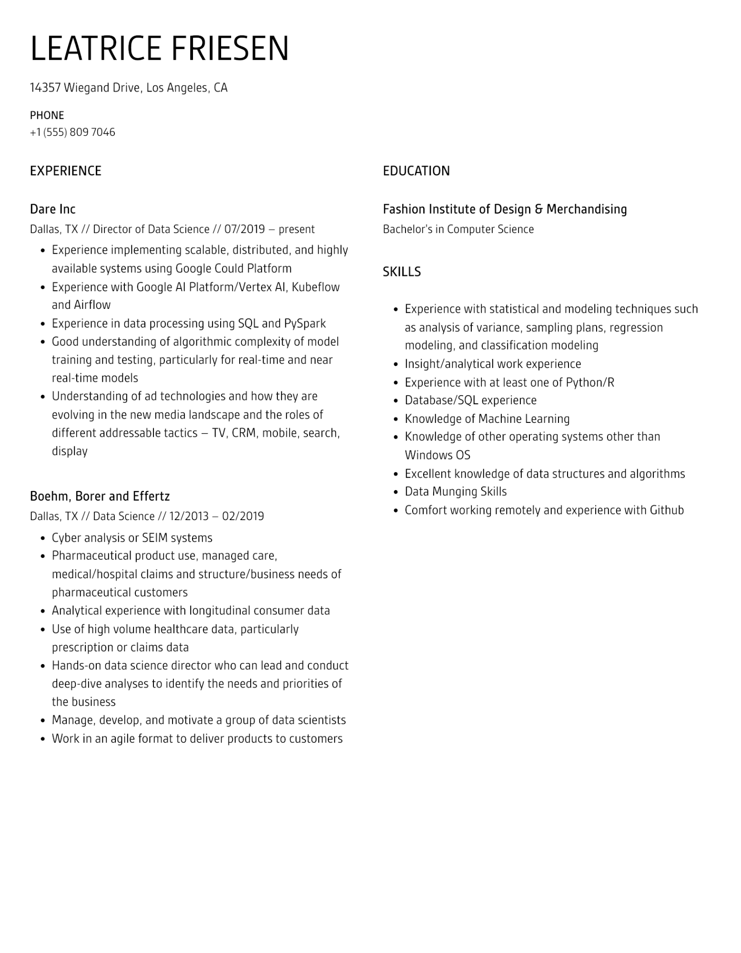

LEATRICE FRIESEN

14357 Wiegand Drive, Los Angeles, CA

PHONE

+1 (555) 809 7046

EXPERIENCE

Dare Inc

Dallas, TX // Director of Data Science // 07/2019 - present

•

•

•

Experience implementing scalable, distributed, and highly available systems using Google Could Platform

Experience with Google Al Platform/Vertex Al, Kubeflow and Airflow

Experience in data processing using SQL and PySpark

• Good understanding of algorithmic complexity of model training and testing, particularly for real-time and near real-time models

Understanding of ad technologies and how they are

evolving in the new media landscape and the roles of different addressable tactics - TV, CRM, mobile, search, display

Boehm, Borer and Effertz

Dallas, TX // Data Science // 12/2013 - 02/2019

•

Cyber analysis or SEIM systems

·

•

Pharmaceutical product use, managed care,

medical/hospital claims and structure/business needs of pharmaceutical customers

Analytical experience with longitudinal consumer data

• Use of high volume healthcare data, particularly

prescription or claims data

• Hands-on data science director who can lead and conduct deep-dive analyses to identify the needs and priorities of the business

•

Manage, develop, and motivate a group of data scientists

• Work in an agile format to deliver products to customers

EDUCATION

Fashion Institute of Design & Merchandising

Bachelor's in Computer Science

SKILLS

•

•

•

•

·

Experience with statistical and modeling techniques such

as analysis of variance, sampling plans, regression

modeling, and classification modeling

Insight/analytical work experience

Experience with at least one of Python/R

Database/SQL experience

Knowledge of Machine Learning

Knowledge of other operating systems other than Windows OS

Excellent knowledge of data structures and algorithms Data Munging Skills

• Comfort working remotely and experience with Github