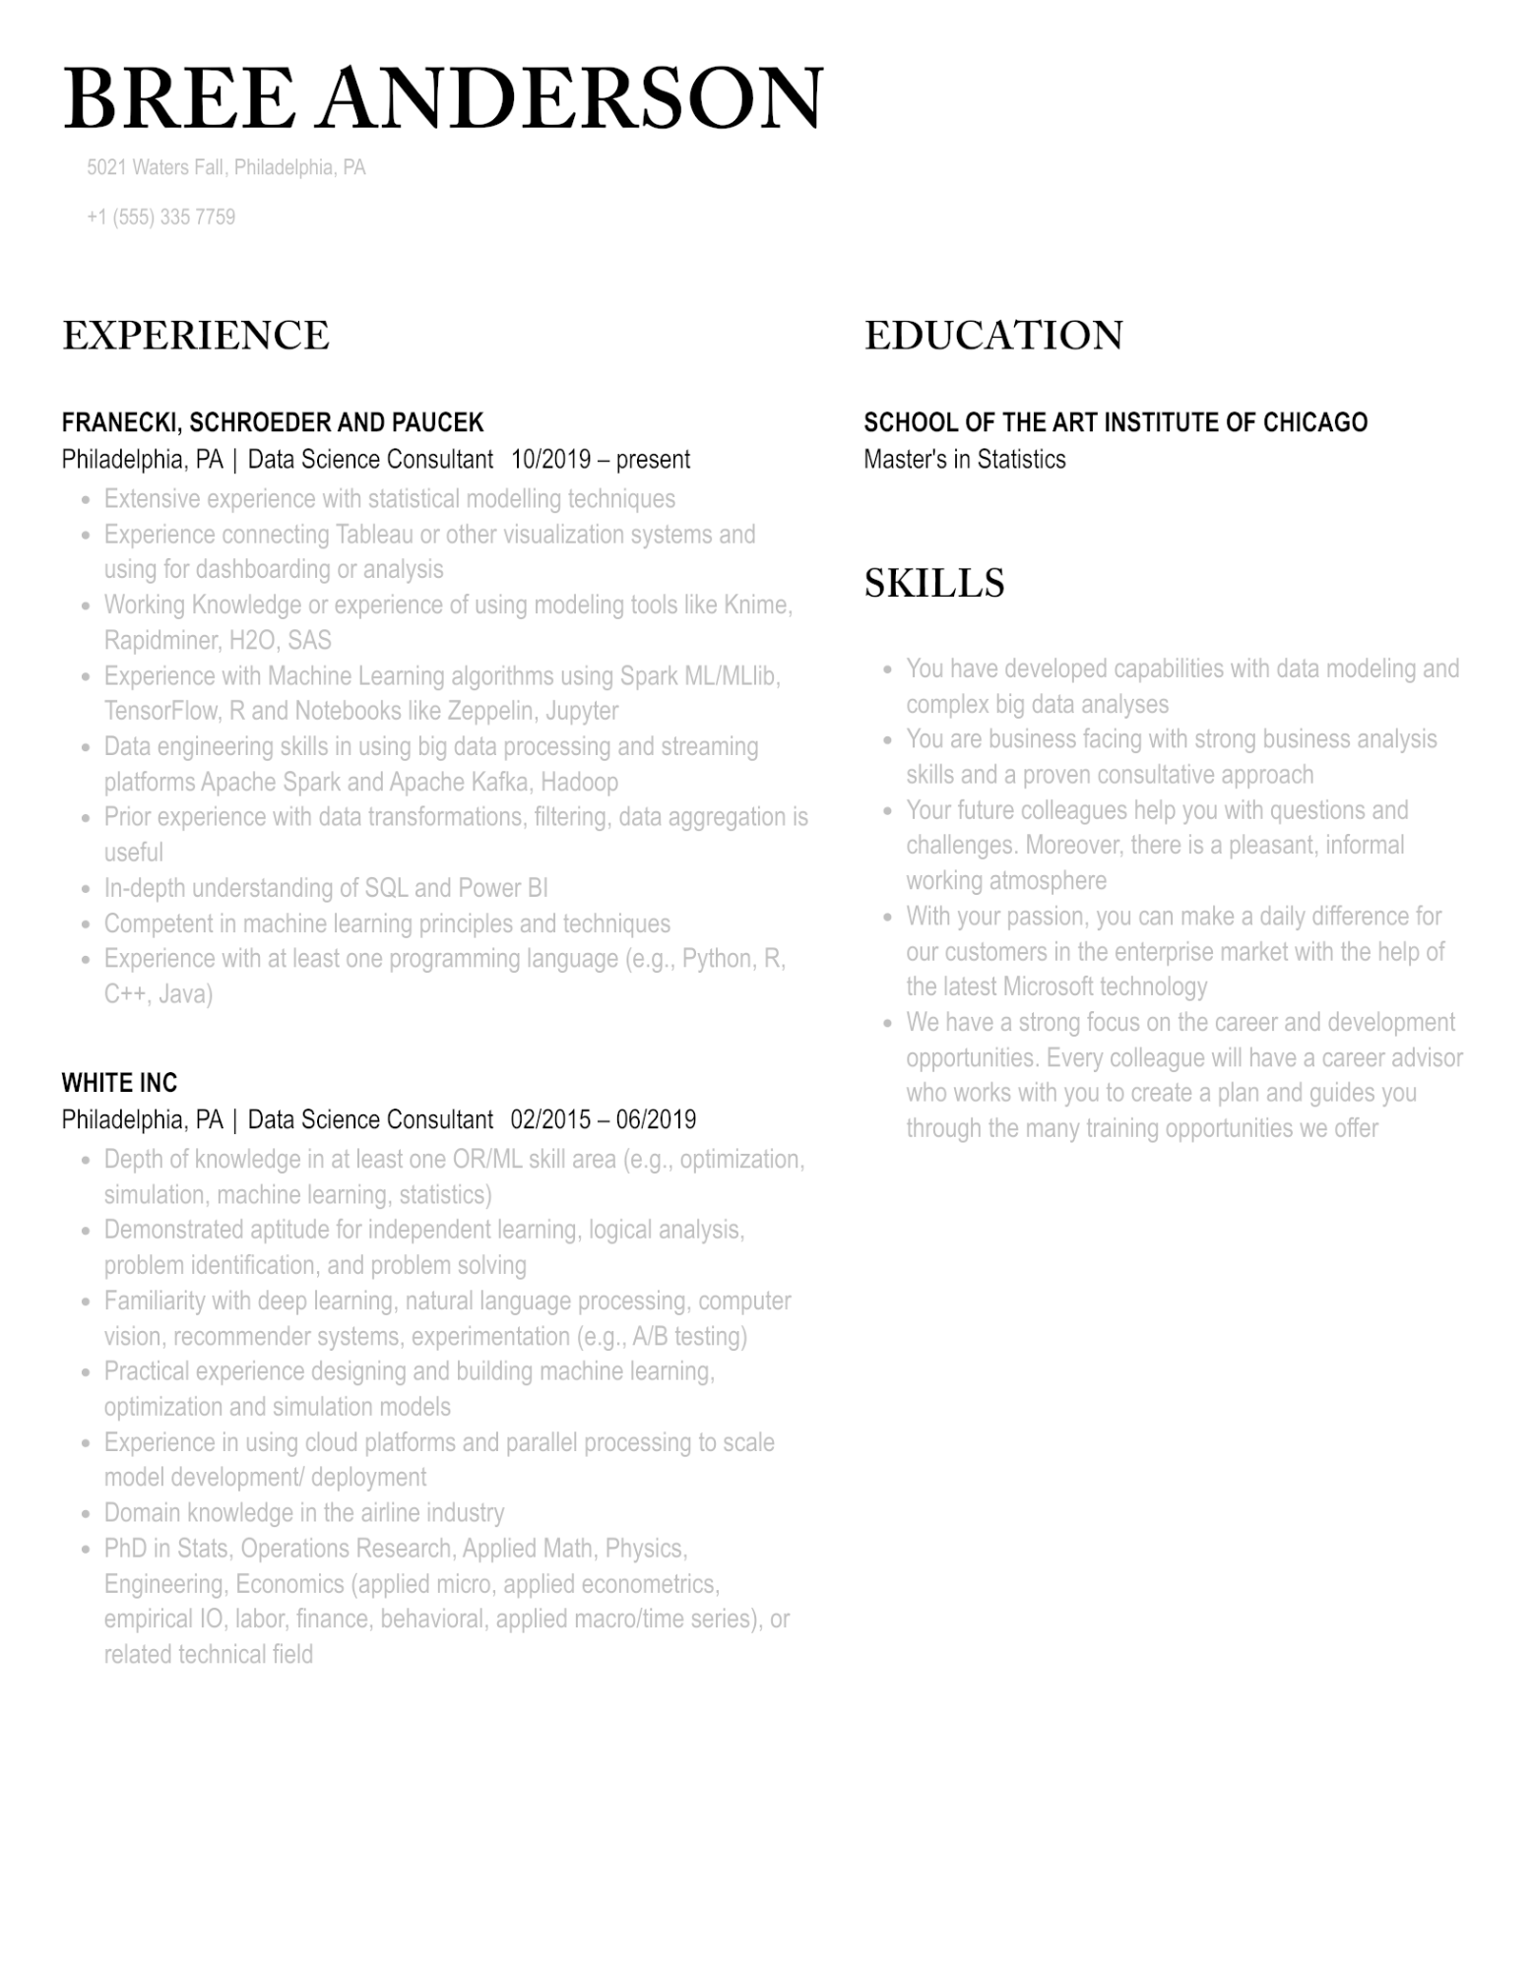

BREE ANDERSON

5021 Waters Fall, Philadelphia, PA

+1 (555) 335 7759

EXPERIENCE

**FRANECKI, SCHROEDER AND PAUCEK**

Philadelphia, PA | Data Science Consultant 10/2019 - present

•

•

•

•

•

•

•

•

Extensive experience with statistical modelling techniques

Experience connecting Tableau or other visualization systems and using for dashboarding or analysis

Working Knowledge or experience of using modeling tools like Knime, Rapidminer, H2O, SAS

Experience with Machine Learning algorithms using Spark ML/MLlib, TensorFlow, R and Notebooks like Zeppelin, Jupyter

Data engineering skills in using big data processing and streaming platforms Apache Spark and Apache Kafka, Hadoop

Prior experience with data transformations, filtering, data aggregation is useful

In-depth understanding of SQL and Power BI

Competent in machine learning principles and techniques

Experience with at least one programming language (e.g., Python, R, C++, Java)

**WHITE INC**

Philadelphia, PA | Data Science Consultant 02/2015 - 06/2019

•

•

•

•

•

Depth of knowledge in at least one OR/ML skill area (e.g., optimization, simulation, machine learning, statistics)

Demonstrated aptitude for independent learning, logical analysis,

problem identification, and problem solving

Familiarity with deep learning, natural language processing, computer

vision, recommender systems, experimentation (e.g., A/B testing)

Practical experience designing and building machine learning,

optimization and simulation models

Experience in using cloud platforms and parallel processing to scale

model development/ deployment

Domain knowledge in the airline industry

PhD in Stats, Operations Research, Applied Math, Physics,

Engineering, Economics (applied micro, applied econometrics,

empirical IO, labor, finance, behavioral, applied macro/time series), or related technical field

EDUCATION

**SCHOOL OF THE ART INSTITUTE OF CHICAGO Master's in Statistics**

SKILLS

•

•

You have developed capabilities with data modeling and complex big data analyses

You are business facing with strong business analysis skills and a proven consultative approach

Your future colleagues help you with questions and challenges. Moreover, there is a pleasant, informal working atmosphere

With your passion, you can make a daily difference for our customers in the enterprise market with the help of the latest Microsoft technology

• We have a strong focus on the career and development opportunities. Every colleague will have a career advisor who works with you to create a plan and guides you through the many training opportunities we offer