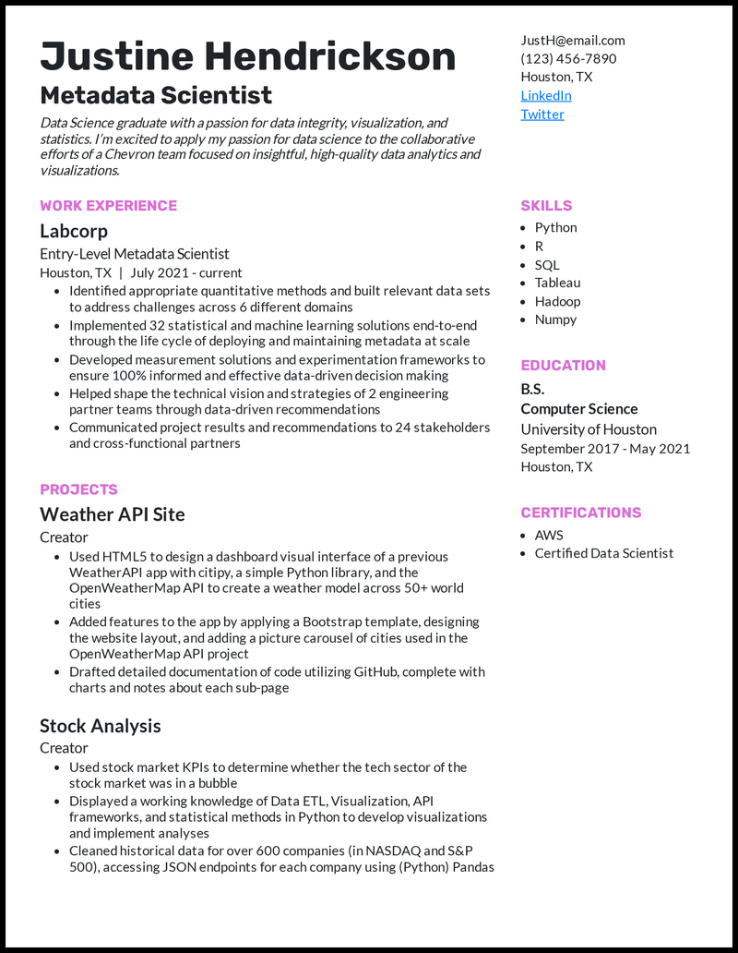

**Justine Hendrickson**

**Metadata Scientist**

*Data Science graduate with a passion for data integrity, visualization, and statistics. I'm excited to apply my passion for data science to the collaborative efforts of a Chevron team focused on insightful, high-quality data analytics and visualizations.*

**WORK EXPERIENCE**

**Labcorp**

Entry-Level Metadata Scientist

Houston, TX | July 2021 - current

• Identified appropriate quantitative methods and built relevant data sets to address challenges across 6 different domains

• Implemented 32 statistical and machine learning solutions end-to-end through the life cycle of deploying and maintaining metadata at scale • Developed measurement solutions and experimentation frameworks to ensure 100% informed and effective data-driven decision making

• Helped shape the technical vision and strategies of 2 engineering partner teams through data-driven recommendations

• Communicated project results and recommendations to 24 stakeholders and cross-functional partners

**PROJECTS**

Weather API Site

Creator

• Used HTML5 to design a dashboard visual interface of a previous Weather API app with citipy, a simple Python library, and the OpenWeatherMap API to create a weather model across 50+ world

cities

• Added features to the app by applying a Bootstrap template, designing the website layout, and adding a picture carousel of cities used in the OpenWeatherMap API project

• Drafted detailed documentation of code utilizing GitHub, complete with charts and notes about each sub-page

Stock Analysis

Creator

• Used stock market KPIs to determine whether the tech sector of the stock market was in a bubble

• Displayed a working knowledge of Data ETL, Visualization, API frameworks, and statistical methods in Python to develop visualizations and implement analyses

• Cleaned historical data for over 600 companies (in NASDAQ and S&P 500), accessing JSON endpoints for each company using (Python) Pandas

JustH@email.com

(123) 456-7890 Houston, TX

LinkedIn

Twitter

**SKILLS**

• Python • R

• SQL

• Tableau

• Hadoop • Numpy

**EDUCATION**

B.S. Computer Science

University of Houston September 2017 - May 2021 Houston, TX

**CERTIFICATIONS**

• AWS

• Certified Data Scientist