Pearls Lahore AQI Prediction System

Developed by: Saifullah Khalid
Technology Used: Python, Streamlit, Scikit-learn, AQICN API
Model Used: Random Forest Regressor
Dashboard Tool: Streamlit
Data Source: AQICN (World Air Quality Index) API

1. Introduction
The Pearls Lahore AQI Prediction System is a data-driven project designed to monitor and forecast the Air Quality Index (AQI) for Lahore, Pakistan.
This system uses live air quality data fetched directly from the AQICN API, analyzes pollutant levels, and predicts the next 30 days of AQI using a trained Machine Learning model (Random Forest Regressor).
The main aim of this project is to help users, researchers, and environmental authorities understand current air pollution levels and forecast future air quality trends using real-time and predictive analytics.

2. Objectives of the Project
The key objectives of this project were:
- To develop a real-time AQI monitoring system for Lahore using live API data.
- To train a machine learning model that predicts future AQI levels for the next 30 days.
- To display interactive visualizations and trends through a Streamlit web dashboard.
- To automate the process of data fetching, model training, and prediction.
- To provide a clear and user-friendly interface for visualizing air quality levels, pollutant breakdowns, and forecasted data.

3. Project Requirements and Implementation
The project was based on the following major requirements and tasks (as per the official project brief):
Requirement | Work Completed (According to Project)
Feature Pipeline Development | Fetched live raw weather and pollutant data from the AQICN API and computed time-based features such as day, week, and month.
Historical Data Backfill | Retrieved the past 7-day AQI data from AQICN for analysis and training.
Training Pipeline Implementation | Trained the Random Forest Regressor and Ridge Regression models using the generated dataset. Evaluated performance using MAE, RMSE, and R² metrics.
Model Registry | Stored trained models in a model registry folder for easy loading in the web dashboard.
Web Application Dashboard | Developed a Streamlit dashboard that loads the model, fetches live data, and visualizes predictions using interactive charts.
Advanced Analytics Features | Implemented EDA-style charts including trend lines, heatmaps, pollutant compositions, radar comparison with WHO limits, and histogram distributions.
Alerts for Hazardous Levels | The dashboard highlights a warning message if AQI exceeds safe levels.
Automated CI/CD Pipeline (Optional) | Can be extended to automatically refresh live data hourly and retrain models daily using GitHub Actions or Apache Airflow.

4. Tools and Technologies Used
- Programming Language: Python
- Libraries: Pandas, NumPy, Plotly, Scikit-learn, Requests, Joblib
- Frontend Framework: Streamlit
- Data Source: AQICN API (https://aqicn.org/api/)
- Machine Learning Algorithms:
  - Random Forest Regressor
  - Ridge Regression (for comparison)
- Visualization: Plotly (line charts, heatmaps, bar charts, radar graphs, pie charts)
5. Features of the Dashboard
The Streamlit Web Dashboard includes the following main features:
- Live AQI Fetching:
Displays the current AQI of Lahore fetched directly from the AQICN API in real-time.
- Past 7-Day Historical Trend:
Visualizes the past seven days of AQI levels using a clean line chart.
- 30-Day Forecast:
Predicts the air quality for the next 30 days using the Random Forest model.
- Interactive Visual Charts:
  - Line Chart: Displays daily AQI trend for the next 30 days.
  - Heatmap: Shows AQI intensity by week and day.
  - Pollutant Composition Pie Chart: Shows live pollutant breakdown (PM2.5, PM10, NO₂, SO₂, CO, O₃).
  - Bar Chart: Weekly average AQI.
  - Radar Chart: Compares live pollutants against WHO safety limits.
  - Histogram: Shows distribution of predicted AQI levels.
- Summary Metrics:
Displays the Average AQI, Highest AQI, and Lowest AQI predicted for the next 30 days.
- Hazard Alerts:
The app shows a warning message if the AQI crosses hazardous levels (above 150).
- Author Information:
Includes developer credits at the bottom:
Developed by Saifullah Khalid — © 2025 Pearls Data Projects

6. How It Works
- The system connects to the AQICN API to fetch live and historical AQI data for Lahore.
- A pre-trained Random Forest model loads from the model registry and uses live data as a reference to generate predictions.
- The results are displayed through interactive visualizations using Plotly inside Streamlit.
- The user can analyze the past, present, and future AQI levels in one dashboard view.

7. Screenshots to Include in Report
- Dashboard Header and Live AQI Section
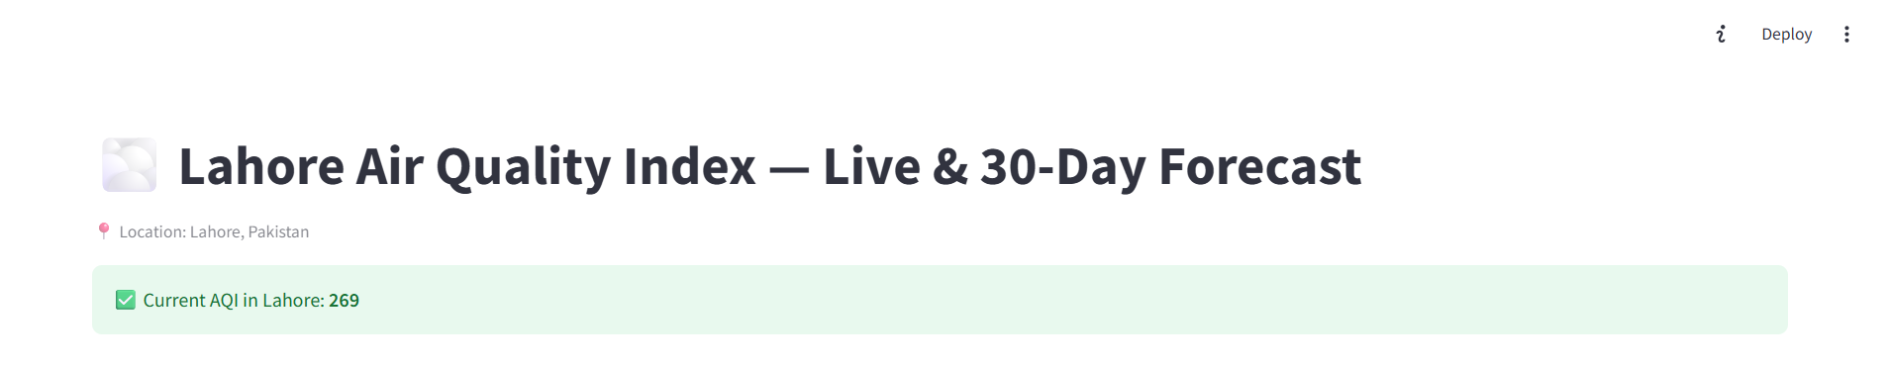
  - Shows “🌫️ Lahore Air Quality Index — Live & 30-Day Forecast” and “Current AQI in Lahore: 164”.
- Past 7-Day AQI Trend Chart
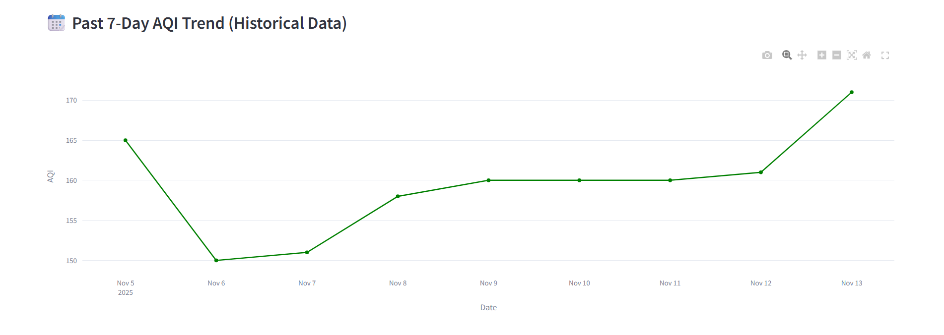
  - The line chart showing last week’s historical AQI data.
- 30-Day Forecast Line Chart and Heatmap
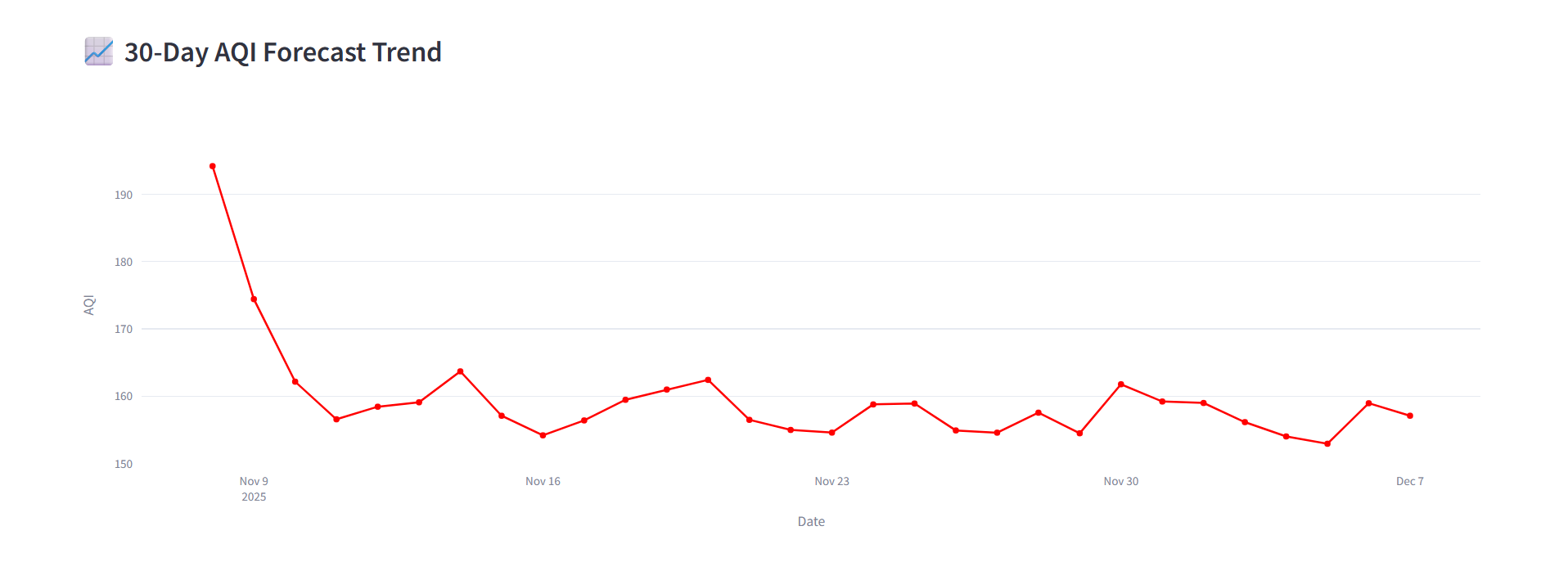
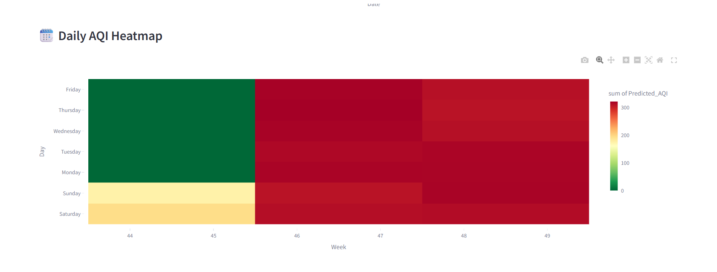
  - Display both charts (Forecast Trend and Daily Heatmap).

- Pollutant Composition and Weekly AQI Bar Chart
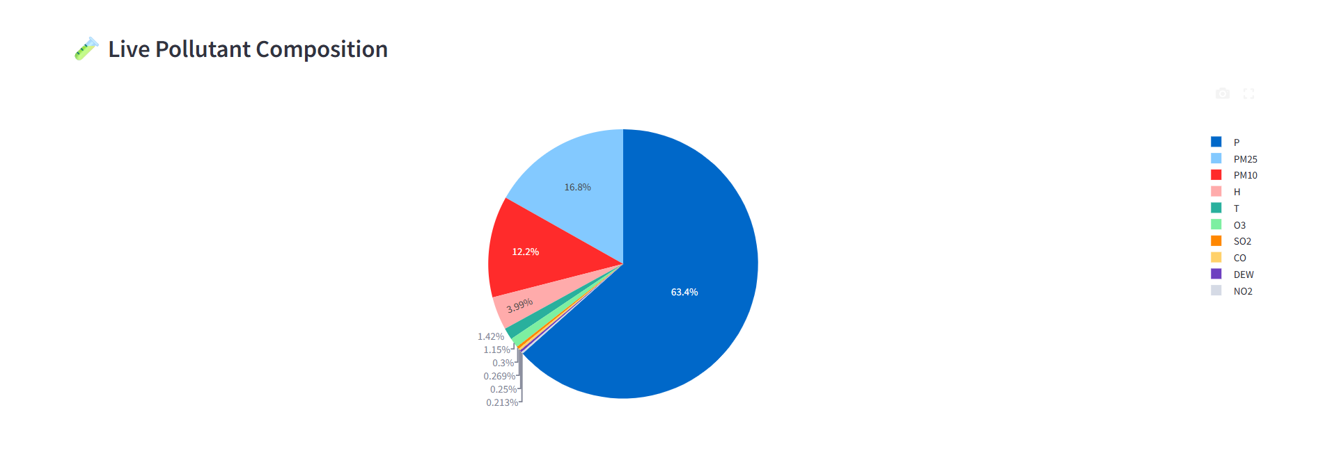
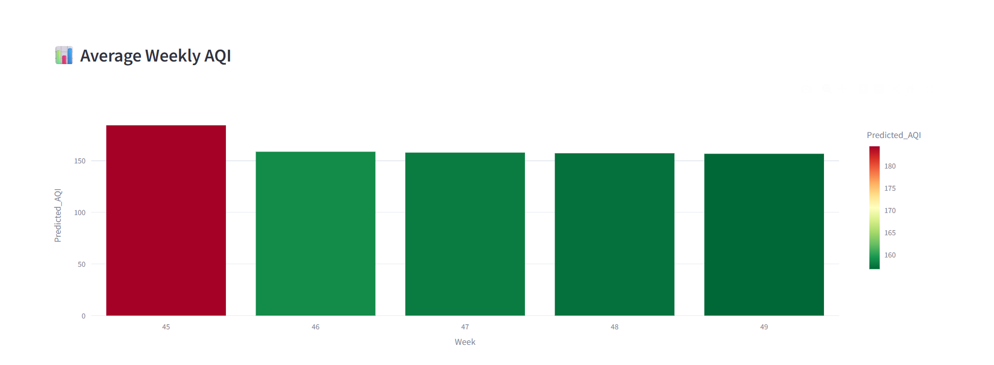
  - Pie chart of pollutant composition and weekly bar chart together.

- Radar Chart (WHO Comparison)
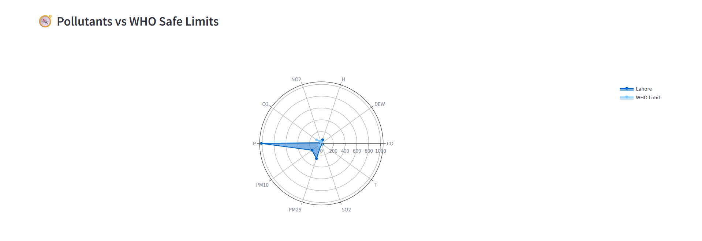
  - Shows pollutants vs WHO safe limits.

AQI Distribution on (Next 30-Days)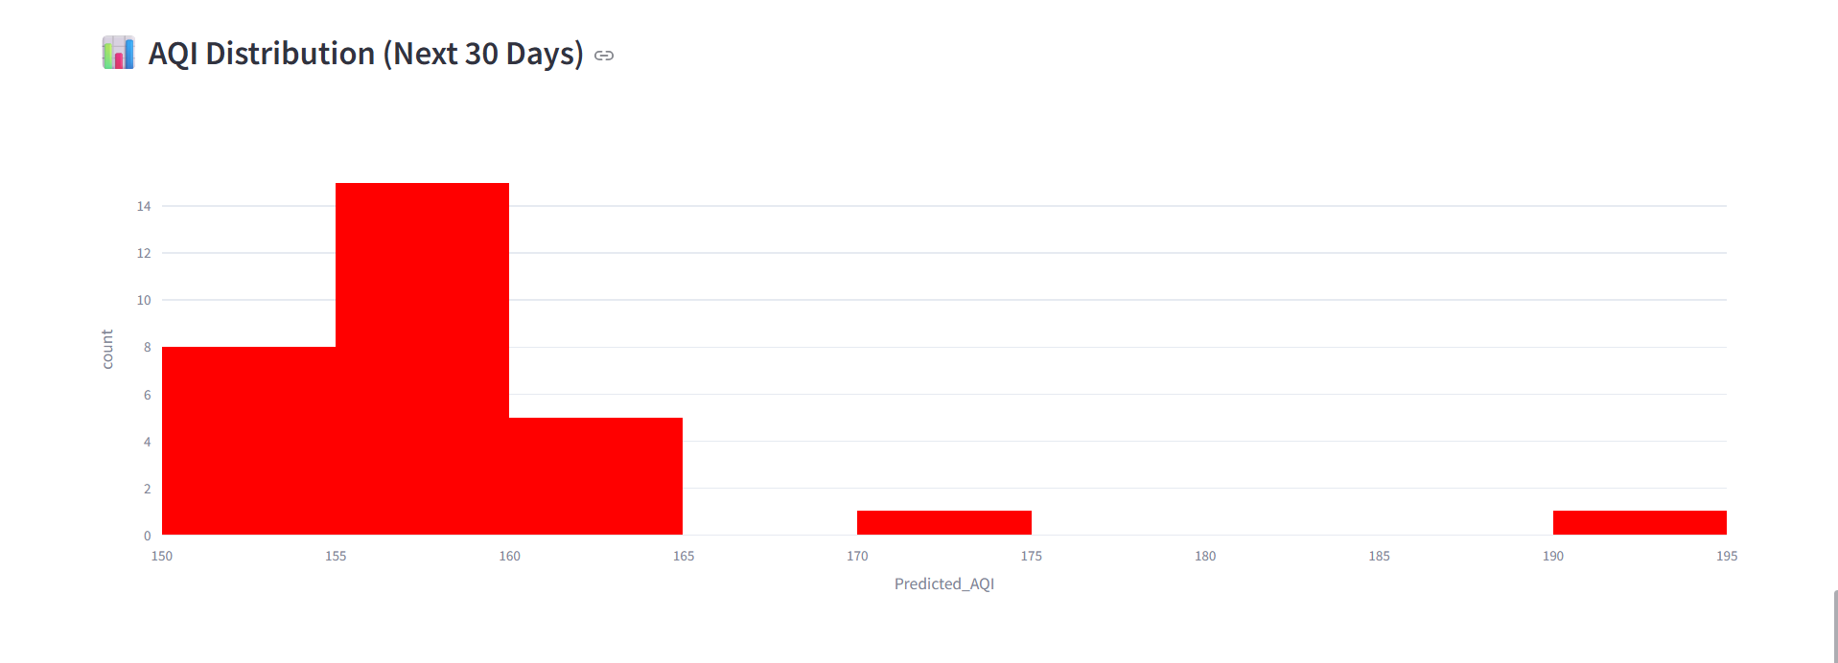
- Bottom Section (Summary Metrics)
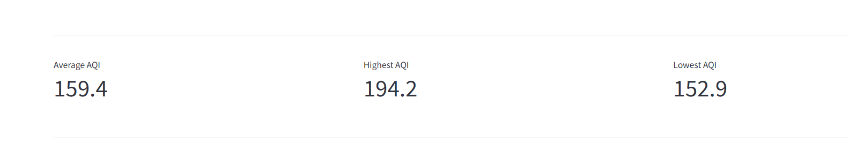
  - Capture Average, Highest, and Lowest AQI metrics with your name credit at the bottom.

8. Results and Observations
- The model successfully fetches live AQI data and aligns predictions with recent pollution trends.
- Forecast charts indicate that Lahore’s AQI remains mostly between 150–180, which falls under “Unhealthy” levels.
- Visual analytics like radar comparison and heatmaps make interpretation more intuitive.
- The system can be enhanced further by automating model retraining and integrating deep learning models for improved accuracy.

9. Conclusion
The Pearls Lahore AQI Predictor is a complete end-to-end system for monitoring and forecasting air quality.
It combines machine learning, API integration, and data visualization to deliver meaningful insights into environmental conditions.
The project demonstrates a full pipeline — from data collection to model deployment — and provides an interactive web dashboard that can be expanded for multiple cities or advanced model integration in the future.

10. Future Enhancements
- Integrate Deep Learning models (LSTM / GRU) for time-series forecasting.
- Extend system to multiple cities (Karachi, Islamabad, etc.).
- Automate data and model pipelines using Apache Airflow or GitHub Actions.
- Deploy online using Streamlit Cloud or AWS EC2 for public access.
Developed By:
Saifullah Khalid
Junior Data Developer
© 2025 Pearls Data Projects

