**NAME: SAIF UR REHMAN (2303.KHI.DEG.007)**

**Partner: MAVIA ALAM KHAN (2303.KHI.DEG.017)**

**Assignment Question:**

* On a Linux server setup, a cron job for copying example data with *rsync* periodically.
* Ensure the copying is handled in the background and independently of the user session.

Step 1: Manually create two directories

1. **cronjob_task**
2. **cronjob_rsync**

Step 2: Create two files in **cronjob_task** directory

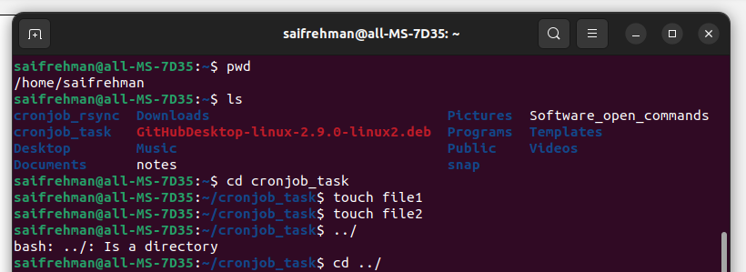

Step 3: Look there is no cronjob running



Step 4: Using rsync to backup files those above created files

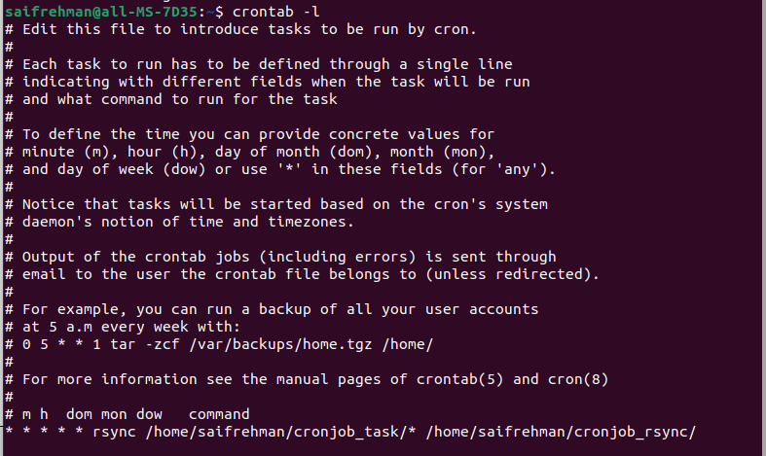

Result:

