**Name:** Saif Ur Rehman (2303.KHI.DEG.007)

**Partner:** Mavia Alam Khan (2303.KHI.DEG.017)

1: Insert 2 rows into articles table

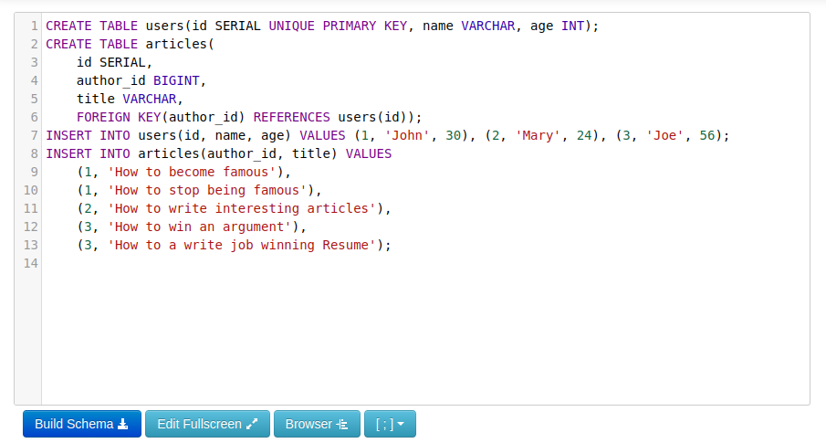

2: Select all columns from both tables by applying inner join

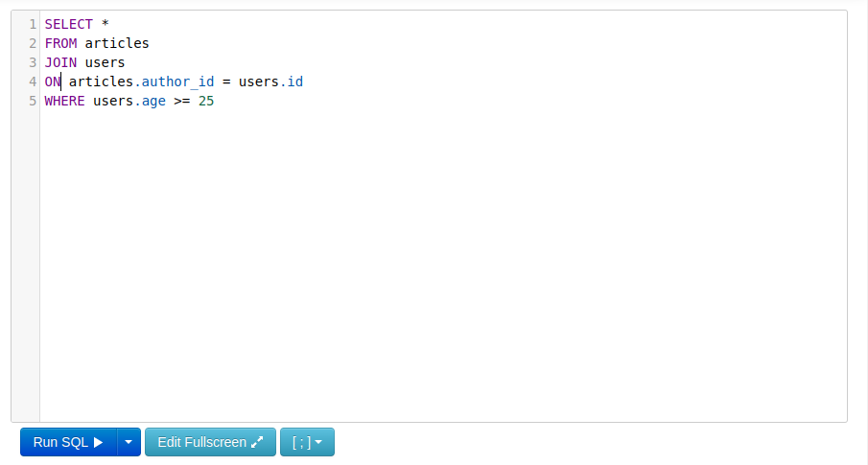

3: OUTPUT

