**Name:** Saif Ur Rehman (2303.KHI.DEG.007)

**Partner:** Mavia Alam Khan (2303.KHI.DEG.017)

**Assignment:**

Write a dataclass describing a mountain (containing fields for name and elevation):  
- Construct an instance of the dataclass  
- Convert it to string

**Code:**

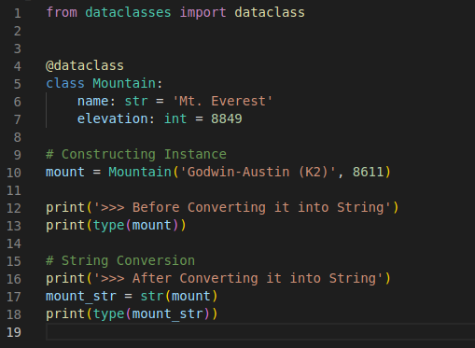

**Explanation:**

1. Imported **dataclass** module from **dataclasses** library.
2. we created a class named Mountain and initialize two different attributes inside of this class.
3. Then we constructed the class instance named **mount**
4. At first, we printed the type of our class
5. Then converted it by using python built-in function **str()**
6. As you see that the type is now changed

**Output:**

