**Software Requirements and Design Document**

**for**

**Citizen Data Integration System**

**Prepared by Muuhammad Owais, Ibrahim Ahmed Lone, Saif Ali**

**IDMatrix**

**24/11/24**

Table of Contents

Table of Contents ii

1. Introduction 1

1.1 Purpose 1

1.2 Product Scope 1

1.3 Title 1

1.4 Objectives 1

1.5 Problem Statement 1

2. Overall Description 1

2.1 Product Perspective 1

2.2 Product Functions 2

2.3 List of Use Cases 2

2.4 Extended Use Cases 2

2.5 Use Case Diagram 2

3. Other Nonfunctional Requirements 2

3.1 Performance Requirements 2

3.2 Safety Requirements 2

3.3 Security Requirements 2

3.4 Software Quality Attributes 2

3.5 Business Rules 3

3.6 Operating Environment 3

3.7 User Interfaces 3

4. Domain Model 3

5. System Sequence Diagram 3

6. Sequence Diagram 3

7. Class Diagram 4

8. Package Diagram 4

9. Deployment Diagram 4

**1. Introduction**

**1.1 Purpose**

*The* ***Citizen Data Integration System (CDIS)****, a unified data management platform designed for Pakistani citizens. The initial release focuses on integrating personal details, and educational records into a secure and centralized system. The scope of this Software Requirements Specification (SRS) covers all core functionalities and features that ensure efficient data handling and service delivery for authorized government bodies.*

**1.2 Product Scope**

*The* ***Citizen Data Integration System*** *is a comprehensive software solution aimed at enhancing the efficiency of data management and verification processes. The system addresses the limitations of fragmented data across various government departments by consolidating personal, educational, and travel information into a unified platform.*

*By enabling real-time access for authorized agencies, the system reduces redundancies, improves data accuracy, and ensures compliance with national regulations. Its objectives align with government strategies for improved public service delivery, better resource management, and strengthened national security through effective data integration. This system is pivotal in supporting services such as identity verification, educational document attestation, and travel history tracking.*

**1.3 Title**

*Citizen Data Integration System*

**1.4 Objectives**

***Unified Data Hub:*** *Establish a one-stop platform for managing citizens' personal, educational, and travel records.*

***Enhanced Data Quality:*** *Ensure accurate, real-time updates and seamless data synchronization.*

***Speedy Online Services:*** *Minimize processing delays through an efficient online system for citizens.*

***Educational Record Management:*** *Streamline the storage and attestation of citizens' academic credentials.*

**1.5 Problem Statement**

*Fragmented data across multiple government departments leads to delays, errors, and redundancies in service delivery. Citizens face long processing times due to inefficient workflows, while government agencies struggle with outdated and disorganized information. These inefficiencies result in increased administrative costs, reduced public trust, and weakened national data management systems.*

*The* ***Citizen Data Integration System*** *offers a solution by centralizing personal, and educational data into a secure platform. This integration improves data accuracy, ensures compliance with regulations, and enables authorized agencies to access real-time information. As a result, the system reduces redundancies, enhances workflow efficiency, lowers administrative costs, and improves service delivery for citizens, ensuring streamlined and transparent government processes.*

**2. Overall Description**

**2.1 Product Perspective**

*The* ***Citizen Data Integration System (CDIS)*** *is a new, self-contained software solution designed to replace fragmented data management systems in Pakistan. It consolidates personal, and educational information into a unified platform. Unlike existing systems, CDIS integrates these data categories to streamline services such as identity verification, document issuance, and credential equivalency evaluation.*

*CDIS operates as a central hub within the national data management ecosystem, connecting with government databases and external entities like educational institutions for real-time updates and verifications. The system interacts seamlessly with other modules (e.g., payment processing, document delivery) to enhance its overall functionality.*

#### *System Overview Diagram*

*The diagram below illustrates the major components of CDIS, including:*

1. ***User Interface*** *– Access points for customers and employees.*
2. ***Data Integration Module*** *– Combines data from personal, educational, and travel records.*
3. ***Verification Services*** *– Interfaces with external authorities for validation.*
4. ***Document Management Module*** *– Handles document generation, updates, and secure storage.*

***Software Requirements Specification for <Project> Page 4***

**2.2 Product Functions**

*The major functions of CDIS include:*

* ***User Registration and Profile Management:*** *Citizens can register, update their profiles, and manage their data.*
* ***Verification Services:*** *Validate educational credentials, travel history, and document authenticity.*
* ***Document Services:*** *Apply for and receive CNICs, passports, domiciles, and other official documents.*
* ***Data Updates:*** *Update personal details, educational qualifications, and documents.*
* ***Equivalence Evaluation:*** *Facilitate academic equivalence requests and approvals.*
* ***Secure Storage:*** *Store documents in a biometric-secured vault.*
* ***Service Fee Processing:*** *Manage payments via multiple channels (e.g., Easypaisa, credit cards).*

**2.3 List of Use Cases**

1. **Issue equivalence certificate**
2. **Process Passport Application**
3. **Register using OTP**
4. **Generate Domicile**
5. **Issue Duplicate for Lost Documents**
6. **Process Service Fees**
7. **Manage Customer Accounts**
8. **Manage Employees**
9. **Process CNIC Issuance**
10. **Process B-Form Issuance**

**2.4 Extended Use Cases**

### Use Case Name:

**Issue Equivalence Certificate**

### 1. Actors:

**Primary Actor**: Customer

### 2. Scope:

Citizen Data Integration System

### 3. Level:

User Goal

### 4. Stakeholders and Interests:

* **Customer**: The individual requesting the issuance of an equivalence certificate for educational purposes such as further studies, employment, or migration.
* **Education Department**: Ensures the certificate issuance process is accurate and aligns with the institution's policies.
* **Employee**: Staff responsible for reviewing and approving equivalence requests.
* **System Admin**: Ensures the secure and seamless operation of the equivalence certificate system.

### 5. Preconditions:

1. The customer must be registered in the system with valid credentials.
2. Educational documents required for equivalence must be uploaded to the customer’s profile.
3. The system must be operational and integrated with relevant educational bodies or institutions for validation.

### 6. Success Guarantee:

The equivalence certificate is either issued or the request is rejected.

* If issued: The equivalence certificate is available in the customer's profile.
* If rejected: The customer is notified with reasons for rejection.

Main Success Scenario:

|  |  |
| --- | --- |
| 1. The customer logs in and selects **Equivalence Certificate Issuance**. | 2. The system displays the equivalence certificate application form. |

|  |  |
| --- | --- |
| 3. The customer fills out the application form, uploads required documents, and submits the request. | 4. The system acknowledges receipt of the application and provides a confirmation receipt to the customer. |

|  |  |
| --- | --- |
| 5. The customer pays the required fee through **Process Service Fees**. | 6. The system updates the status of the request to "Pending Review." |

|  |  |
| --- | --- |
| 7. The employee logs into the system and navigates to pending equivalence certificate requests. | 8. The system displays a list of pending equivalence certificate requests. |

|  |  |
| --- | --- |
| 9. The employee selects the customer’s request for review. | 10. The system displays the customer details and uploaded documents for verification. |

|  |  |
| --- | --- |
| 11. The employee reviews the application and approves it if all details are valid. | 12. The system prepares the equivalence certificate for issuance. |

**Extensions:**

**3a. Missing Required Documents**

1. The system prompts the customer to upload the missing documents before submission.
2. The customer updates their application with the required documents.

**11a. Invalid Information**

1. The employee rejects the application.
2. The customer receives a notification explaining the reasons for rejection.

|  |  |
| --- | --- |
| Use Case Name | Process Passport Application |
| Scope | Citizen Data Integration System |
| Level | User Goal |
| Primary Actor | Customer |

Component Description

1. Customer: Wants to apply for a passport or renew an existing passport.
2. Government: Needs to ensure that the passport application process is secure

Stakeholders and and efficient, verifying customer data and documents.

Interests 3. System Employee: Ensures the system operates smoothly for both customers and officials.

1. Customer must be logged in to the system.

Preconditions 2. Customer’s personal and contact details must be up-to-date in their profile.

3. The customer must not have an active passport application.

Postconditions

1. The passport application is submitted for processing.

2. The status of the application is updated in the customer’s profile, and a notification is sent.

3. Once the passport is generated, the customer is notified, can view the status in their profile, and completes the payment.

Success Scenario:

Customer System

1. Customer logs in to system and navigates to 2. The system displays any previous passport the "Passport Application" section. applications and their statuses.

3. Customer fills out the passport application 4. The system verifies the provided form, providing all required information information, checks for any discrepancies,

and identification and ensures that all required documents are

uploaded.

5. Customer submits the application. 6. The system updates the customer’s profile

with the current status of the application.

7. Perform usecase Process Service Fees 8. Once the passport is ready, the system notifies the customer that their passport is ready and updates the status to "Passport Generated".

Extensions

Step Condition Handling

|  |  |  |
| --- | --- | --- |
| 1a | Customer enters incorrect login The system displays an error message and prompts the | |
| credentials | customer to retry or reset their password. |
| 3a | Customer provides incomplete or invalid information in the form | The system displays an error message, specifying which information needs to be corrected, and prompts the customer to revise the application. |
| 4a | System detects missing or invalid documents | The system notifies the customer to upload the missing or correct documents before proceeding with the application. |
| 5a | Customer tries to submit  without completing mandatory fields | The system prevents submission and highlights the missing or incomplete fields that require attention. |

### ****Use Case Name:****

Register Using OTP

### ****Actors:****

* **Primary Actor**: Customer

### ****Scope:****

Citizen Data Integration System

### ****Level:****

User Goal

### ****Stakeholders and Interests:****

* **Customer**: Wants a secure and hassle-free method for registering in the system.
* **System Admin**: Ensures the registration process is secure and operational.

### ****Preconditions:****

1. The customer must have a valid phone number or email address to receive the OTP.
2. The system is operational and capable of generating and sending OTPs.

### ****Success Guarantee:****

The customer is successfully registered in the system with verified contact information.

### ****Main Success Scenario:****

| **Customer** | **System** |
| --- | --- |
| 1. The customer opens the registration page and enters their contact details (phone number or email). | 2. The system validates the format of the contact details and generates an OTP. |
| 3. The customer receives the OTP via SMS or email. | 4. The system sends the OTP to the provided contact details. |
| 5. The customer enters the OTP in the system and submits it for verification. | 6. The system verifies the OTP. If valid, the registration process proceeds. |
| 7. The customer fills in additional registration details (e.g., name, password) and submits the form. | 8. The system completes the registration process and provides a confirmation message. |

**Extensions:**

**2a. Invalid Contact Details**

1. The system notifies the customer that the contact details are invalid.
2. The customer corrects the contact details and resubmits the request.

**4a. OTP Delivery Failure**

1. The customer does not receive the OTP due to a technical issue or incorrect contact details.
2. The system provides an option to resend the OTP or update contact details.

**6a. Incorrect OTP**

1. The system notifies the customer of an invalid OTP.
2. The customer retries entering the correct OTP or requests a new OTP.

**8a. System Error During Registration**

1. The system notifies the customer of the error and provides troubleshooting steps.
2. The customer retries the registration process after resolving the issue.

|  |  |
| --- | --- |
| Use Case Name | Generate Domicile |
| Scope | Citizen Data Integration System |
| Level | User Goal |
| Primary Actor | Customer |
| Stakeholders and Interests | 1. Customer: Wants to obtain a domicile certificate for identity and residency verification. 2. Government: Ensures proper processing and verification of domicile applications. 3. System Employee: Ensures the system operates smoothly for both customers and officials. |
| Preconditions | 1. Customer must be logged in to the system. 2. The customer must have valid proof of residence and identification uploaded. 3. The customer must not have any pending domicile applications. |
| Postconditions | 1. A domicile certificate is generated and issued to the customer. 2. The customer's profile is updated with the domicile certificate details. 3. The customer receives a notification about the domicile generation. |

Main Success Scenario

Customer System

1. Customer logs in to the system and
2. The system displays any previous domicile

navigates to the "Domicile Application" applications and their statuses.

section.

1. Customer fills out the domicile application 4. The system verifies the provided form, providing all required information, information, checks for any discrepancies,

including proof of residence and and ensures that all required documents are identification. uploaded.

6. The system processes the application and

5. Customer submits the application. checks for eligibility based on provided

data.

7. The system updates the customer’s profile

with the current status of the application

(e.g., "Under Review").

8. Customer gets notified of the domicile 9. The system notifies the customer that their application submission and can track the domicile certificate has been generated and status. is available for download

11. The system marks the domicile application

10. Perform usecase Process Service Fees as "Completed" in the customer’s profile.

Extensions

Step Condition Handling

|  |  |
| --- | --- |
| 1a | Customer enters incorrect login The system displays an error message and prompts the credentials customer to retry or reset their password. |
| 3a | The system displays an error message, specifying which  Customer provides incomplete or information needs to be corrected, and prompts the customer  invalid information in the form to revise the application. |
| 4a | System detects missing or invalid The system notifies the customer to upload the missing or documents correct documents before proceeding with the application. |
| 5a | The system logs the error and notifies the customer of the  Technical error occurs during issue, automatically retrying submission or providing steps to  submission resolve the issue. |
| 8a | Customer does not receive  The system retries sending the notification and offers the  notification about the domicile option to manually check the status via the customer's profile.  certificate |

1. Use Case Name:

Issue Duplicate for Lost Documents

1. Scope

The IDMatrix system is designed to facilitate the issuance of duplicate documents for individuals who have lost their original documents. This includes functionalities similar to NADRA services and the issuance of educational certificates.

1. Level

User Goal Level

1. Primary Actor

User (individual applying for a duplicate document)

1. Stakeholders and Interests

Users: Interested in receiving a duplicate of their lost documents efficiently and without unnecessary delays.

Employees: Responsible for processing duplicate requests and ensuring proper verification of identity and claims.

System Administrators: Ensure the system functions correctly and securely stores user information.

1. Preconditions

The User must be registered in the IDMatrix system.

The User must have valid identification documents or relevant information (e.g., CNIC, educational credentials).

The User must have reported the loss of the original document to the relevant authorities (if required).

1. Postcondition

The User receives a duplicate of the lost document.

The system updates the status of the original document to reflect that a duplicate has been issued. h. Main Success Scenario:

|  |  |
| --- | --- |
| User Action | System Response |
| 1. The User logs into the IDMatrix system. | 2. The system authenticates the user and displays the dashboard. |
| 3. The User navigates to the "Issue Duplicate for Lost Documents" section. | 4. The system presents the application form for requesting a duplicate. |  |
| 5. The User fills out the application form with relevant details (e.g., CNIC, document type) | 6. The system prompts the user to ensure all required fields are completed. |
| 7. The User submits the application for a duplicate document. | 8. The system processes the request and verifies the user's identity and document loss report. |
| 9. The Employee reviews the application and verifies the information provided by the User. | 10. The system displays the application details for the Employee to review. |
| 11. The Employee approves the request and issues a duplicate document. | 12. The system generates a duplicate document and updates the user’s profile. |
| 13. The User accesses their profile to download the duplicate document | 14. The system provides the duplicate document in a downloadable format. |

i. Extensions:

1a. User Not Registered:

User Action: The User attempts to log in but is not registered.

System Response: The system prompts the User to register before proceeding.

5a. Missing Required Information:

User Action: The User submits the application form without completing all required fields.

System Response: The system highlights the missing fields and prompts the User to complete them.

7a. Application Submission Failure:

User Action: The User attempts to submit the application, but an error occurs (e.g., network issue). System Response: The system displays an error message and prompts the User to try again.

9a. Verification Failure:

User Action: The Employee reviews the application but finds discrepancies in the information provided.

System Response: The system flags the application for further review and informs the Employee of the discrepancies.

11a. Employee Rejects the Application:

User Action: The Employee determines that the application does not meet the requirements. System Response: The system updates the application status to "Rejected" and informs the User of the reason for rejection.

**Use Case Name:** Process Service Fees  
**Scope:** Citizen Data Integration System  
**Level:** User Goal  
**Primary Actor:** Customer  
**Stakeholders and Interests:**

1. **Customer:** Wants a convenient, secure method to pay service fees.
2. **Admin:** Oversees seamless payment processing and ensures error resolution.
3. **Payment Gateway Provider:** Ensures secure and accurate payment transactions.

**Preconditions:**

1. The customer must be registered in the system.
2. The customer must have a valid service request initiated that requires fee payment.
3. The payment gateway must be operational and integrated with the system.

**Postconditions:**

1. The service fee is successfully processed and reflected in the system.
2. The customer receives a receipt or confirmation of the transaction

Main Success Scenario:

| **Customer Action** | **System Responsibility** |
| --- | --- |
| 1. Customer logs in and selects the pending service request. | 2. The system displays the service details along with the applicable fees. |
| 3. Customer proceeds to the payment option. | 4. The system redirects the customer to the integrated payment gateway. |
| 5. Customer enters payment details and confirms the transaction. | 6. The payment gateway processes the payment and sends a success response to the system. |
| 7. The system updates the service request status to "Fee Paid." | 8. The system generates a receipt and sends a confirmation notification to the customer. |

#### Extensions:

**4a. Payment Gateway Timeout:**

1. The system notifies the customer of the timeout.
2. The customer is prompted to retry the transaction or contact support.

**5a. Payment Declined:**

1. The payment gateway returns a "Declined" status.
2. The system informs the customer, providing reasons if available.
3. The customer is prompted to retry with updated payment details.

**6a. Payment Gateway Error:**

1. The system receives an error response from the gateway.
2. The system logs the error and notifies the admin for resolution.
3. The customer is informed and provided with alternative payment options.
4. Use Case Name: Manage Employees
5. Actors:

Primary Actor: Administrator

1. Scope:

Citizen Data integration system

4: Level:

User-goal

1. Stakeholders and Interests:

Administrator: Responsible for managing employee records and ensuring the accuracy of data.

Employees: Users who may need to view their own data and updates made by the administrator.

Customers: Users want their data to be managed by proper employees.

1. Preconditions:

The administrator must be logged into the system with appropriate permissions.

Employee records exist in the system.

1. Success guarantee:

Employee information is created, updated, or deleted as requested

1. Main Success Scenario:

|  |  |
| --- | --- |
| Actor Action | System responsibility |
| 1. The Administrator logs into the system and navigates to the employee account management section. | 2. The system displays view employee, add employee, update employee, and delete employee options. |

|  |  |  |
| --- | --- | --- |
| 3. The admin chooses action type:   1. If view employee, see section view em-ployee. 2. If add employee, see section add employee. 3. If delete employee, see section delete em-ployee. 4. If update employee, see section update em-ployee. | 4. The system displays a prompt to confirm changes made and asks user if another action is needed. |  |
| 5. Repeat steps 2-4 until the administrator is satisfied. | 6. System logs changes made. |

Section view employee:

|  |  |
| --- | --- |
| Actor Action | System responsibility |
|  | 1. The system displays the list of employees. |
| ~~2~~2. The Admin searches for a specific employee account and selects the desired account. | ~~3~~3. The system displays the details of the selected employee account. |

Alternative courses:

3a: Employee not found

1. The system displays a "Employee not found" message.

Section add employee:

|  |  |
| --- | --- |
| Actor Action | System responsibility |
| 1. The administrator enters the new employee’s details in the provided fields | 2. The system validates input data and prompts user for confirmation |
| ~~2~~3. The Administrator confirms through the prompt. | ~~3~~4. The system makes necessary action and displays a success message. |

Alternative courses:

2a: The input is invalid

* 1. The system provides feedback on what is wrong.
  2. The system prompts the employee to correct the input

Section delete employee:

|  |  |
| --- | --- |
| Actor Action | System responsibility |
|  | 1. The system displays the list of employees. |
| ~~2~~2. The Admin searches for a specific employee account and selects the desired account. | ~~3~~3. The system displays the details of the selected employee account and asks for confirmation |
| 4. The administrator confirms deletion, | 5. The system makes necessary action and displays a success message. |

Alternative courses:

2a: Employee not found

1. The system displays a "Employee not found" message.

3a: The Administrator does not have authorization to delete.

* 1. The system displays the message that the account cannot be deleted

Section update employee:

|  |  |
| --- | --- |
| Actor Action | System responsibility |
|  | 1. The system displays the list of employees. |
| ~~2~~2. The Admin searches for a specific employee account and selects the desired account. | ~~3~~3. The system displays the details of the selected employee account. |
| 4. The Administrator modifies the necessary fields. | 5. The system asks for confirmation. |
| 6. The administrator confirms update. | 7. The system makes necessary action and displays a success message. |

Alternative courses:

2a: Employee not found

* 1. The system displays a "Employee not found" message.

3a: The Administrator does not have authorization to Update.

~~1.~~2.The system displays the message that the account cannot be updated.

4a: The input is invalid

* 1. The system provides feedback on what is wrong.
  2. The system prompts the employee to correct the input

1. Use Case Name: Manage Customer Accounts
2. Actors:

Primary Actor: Employee

1. Scope: Citizen Data integration system

4: Level:

User-goal

1. Stakeholders and Interests:

Employee: Wants to efficiently manage customer accounts to assist customers and ensure accurate information.

Customer: Wants to update their account information, view order history, and manage preferences.

Administrator: Wants to ensure employees have the necessary permissions to manage customer accounts effectively.

1. Preconditions:

Employees must be logged into the system with appropriate permissions to access customer account management features.

Customer accounts must already exist for management purposes.

1. Success guarantee:

Customer account details are updated, created, or deleted as needed.

8

. Main Success Scenario:

Actor Action

System responsibility

1.

The employee logs into the system and

navigates to the customer account manage-

ment section.

2

.

The system displays the list of customers.

~~2~~

3

.

The employee searches for a specific cus-

tomer account and selects the desired account.

~~3~~

4

.

The system displays the details of the se-

lected customer account.

~~4~~

5

.

Employee chooses action type:

a. If update account, see section Update ac-

count.

b. If delete account, see section Delete ac-

count.

~~.~~

~~5~~

6

.

The system displays a prompt for con-

firming changes made.

~~6~~

7

.

After performing any actions, the em-

ployee confirms the changes through a

prompt.

~~7~~

8

. The system makes necessary action and

displays a success message and logs the ac-

tion.

Section Update account:

Formatted:

Font: Liberation, Not Bold

|  |  |
| --- | --- |
| Actor Action | System responsibility |
| 1. The employee modifies the necessary fields, such as Name, Email, Phone number, Shipping address, Billing information | 2. The system validates the input and asks for confirmation~~,~~. |
| 3. The employee confirms changes. |  |
|  |  |

Alternative courses:

2a: The input is invalid

* 1. The system provides feedback on what is wrong.
  2. The system prompts the employee to correct the input

Section Delete account:

|  |  |
| --- | --- |
| Actor Action | System responsibility |
| 1. The employee choses to delete the account. | 2: The system warns the user that the account will be deleted permanently and asks for confirmation. |
| 3. The employee confirms deletion. |  |

Alternative courses:

1a: The employee does not have authorization to delete.

1. The system displays the message that the account cannot be deleted

Extensions:

3a: Customer not found

1. The system displays a "Customer not found" message.

8a: System Error:

1. The system alerts the employee with an appropriate error message.

1. Use Case Name:

**Process B-Form Issuence**

1. Actors:

Primary Actor: Customer

1. Scope:

Citizen Data integration system

4: Level:

User-goal

1. Stakeholders and Interests:

Customer: The individual requesting the issuance of a B-Form.

Employee: The staff responsible for processing and approving the B-Form requests.

Government Agency: The organization responsible for issuing B-Form, which relies on accurate data processing.

Admin: Insuring the operation is running smoothly.

1. Preconditions:

The customer must be registered in the system and possess valid identification documents.

The employee must be logged into the system with appropriate permissions to approve requests.

1. Success guarantee:

The B-Form request is either approved or rejected.

If approved, the B-Form is processed for issuance; if rejected, the customer is notified with reasons. Main Success Scenario:

|  |  |
| --- | --- |
| Actor Action | System responsibility |
| 1. The customer logs in and selects B-Form Issuance. |  |
| 2. The customer fills out the B-Form application form, providing personal details and Required identification documents and submits the form. | 3. The system acknowledges receipt of the application and provides a confirmation receipt to the customer. |
| 4. The customer pays through Process service fees. |  |
| 5. The employee logs into the system and navigates to the pending B-Form requests. | 7. The system displays list of pending B-Form requests. |
| 8. The employee selects the customer’s request for review. | 9. The system displays the customer details and form submitted of the selected customer. |
| 10. The employee checks the submitted documents and approves it. | 11. The system prepares the B-Form for issuance. |
|  | 12. The system sends a notification to the customer, confirming that their B-Form request has been approved and will be issued shortly. |  |

Extensions:

10a. Missing Information

1. The employee marks the application as “Needs More Information.” 2. The customer is notified of the required documents to complete the application.

10b. Invalid Information:

* 1. The employee rejects the application.
  2. The customer receives a notification explaining the reasons for rejection.

1. **Use Case Name: Process Cnic Issuence**
2. Actors:

Primary Actor: Customer

1. Scope:

Citizen Data integration system

4: Level:

User-goal

1. Stakeholders and Interests:

Customer: The individual requesting the issuance of a CNIC.

Employee: The staff responsible for processing and approving the CNIC requests.

Government Agency: The organization responsible for issuing CNICs, which relies on accurate data processing.

Admin: Insuring the operation is running smoothly.

1. Preconditions:

The customer must be registered in the system and possess valid identification documents.

The employee must be logged into the system with appropriate permissions to approve requests.

1. Success guarantee:

The CNIC request is either approved or rejected.

If approved, the CNIC is processed for issuance; if rejected, the customer is notified with reasons.

Main Success Scenario:

|  |  |  |
| --- | --- | --- |
| Actor Action | System responsibility |  |
| 1. The customer logs in and selects CNIC Issuance. |  |
| 2. The customer fills out the CNIC application form, providing personal details and Required identification documents such as a B.Form and submits the form. | 3. The system acknowledges receipt of the application and provides a confirmation receipt to the customer. |
| 4. The customer pays through Process service fees. |  |
| 5. The employee logs into the system and navigates to the pending CNIC requests. | 7. The system displays list of pending CNIC requests. |
| 8. The employee selects the customer’s request for review. | 9. The system displays the customer details and form submitted of the selected customer. |
| 10. The employee checks the submitted documents and approves it. | 11. The system prepares the CNIC for issuance. |
|  | 12. The system sends a notification to the customer, confirming that their CNIC request has been approved and will be issued shortly. |

Extensions:

10a. Missing Information

1. The employee marks the application as “Needs More Information.” 2. The customer is notified of the required documents to complete the application.

10b. Invalid Information:

* 1. The employee rejects the application.
  2. The customer receives a notification explaining the reasons for rejection.

**2.5 Use Case Diagram**

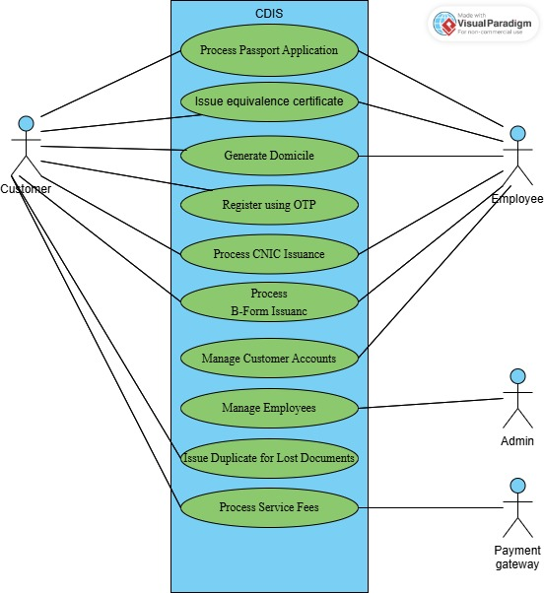

**3. Other Nonfunctional Requirements 3.1 Performance Requirements**

*The system must handle up to 10,000 concurrent user sessions without performance degradation.*

*Response times for critical operations (e.g., login, data retrieval, or verification requests) should not exceed 2 seconds under normal loads.*

*The system should support real-time synchronization of educational data, with a maximum delay of 5 seconds for updates.*

*Document uploads and processing times should complete within 10 seconds, depending on file size.*

*The system must maintain 99.9% uptime, ensuring minimal service disruption.*

**3.2 Safety Requirements**

*The system must comply with* national safety regulations *concerning the handling of sensitive personal data, including CNICs, passports, and academic records.*

*Regular data backup must occur every 12 hours to prevent data loss.*

*The system should log and notify administrators of any unauthorized access attempts, ensuring safeguards against data tampering or misuse.*

*Clear and precise error messages should guide users in case of incorrect data submissions without exposing sensitive details.*

**3.3 Security Requirements**

*The system must implement* ***multi-factor authentication (MFA)*** *for accessing sensitive operations, such as profile updates or document requests.*

*All user data, including personal, educational, and travel records, must be encrypted both at rest and in transit using* ***AES-256 encryption****.*

*Access to the system should be role-based, with* ***permissions assigned to employees and administrators*** *as per their responsibilities.*

*Logs of user and employee activities must be retained for a minimum of* ***six months*** *for auditing purposes.*

*The system should comply with* ***Pakistan’s Personal Data Protection Bill (PDPB)*** *for privacy and security regulations*

**3.4 Software Quality Attributes**

***Reliability:*** *The system must function continuously without crashes or errors, ensuring uninterrupted services.*

***Usability:*** *The user interface should be intuitive, with clear navigation and helpful tooltips for first-time users.*

***Adaptability:*** *The system should accommodate future feature integrations, such as additional document types or external API connections.*

***Interoperability:*** *Seamless integration with existing government databases, educational institutions, and financial systems.*

***Scalability:*** *The system must handle increased user loads, scaling up to* ***50,000 users*** *during peak periods.*

***Testability:*** *All modules should be verifiable through automated test cases to ensure accuracy and performance.*

**3.5 Business Rules**

*Only* ***registered customers*** *can access the system’s features.*

*Employees must be authorized to approve document requests or updates.*

*Only verified educational institutions are allowed to provide credentials for equivalence evaluations.*

*Document delivery must occur only after full payment of associated service fees.*

**3.6 Operating Environment**

*<Describe the environment in which the software will operate, including the hardware platform, operating system and versions, and any other software components or applications with which it must peacefully coexist.>*

**3.7 User Interfaces**

#### *Logical Characteristics*

* ***Dashboard Layout:***
  + ***Admin Interface:*** *Displays system metrics, user activity logs, and employee management tools. Includes options for monitoring pending approvals, generating reports, and configuring system settings.*
  + ***Employee Interface:*** *Modular layout showing assigned tasks, customer requests for approval, and notifications for updates or pending actions.*
  + ***Customer Interface:*** *Presents pending requests, notifications about application statuses, and shortcuts for frequently used services (e.g., CNIC applications or document updates).*

**4. Domain Model**

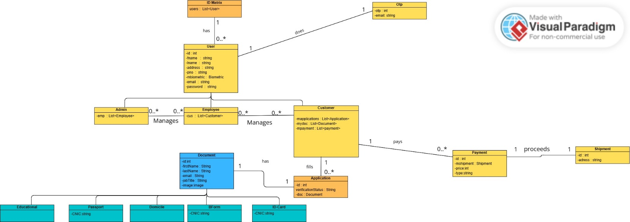

**5. System Sequence Diagram**

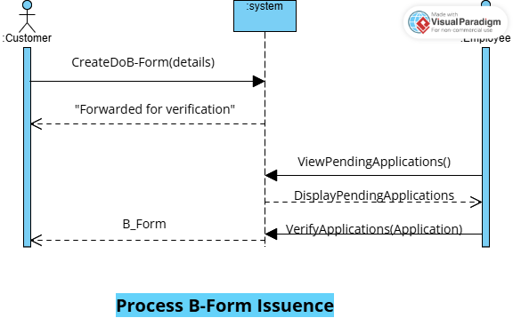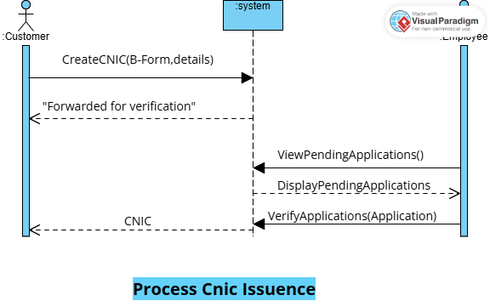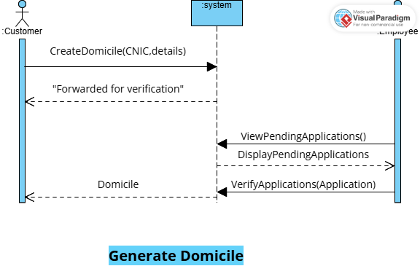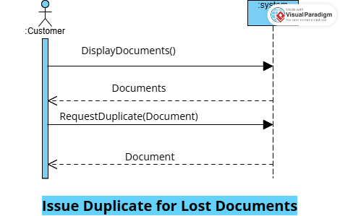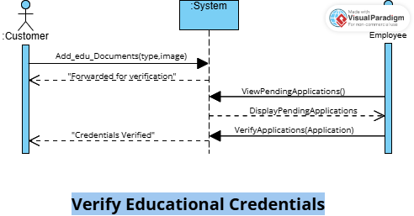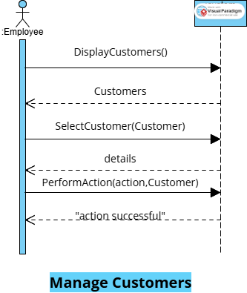

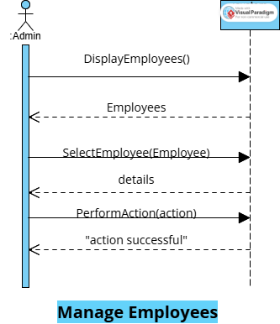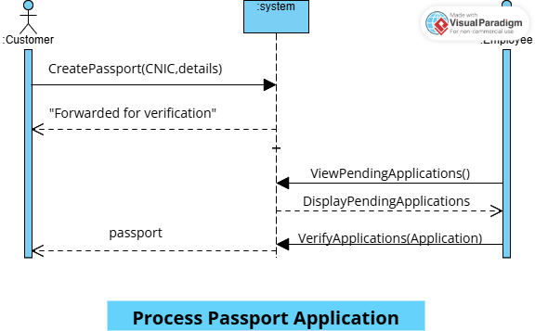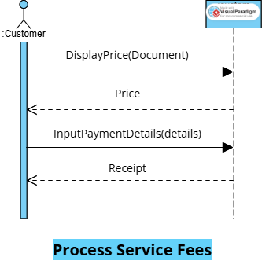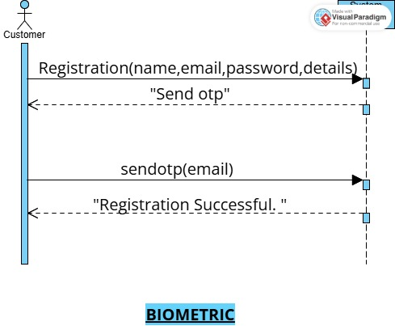

**6. Sequence Diagram**

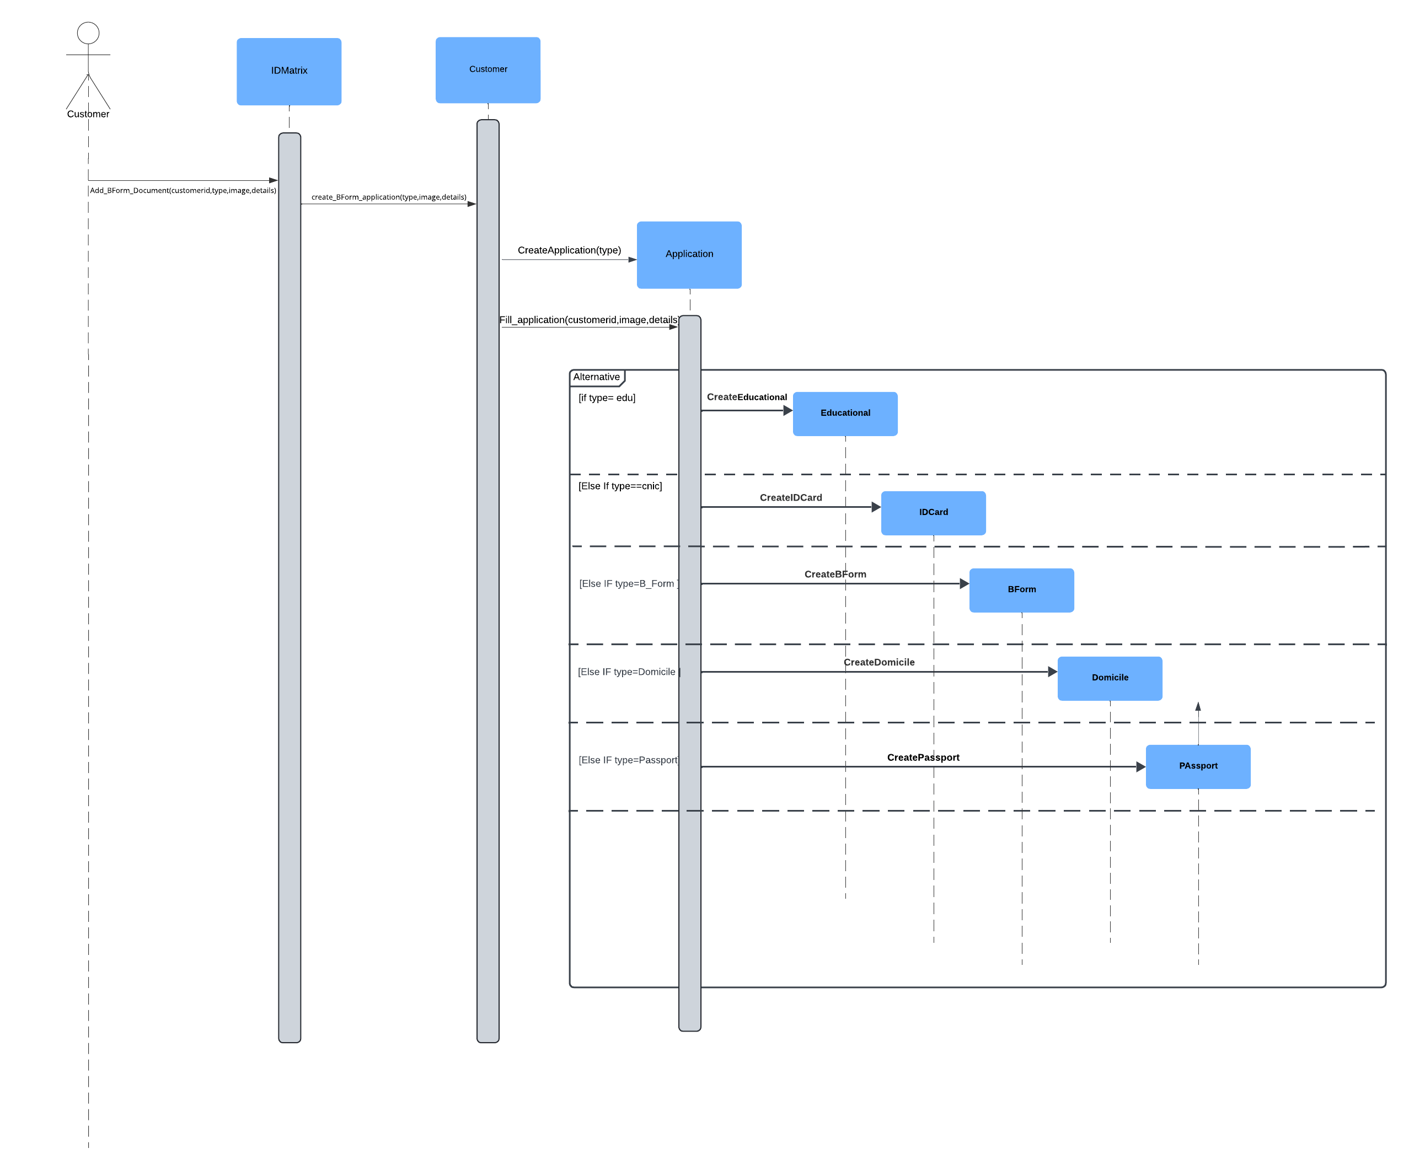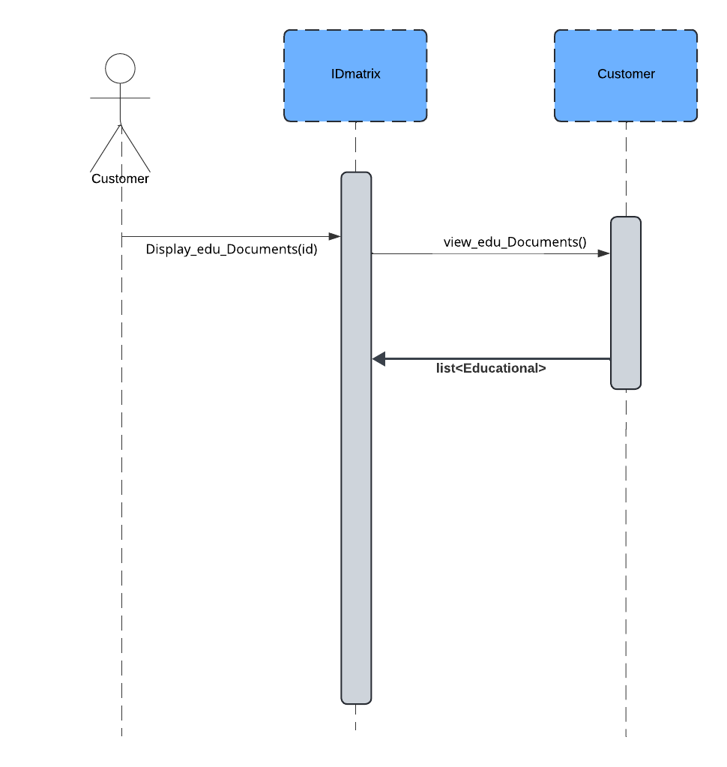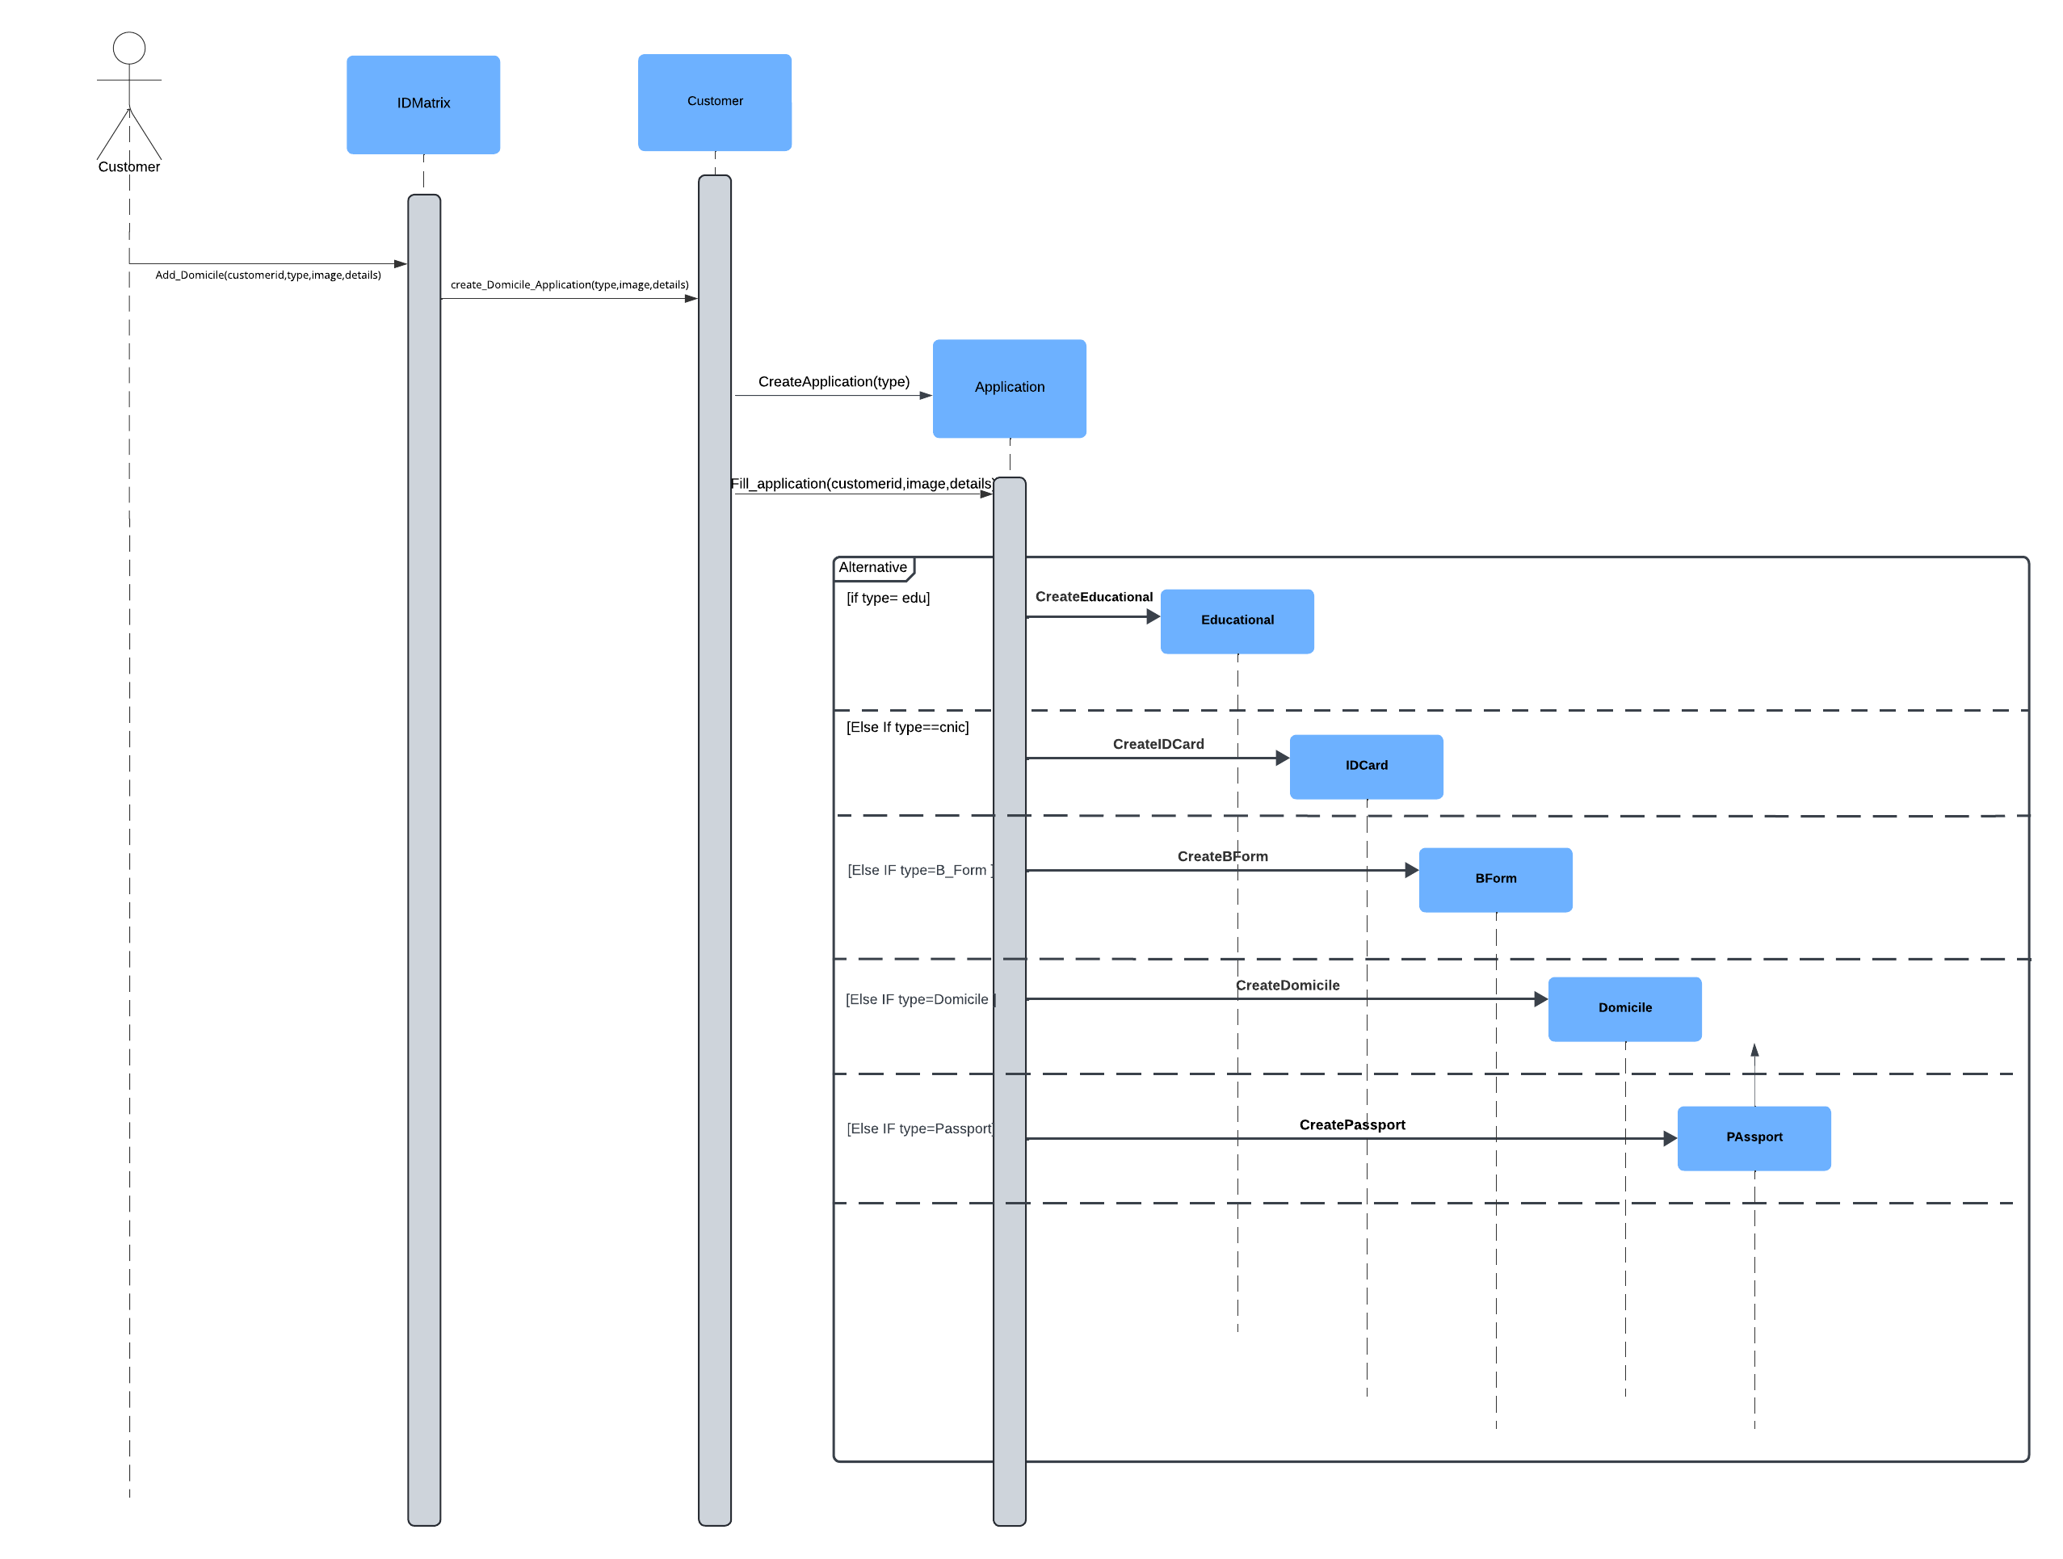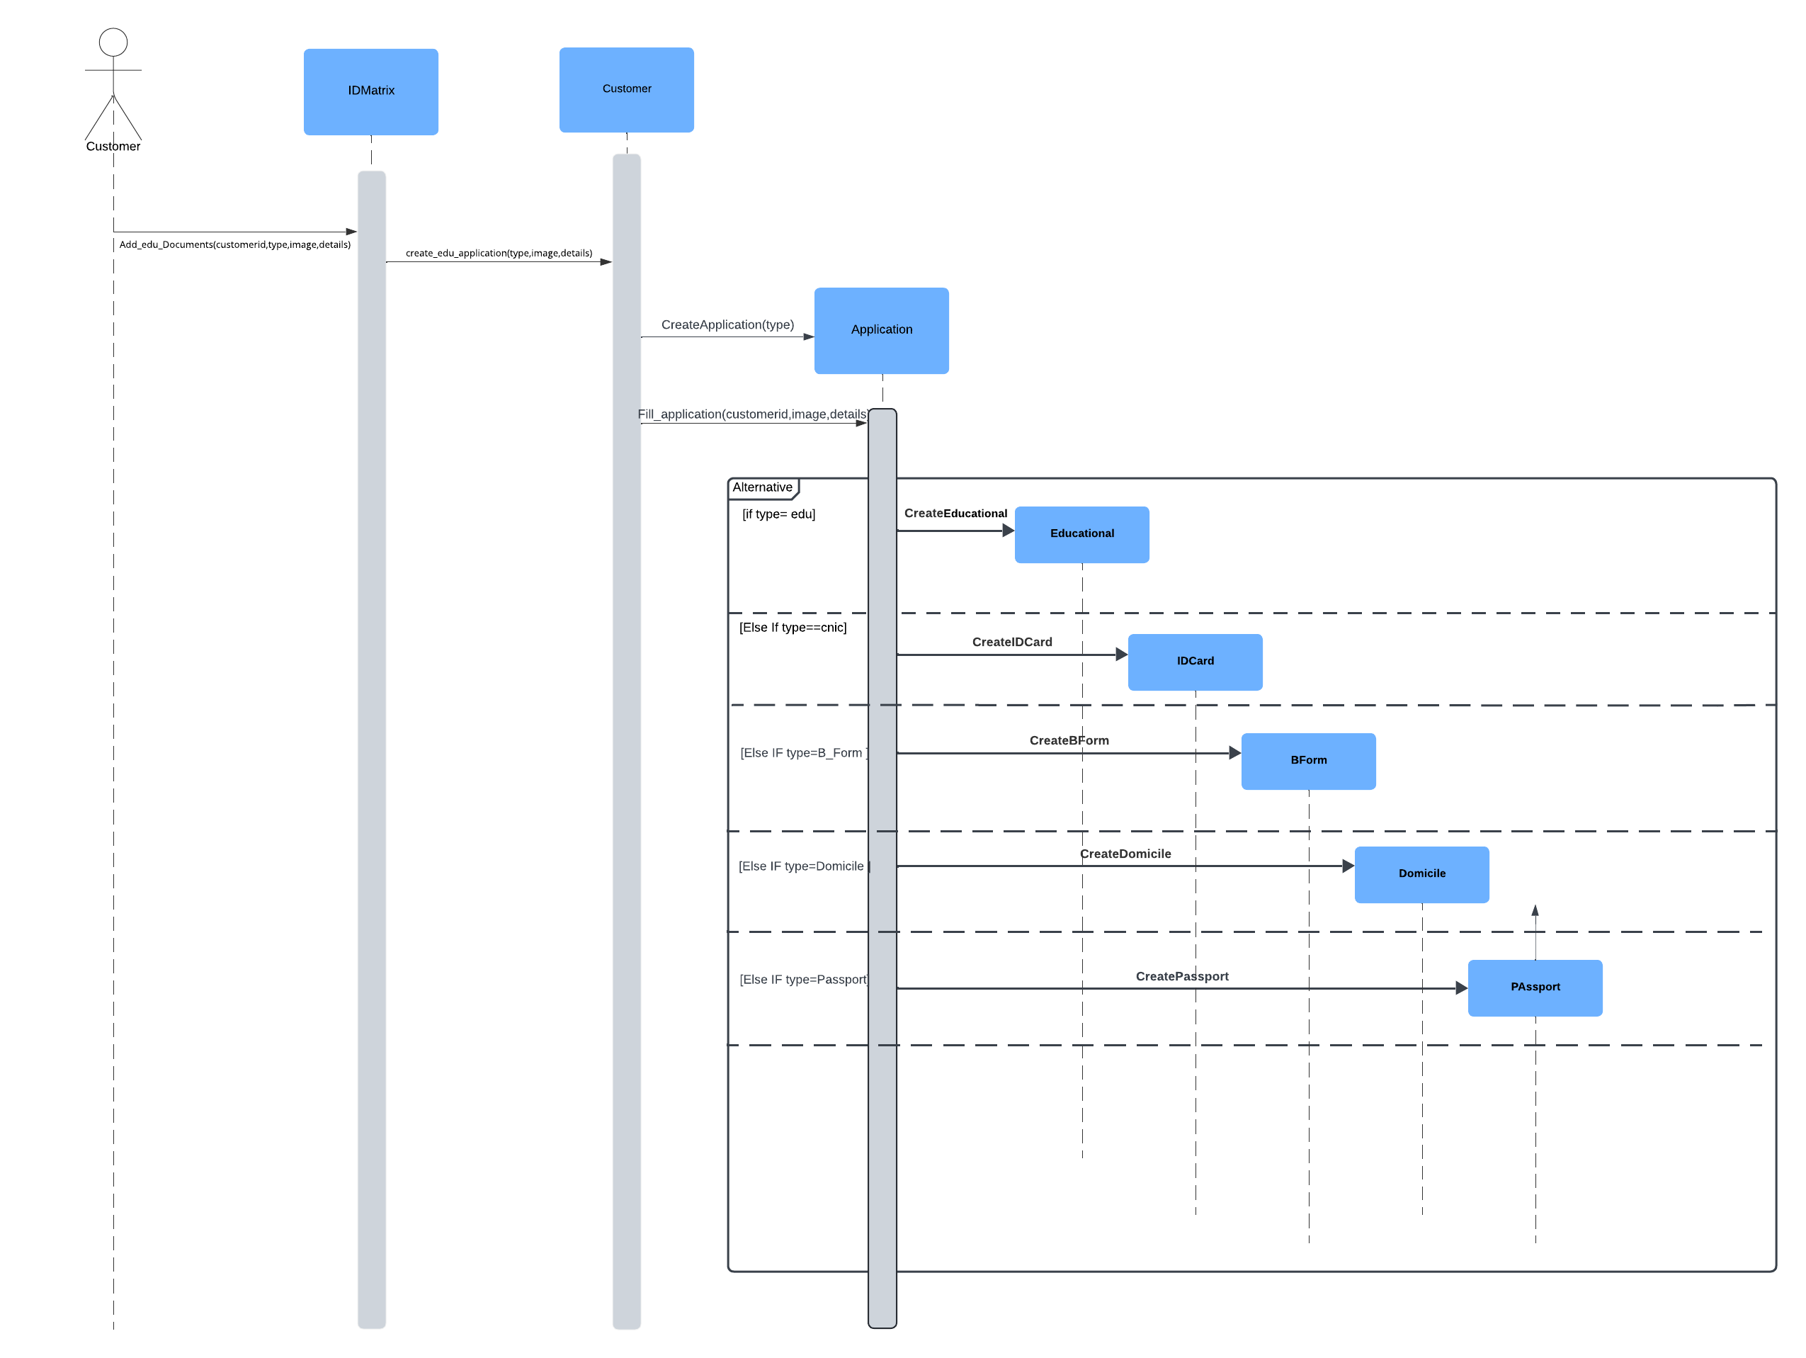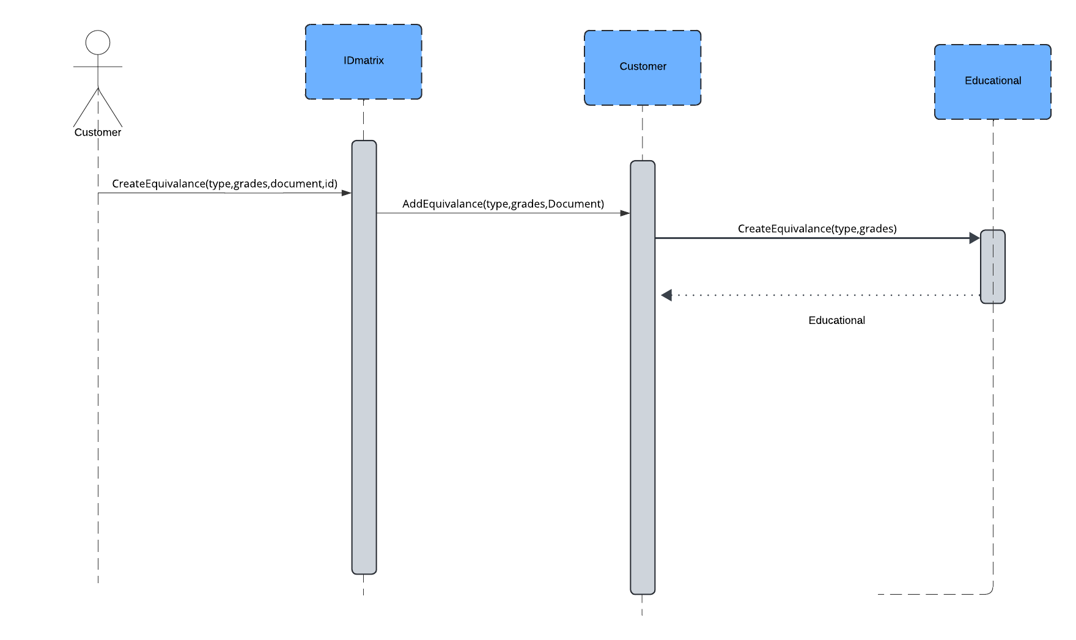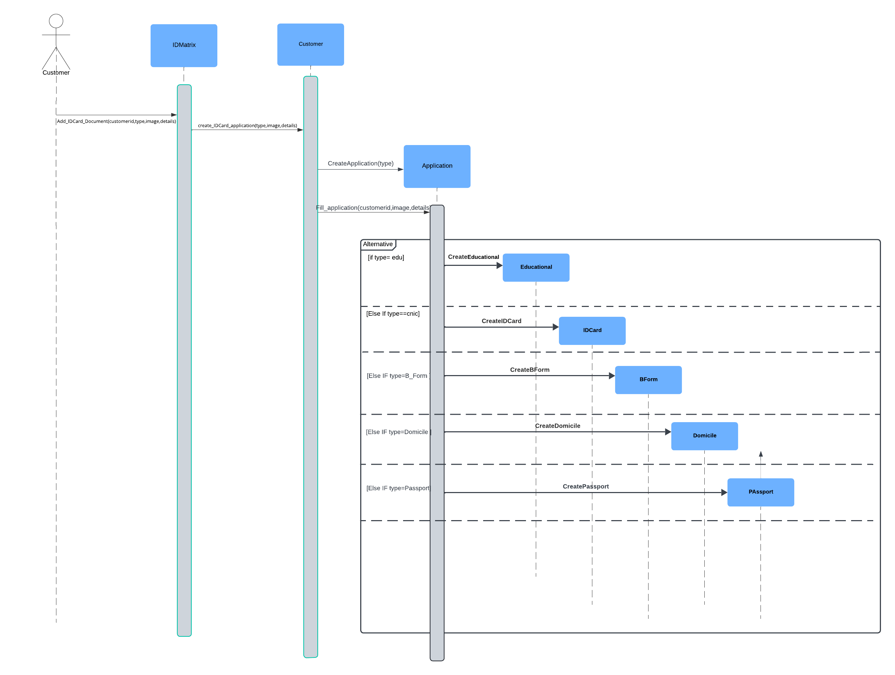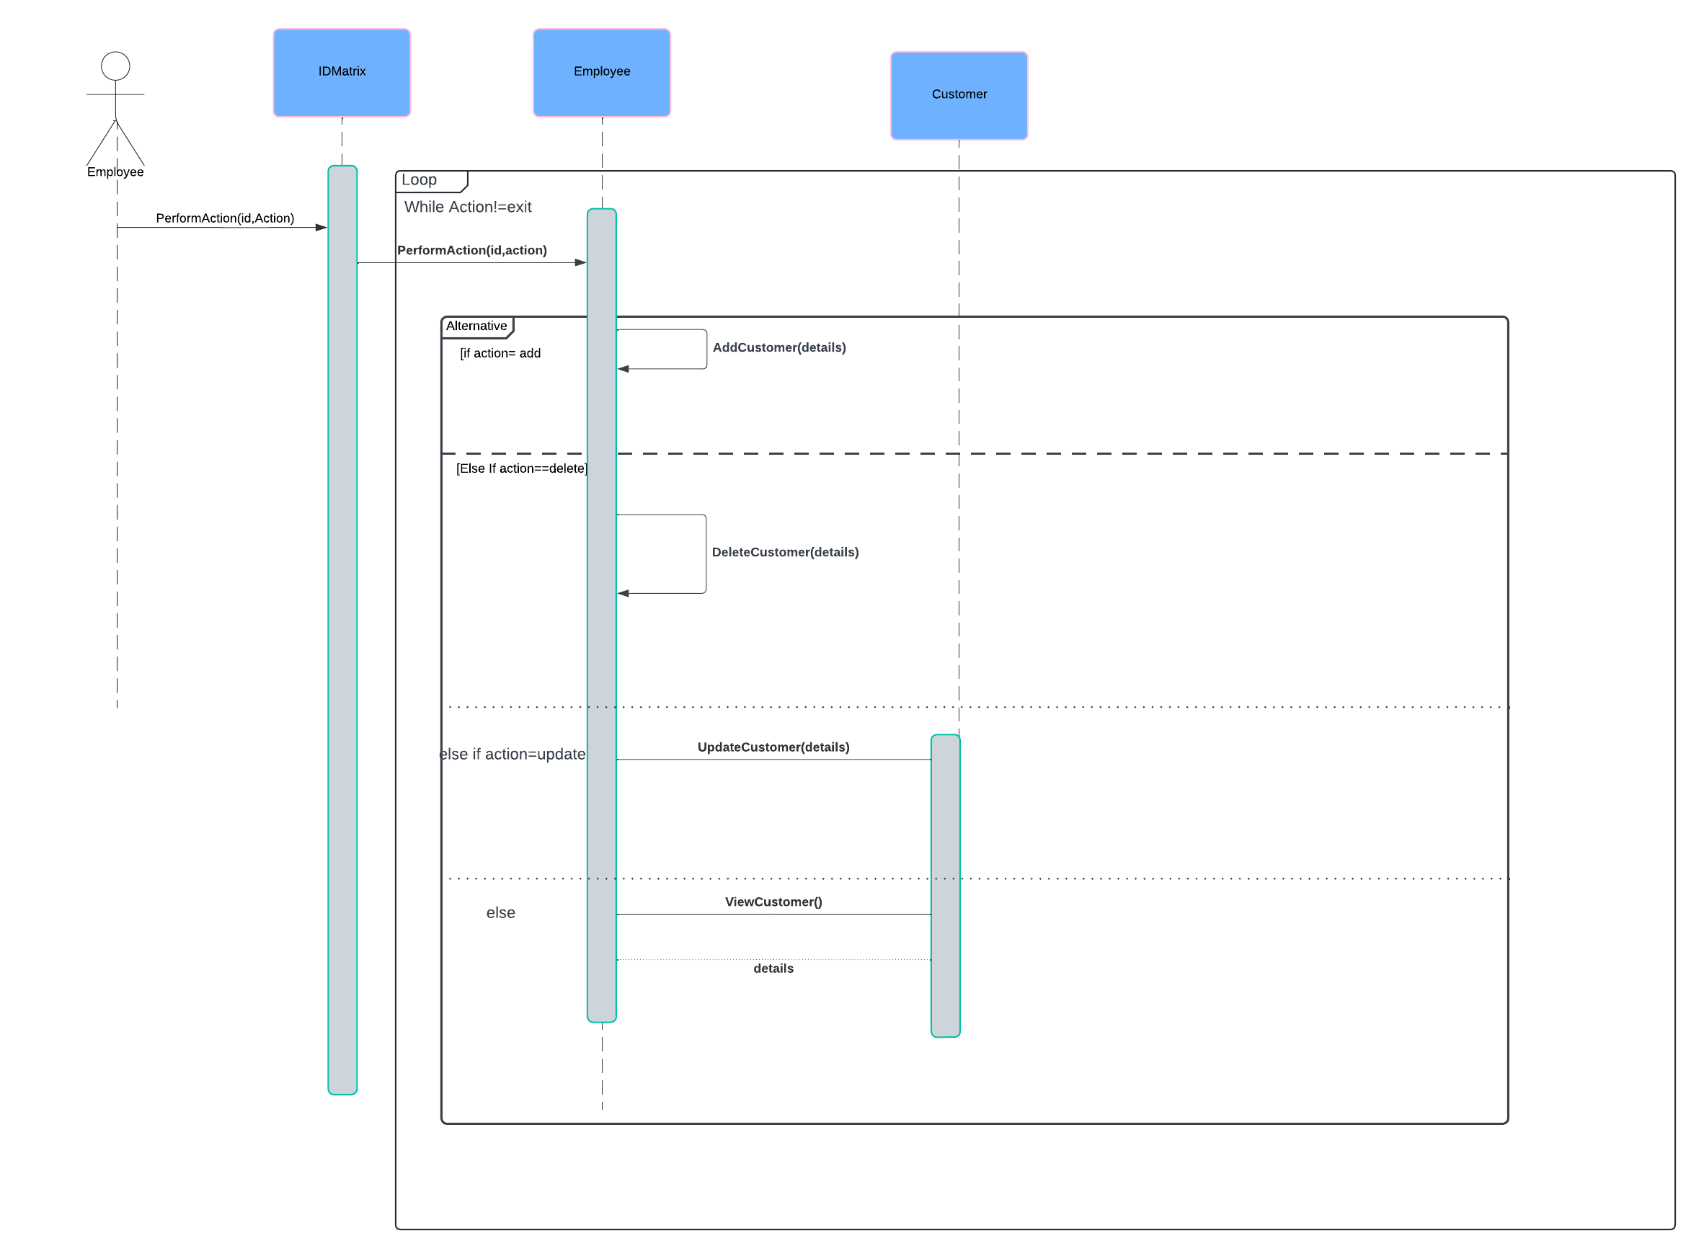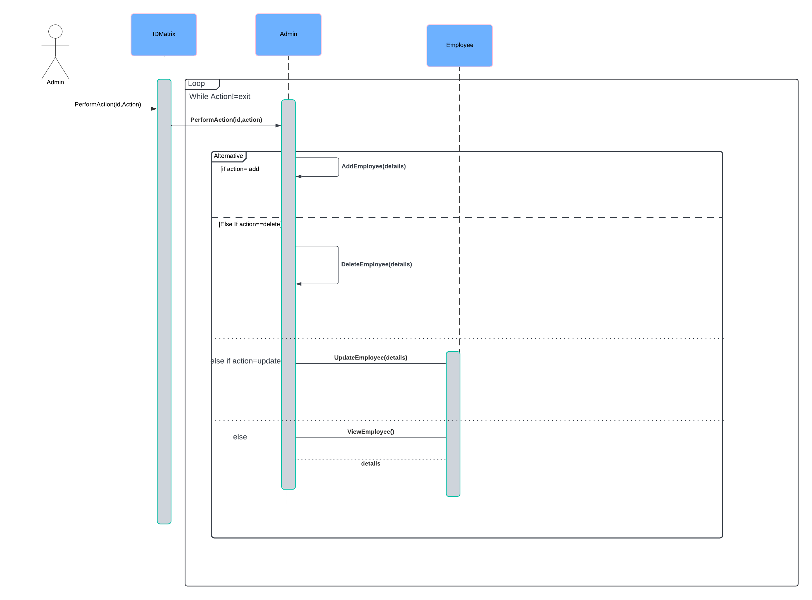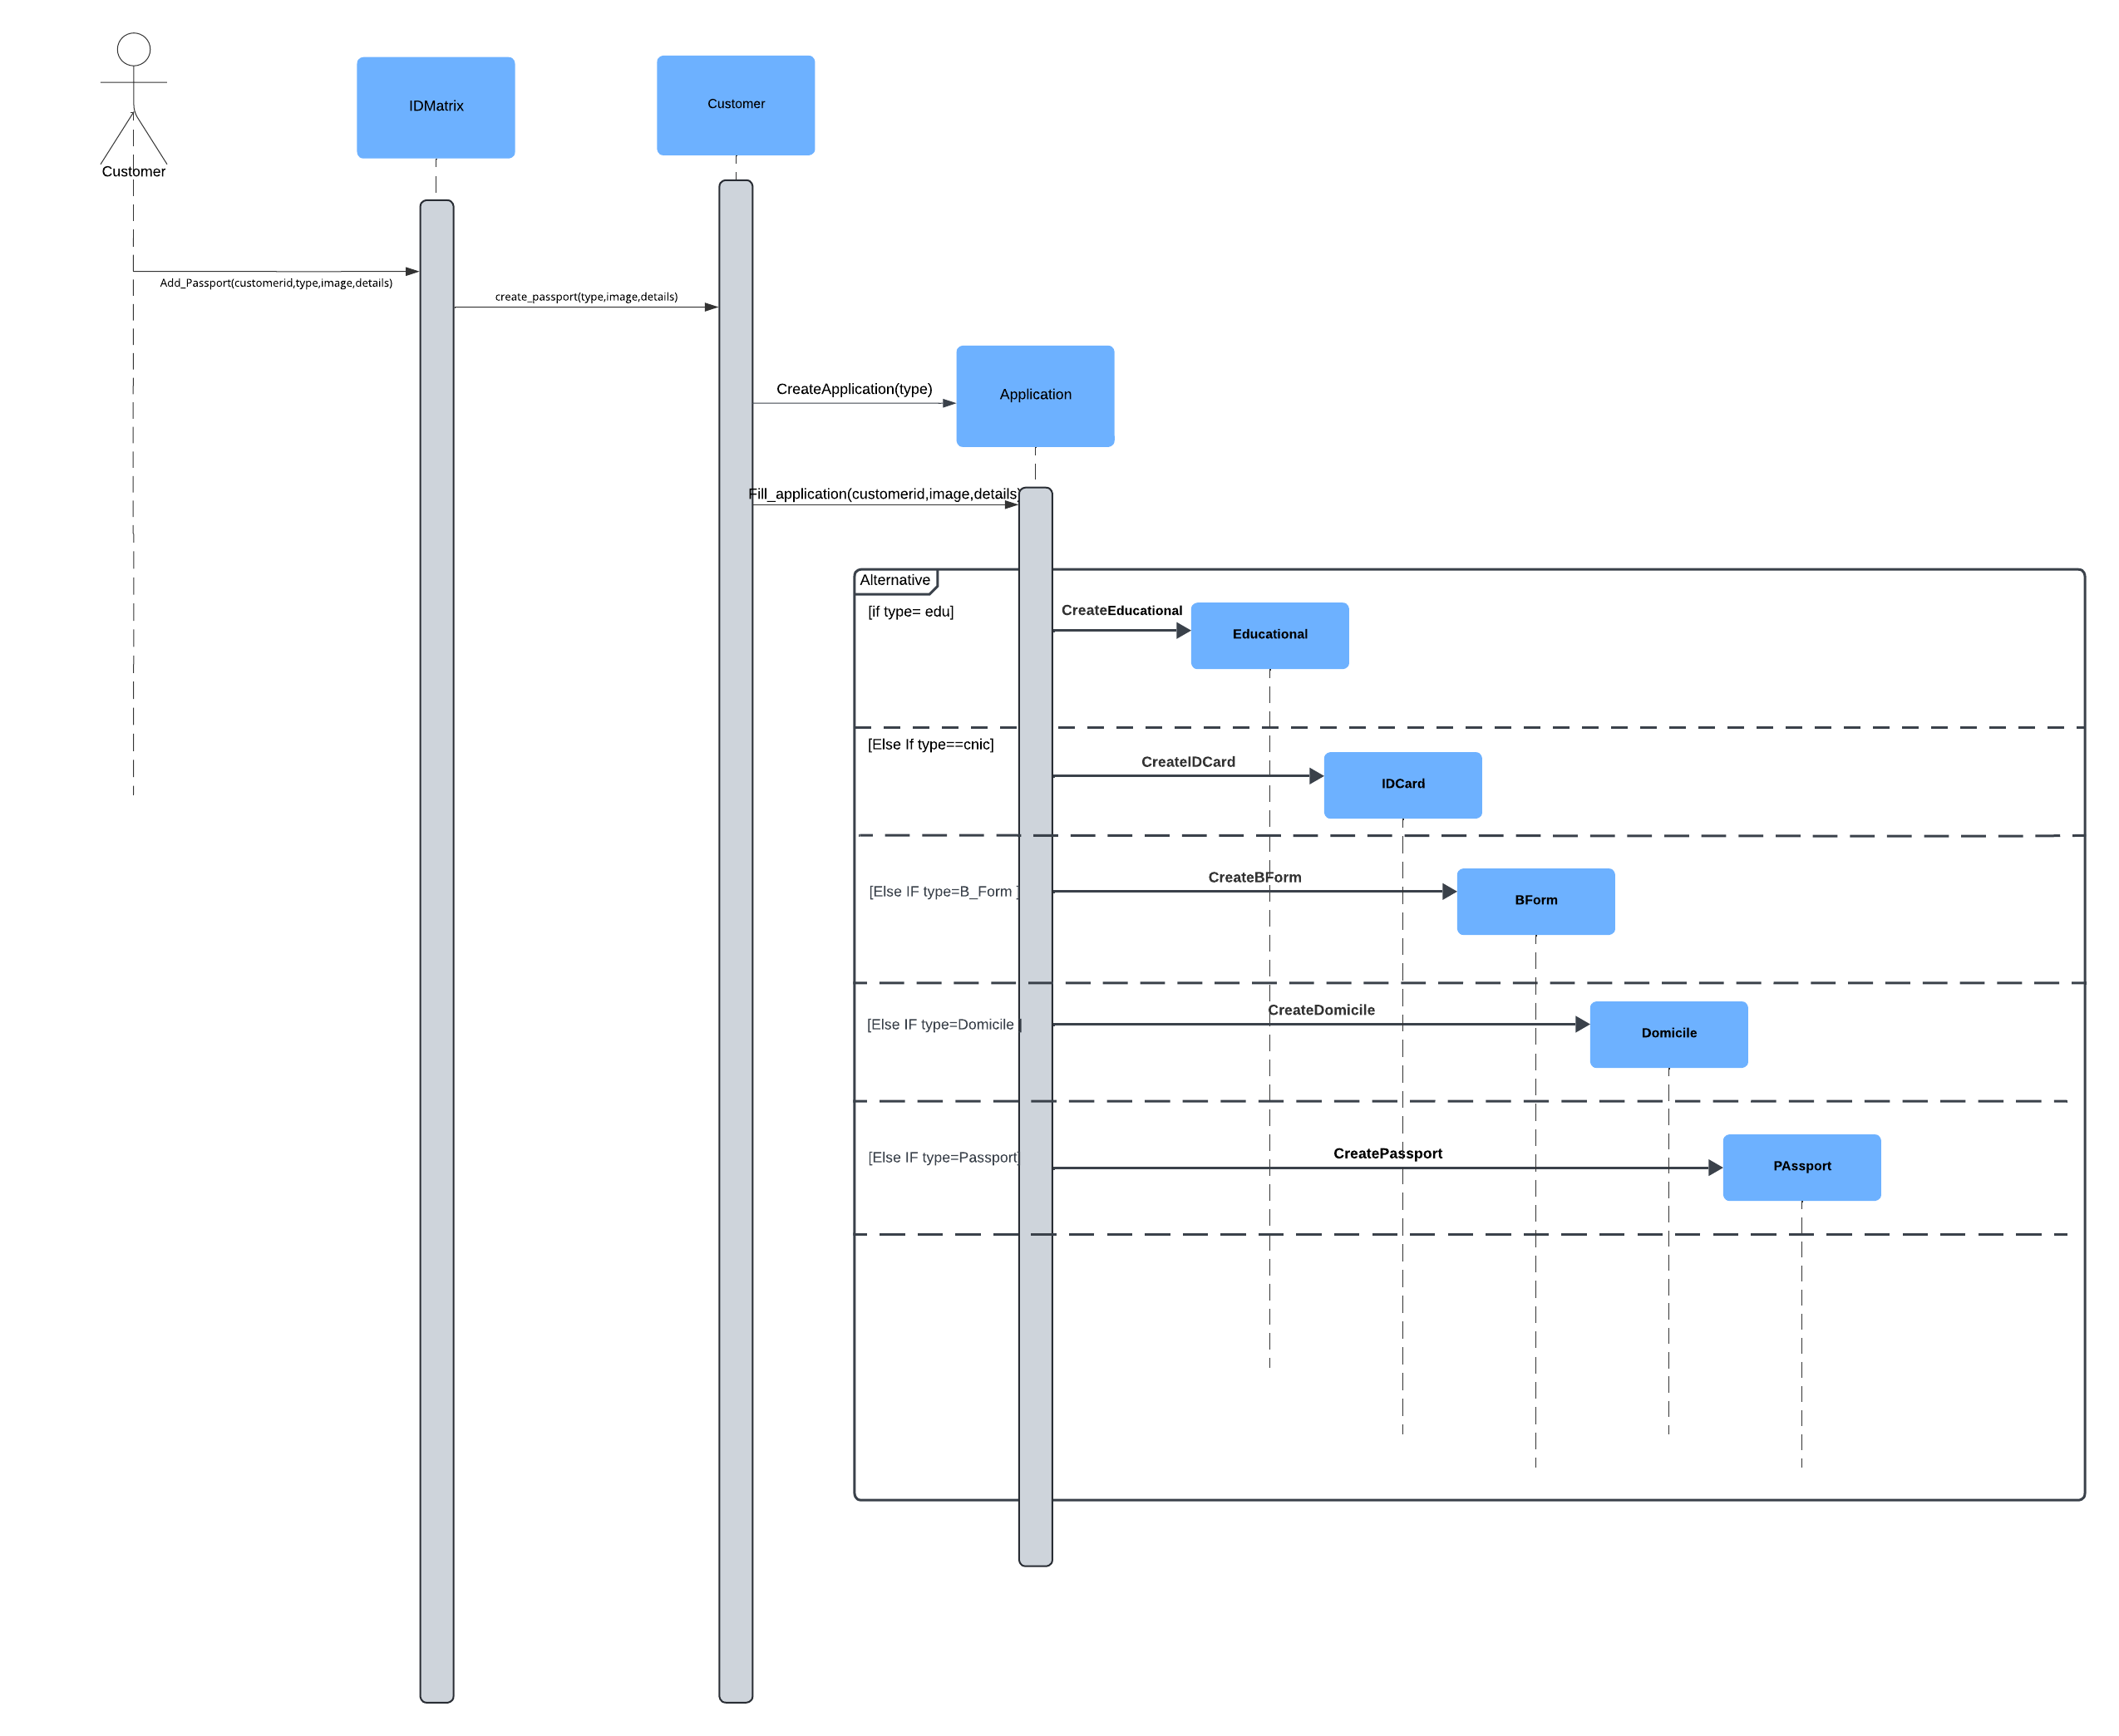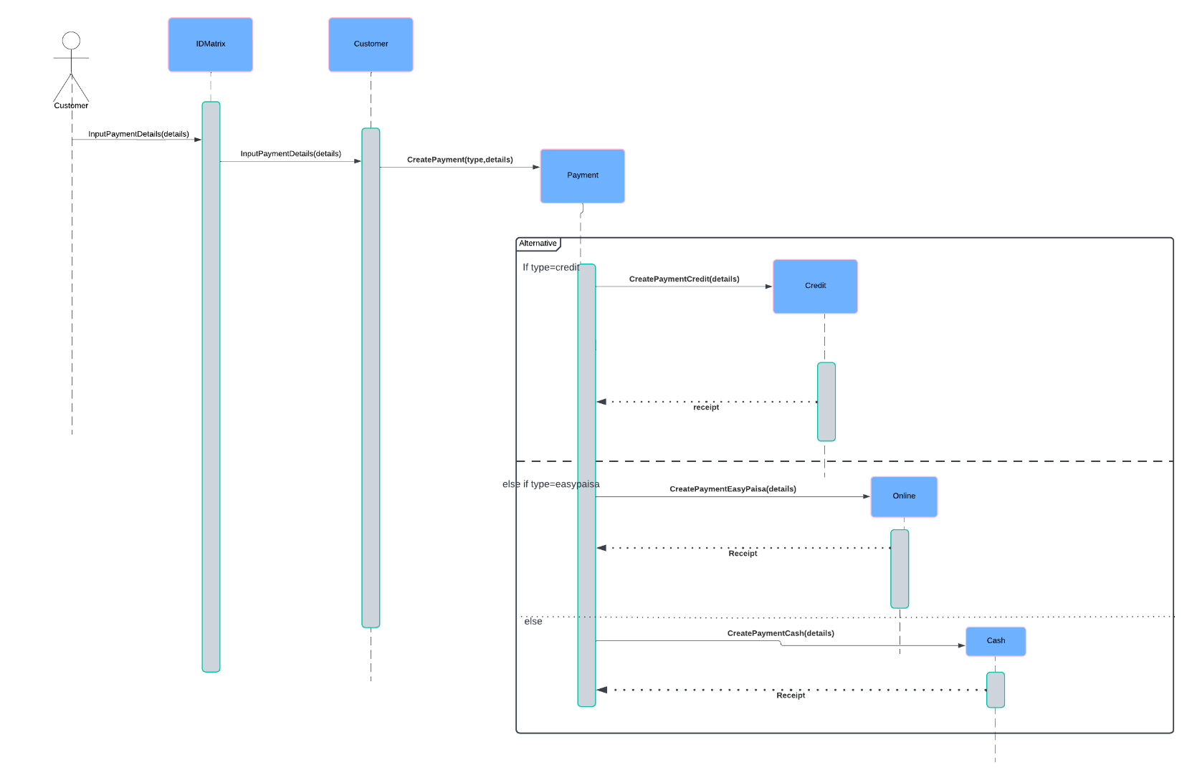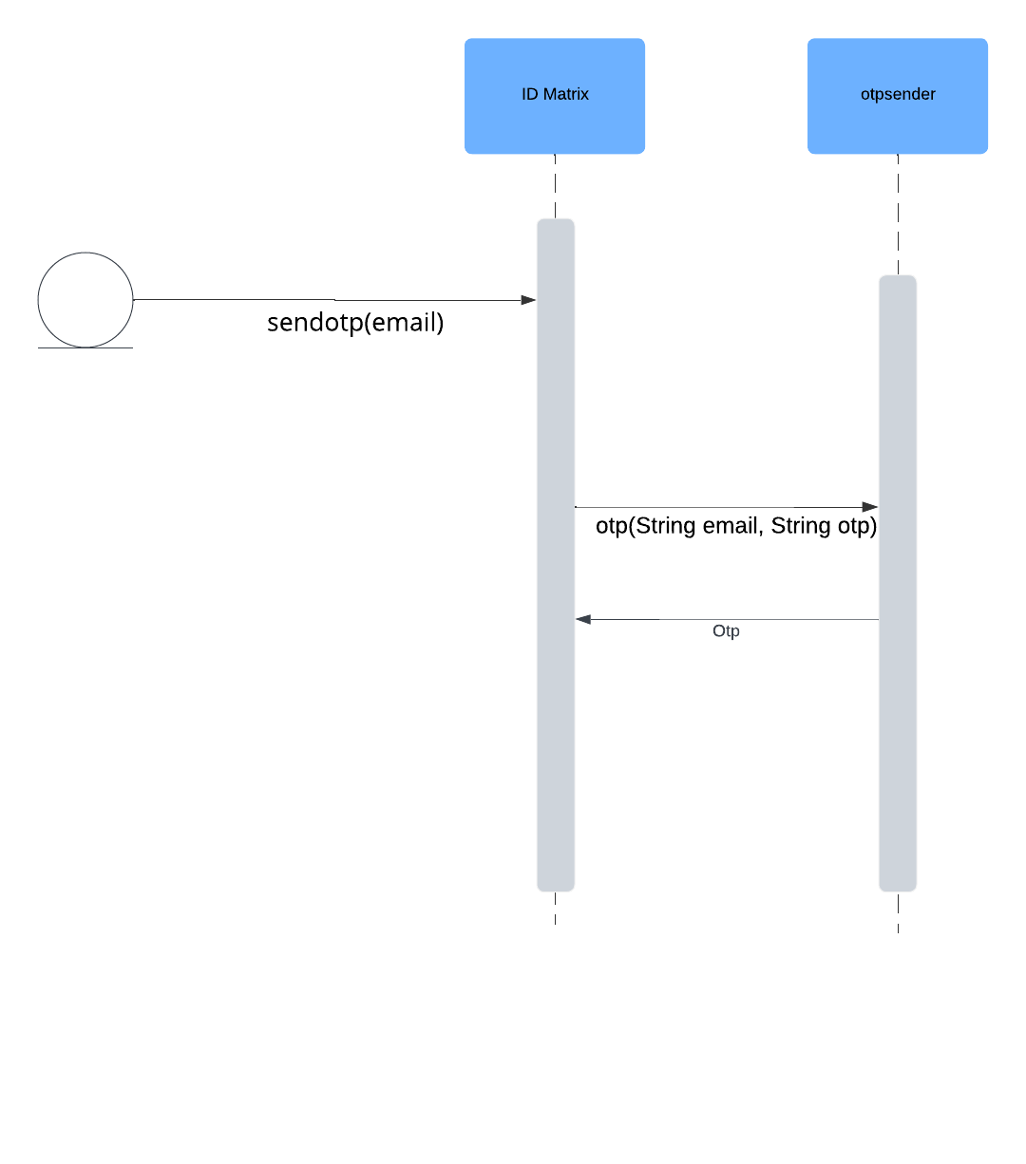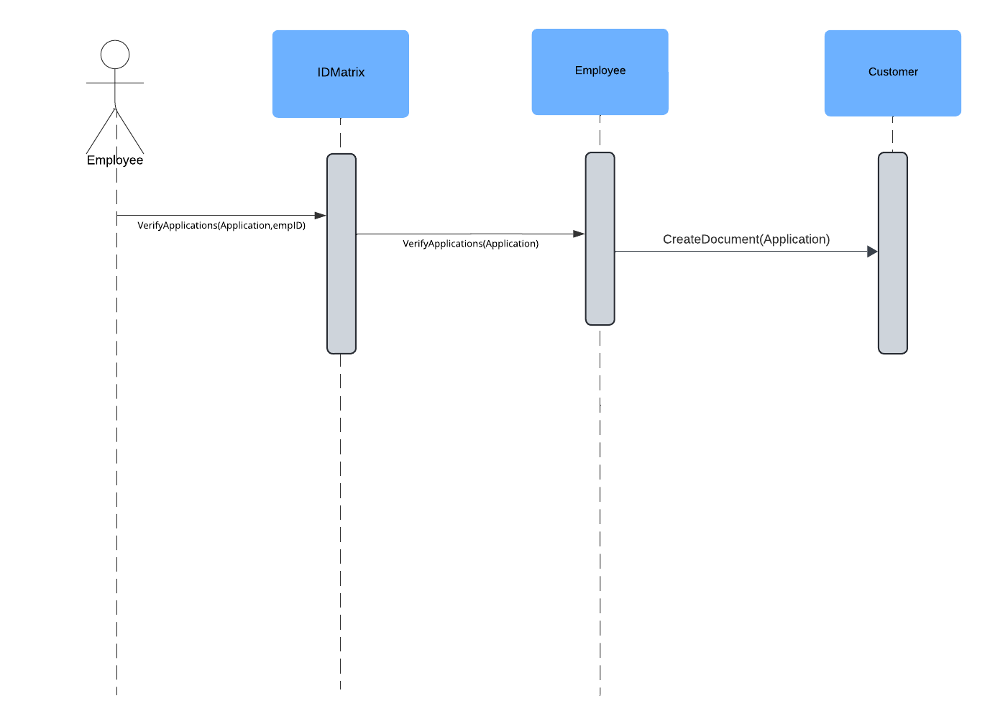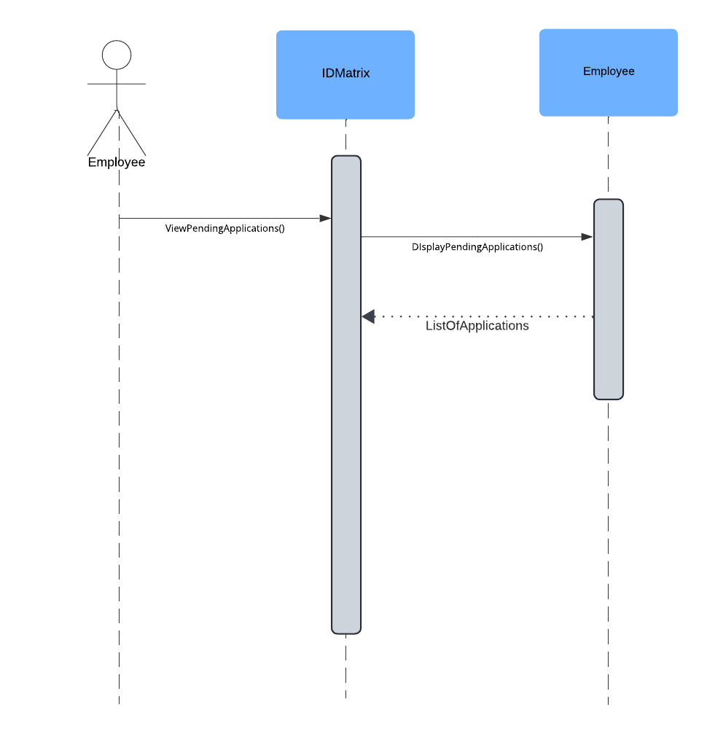

**7. Class Diagram**

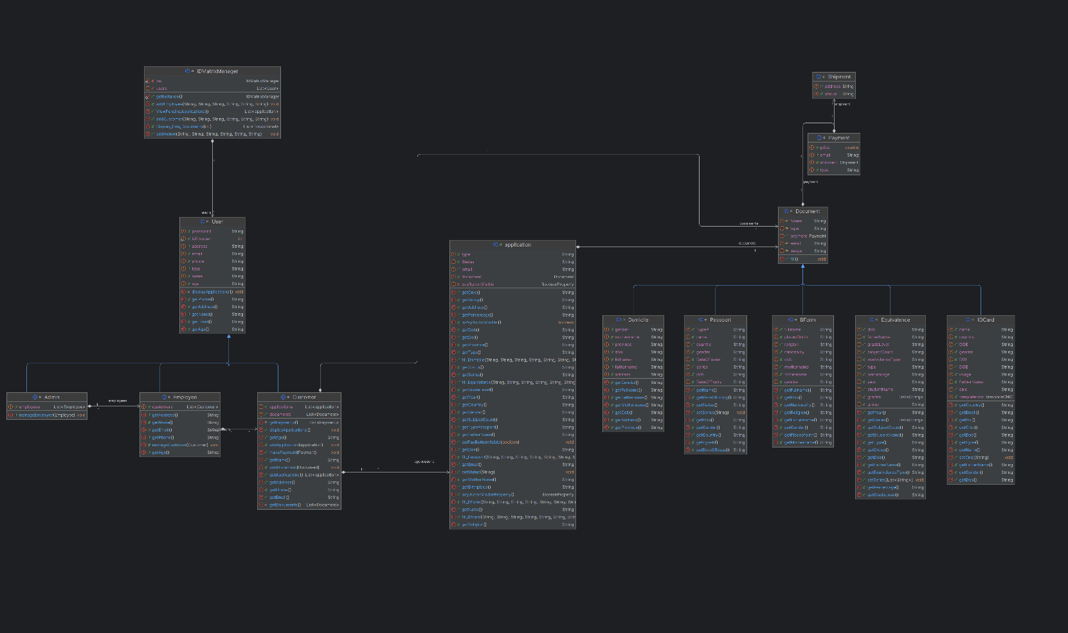

**8. Component Diagram**

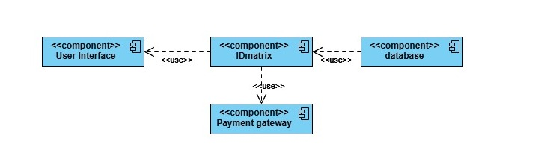

**9. Package Diagram**

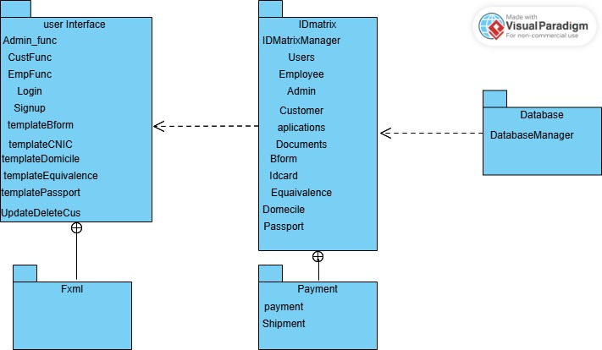

**10. Deployment Diagram**

