# Experiment 1

## Overview and Fundamentals of Unix(Linux) Operating System.

### Introduction to Operating Systems

An operating system (OS) is the program that, after being initially loaded into the computer by a **boot program**, manages all of the other application programs in a computer. Operating System lies in the category of system software. It basically manages all the resources of the computer. An operating system acts as an interface between the software and different parts of the computer or the computer hardware. The operating system is designed in such a way that it can manage the overall resources and operations of the computer. 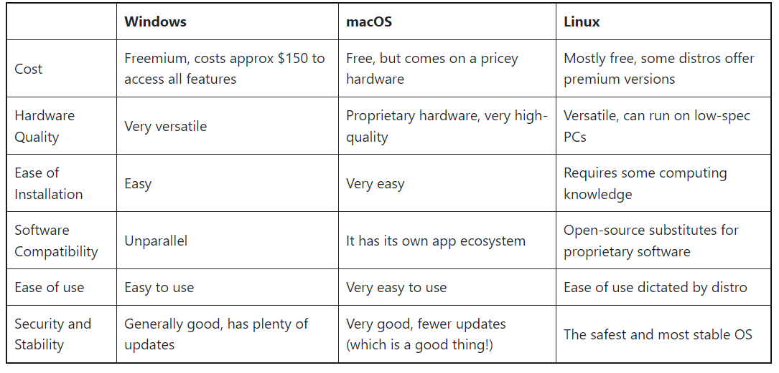

## 

## Unix Operating System

Unix is a powerful and versatile operating system that originated in the late 1960s by **Ken Thompson and Dennis Ritchie** at Bell Labs. It was designed to provide a flexible and stable computing environment. Unix has been the foundation for many other operating systems, including Linux and macOS. Its principles and design have had a profound influence on the development of modern computing systems.

#### Features:

1. **Multi User:** Unix supports multiple users working on the same system simultaneously. Each user can have their own account, files, and processes.

2. **Multitasking:** It allows multiple processes to run concurrently, giving the appearance that they are all executing at the same time.

3. **Multiplatform:** Unix is highly portable and can run on various hardware architectures. This portability has led to its adoption on a wide range of devices, from supercomputers to embedded systems.

4. **Hierarchical File System:** Unix organizes files in a hierarchical directory structure, which allows for easy organization and management of files and directories.

5. **Command Line Interface (CLI):** Unix primarily uses a text-based command-line interface for interaction. This allows users to perform tasks by typing commands rather than relying on graphical interfaces.

6. **Modularity:** Unix is composed of small, specialized utilities that perform specific tasks. These utilities can be combined using pipes and filters to accomplish more complex operations.

7. **Shell:** The shell is the command interpreter that provides a user interface for interacting with the Unix system. There are different shells available, such as Bash, C-shell, and Korn shell, each with its own features and syntax.

8. **Networking Capabilities:** Unix was designed from the ground up with networking in mind. It includes a suite of networking tools and protocols that allow for seamless communication between Unix systems and with other types of systems.

9. **Security:** Unix has a robust security model, including user authentication, file permissions, and access control lists, which helps protect system resources and data.

10. **Stability and Reliability:** Unix systems are known for their stability and robustness. They can run for long periods of time without needing to be restarted.

11**. Open Standards and Compatibility:** Unix adheres to open standards, which means that software developed for one Unix system can often run on another Unix system without modification.

12. **Extensibility:** Unix supports the development of custom software through its rich set of programming tools and libraries, making it a popular choice for software development environments.

13. **Scripting and Automation:** Unix provides powerful scripting capabilities that allow users to automate tasks and create custom workflows using shell scripts and other scripting languages.

