# Experiment 3

## Architecture of Unix(Linux) Operating System.

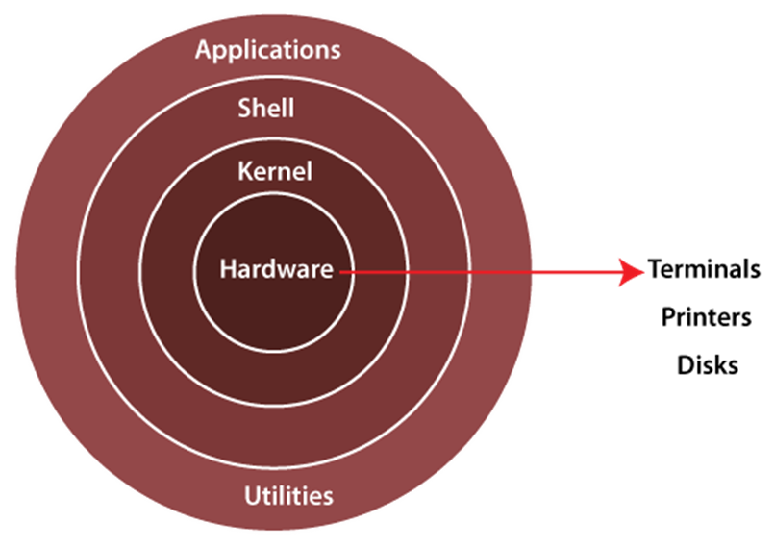

The Linux operating system's architecture mainly contains some of the components: **the Kernel, System Library, Hardware layer, System,** and **Shell utility**.

**1. Kernel:-** The kernel is one of the core sections of an operating system. It is responsible for each of the major actions of the Linux OS. This operating system contains distinct types of modules and cooperates with underlying hardware directly. The kernel facilitates required abstraction for hiding details of low-level hardware or application programs to the system. There are some of the important kernel types which are mentioned below:

* Monolithic Kernel
* Micro kernels
* Exo kernels
* Hybrid kernels

**2. System Libraries:-** These libraries can be specified as some special functions. These are applied for implementing the operating system's functionality and don't need code access rights of the modules of the kernel.

**3. System Utility Programs:-** It is responsible for doing specialized level and individual activities.

**4. Hardware layer:-** Linux operating system contains a hardware layer that consists of several peripheral devices like CPU, HDD, and RAM.

**5. Shell:-** It is an interface among the kernel and user. It can afford the services of the kernel. It can take commands through the user and runs the functions of the kernel. The shell is available in distinct types of OSes. These operating systems are categorized into two different types, which are the **graphical shells** and **command-line shells**. The graphical line shells facilitate the graphical user interface, while the command line shells facilitate the command line interface. Thus, both of these shells implement operations. However, the graphical user interface shells work slower as compared to the command-line interface shells.

______________________________________________________________________________________________________________

**Advantages of Linux**

1. The main advantage of Linux is it is an open-source operating system. This means the source code is easily available for everyone and you are allowed to contribute, modify and distribute the code to anyone without any permissions.
2. In terms of security, Linux is more secure than any other operating system. It does not mean that Linux is 100 percent secure; it has some malware for it but is less vulnerable than any other operating system. So, it does not require any anti-virus software.
3. The software updates in Linux are easy and frequent.
4. Various Linux distributions are available so that you can use them according to your requirements or according to your taste.
5. Linux is freely available to use on the internet.
6. It has large community support.
7. It provides high stability. It rarely slows down or freezes and there is no need to reboot it after a short time.
8. It maintains the privacy of the user.
9. The performance of the Linux system is much higher than other operating systems. It allows a large number of people to work at the same time and it handles them efficiently.
10. It is network friendly.
11. The flexibility of Linux is high. There is no need to install a complete Linux suit; you are allowed to install only required components.
12. Linux is compatible with a large number of file formats.
13. It is fast and easy to install from the web. It can also install on any hardware even on your old computer system.
14. It performs all tasks properly even if it has limited space on the hard disk.

**Disadvantages of Linux**

1. It is not very user-friendly. So, it may be confusing for beginners.
2. It has small peripheral hardware drivers as compared to windows.