# Experiment 4

## Programs on Linux Console (TryHackMe)

1. **echo:** Output text that we provide.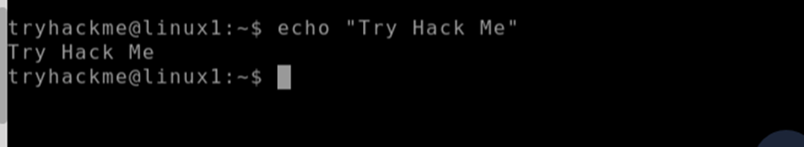

1. **whoami:** Find’s what user we're currently logged in as.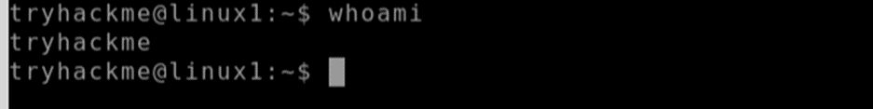
2. **ls:** Listing files in current directory. Before we can do anything such as finding out the contents of any files or folders, we need to know what exists in the first place. This can be done using the "**ls**" command (short for listing).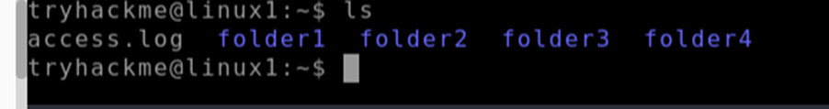
3. **mkdir:** For adding new directories.

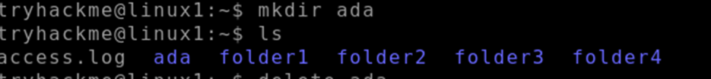

1. **rmdir:** For removing directories.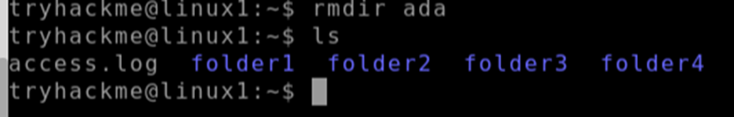
2. cat: Read the contents of the file.

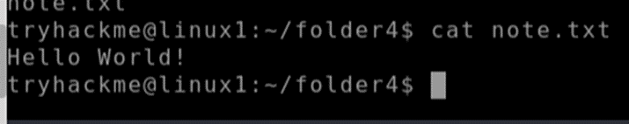

1. **man:** Know all related commands using **man (**function**/**command_name**)**.

