Name- Ansari Mohd Saif
Roll No- 25AI22
Div - A
Experiment 1.1
Aim- Write a Java program to input the name, roll number, and CGPA of a student using the Scanner class.

Theory: Java Program to Input Student Details using Scanner Class
In Java, user input can be taken using the Scanner class, which is a part of the java.util package. It allows a program to read different types of data such as strings, integers, and floating-point numbers from the user through the keyboard.
🔹 Purpose of the Program
The aim of this program is to:
- Accept student detailslike:
  - Name (String)
  - Roll Number (Integer)
  - CGPA (Float/Double)
- Store these values in variables
- Display the entered information
🔹 Scanner Class
The Scanner class is used to take input from the user. To use it, we need to:
- Import the package:
- import java.util.Scanner;
- Create an object of Scanner class:
- Scanner sc = new Scanner(System.in);
Here, System.in represents the standard input stream (keyboard input).
🔹 Methods Used in Scanner Class
Some commonly used methods:
- nextLine() → to read a full line (for name)
- nextInt() → to read integer values (for roll number)
- nextFloat() or nextDouble() → to read decimal values (for CGPA)
🔹 Working of the Program
- The program starts execution from the main() method.
- A Scanner object is created to take input.
- The user is prompted to enter:
  - Name
  - Roll Number
  - CGPA
- The entered values are stored in variables.
- The program displays the entered details using System.out.println().
🔹 Advantages of Using Scanner
- Easy to use for beginners
- Supports multiple data types
- Helps in making programs interactive
Code-
import java.util.Scanner;

public class StudentDetails {
public static void main(String[] args) {

// Creating Scanner object
Scanner sc = new Scanner(System.in);

// Taking input from user
System.out.print("Enter Student Name: ");
String name = sc.nextLine();

System.out.print("Enter Roll Number: ");
int rollNo = sc.nextInt();

System.out.print("Enter CGPA: ");
float cgpa = sc.nextFloat();

// Displaying the entered details
System.out.println("\n--- Student Details ---");
System.out.println("Name: " + name);
System.out.println("Roll Number: " + rollNo);
System.out.println("CGPA: " + cgpa);

// Closing Scanner
sc.close();
}
}
Output-
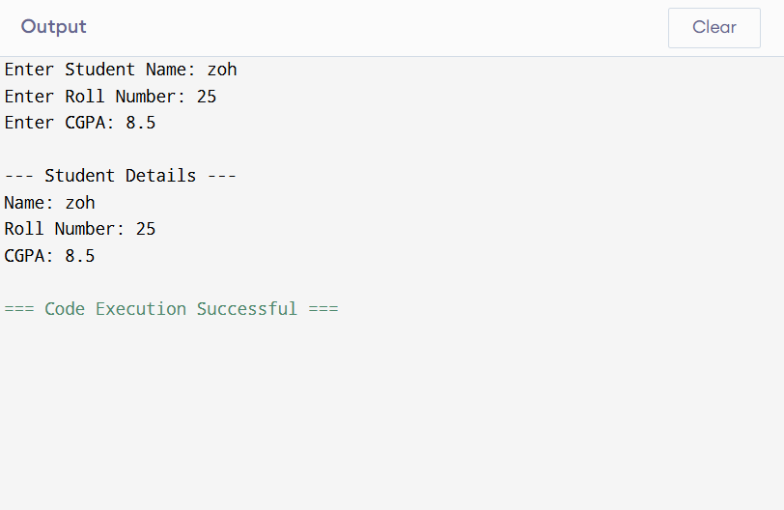
Conclusion-
The Scanner class plays an important role in Java for handling user input. By using it, we can easily create interactive programs like this one that collects and displays student information. This program helps in understanding basic input/output operations and data handling in Java.

Experiment 1.2
Aim- Write a Java program that takes the following details such as Employee ID (String or Integer), Name and Monthly Basic Salary for employee and perform the following operations: Calculate the Annual Basic Salary (12 * monthly basic).
Compute the following based on the monthly basic salary :
● HRA (House Rent Allowance) = 20% of basic salary
● DA (Dearness Allowance) = 10% of basic salary
● PF (Provident Fund deduction) = 12% of basic salary
● Gross Monthly Salary = Basic + HRA + DA
● Net Monthly Salary = Gross Salary – PF
● Annual Net Salary = Net Monthly Salary × 12

Theory: Employee Salary Calculation using Java
This Java program is designed to accept employee details and perform various salary-related calculations based on the given monthly basic salary. It demonstrates the use of input handling, arithmetic operations, and output display in Java.
🔹 Objective of the Program
The main objectives are:
- To take input such as:
  - Employee ID
  - Employee Name
  - Monthly Basic Salary
- To calculate different components of salary like:
  - Annual Basic Salary
  - HRA (House Rent Allowance)
  - DA (Dearness Allowance)
  - PF (Provident Fund)
  - Gross and Net Salary
🔹 Scanner Class Usage
The program uses the Scanner class (from java.util package) to take input from the user through the keyboard.
- nextLine() → used for Employee ID and Name
- nextDouble() → used for salary input
This makes the program interactive and user-friendly.
🔹 Salary Components Explained
- Basic Salary
The fixed monthly salary entered by the user.
- Annual Basic Salary
Calculated as:
- Annual Basic = Monthly Basic × 12
- HRA (House Rent Allowance)
Given as 20% of basic salary:
- HRA = 0.20 × Basic Salary
- DA (Dearness Allowance)
Given as 10% of basic salary:
- DA = 0.10 × Basic Salary
- PF (Provident Fund)
Deduction of 12% from basic salary:
- PF = 0.12 × Basic Salary
🔹 Salary Calculations
- Gross Monthly Salary
Total earnings before deductions:
- Gross = Basic + HRA + DA
- Net Monthly Salary
Final salary after deduction:
- Net Monthly = Gross – PF
- Annual Net Salary
- Annual Net = Net Monthly × 12
🔹 Working of the Program
- The program starts execution from the main() method.
- It accepts employee details using the Scanner object.
- It performs all salary-related calculations using arithmetic formulas.
- The calculated values are stored in variables.
- Finally, the results are displayed using System.out.println().
🔹 Advantages of this Program
- Helps understand real-life salary structure
- Demonstrates basic Java concepts
- Improves knowledge of calculations and data handling
- Useful for beginners learning Java programming
Code-
import java.util.Scanner;

public class EmployeeSalary {
public static void main(String[] args) {

Scanner sc = new Scanner(System.in);

// Taking input
System.out.print("Enter Employee ID: ");
String empId = sc.nextLine();

System.out.print("Enter Employee Name: ");
String name = sc.nextLine();

System.out.print("Enter Monthly Basic Salary: ");
double basic = sc.nextDouble();

// Calculations
double annualBasic = basic * 12;

double hra = basic * 0.20; // 20% HRA
double da = basic * 0.10; // 10% DA
double pf = basic * 0.12; // 12% PF

double grossMonthly = basic + hra + da;
double netMonthly = grossMonthly - pf;
double annualNet = netMonthly * 12;

// Displaying results
System.out.println("\n--- Employee Salary Details ---");
System.out.println("Employee ID: " + empId);
System.out.println("Name: " + name);

System.out.println("Monthly Basic Salary: " + basic);
System.out.println("Annual Basic Salary: " + annualBasic);

System.out.println("HRA (20%): " + hra);
System.out.println("DA (10%): " + da);
System.out.println("PF (12%): " + pf);

System.out.println("Gross Monthly Salary: " + grossMonthly);
System.out.println("Net Monthly Salary: " + netMonthly);
System.out.println("Annual Net Salary: " + annualNet);

sc.close();
}
}

Output-
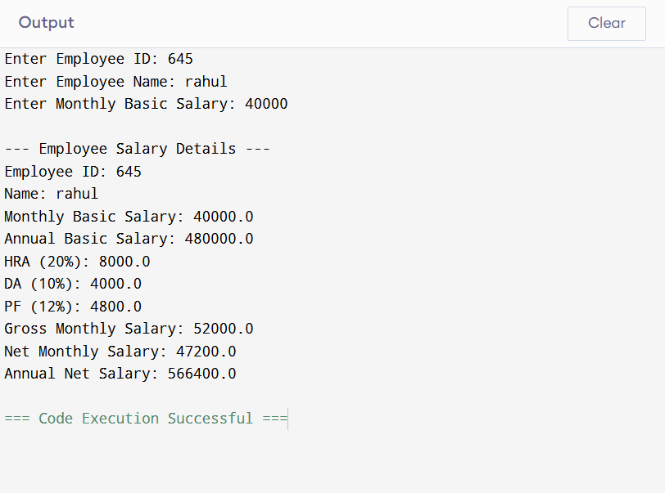

Conclusion-
This program is a simple yet effective example of applying Java programming to solve real-world problems. It helps in understanding how salary components are calculated and how Java can be used to automate such calculations efficiently.

Experiment 1.3
Aim- Developing Conversion Utilities: Develop any converter, such as Rupees to dollars, temperature converter, inch to feet, etc.
Theory: Conversion Utilities in Java
This program is designed to perform different types of unit conversions such as currency conversion, temperature conversion, and length conversion. It demonstrates how Java can be used to solve real-world problems using user input, decision-making, and mathematical calculations.
🔹 Objective of the Program
The main objectives are:
- To take input from the user
- To provide multiple conversion options
- To perform calculations based on the selected option
- To display the converted result
🔹 Concepts Used in the Program
1. Scanner Class
The program uses the Scanner class (from java.util package) to take input from the user.
- nextInt() → to select conversion type
- nextDouble() → to input numeric values
This allows the program to interact with the user.
2. Switch-Case Statement
A switch-case is used to handle multiple conversion options:
- Case 1 → Rupees to Dollars
- Case 2 → Celsius to Fahrenheit
- Case 3 → Inches to Feet
This makes the program structured and easy to understand.
3. Mathematical Formulas Used
- Rupees to Dollars
- Dollars = Rupees ÷ 83 (approx.)
- Celsius to Fahrenheit
- Fahrenheit = (Celsius × 9/5) + 32
- Inches to Feet
- Feet = Inches ÷ 12
🔹 Working of the Program
- The program starts from the main() method.
- A menu is displayed with different conversion options.
- The user selects an option.
- Based on the choice, the program:
  - Takes the required input
  - Applies the relevant formula
  - Displays the result
- If the user enters an invalid option, an error message is shown.
🔹 Applications of Conversion Utilities
- Currency conversion in finance apps
- Temperature conversion in weather systems
- Unit conversions in engineering and daily life
🔹 Advantages of the Program
- Easy to understand and use
- Demonstrates real-life applications
- Helps in learning decision-making and logic building

Code-
import java.util.Scanner;

public class Converter {
public static void main(String[] args) {

Scanner sc = new Scanner(System.in);

System.out.println("=== Conversion Utilities ===");
System.out.println("1. Rupees to Dollars");
System.out.println("2. Celsius to Fahrenheit");
System.out.println("3. Inches to Feet");
System.out.print("Choose an option: ");

int choice = sc.nextInt();

switch (choice) {

case 1:
System.out.print("Enter amount in Rupees: ");
double rupees = sc.nextDouble();
double dollars = rupees / 83.0; // approx rate
System.out.println("Dollars: $" + dollars);
break;

case 2:
System.out.print("Enter temperature in Celsius: ");
double celsius = sc.nextDouble();
double fahrenheit = (celsius * 9/5) + 32;
System.out.println("Temperature in Fahrenheit: " + fahrenheit);
break;

case 3:
System.out.print("Enter length in inches: ");
double inches = sc.nextDouble();
double feet = inches / 12;
System.out.println("Length in feet: " + feet);
break;

default:
System.out.println("Invalid choice!");
}

sc.close();
}
}
Output-
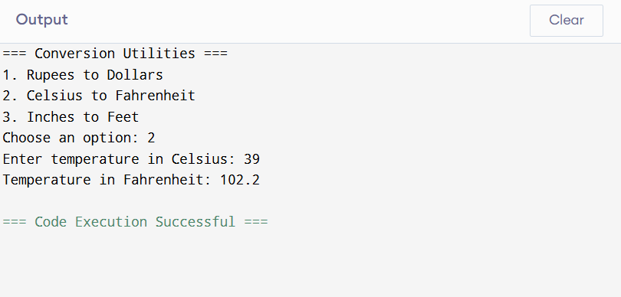

Conclusion-
The Conversion Utilities program is a simple yet powerful example of how Java can be used to perform everyday calculations. It enhances programming skills by combining input handling, control structures, and arithmetic operations in a practical way.

