Name- Ansari Mohd Saif
Roll No- 25AI22
Div - A

Experiment 3.1
Aim-Write a Java program to create a Bank Account Simulator with Bank Account class with the attributes: account_number and balance. The program should: Create an object of Bank Account, Set account number and initial balance using setter methods or direct assignment. Accept a series of operations (deposit or withdraw) and apply them and Display the final balance after all operations.

Theory: Bank Account Simulator in Java
This program simulates basic banking operations using a class-based approach (Object-Oriented Programming) in Java. It allows users to perform deposit and withdrawal operations and view the final account balance.
🔹 Objective of the Program
- To create a Bank Account class
- To store:
  - Account Number
  - Balance
- To perform operations:
  - Deposit money
  - Withdraw money
- To display the final balance
🔹 Concepts Used
1. Class and Object (OOP Concept)
- A class is a blueprint for creating objects.
- An object represents a real-world entity.
Here:
- BankAccount → Class
- acc → Object
2. Instance Variables
- accountNumber → stores account number
- balance → stores account balance
3. Methods
- deposit(amount) → adds money
- withdraw(amount) → subtracts money
- Includes condition to prevent over-withdrawal
4. Encapsulation (Optional Concept)
Data can be accessed using setter methods:
- setAccountNumber()
- setBalance()
5. Loop for Operations
A loop is used to perform multiple transactions (deposit/withdraw).
🔹 Working of the Program
- Create a BankAccount object
- Set account number and initial balance
- Ask user for number of operations
- Perform deposit or withdrawal based on user choice
- Update balance after each operation
- Display final balance
🔹 Advantages
- Demonstrates real-world banking logic
- Introduces OOP concepts
- Helps understand methods and data handling

Code-
import java.util.Scanner;

class BankAccount {
int account_number;
double balance;

// Method to set account details
void setAccount(int accNo, double bal) {
account_number = accNo;
balance = bal;
}

// Deposit method
void deposit(double amount) {
balance += amount;
System.out.println("Deposited: " + amount);
}

// Withdraw method
void withdraw(double amount) {
if (amount > balance) {
System.out.println("Insufficient Balance!");
} else {
balance -= amount;
System.out.println("Withdrawn: " + amount);
}
}

// Display balance
void display() {
System.out.println("Final Balance: " + balance);
}
}

public class Main {
public static void main(String[] args) {

Scanner sc = new Scanner(System.in);

BankAccount acc = new BankAccount();

// Set account details
System.out.print("Enter Account Number: ");
int accNo = sc.nextInt();

System.out.print("Enter Initial Balance: ");
double bal = sc.nextDouble();

acc.setAccount(accNo, bal);

// Number of operations
System.out.print("Enter number of transactions: ");
int n = sc.nextInt();

// Perform operations
for (int i = 1; i <= n; i++) {
System.out.println("\nTransaction " + i);
System.out.println("1. Deposit");
System.out.println("2. Withdraw");

int choice = sc.nextInt();

System.out.print("Enter amount: ");
double amount = sc.nextDouble();

if (choice == 1) {
acc.deposit(amount);
} else if (choice == 2) {
acc.withdraw(amount);
} else {
System.out.println("Invalid choice!");
}
}

// Final balance
System.out.println("\n--- Account Summary ---");
acc.display();

sc.close();
}
}

Output-
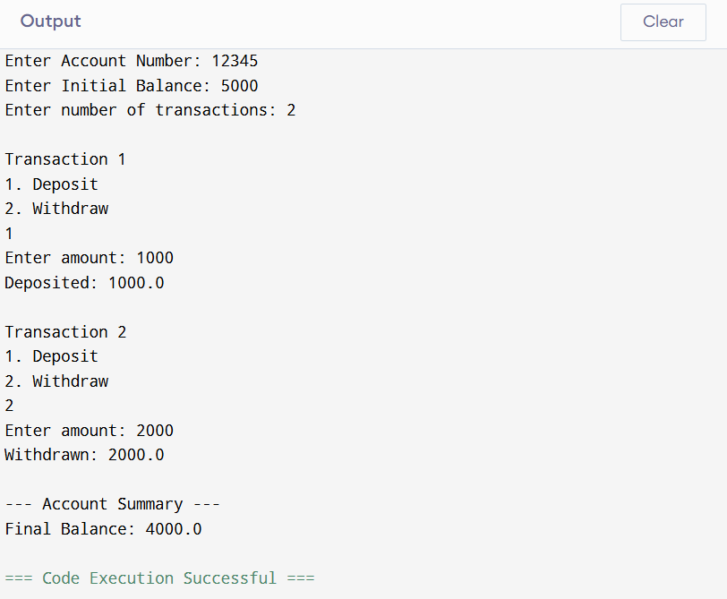

Conclusion-
This program is a practical example of how Java can be used to model real-life systems like banking. It strengthens understanding of classes, objects, and operations on data.

