Name- Ansari Mohd Saif
Roll No- 25AI22
Div - A

Experiment 4.1
Aim-Write a Java program that calculates the area of 2D shapes and the volume of 3D shapes using method overloading. The program should include the 2D Shapes like Circle, Rectangle, Square, Triangle, 3D Shapes like Sphere, Cylinder, Cuboid, Cube.

Theory: Area & Volume Calculation using Method Overloading in Java
This program demonstrates the concept of method overloading in Java to calculate the area of 2D shapes and volume of 3D shapes. It shows how the same method name can be used with different parameters to perform different tasks.
🔹 Objective of the Program
- To calculate area of 2D shapes:
  - Circle
  - Rectangle
  - Square
  - Triangle
- To calculate volume of 3D shapes:
  - Sphere
  - Cylinder
  - Cuboid
  - Cube
- To use method overloading for all calculations
🔹 Concepts Used
1. Method Overloading
Method overloading means:
- Using the same method name
- But with different parameter lists (type/number)
Example:
area(double r); // Circle
area(double l, double b); // Rectangle
2. Mathematical Formulas
✅ 2D Shapes (Area)
- Circle → πr²
- Rectangle → l × b
- Square → a²
- Triangle → ½ × base × height
✅ 3D Shapes (Volume)
- Sphere → (4/3)πr³
- Cylinder → πr²h
- Cuboid → l × b × h
- Cube → a³
3. Class and Methods
- A class contains multiple overloaded methods:
  - area() → for 2D shapes
  - volume() → for 3D shapes
🔹 Working of the Program
- Program starts from main()
- Object of class is created
- Methods are called with different arguments
- Based on parameters, correct method is executed
- Results are displayed
🔹 Advantages
- Reduces code duplication
- Improves readability
- Demonstrates polymorphism (compile-time)

Code-
import java.util.Scanner;

class Shapes {

// 2D Shapes (Area)

double area(double r) {
return Math.PI * r * r; // Circle
}

double area(double l, double b) {
return l * b; // Rectangle
}

double area(int a) {
return a * a; // Square
}

double area(double base, double height, boolean isTriangle) {
return 0.5 * base * height; // Triangle
}

// 3D Shapes (Volume)

double volume(double r, double h) {
return Math.PI * r * r * h; // Cylinder
}

double volume(double l, double b, double h) {
return l * b * h; // Cuboid
}

double volume(int a) {
return a * a * a; // Cube
}

double volume(double r, boolean isSphere) {
return (4.0 / 3.0) * Math.PI * r * r * r; // Sphere
}
}

public class ShapeCalculator {
public static void main(String[] args) {

Scanner sc = new Scanner(System.in);
Shapes s = new Shapes();

// 2D Shapes
System.out.print("Enter radius of circle: ");
double r = sc.nextDouble();
System.out.println("Area of Circle: " + s.area(r));

System.out.print("\nEnter length and breadth of rectangle: ");
double l = sc.nextDouble();
double b = sc.nextDouble();
System.out.println("Area of Rectangle: " + s.area(l, b));

System.out.print("\nEnter side of square: ");
int a = sc.nextInt();
System.out.println("Area of Square: " + s.area(a));

System.out.print("\nEnter base and height of triangle: ");
double base = sc.nextDouble();
double height = sc.nextDouble();
System.out.println("Area of Triangle: " + s.area(base, height, true));

// 3D Shapes
System.out.print("\nEnter radius of sphere: ");
double sr = sc.nextDouble();
System.out.println("Volume of Sphere: " + s.volume(sr, true));

System.out.print("\nEnter radius and height of cylinder: ");
double cr = sc.nextDouble();
double ch = sc.nextDouble();
System.out.println("Volume of Cylinder: " + s.volume(cr, ch));

System.out.print("\nEnter length, breadth, height of cuboid: ");
double cl = sc.nextDouble();
double cb = sc.nextDouble();
double ch2 = sc.nextDouble();
System.out.println("Volume of Cuboid: " + s.volume(cl, cb, ch2));

System.out.print("\nEnter side of cube: ");
int ca = sc.nextInt();
System.out.println("Volume of Cube: " + s.volume(ca));

sc.close();
}
}
Output-
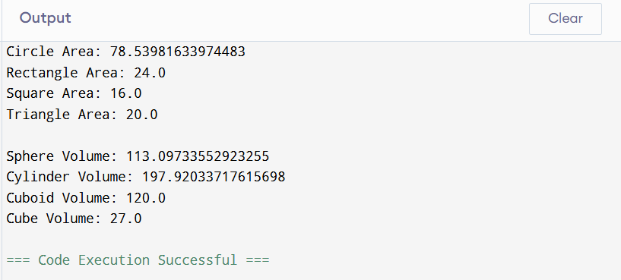

Conclusion-
This program is a good example of method overloading in Java. It shows how a single method name can handle multiple tasks efficiently, making the code clean and reusable.

Experiment 4.2
Aim-Create a Student class to demonstrate constructor overloading by allowing the creation of student objects using different initialization formats. The program should include Student Class Fields like rollNumber, name, department.
Theory: Constructor Overloading in Java (Student Class)
This program demonstrates the concept of constructor overloading in Java using a Student class. Constructor overloading allows a class to have multiple constructors with different parameter lists, enabling objects to be initialized in different ways.
🔹 Objective of the Program
- To create a Studentclass with fields:
  - rollNumber
  - name
  - department
- To implement multiple constructors
- To create objects using different initialization formats
🔹 Concepts Used
1. Constructor
A constructor is a special method:
- Has the same name as the class
- Is automatically called when an object is created
- Used to initialize object values
2. Constructor Overloading
Constructor overloading means:
- Defining multiple constructors in the same class
- Each constructor has a different number or type of parameters
Example:
Student()
Student(int rollNumber)
Student(int rollNumber, String name)
3. Instance Variables
- rollNumber → stores student roll number
- name → stores student name
- department → stores department
🔹 Types of Constructors Used
- Default Constructor
  - No parameters
  - Assigns default values
- Parameterized Constructors
  - With one parameter
  - With two parameters
  - With all parameters
🔹 Working of the Program
- A class Student is created with required fields
- Multiple constructors are defined
- Objects are created using different constructors
- Each constructor initializes values differently
- Details are displayed using a method
🔹 Advantages
- Provides flexibility in object creation
- Improves code readability
- Demonstrates compile-time polymorphism

Code-
class Student {
int rollNumber;
String name;
String department;

// Default Constructor
Student() {
rollNumber = 0;
name = "Unknown";
department = "Not Assigned";
}

// Constructor with roll number
Student(int r) {
rollNumber = r;
name = "Unknown";
department = "Not Assigned";
}

// Constructor with roll number and name
Student(int r, String n) {
rollNumber = r;
name = n;
department = "Not Assigned";
}

// Constructor with all details
Student(int r, String n, String d) {
rollNumber = r;
name = n;
department = d;
}

// Method to display details
void display() {
System.out.println("Roll Number: " + rollNumber);
System.out.println("Name: " + name);
System.out.println("Department: " + department);
System.out.println();
}
}

public class StudentDemo {
public static void main(String[] args) {

// Creating objects using different constructors
Student s1 = new Student();
Student s2 = new Student(101);
Student s3 = new Student(102, "Zoheb");
Student s4 = new Student(103, "Aman", "Computer Science");

// Display details
s1.display();
s2.display();
s3.display();
s4.display();
}
}
Output-
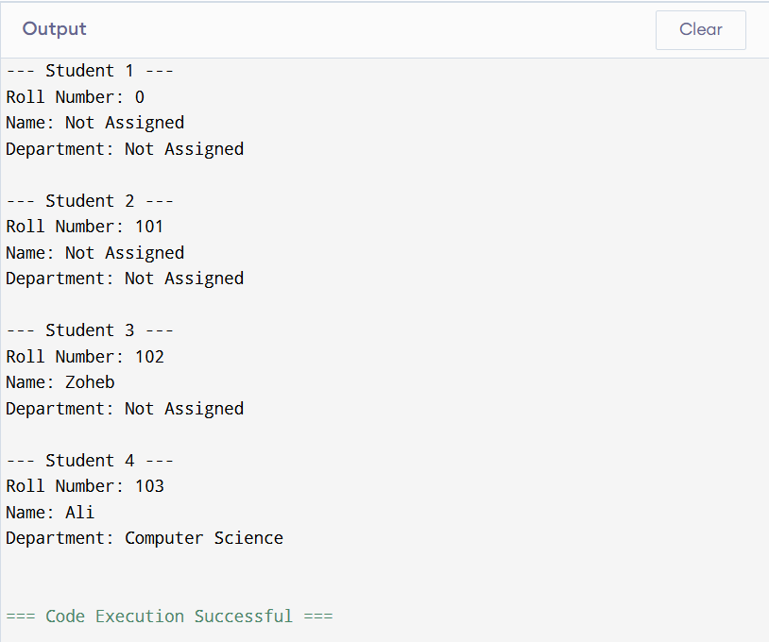

Conclusion-
Constructor overloading is an important feature of Java that allows objects to be initialized in multiple ways. This program helps in understanding how constructors work and how they can be overloaded for flexibility.

Experiment 4.3
Aim-Write a program that demonstrates use of Static member and static functions.

Theory: Static Members and Static Functions in Java
In Java, the keyword static is used to define variables and methods that belong to the class rather than any specific object. This means all objects of the class share the same copy of static members.
🔹 Objective of the Program
- To understand the use of static variables (members)
- To understand the use of static methods (functions)
- To demonstrate how static members are shared among objects
🔹 Concepts Used
1. Static Variable (Class Variable)
- Declared using the static keyword
- Shared among all objects of the class
- Memory is allocated only once
Example:
static int count;
2. Static Method
- Declared using static keyword
- Can be called without creating an object
- Can access only static variables directly
Example:
static void displayCount() {
System.out.println(count);
}
3. Difference Between Static and Non-Static
Feature | Static | Non-Static
Belongs to | Class | Object
Memory | Single copy | Separate for each object
Access | Class name | Object reference

🔹 Working of the Program
- A class is created with:
  - Static variable → shared count
  - Non-static variable → individual data
- Each time an object is created:
  - Static variable is updated
- Static method is used to display shared data
- Non-static method displays individual data
🔹 Advantages
- Saves memory (shared data)
- Easy access without object creation
- Useful for constants and counters

Code-
class Student {
int rollNumber;
String name;

// Static variable
static String collegeName = "XYZ College";
static int count = 0;

// Constructor
Student(int r, String n) {
rollNumber = r;
name = n;
count++; // Increment static count
}

// Static method
static void displayCount() {
System.out.println("Total Students: " + count);
}

// Non-static method
void display() {
System.out.println("Roll Number: " + rollNumber);
System.out.println("Name: " + name);
System.out.println("College: " + collegeName);
System.out.println();
}
}

public class StaticDemo {
public static void main(String[] args) {

// Creating objects
Student s1 = new Student(101, "Zoheb");
Student s2 = new Student(102, "Aman");
Student s3 = new Student(103, "Rahul");

// Display individual details
s1.display();
s2.display();
s3.display();

// Call static method
Student.displayCount();
}
}

Output-
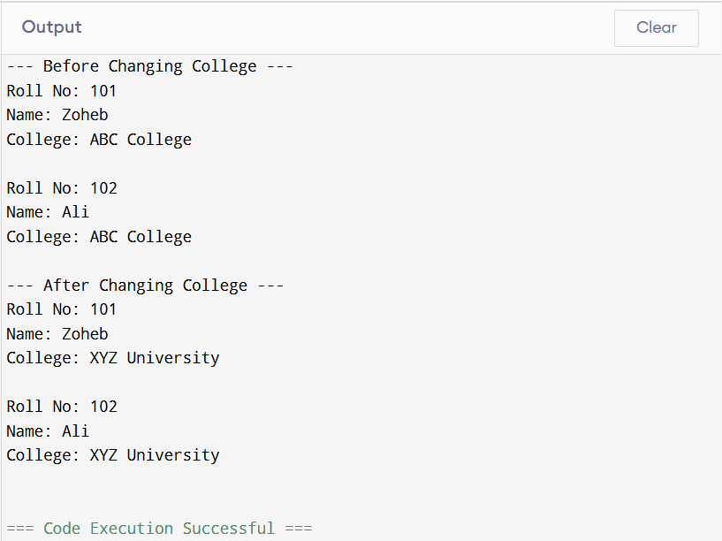

Conclusion-
Static members and methods are important in Java for managing shared data and utility functions. They help in writing efficient and organized programs.

