Name- Ansari Mohd Saif
Roll No- 25AI22
Div - A
Experiment 5.1

Aim- Write a program that demonstrates the use of various methods.

Theory: String Class Methods in Java
In Java, a String is a sequence of characters used to store and manipulate text. The String class provides many built-in methods that help perform various operations like finding length, comparing strings, extracting substrings, converting case, etc.
🔹 Objective of the Program
- To understand the use of String class methods
- To perform operations like:
  - Finding length
  - Converting case
  - Comparing strings
  - Extracting substring
  - Replacing characters
🔹 Important String Methods
1. length()
- Returns the number of characters in a string
str.length();
2. toUpperCase() / toLowerCase()
- Converts string to uppercase or lowercase
str.toUpperCase();
str.toLowerCase();
3. charAt(index)
- Returns character at a specific position
str.charAt(0);
4. substring(start, end)
- Extracts part of the string
str.substring(0, 5);
5. equals()
- Compares two strings (case-sensitive)
str1.equals(str2);
6. equalsIgnoreCase()
- Compares strings ignoring case
str1.equalsIgnoreCase(str2);
7. contains()
- Checks if a string contains a specific sequence
str.contains("Java");
8. replace()
- Replaces characters in a string
str.replace('a', 'o');
9. trim()
- Removes extra spaces from beginning and end
str.trim();
🔹 Working of the Program
- A string is taken as input
- Various String methods are applied
- Results are displayed using System.out.println()
🔹 Advantages
- Simplifies text processing
- Provides built-in functions
- Reduces coding effort

Code-
import java.util.Scanner;

public class StringDemo {
public static void main(String[] args) {

Scanner sc = new Scanner(System.in);

// Input
System.out.print("Enter a string: ");
String str = sc.nextLine();

System.out.println("\n--- String Operations ---");

// length()
System.out.println("Length: " + str.length());

// toUpperCase() and toLowerCase()
System.out.println("Uppercase: " + str.toUpperCase());
System.out.println("Lowercase: " + str.toLowerCase());

// charAt()
System.out.println("Character at index 0: " + str.charAt(0));

// substring()
if (str.length() >= 5) {
System.out.println("Substring (0 to 5): " + str.substring(0, 5));
}

// equals() and equalsIgnoreCase()
String str2 = "Java";
System.out.println("Equals 'Java': " + str.equals(str2));
System.out.println("Equals Ignore Case 'java': " + str.equalsIgnoreCase("java"));

// contains()
System.out.println("Contains 'Java': " + str.contains("Java"));

// replace()
System.out.println("Replace 'a' with 'o': " + str.replace('a', 'o'));

// trim()
System.out.println("Trimmed String: " + str.trim());

sc.close();
}
}

Output-
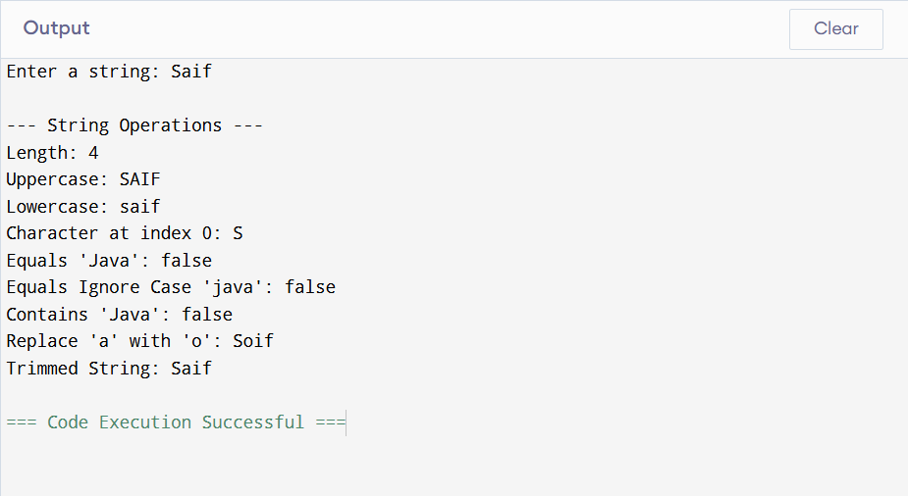

Conclusion-
The String class in Java is powerful and widely used for text manipulation. Understanding its methods is essential for efficient programming and real-world applications.

Experiment 5.2
Aim-Write a program that demonstrates the use of various methods available in String Buffer class.

Theory: StringBuffer Class Methods in Java
In Java, StringBuffer is a class used to create mutable (changeable) strings. Unlike the String class (which is immutable), StringBuffer allows modification of the same object without creating new ones, making it more efficient for frequent string operations.
🔹 Objective of the Program
- To understand the use of StringBuffer class
- To perform operations like:
  - Append
  - Insert
  - Replace
  - Delete
  - Reverse
  - Capacity & length
🔹 Key Features of StringBuffer
- Mutable (modifiable)
- Thread-safe (synchronized)
- Efficient for repeated modifications
🔹 Important StringBuffer Methods
1. append()
- Adds text at the end
sb.append("World");
2. insert(index, text)
- Inserts text at a specific position
sb.insert(5, " Java");
3. replace(start, end, text)
- Replaces a portion of the string
sb.replace(0, 5, "Hi");
4. delete(start, end)
- Deletes part of the string
sb.delete(0, 2);
5. reverse()
- Reverses the string
sb.reverse();
6. length()
- Returns number of characters
7. capacity()
- Returns current storage capacity
🔹 Working of the Program
- A StringBuffer object is created
- Various methods are applied step by step
- After each operation, the result is displayed
🔹 Advantages
- Faster than String for modifications
- Saves memory (no new objects created repeatedly)
- Useful in dynamic string operations

Code-
public class StringBufferDemo {
public static void main(String[] args) {

// Creating StringBuffer object
StringBuffer sb = new StringBuffer("Hello");

System.out.println("Original String: " + sb);

// append()
sb.append(" World");
System.out.println("After append: " + sb);

// insert()
sb.insert(5, " Java");
System.out.println("After insert: " + sb);

// replace()
sb.replace(0, 5, "Hi");
System.out.println("After replace: " + sb);

// delete()
sb.delete(0, 3);
System.out.println("After delete: " + sb);

// reverse()
sb.reverse();
System.out.println("After reverse: " + sb);

// length()
System.out.println("Length: " + sb.length());

// capacity()
System.out.println("Capacity: " + sb.capacity());
}
}

Output-
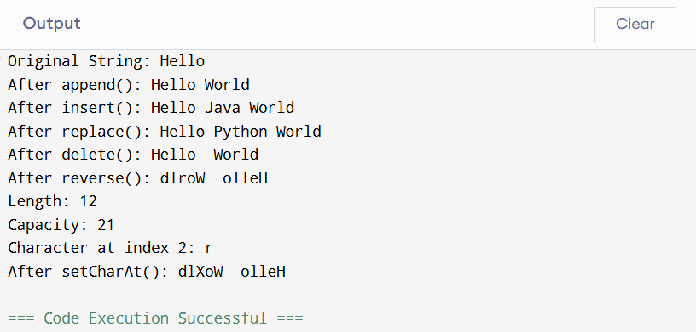

Conclusion-
The String Buffer class is an important tool in Java for handling strings that require frequent changes. It improves performance and efficiency compared to regular strings.

Experiment 5.3
Aim-Write a program to find the Maximum Element in an Integer Array

Theory:
In Java, StringBuffer is a class used to create mutable (changeable) strings. Unlike the String class (which is immutable), StringBuffer allows modification of the same object without creating new ones, making it more efficient for frequent string operations.
🔹 Objective of the Program
- To understand the use of StringBuffer class
- To perform operations like:
  - Append
  - Insert
  - Replace
  - Delete
  - Reverse
  - Capacity & length
🔹 Key Features of StringBuffer
- Mutable (modifiable)
- Thread-safe (synchronized)
- Efficient for repeated modifications
🔹 Important StringBuffer Methods
1. append()
- Adds text at the end
sb.append("World");
2. insert(index, text)
- Inserts text at a specific position
sb.insert(5, " Java");
3. replace(start, end, text)
- Replaces a portion of the string
sb.replace(0, 5, "Hi");
4. delete(start, end)
- Deletes part of the string
sb.delete(0, 2);
5. reverse()
- Reverses the string
sb.reverse();
6. length()
- Returns number of characters
7. capacity()
- Returns current storage capacity
🔹 Working of the Program
- A StringBuffer object is created
- Various methods are applied step by step
- After each operation, the result is displayed
🔹 Advantages
- Faster than String for modifications
- Saves memory (no new objects created repeatedly)
- Useful in dynamic string operations

Code-
public class StringBufferDemo {
public static void main(String[] args) {

// Creating StringBuffer object
StringBuffer sb = new StringBuffer("Hello");

System.out.println("Original String: " + sb);

// append()
sb.append(" World");
System.out.println("After append: " + sb);

// insert()
sb.insert(5, " Java");
System.out.println("After insert: " + sb);

// replace()
sb.replace(0, 5, "Hi");
System.out.println("After replace: " + sb);

// delete()
sb.delete(0, 3);
System.out.println("After delete: " + sb);

// reverse()
sb.reverse();
System.out.println("After reverse: " + sb);

// length()
System.out.println("Length: " + sb.length());

// capacity()
System.out.println("Capacity: " + sb.capacity());
}
}

Output-
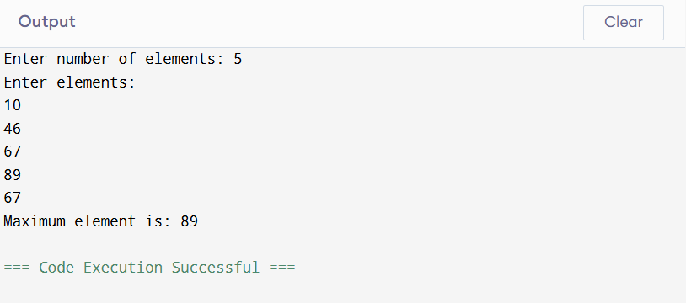

Conclusion-
The String Buffer class is an important tool in Java for handling strings that require frequent changes. It improves performance and efficiency compared to regular strings.

