Name- Ansari Mohd Saif
Roll No- 25AI22
Div - A
Experiment 7.1
Aim-Create a Java program to demonstrate inheritance by designing an Employee superclass and a Manager subclass. The program should include the appropriate methods to demonstrate the inheritance hierarchy.
Theory: Inheritance in Java
Inheritance is an important concept of Object-Oriented Programming (OOP) where one class (child/subclass) acquires the properties and behaviors of another class (parent/superclass).
🔹 Key Points:
- The parent class is also called Superclass
- The child class is also called Subclass
- Inheritance is achieved using the keyword extends
- It helps in:
  - Code reusability
  - Method overriding
  - Better organization of code
🧑‍💼 Example Concept
Superclass: Employee
- Attributes: name, salary
- Method: displayDetails()
Subclass: Manager
- Inherits Employee properties
- Additional attribute: bonus
- Method: displayManagerDetails()

Code-
import java.util.Scanner;

// Superclass
class Employee {
String name;
double salary;

// Method to set employee details
void setEmployee(String name, double salary) {
this.name = name;
this.salary = salary;
}

// Method to display employee details
void displayEmployee() {
System.out.println("Employee Name: " + name);
System.out.println("Salary: " + salary);
}
}

// Subclass
class Manager extends Employee {
double bonus;

// Method to set manager details
void setManager(String name, double salary, double bonus) {
setEmployee(name, salary); // calling superclass method
this.bonus = bonus;
}

// Method to display manager details
void displayManager() {
displayEmployee(); // inherited method
System.out.println("Bonus: " + bonus);
System.out.println("Total Salary: " + (salary + bonus));
}
}

// Main class
public class Main {
public static void main(String[] args) {
Scanner sc = new Scanner(System.in);

Manager m = new Manager();

// Input
System.out.print("Enter Name: ");
String name = sc.nextLine();

System.out.print("Enter Salary: ");
double salary = sc.nextDouble();

System.out.print("Enter Bonus: ");
double bonus = sc.nextDouble();

// Setting values
m.setManager(name, salary, bonus);

// Displaying output
System.out.println("\n--- Manager Details ---");
m.displayManager();

sc.close();
}
}

Output-
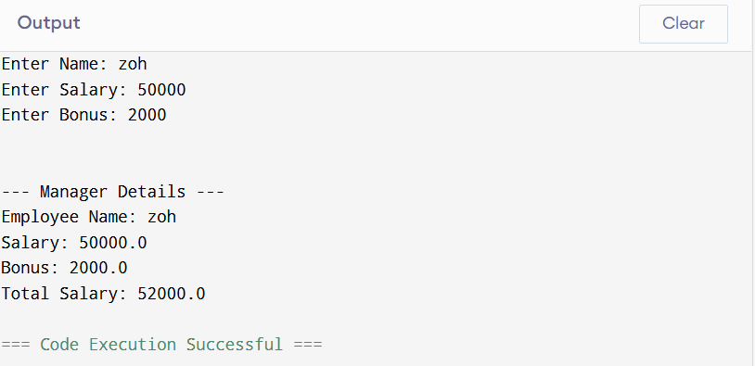

Conclusion-
This program demonstrates:
- Inheritance using extends
- Reuse of superclass methods in subclass
- Adding new features in subclass (bonus)

Experiment 7.2-
Aim-Write a Java program to create a Vehicle class with a method
showSpeed() that displays the default speed of a generic vehicle.
Create a Car subclass that overrides this method to show specific
speed. Then, extend Car with a SportsCar class that further
overrides showSpeed() and uses the super keyword to invoke both the Car and Vehicle implementations of showSpeed().

Theory: Method Overriding & Multilevel Inheritance
🔹 Method Overriding
- When a subclass provides its own implementation of a method already defined in the superclass.
- Achieved using the same method name, return type, and parameters.
- Enables runtime polymorphism.
🔹 Multilevel Inheritance
- A class is derived from another derived class.
- Example:
- Vehicle → Car → SportsCar
🔹 super Keyword
- Used to call the parent class method or constructor.
- Helps access overridden methods from the superclass.
🚗 Example Concept
1. Vehicle (Superclass)
- Method: showSpeed() → shows default speed
2. Car (Subclass of Vehicle)
- Overrides showSpeed() → shows car speed
3. SportsCar (Subclass of Car)
- Overrides showSpeed()
- Uses super.showSpeed() to call parent methods

Code-
// Superclass
class Vehicle {
void showSpeed() {
System.out.println("Vehicle Speed: 60 km/h");
}
}

// Subclass 1
class Car extends Vehicle {
void showSpeed() {
System.out.println("Car Speed: 120 km/h");
}
}

// Subclass 2 (Multilevel Inheritance)
class SportsCar extends Car {
void showSpeed() {
System.out.println("SportsCar Speed: 200 km/h");

// Calling parent class method (Car)
super.showSpeed();

// Calling grandparent class method (Vehicle)
System.out.println("Calling Vehicle speed using super-super concept:");
Vehicle v = new Vehicle();
v.showSpeed();
}
}

// Main class
public class Main {
public static void main(String[] args) {

SportsCar sc = new SportsCar();

System.out.println("--- Speed Details ---");
sc.showSpeed();
}
}

Output-
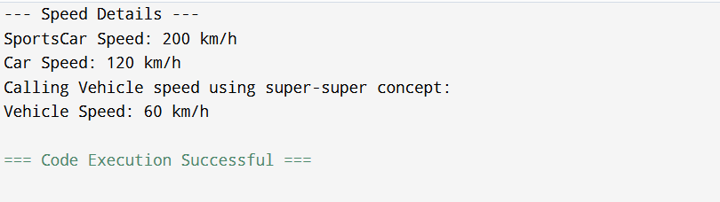

Conclusion-
- This program demonstrates:
- Method overriding at multiple levels
- Multilevel inheritance (Vehicle → Car → SportsCar)
- Use of super keyword to call parent method
- Accessing grandparent method using object creation

