Name- Ansari Mohd Saif
Roll No- 25AI22
Div - A

Experiment 8.1
Aim-Write a program that declares an abstract class Shape that
implements the Drawable method and also includes a field String
color and an abstract method calculateArea().

Theory: Abstract Class & Abstraction in Java
🔹 Abstract Class
- A class declared with the keyword abstract
- Cannot be instantiated (no objects can be created directly)
- Can contain:
  - Abstract methods (without body)
  - Concrete methods (with body)
  - Variables (fields)
🔹 Abstract Method
- A method declared without implementation
- Must be implemented by subclasses
🔹 Interface (Drawable)
- Used to define behavior
- All methods are abstract by default
- A class implements an interface using implements
🎨 Example Concept
Interface: Drawable
- Method: draw()
Abstract Class: Shape
- Implements Drawable
- Field: color
- Abstract method: calculateArea()
Subclasses:
- Circle
- Rectangle

Code-
// Interface
interface Drawable {
void draw();
}

// Abstract class
abstract class Shape implements Drawable {
String color;

// Constructor
Shape(String color) {
this.color = color;
}

// Abstract method
abstract double calculateArea();

// Concrete method
void displayColor() {
System.out.println("Color: " + color);
}
}

// Circle subclass
class Circle extends Shape {
double radius;

Circle(String color, double radius) {
super(color);
this.radius = radius;
}

// Override calculateArea()
double calculateArea() {
return Math.PI * radius * radius;
}

// Override draw()
public void draw() {
System.out.println("Drawing Circle");
}
}

// Rectangle subclass
class Rectangle extends Shape {
double length, breadth;

Rectangle(String color, double length, double breadth) {
super(color);
this.length = length;
this.breadth = breadth;
}

// Override calculateArea()
double calculateArea() {
return length * breadth;
}

// Override draw()
public void draw() {
System.out.println("Drawing Rectangle");
}
}

// Main class
public class Main {
public static void main(String[] args) {

// Polymorphism (Shape reference)
Shape s1 = new Circle("Red", 5);
Shape s2 = new Rectangle("Blue", 4, 6);

System.out.println("--- Circle ---");
s1.draw();
s1.displayColor();
System.out.println("Area: " + s1.calculateArea());

System.out.println("\n--- Rectangle ---");
s2.draw();
s2.displayColor();
System.out.println("Area: " + s2.calculateArea());
}
}

Output-
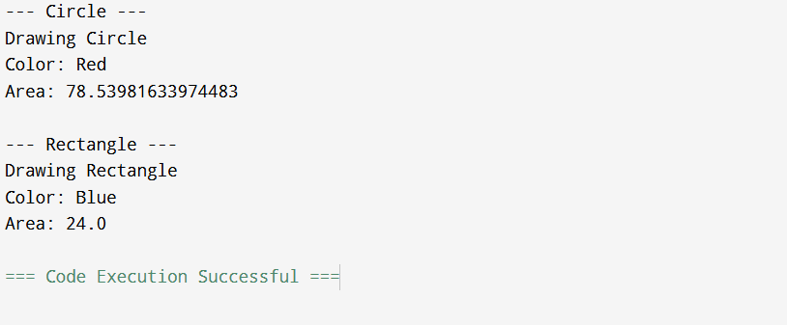

Conclusion-
This program demonstrates:
- Abstract class (Shape) with field and abstract method
- Interface (Drawable) implementation
- Method overriding in subclasses
- Runtime polymorphism using Shape reference

Experiment 8.2
Aim-Write a Java program that defines a Payment interface with: void processPayment(double amount) ● Implements ‘this’ interface in two classes: 1. CreditCardPayment with additional fields: cardNumber, cardHolderName, cvv 2. UPIPayment with additional fields: upiId, mobileNumber ● Use validation where necessary (e.g., CVV must be 3 digits, UPI ID must contain '@') ● In main() method: Accept details from user Display confirmation messages.

Theory: Interface & Implementation
🔹 Interface (Payment)
- Defines a contract with method:
- void processPayment(double amount);
- Any class implementing this must provide its own logic
🔹 Implementing Classes
- CreditCardPayment
  - Fields: cardNumber, cardHolderName, cvv
  - Validation: CVV must be exactly 3 digits
- UPIPayment
  - Fields: upiId, mobileNumber
  - Validation: UPI ID must contain '@'
🔹 Concept Used
- Interface implementation
- Method overriding
- User input using Scanner
- Basic validation logic

Code-
import java.util.Scanner;

// Interface
interface Payment {
void processPayment(double amount);
}

// Credit Card Payment Class
class CreditCardPayment implements Payment {
String cardNumber;
String cardHolderName;
String cvv;

CreditCardPayment(String cardNumber, String cardHolderName, String cvv) {
this.cardNumber = cardNumber;
this.cardHolderName = cardHolderName;
this.cvv = cvv;
}

// Validation for CVV
boolean isValidCVV() {
return cvv.length() == 3 && cvv.matches("\\d{3}");
}

public void processPayment(double amount) {
if (!isValidCVV()) {
System.out.println("Invalid CVV! Payment Failed.");
return;
}

System.out.println("\n--- Credit Card Payment ---");
System.out.println("Card Holder: " + cardHolderName);
System.out.println("Amount Paid: " + amount);
System.out.println("Payment Successful via Credit Card!");
}
}

// UPI Payment Class
class UPIPayment implements Payment {
String upiId;
String mobileNumber;

UPIPayment(String upiId, String mobileNumber) {
this.upiId = upiId;
this.mobileNumber = mobileNumber;
}

// Validation for UPI ID
boolean isValidUPI() {
return upiId.contains("@");
}

public void processPayment(double amount) {
if (!isValidUPI()) {
System.out.println("Invalid UPI ID! Payment Failed.");
return;
}

System.out.println("\n--- UPI Payment ---");
System.out.println("UPI ID: " + upiId);
System.out.println("Amount Paid: " + amount);
System.out.println("Payment Successful via UPI!");
}
}

// Main Class
public class Main {
public static void main(String[] args) {
Scanner sc = new Scanner(System.in);

System.out.println("Choose Payment Method:");
System.out.println("1. Credit Card");
System.out.println("2. UPI");
int choice = sc.nextInt();
sc.nextLine(); // consume newline

System.out.print("Enter Amount: ");
double amount = sc.nextDouble();
sc.nextLine();

Payment payment;

if (choice == 1) {
System.out.print("Enter Card Number: ");
String cardNumber = sc.nextLine();

System.out.print("Enter Card Holder Name: ");
String name = sc.nextLine();

System.out.print("Enter CVV: ");
String cvv = sc.nextLine();

payment = new CreditCardPayment(cardNumber, name, cvv);

} else {
System.out.print("Enter UPI ID: ");
String upiId = sc.nextLine();

System.out.print("Enter Mobile Number: ");
String mobile = sc.nextLine();

payment = new UPIPayment(upiId, mobile);
}

// Polymorphism
payment.processPayment(amount);

sc.close();
}
}

Output-
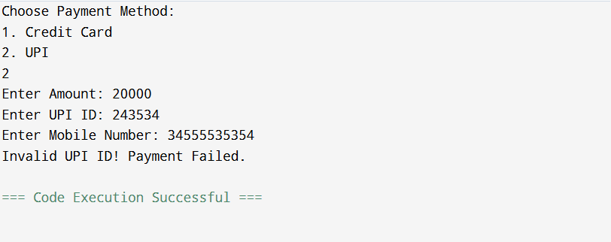

Conclusion-
This program demonstrates:
- Interface (Payment) usage
- Multiple class implementation
- Validation logic (CVV & UPI ID)
- Runtime polymorphism
- User interaction using Scanner

