NAME : Maaz Aslam Chogle
ROLL NO : 21CO19
BATCH NO : 03
Date of performance : September 21, 2025

EXPERIMENT NO : 02
AIM : Develop a responsive multi-column blog page using CSS Grid and Flexbox with media queries for different screen sizes

Theory:
Responsive Web Design (RWD) is an approach that makes web pages render well on a variety of devices and window or screen sizes. The primary goal of RWD is to provide an optimal viewing and interaction experience , easy reading and navigation with a minimum of resizing, panning, and scrolling across a wide range of devices.
Key technologies used in this experiment include:
- CSS Grid Layout: A two-dimensional layout system for CSS, designed for creating complex layouts with rows and columns. It's ideal for structuring the main sections of a webpage, such as the header, main content, sidebar, and footer. We use properties like display: grid, grid-template-columns, and gap to define the structure.
- CSS Flexbox Layout: A one-dimensional layout model designed for distributing space among items in an interface and aligning them. It excels at managing components within a container, like navigation links in a header or items in a card. Key properties include display: flex, flex-direction, justify-content, and align-items.
- Media Queries: A core feature of RWD, media queries allow you to apply CSS rules only when certain conditions are met, such as the viewport width being above or below a specific size. This enables the layout to change dynamically. The syntax is @media (condition) { /* CSS rules */ }. For example, @media (min-width: 768px) applies styles for screens 768px or wider.
By combining these three technologies, we can create a "mobile-first" design. We start by styling for a single-column mobile layout and then use media queries to add more complex, multi-column layouts for tablets and desktops.

HTML Code:
<!DOCTYPE html>
<html lang="en">
<head>
<meta charset="UTF-8">
<meta name="viewport" content="width=device-width, initial-scale=1.0">
<title>Responsive Blog Page</title>
<link rel="stylesheet" href="./22se.css">
</head>
<body>
<header>
<h1>My Tech Blog</h1>
</header>

<div class="container">
<div class="post">
<h2>Introduction to HTML</h2>
<p class="post-meta">Posted on September 21, 2025 by Maaz</p>
<p>HTML is the standard markup language for creating Web pages. It stands for Hyper Text Markup Language.</p>
<div class="read-more"><a href="#">Read More</a></div>
</div>

<div class="post">
<h2>Understanding CSS</h2>
<p class="post-meta">Posted on September 20, 2025 by Maaz</p>
<p>CSS describes how HTML elements are to be displayed on screen, paper, or in other media. It saves a lot of work.</p>
<div class="read-more"><a href="#">Read More</a></div>
</div>

<div class="post">
<h2>JavaScript Basics</h2>
<p class="post-meta">Posted on September 19, 2025 by Maaz</p>
<p>JavaScript is the programming language of the Web. It can update and change both HTML and CSS.</p>
<div class="read-more"><a href="#">Read More</a></div>
</div>

<div class="post">
<h2>Responsive Design</h2>
<p class="post-meta">Posted on September 18, 2025 by Maaz</p>
<p>Responsive web design makes your web page look good on all devices. It uses flexible layouts and media queries.</p>
<div class="read-more"><a href="#">Read More</a></div>
</div>

<div class="post">
<h2>Introduction to Git</h2>
<p class="post-meta">Posted on September 17, 2025 by Maaz</p>
<p>Git is a free and open source distributed version control system designed to handle projects of all sizes.</p>
<div class="read-more"><a href="#">Read More</a></div>
</div>

<div class="post">
<h2>Basics of Python</h2>
<p class="post-meta">Posted on September 16, 2025 by Maaz</p>
<p>Python is an interpreted, high-level programming language. Its simple syntax makes it beginner-friendly.</p>
<div class="read-more"><a href="#">Read More</a></div>
</div>
</div>

<footer>
<p>© 2025 My Tech Blog. All rights reserved.</p>
</footer>
</body>
</html>

CSS Code :
body {
margin: 0;
font-family: Arial, sans-serif;
background: #fafafa;
}

header, footer {
background: #333;
color: white;
text-align: center;
padding: 1rem;
}

/* Grid Layout */
.container {
display: grid;
grid-template-columns: repeat(3, 1fr); /* 3 columns */
gap: 20px;
padding: 20px;
}

.post-meta {
font-size: 0.9rem;
color: #555;
margin-bottom: 10px;
font-style: italic;
}

/* Blog Post Card */
.post {
background: #fff;
padding: 20px;
border-radius: 8px;
box-shadow: 0 2px 6px rgba(0,0,0,0.1);
display: flex;
flex-direction: column;
}

.post h2 {
margin: 0 0 10px;
color: #333;
}

.post p {
font-size: 14px;
color: #555;
flex-grow: 1;
}

.read-more {
margin-top: 10px;
text-align: right;
}

.read-more a {
text-decoration: none;
color: #007BFF;
font-size: 14px;
}

/* Media Query for tablets */
@media (max-width: 768px) {
.container {
grid-template-columns: repeat(2, 1fr); /* 2 columns */
}
}

/* Media Query for mobile */
@media (max-width: 480px) {
.container {
grid-template-columns: 1fr; /* 1 column */
}
}

Output:
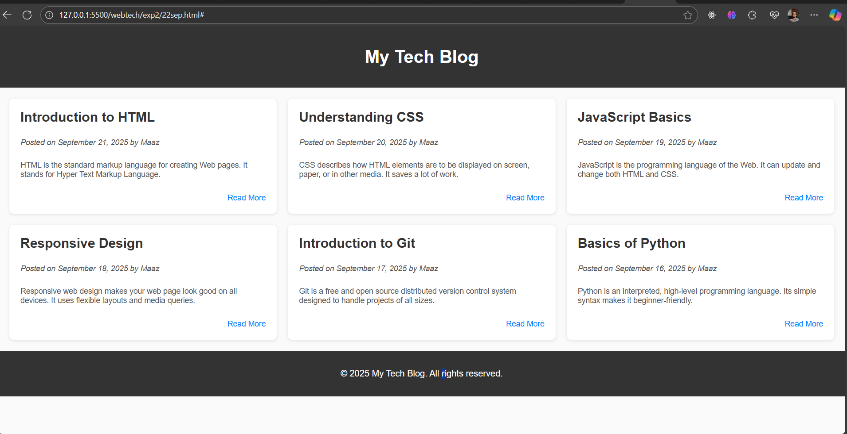
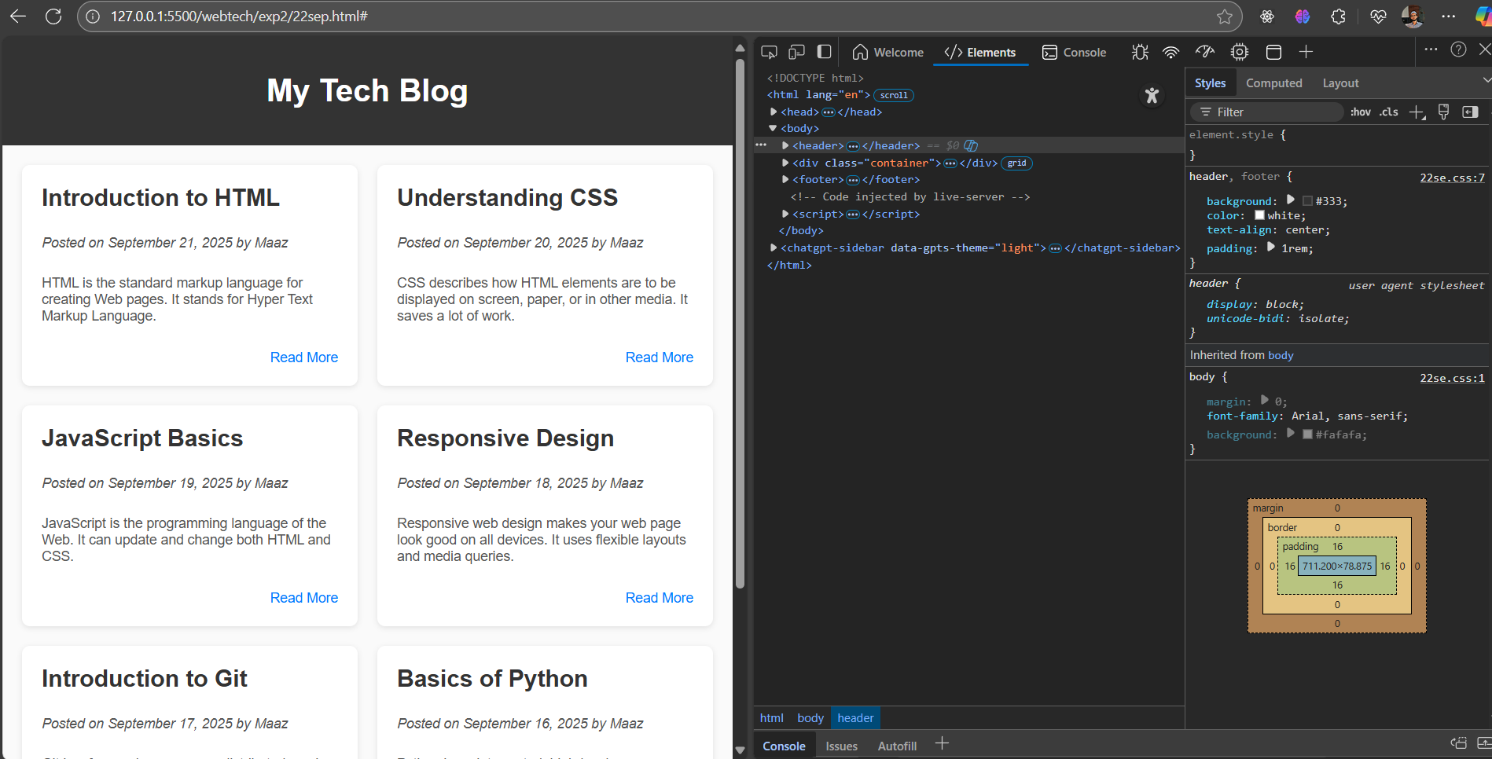

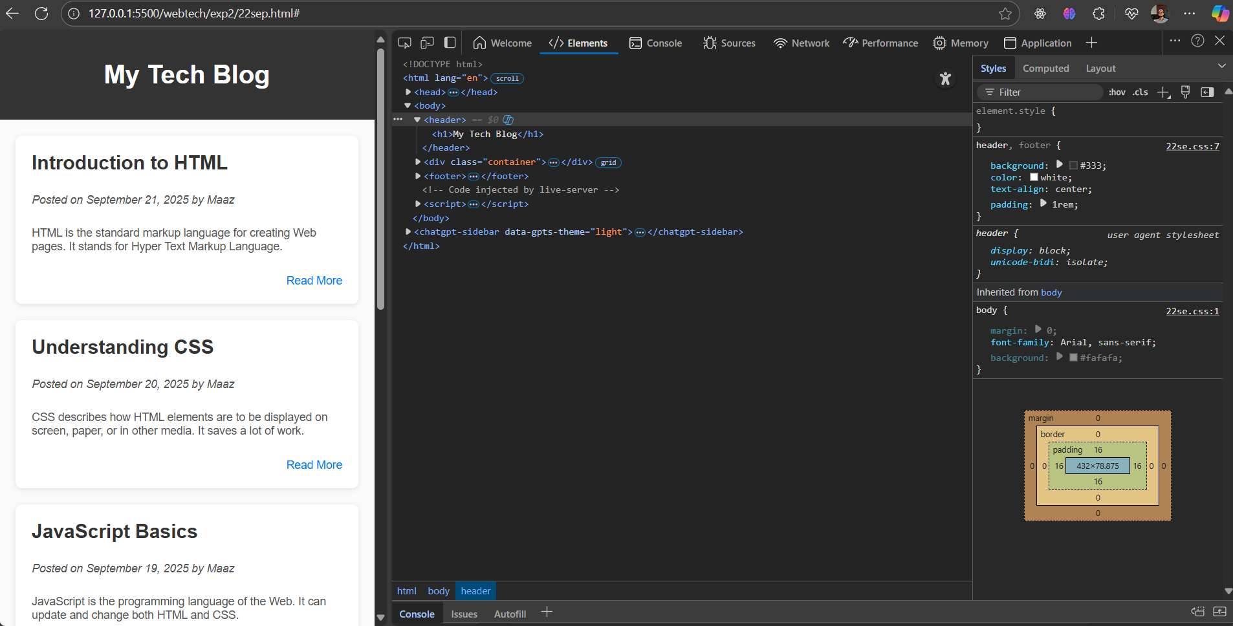

Conclusion:
In this experiment, a responsive multi-column blog page was successfully developed. CSS Grid was used to define the overall page structure, managing the arrangement of the header, main content, sidebar, and footer. CSS Flexbox was effectively utilized to align items within the header component. By implementing media queries with a mobile-first approach, the layout seamlessly adapts from a single-column view on mobile devices to a two-column view on tablets and desktops. This demonstrates a practical understanding of modern CSS layout techniques for creating responsive and user-friendly websites, successfully achieving the objectives of the experiment

