**Date: March 17, 2023**

**Extratech Nepal,**

**Pragya Marg, Sinamangal**

Dear Suman Dai,

I am writing to inform you that I am resigning from my position as a Frontend Developer at Extratech effective as of March 31, 2023. This decision has not been an easy one, but I have decided to pursue further education abroad, which will require me to leave my current position.

I want to take this opportunity to express my sincere appreciation for the support and guidance that you have provided me during my time at the company. I have learned a great deal about web development, teamwork, and project management, and I will always be grateful for the experiences that I have gained here.

I would like to thank the entire team for the opportunities they have given me to contribute to the company's success. Working with such a talented group of individuals has been a pleasure, and I have enjoyed every moment of it.

I will do everything in my power to ensure a smooth and seamless transition of my responsibilities to my successor. I will also make sure that all my work is completed before my last day of work.

Once again, thank you for everything you have done for me, and I will always remember my time at Extratech fondly.

Sincerely,

Tribikram KC

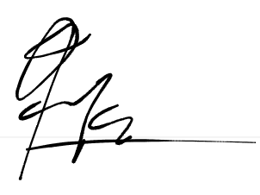

_____________

**Tribikram K C**