After signing in you get

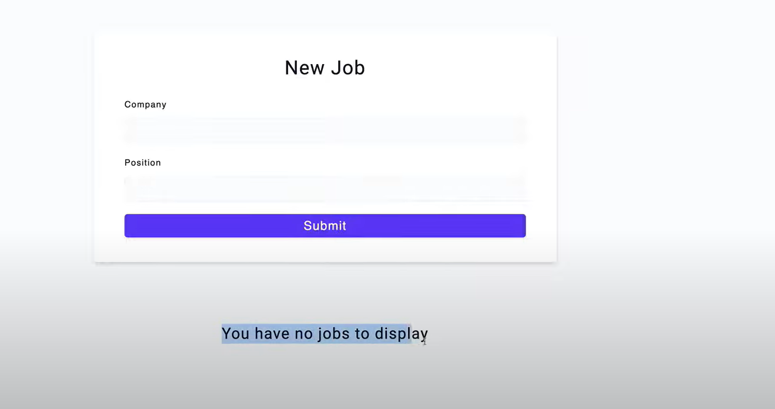after entering company name and position you create a dashboard which has edit, delete and pending status by default

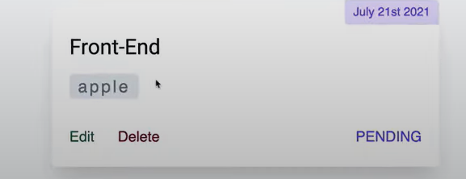

If you click edit the edit form looks like 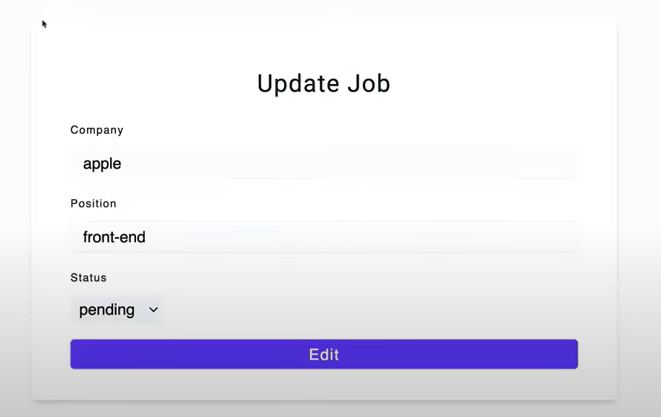

So in edit you actually send a PATCH request not a PUT request

Deleting a job sends the Delete request