

**Electrical and Computer Engineering Department**

**ENCS3310**

**ADVANCED DIGITAL SYSTEMS DESIGN**

**Project Report**

**Design a 2-digit BCD adder (8 bits)**

**Instructor: Dr. Abdallatif AbuIssa.**

**Section: 1.**

**Student’s Name: Saif Battah.**

**Student’s ID: 1170986.**

**Introduction & Abstract**

In this project we're going to create a 2-digit "BCD" adder.

We will use Verilog coding language using "Aldec" program to implement the code.

We will create this system using 1-bit full adder, 4-bit binary adder, 1-bit "BCD" adder and Registers.

So our program should work as "ADDING" Calculator, for example: if we tend to set **A = 54**, **B = 34**, so our program should add these numbers starting from Least significant bit which are **AL = 4, BL = 4** and give us a Least Sum which is **SL = 8**; and set carry to **0** or **1** depending whether the **SL** is less than or greater than **9** "IF **SL > 9 🡪 set carry to 1, else carry = 0**", then after we finish the least significant we move to add the most significant with the carry from the least operation, which are

**AM = 5**, **BM = 3**, **Carry = 0**, so the Most significant sum is **8**.

After that we combine "not adding" the least sum with the most sum and final carry to get the adding result which is **88**.

And as I mentioned before I've built the system using these smaller system:

• Built 1-bit full adder from the basic gates.

• Use the full adder to build 4-bit adder.

• Use the 4-bit adders to build 1-Digit BCD Adder.

• Use the 1-Digit BCD Adder to build the 2-Digit BCD Adder

Also we have these delays to be used when we use a specific gate

|  |  |
| --- | --- |
| **Gate** | **Delay** |
| **Inverter** | **3 ns** |
| **NAND** | **6 ns** |
| **NOR** | **6 ns** |
| **AND** | **8 ns** |
| **OR** | **8 ns** |
| **XNOR** | **10 ns** |
| **XOR** | **12 ns** |

Finally, after building the whole system we have to go over 2 stages, each stage has its own specification to test the output results and searching for any error in the adding process, so we will test 2^16 situations to check the validity and accuracy of our system.

**Program Design**

Starting with basic gates:

1. **And Gate**

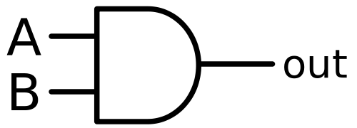

1. **Or Gate**

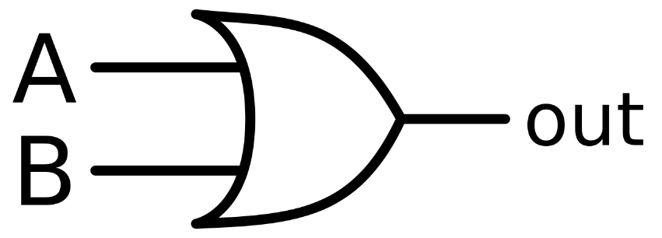

1. **XOR Gate**

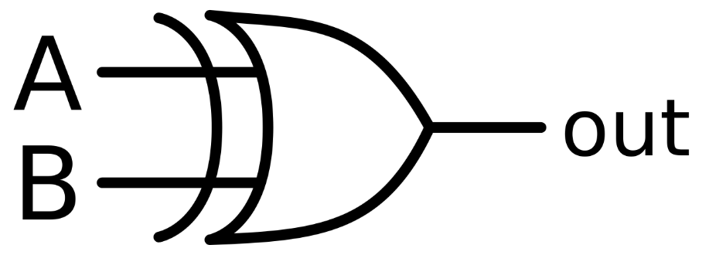

**Full Adder (1-bit)**

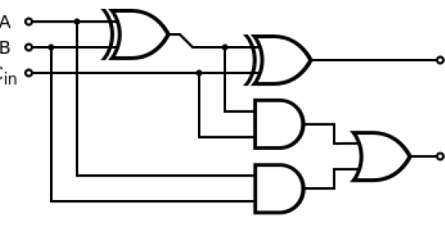

Code

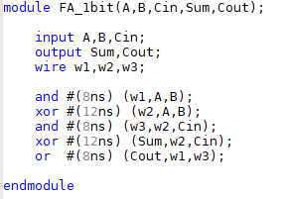

**Binary Adder (4-bit)**

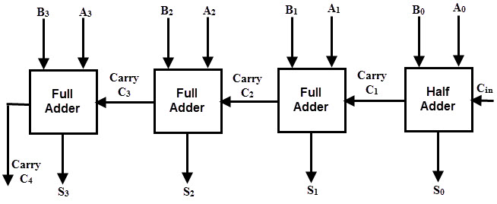

Code

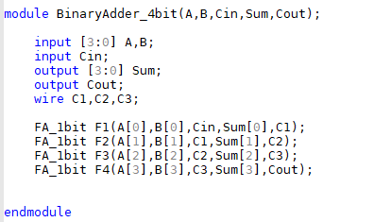

**BCD Adder (1-bit)**

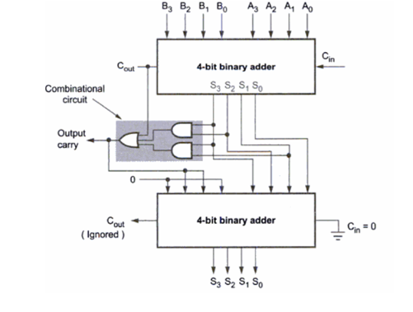

Code

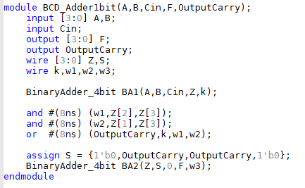

**D Flip Flop**

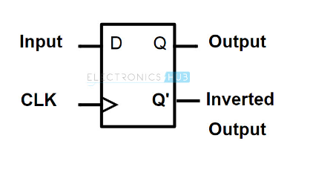

Code

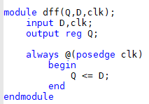

**Input Register**



Code

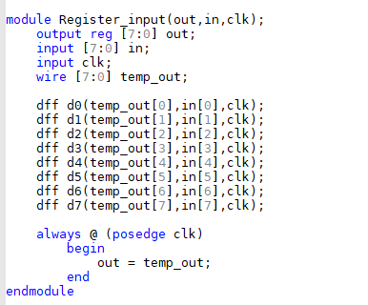

**Output Register**

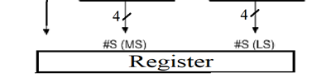

Code

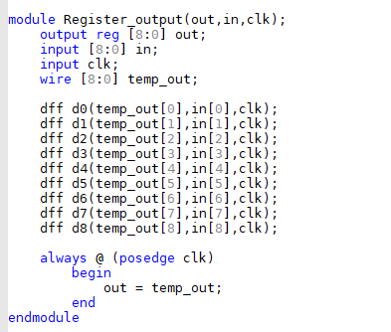

**The Whole System Structurally**

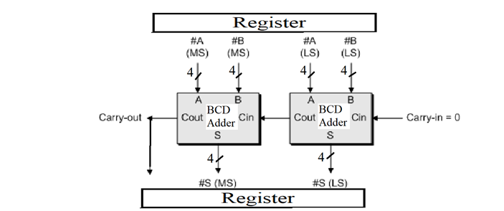

Code

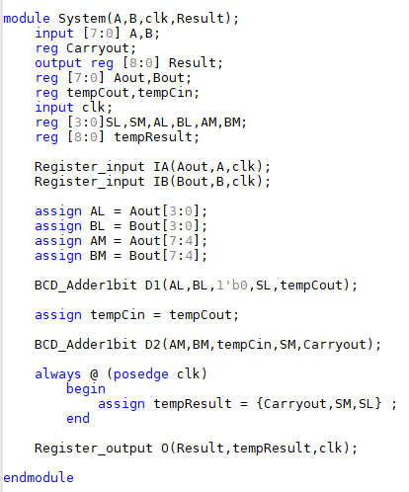

**BCD Tester for Stage 1**

Which is a "BCD" behavioral code

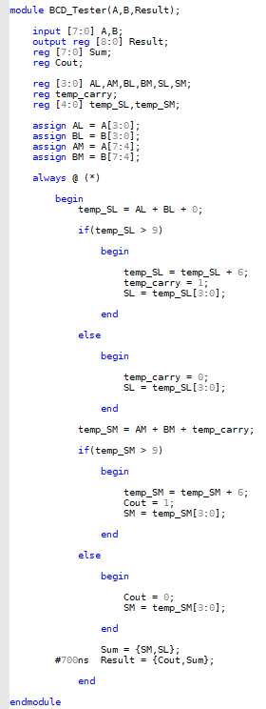

**Stage 1**

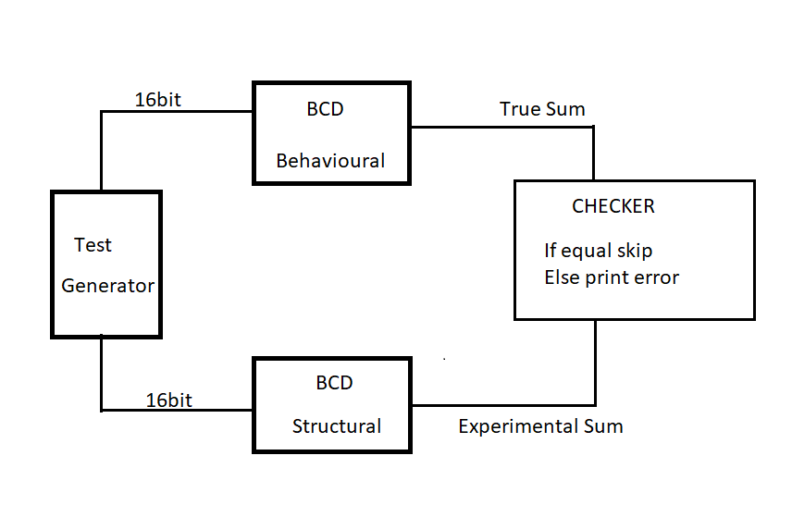

Code

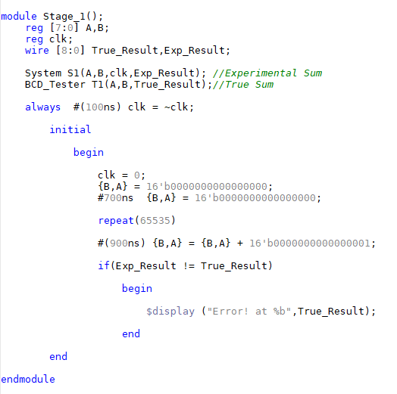

**Carry look ahead adder (4-bit)**

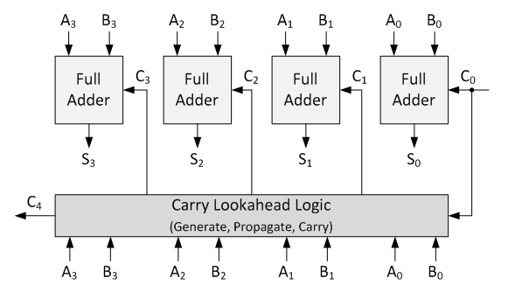

Code

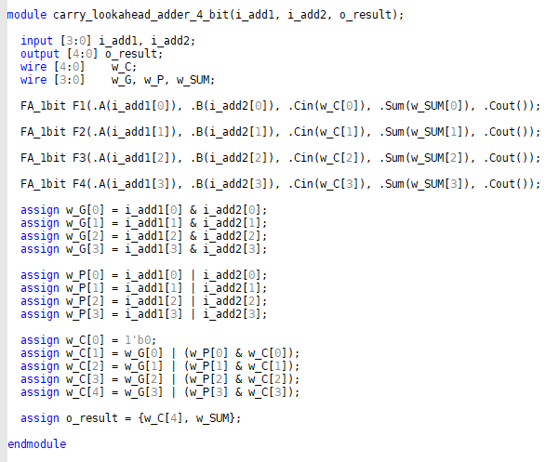

**Look Ahead BCD Adder (1-bit)**

Code

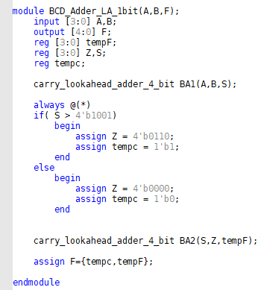

**Look Ahead BCD Adder (2-bit)**

Code

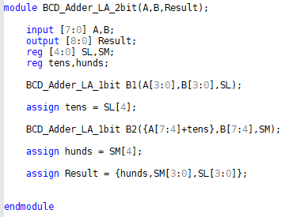

**Stage2**

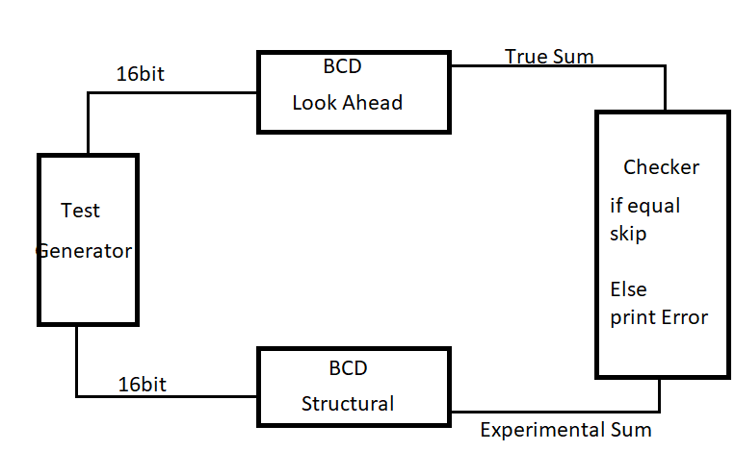

Code

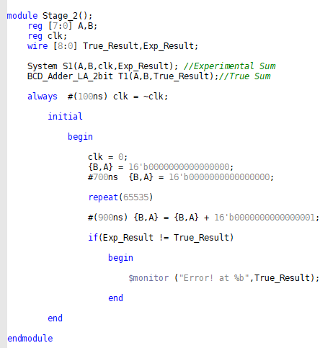

**Results**

Stage 1

For this stage I've tried a lot of delay values until I reached the one which gives us the results we need

These delay values are

700ns in ~BCD_Tester~ Result

100ns in clk

700ns for {B,A} = 16'b0000000000000000;

900ns for {B,A} = {B,A} + 16'b0000000000000001;

Screenshots

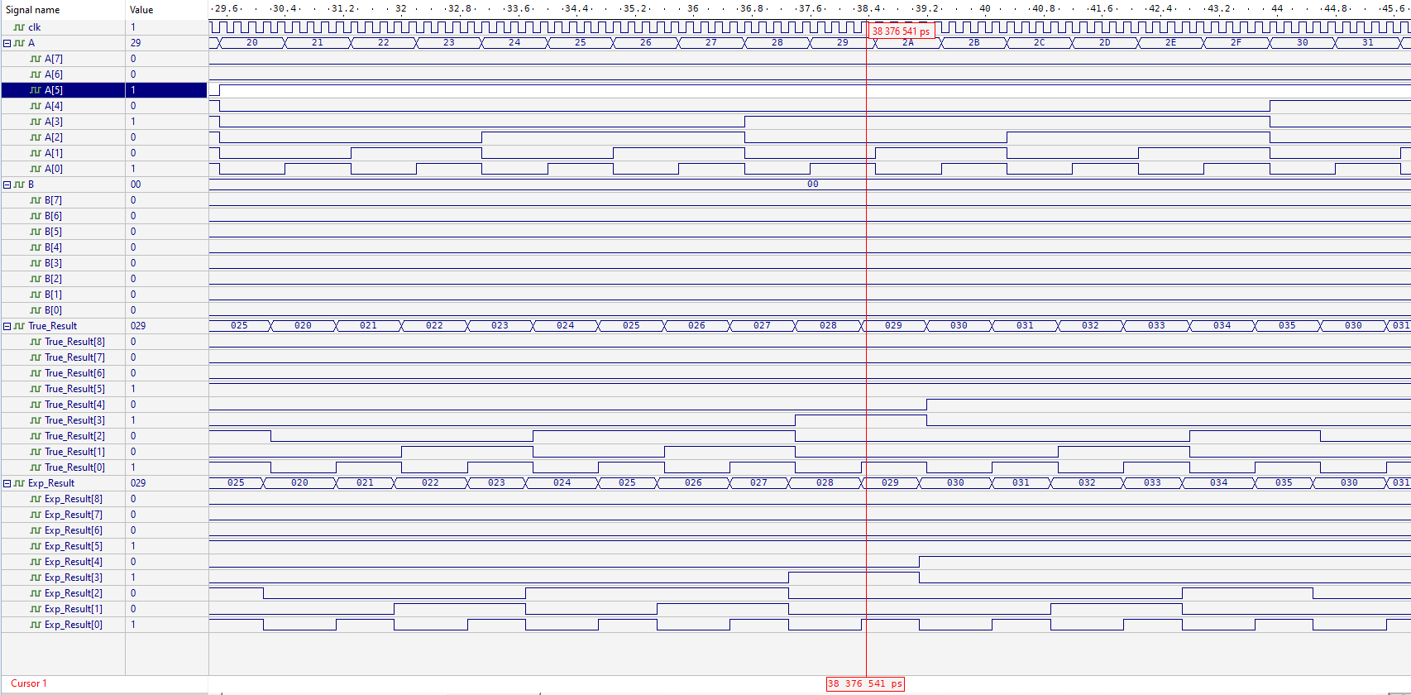

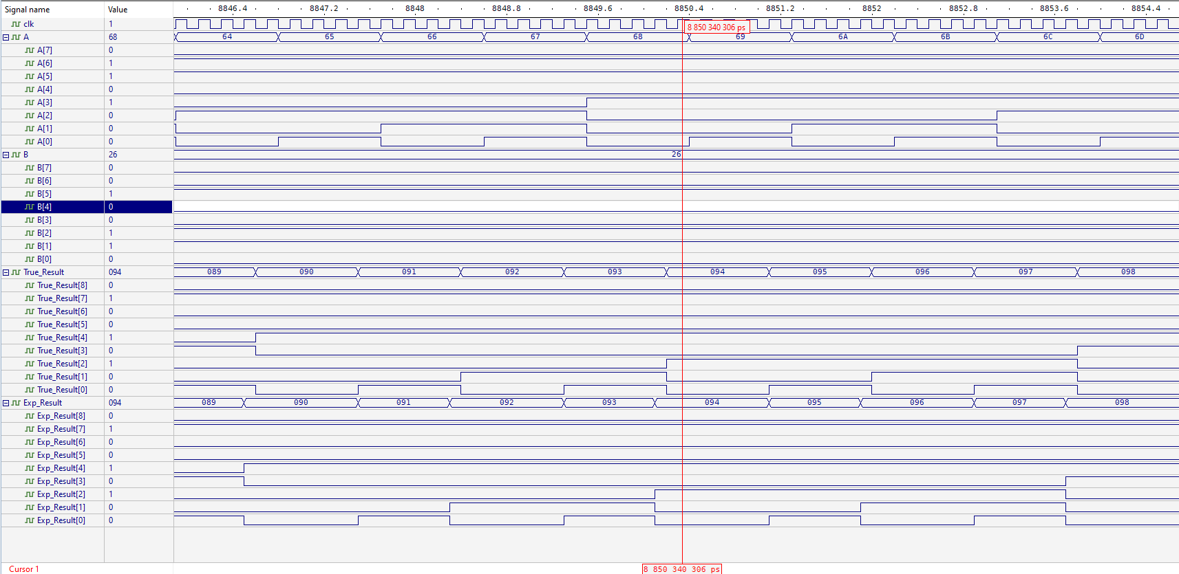

Error

After changing delays from 700 ns, an error occur in checker

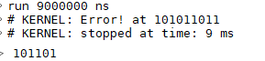

Stage 2

For this stage I've tried a lot of delay values until I reached the one which gives us the results we need

These delay values are

100ns in clk

700ns for {B,A} = 16'b0000000000000000;

900ns for {B,A} = {B,A} + 16'b0000000000000001;

Screenshots

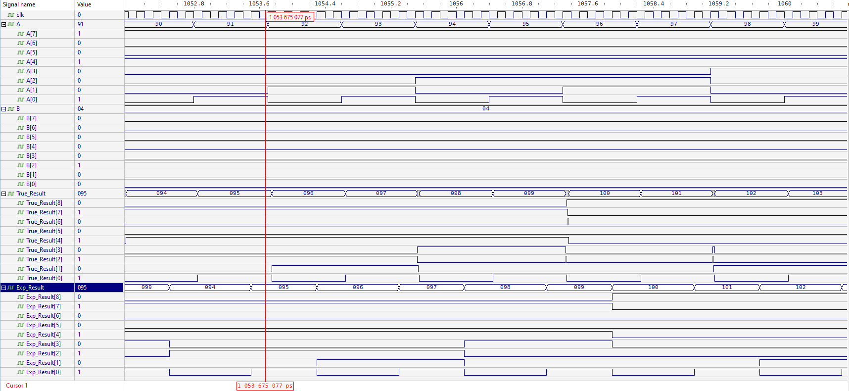

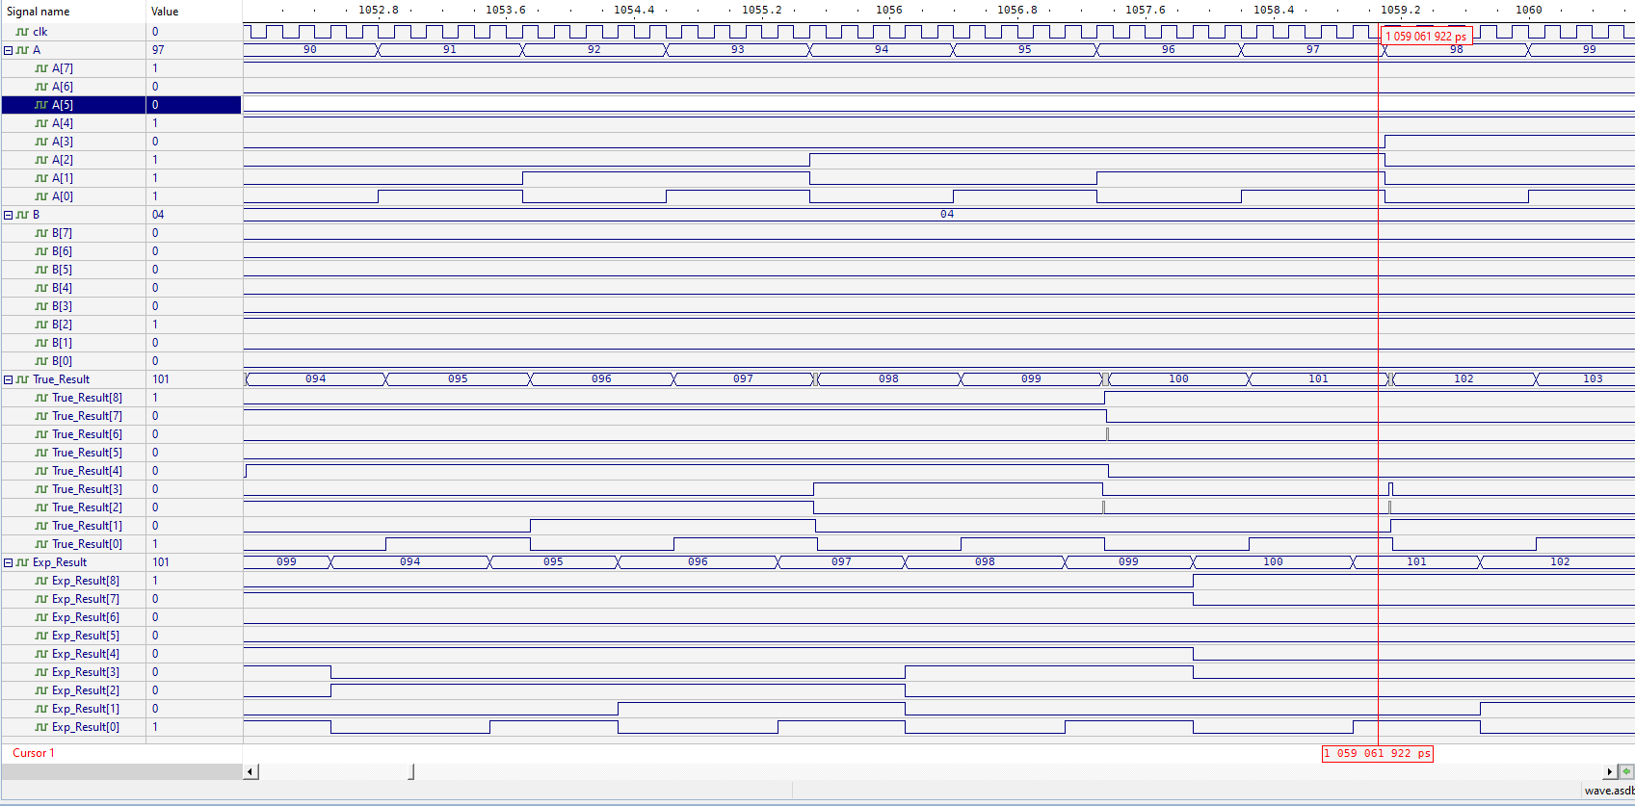

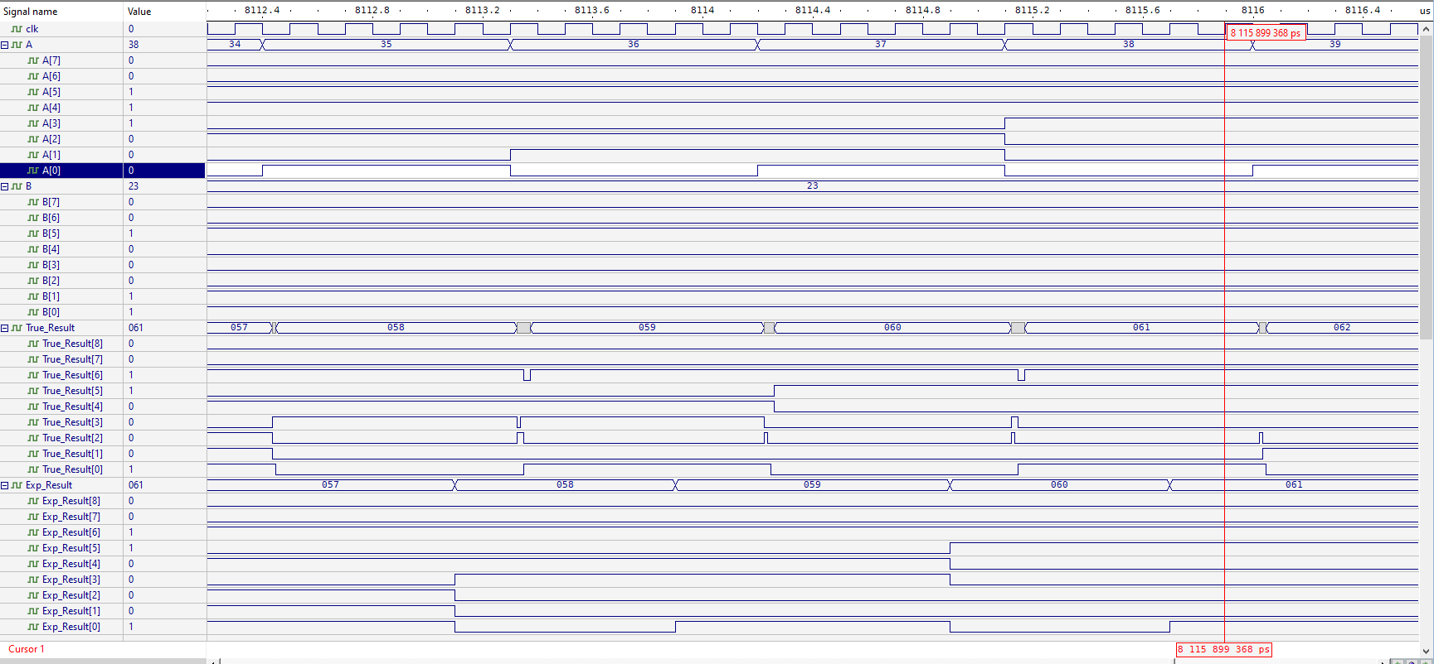

**Conclusion**

* We can construct any circuit, system, design we need in many ways.
* The small delays on and, or, xor….etc gates have a huge future effects on the results of the system design.
* Look ahead adders have more accurate, less delay results we get.

Appendix

module FA_1bit(A,B,Cin,Sum,Cout);

input A,B,Cin;

output Sum,Cout;

wire w1,w2,w3;

and #(8ns) (w1,A,B);

xor #(12ns) (w2,A,B);

and #(8ns) (w3,w2,Cin);

xor #(12ns) (Sum,w2,Cin);

or #(8ns) (Cout,w1,w3);

endmodule

////////////////////////////////////////////////

module BinaryAdder_4bit(A,B,Cin,Sum,Cout);

input [3:0] A,B;

input Cin;

output [3:0] Sum;

output Cout;

wire C1,C2,C3;

FA_1bit F1(A[0],B[0],Cin,Sum[0],C1);

FA_1bit F2(A[1],B[1],C1,Sum[1],C2);

FA_1bit F3(A[2],B[2],C2,Sum[2],C3);

FA_1bit F4(A[3],B[3],C3,Sum[3],Cout);

endmodule

////////////////////////////////////////////////

module BCD_Adder1bit(A,B,Cin,F,OutputCarry);

input [3:0] A,B;

input Cin;

output [3:0] F;

output OutputCarry;

wire [3:0] Z,S;

wire k,w1,w2,w3;

BinaryAdder_4bit BA1(A,B,Cin,Z,k);

and #(8ns) (w1,Z[2],Z[3]);

and #(8ns) (w2,Z[1],Z[3]);

or #(8ns) (OutputCarry,k,w1,w2);

assign S = {1'b0,OutputCarry,OutputCarry,1'b0};

BinaryAdder_4bit BA2(Z,S,0,F,w3);

endmodule

////////////////////////////////////////////////

module dff(Q,D,clk);

input D,clk;

output reg Q;

always @(posedge clk)

begin

Q <= D;

end

endmodule

////////////////////////////////////////////////

module Register_input(out,in,clk);

output reg [7:0] out;

input [7:0] in;

input clk;

wire [7:0] temp_out;

dff d0(temp_out[0],in[0],clk);

dff d1(temp_out[1],in[1],clk);

dff d2(temp_out[2],in[2],clk);

dff d3(temp_out[3],in[3],clk);

dff d4(temp_out[4],in[4],clk);

dff d5(temp_out[5],in[5],clk);

dff d6(temp_out[6],in[6],clk);

dff d7(temp_out[7],in[7],clk);

always @ (posedge clk)

begin

out = temp_out;

end

endmodule

////////////////////////////////////////////////

module Register_output(out,in,clk);

output reg [8:0] out;

input [8:0] in;

input clk;

wire [8:0] temp_out;

dff d0(temp_out[0],in[0],clk);

dff d1(temp_out[1],in[1],clk);

dff d2(temp_out[2],in[2],clk);

dff d3(temp_out[3],in[3],clk);

dff d4(temp_out[4],in[4],clk);

dff d5(temp_out[5],in[5],clk);

dff d6(temp_out[6],in[6],clk);

dff d7(temp_out[7],in[7],clk);

dff d8(temp_out[8],in[8],clk);

always @ (posedge clk)

begin

out = temp_out;

end

endmodule

////////////////////////////////////////////////

module System(A,B,clk,Result);

input [7:0] A,B;

reg Carryout;

output reg [8:0] Result;

reg [7:0] Aout,Bout;

reg tempCout,tempCin;

input clk;

reg [3:0]SL,SM,AL,BL,AM,BM;

reg [8:0] tempResult;

Register_input IA(Aout,A,clk);

Register_input IB(Bout,B,clk);

assign AL = Aout[3:0];

assign BL = Bout[3:0];

assign AM = Aout[7:4];

assign BM = Bout[7:4];

BCD_Adder1bit D1(AL,BL,1'b0,SL,tempCout);

assign tempCin = tempCout;

BCD_Adder1bit D2(AM,BM,tempCin,SM,Carryout);

always @ (posedge clk)

begin

assign tempResult = {Carryout,SM,SL} ;

end

Register_output O(Result,tempResult,clk);

endmodule

////////////////////////////////////////////////

module BCD_Tester(A,B,Result);

input [7:0] A,B;

output reg [8:0] Result;

reg [7:0] Sum;

reg Cout;

reg [3:0] AL,AM,BL,BM,SL,SM;

reg temp_carry;

reg [4:0] temp_SL,temp_SM;

assign AL = A[3:0];

assign BL = B[3:0];

assign AM = A[7:4];

assign BM = B[7:4];

always @ (*)

begin

temp_SL = AL + BL + 0;

if(temp_SL > 9)

begin

temp_SL = temp_SL + 6;

temp_carry = 1;

SL = temp_SL[3:0];

end

else

begin

temp_carry = 0;

SL = temp_SL[3:0];

end

temp_SM = AM + BM + temp_carry;

if(temp_SM > 9)

begin

temp_SM = temp_SM + 6;

Cout = 1;

SM = temp_SM[3:0];

end

else

begin

Cout = 0;

SM = temp_SM[3:0];

end

Sum = {SM,SL};

#700ns Result = {Cout,Sum};

end

endmodule

////////////////////////////////////////////////

module Stage_1();

reg [7:0] A,B;

reg clk;

wire [8:0] True_Result,Exp_Result;

System S1(A,B,clk,Exp_Result); //Experimental Sum

BCD_Tester T1(A,B,True_Result);//True Sum

always #(100ns) clk = ~clk;

initial

begin

clk = 0;

{B,A} = 16'b0000000000000000;

#700ns {B,A} = 16'b0000000000000000;

repeat(65535)

#(900ns) {B,A} = {B,A} + 16'b0000000000000001;

if(Exp_Result != True_Result)

begin

$display ("Error! at %b",True_Result);

end

end

endmodule

////////////////////////////////////////////////

module carry_lookahead_adder_4_bit(i_add1, i_add2, o_result);

input [3:0] i_add1, i_add2;

output [4:0] o_result;

wire [4:0] w_C;

wire [3:0] w_G, w_P, w_SUM;

FA_1bit F1(.A(i_add1[0]), .B(i_add2[0]), .Cin(w_C[0]), .Sum(w_SUM[0]), .Cout());

FA_1bit F2(.A(i_add1[1]), .B(i_add2[1]), .Cin(w_C[1]), .Sum(w_SUM[1]), .Cout());

FA_1bit F3(.A(i_add1[2]), .B(i_add2[2]), .Cin(w_C[2]), .Sum(w_SUM[2]), .Cout());

FA_1bit F4(.A(i_add1[3]), .B(i_add2[3]), .Cin(w_C[3]), .Sum(w_SUM[3]), .Cout());

assign w_G[0] = i_add1[0] & i_add2[0];

assign w_G[1] = i_add1[1] & i_add2[1];

assign w_G[2] = i_add1[2] & i_add2[2];

assign w_G[3] = i_add1[3] & i_add2[3];

assign w_P[0] = i_add1[0] | i_add2[0];

assign w_P[1] = i_add1[1] | i_add2[1];

assign w_P[2] = i_add1[2] | i_add2[2];

assign w_P[3] = i_add1[3] | i_add2[3];

assign w_C[0] = 1'b0;

assign w_C[1] = w_G[0] | (w_P[0] & w_C[0]);

assign w_C[2] = w_G[1] | (w_P[1] & w_C[1]);

assign w_C[3] = w_G[2] | (w_P[2] & w_C[2]);

assign w_C[4] = w_G[3] | (w_P[3] & w_C[3]);

assign o_result = {w_C[4], w_SUM};

endmodule

////////////////////////////////////////////////

module BCD_Adder_LA_1bit(A,B,F);

input [3:0] A,B;

output [4:0] F;

reg [3:0] tempF;

reg [3:0] Z,S;

reg tempc;

carry_lookahead_adder_4_bit BA1(A,B,S);

always @(*)

if( S > 4'b1001)

begin

assign Z = 4'b0110;

assign tempc = 1'b1;

end

else

begin

assign Z = 4'b0000;

assign tempc = 1'b0;

end

carry_lookahead_adder_4_bit BA2(S,Z,tempF);

assign F={tempc,tempF};

endmodule

////////////////////////////////////////////////

module BCD_Adder_LA_2bit(A,B,Result);

input [7:0] A,B;

output [8:0] Result;

reg [4:0] SL,SM;

reg tens,hunds;

BCD_Adder_LA_1bit B1(A[3:0],B[3:0],SL);

assign tens = SL[4];

BCD_Adder_LA_1bit B2({A[7:4]+tens},B[7:4],SM);

assign hunds = SM[4];

assign Result = {hunds,SM[3:0],SL[3:0]};

endmodule

////////////////////////////////////////////////

module Stage_2();

reg [7:0] A,B;

reg clk;

wire [8:0] True_Result,Exp_Result;

System S1(A,B,clk,Exp_Result); //Experimental Sum

BCD_Adder_LA_2bit T1(A,B,True_Result);//True Sum

always #(100ns) clk = ~clk;

initial

begin

clk = 0;

{B,A} = 16'b0000000000000000;

#700ns {B,A} = 16'b0000000000000000;

repeat(65535)

#(900ns) {B,A} = {B,A} + 16'b0000000000000001;

if(Exp_Result != True_Result)

begin

$monitor ("Error! at %b",True_Result);

end

end

endmodule

////////////////////////////////////////////////