
Faculty of Engineering & Technology Electrical & Computer Engineering Department

CONTROL SYSTEMS ENEE3302
Project

Prepared by:

Name: Saif Battah. Number: 1170986

Instructor: Dr. Hakam Shehadeh

Section: 1.

Date: 5/9/2022.

Project solution:
At the beginning we use to define the given parameters and constants to the matlab project system as follows:
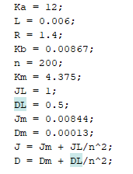
Then we define the Laplace variable as follows:
- We define the armature circuit & motor dynamics T.F as follows:

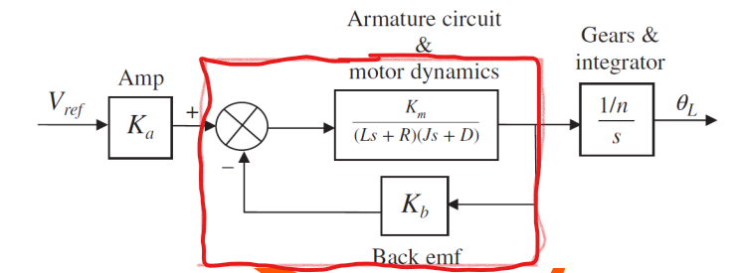

Code:

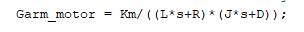

After that we define the whole system open-loop T.F as follows:

And the result of the code is:
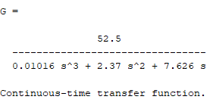
Which is the Open-Loop Transfer Function

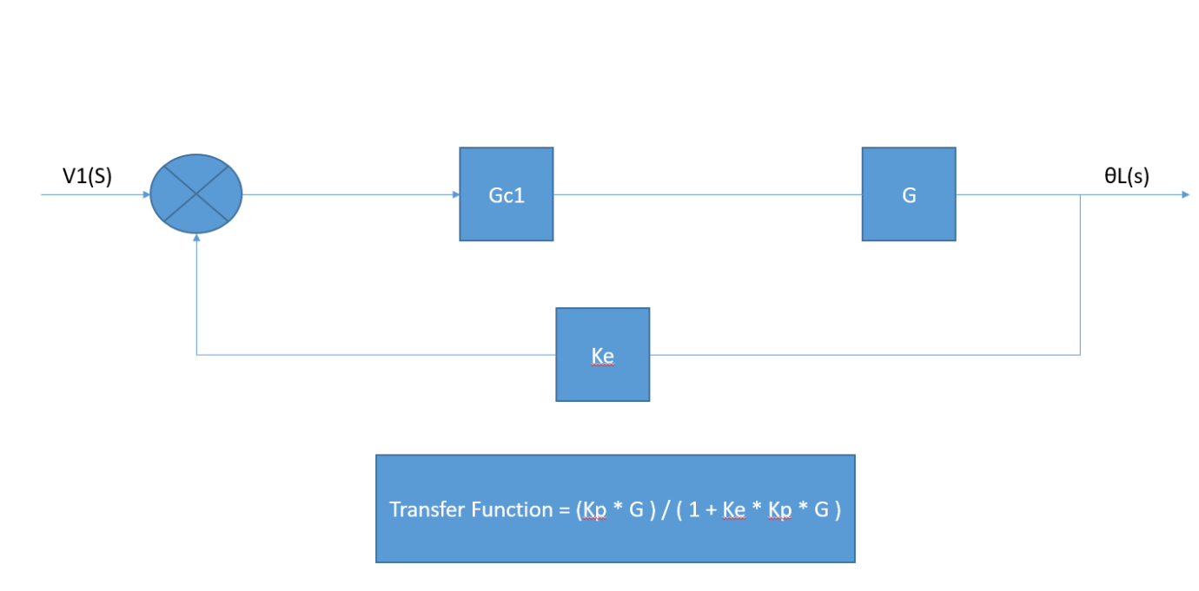

Code
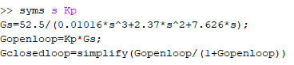

Closed-Loop Transfer Function
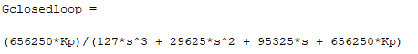

Code
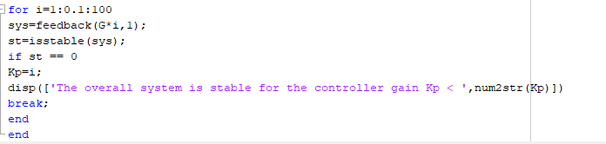

Result

So, System is stable if and only if Kp is less than 33.9

OR

By Using root locus technique

Code
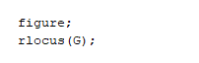
Result
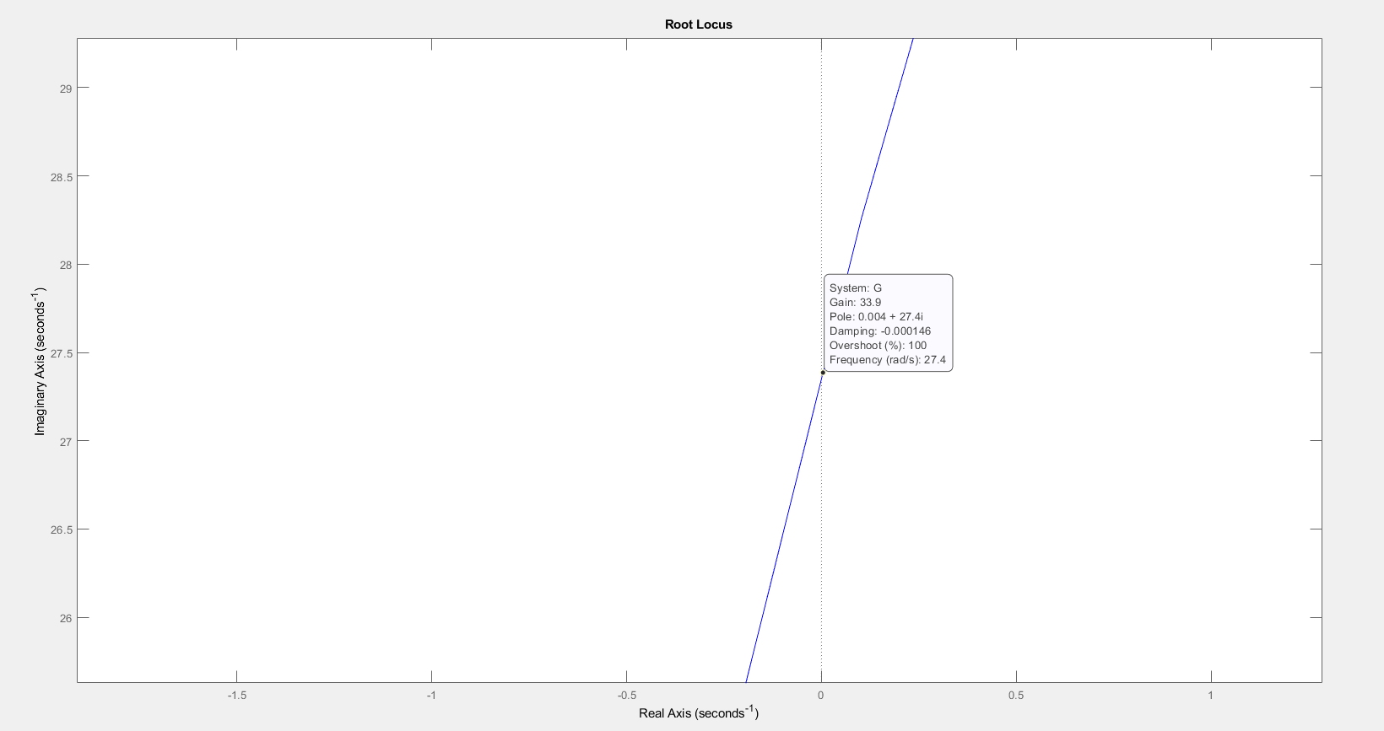

Code

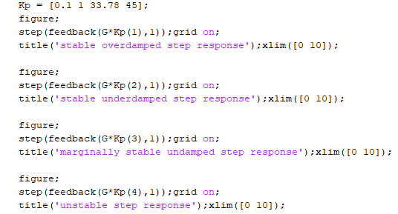

Results

Stable Overdamped step response

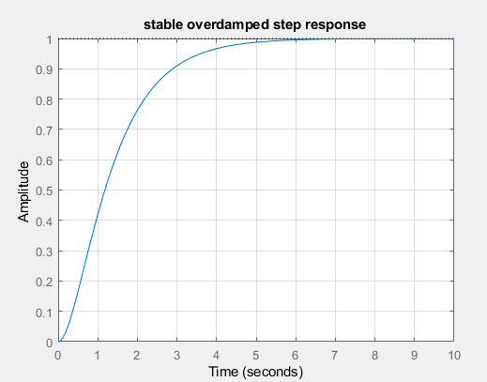

Stable Underdamped step response

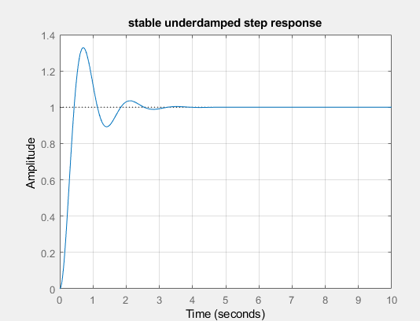

Marginally Stable Undamped step response

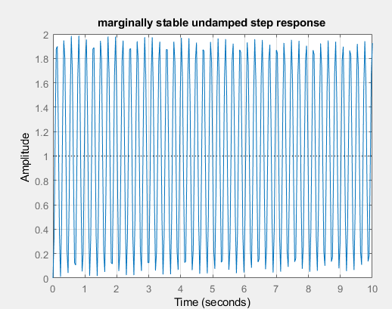
Unstable step response

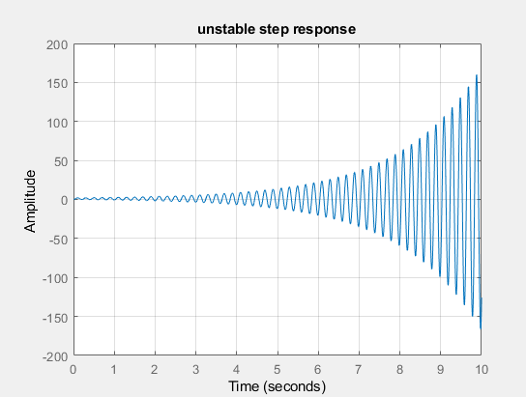

Code
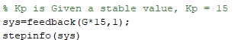

Result
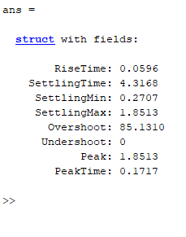

Zero, Look at the stable step response figure!

MATLAB CODE
clc;
close all;
clear all;

% defining the parameters and constants

Ka=12;
L=0.006;
R=1.4;
Kb=0.00867;
n=200;
Km=4.375;
JL=1;
DL=0.5;
Jm=0.00844;
Dm=0.00013;
J=Jm+JL/n^2;
D=Dm+DL/n^2;

% define the laplce variable s
s = tf('s');

% define the armature and motor dynamics transfer function
Garm_motor = Km/((L*s+R)*(J*s+D));

%define the Gears & integrator function
Ggears_integrator = 1/(n*s);

% open-loop transfer function
G = Ka*feedback(Garm_motor,Kb)*Ggears_integrator

% closed-loop transfer function
T = feedback(G,1)

%==========================================================================
% determine the value of Kp for which the system is stable
for i=1:0.1:100
%Calculate the closed loop transfer function for various Kp = i
sys=feedback(G*i,1);
is_stable=isstable(sys); % checks the system is stable or not
if is_stable == 0 % if the system is not stable
Kp=i;
disp(['The overall system is stable for the controller gain Kp < ',num2str(Kp)])
break;
end
end
% OR
% Using root locus technique, on the open loop system
figure;
rlocus(G);

% The step response for four different values of Kp

% stable overdamped
Kp = [0.1 1 33.78 45];
figure;
step(feedback(G*Kp(1),1));grid on;
title('stable overdamped step response');xlim([0 10]);

% stable underdamped
figure;
step(feedback(G*Kp(2),1));grid on;
title('stable underdamped step response');xlim([0 10]);

% marginally stable
figure;
step(feedback(G*Kp(3),1));grid on;
title('marginally stable undamped step response');xlim([0 10]);

% Unstable
figure;
step(feedback(G*Kp(4),1));grid on;
title('unstable step response');xlim([0 10]);

%==========================================================================

% Kp is Given a stable value, Kp = 15
sys=feedback(G*15,1);
stepinfo(sys)

