Assignment: 3 Subject: Data structures and algorithms Total Marks: 30 Last Submission Date: 17 January, 2025

Note:
- Put all your relevant code files along with word file have all of your code in it in a .zip file.
  - Write your Name and registration number in word file.
  - Add screenshots of outputs for each question.
  - Write your Name and registration number in code files and comment them.
- Submission is created, submit .zip file on portal before submission end date.
- Cheating from any source will leads to straight ZERO.

Case Study
An e-commerce company needs an efficient system to manage inventory in its warehouses. The inventory includes millions of products, each identified by a unique product ID. The system should efficiently support:
- Product Lookup: Find a product by its ID to retrieve its details.
- Stock Update: Update stock levels when products are added to or removed from the warehouse.
- Range Queries: Retrieve all products within a certain price or weight range.
- Product Categorization: For quick retrieval, products can be grouped into categories.
Multiple data structures will be implemented and compared for performance and memory usage under various operations to achieve this. The case study involves designing a system using a Binary Search Tree.
Problem:
The system should handle millions of product records efficiently while supporting:
- Insertion of new product data.
- Search for products by ID.
- Range Queries for product prices or weights.
- Categorization and retrieval of products based on groups.
- Finding related products for cross-selling purposes.

INSERTION

DELETION
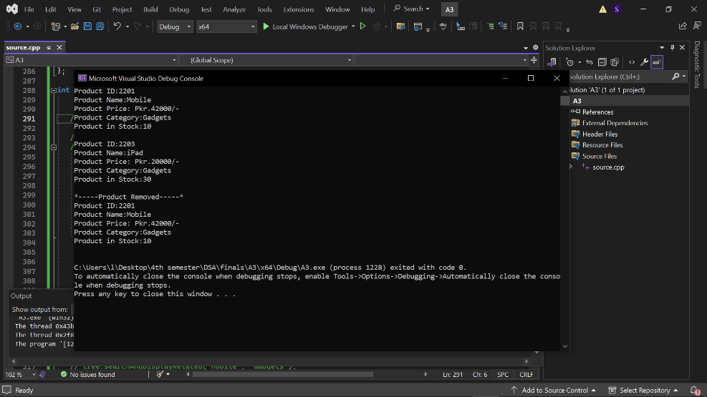

SEARCH
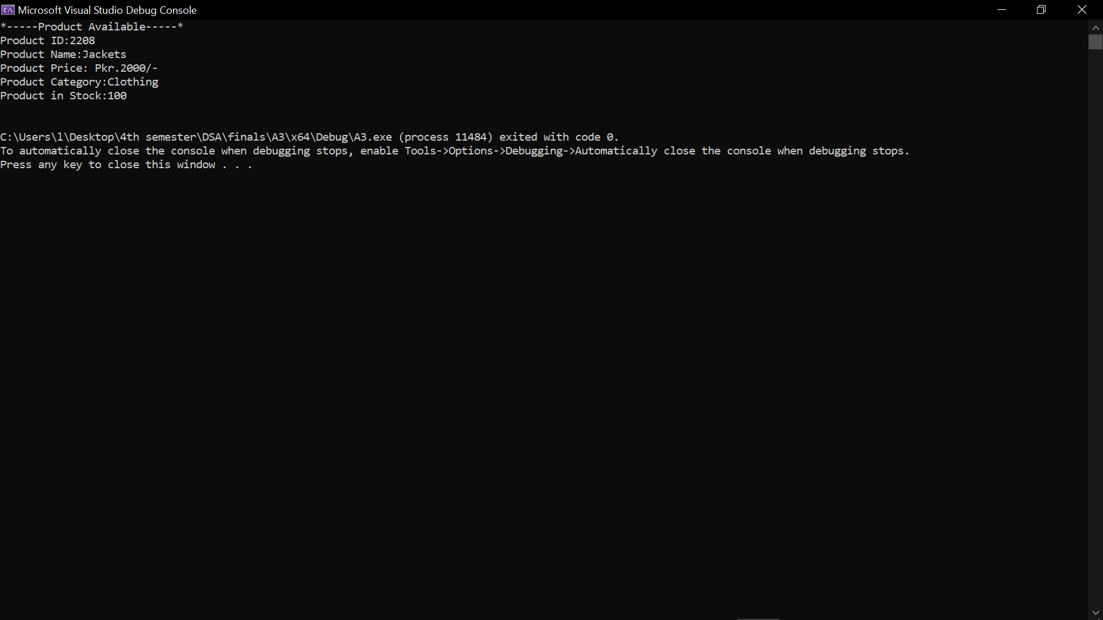

RANGE QUERY
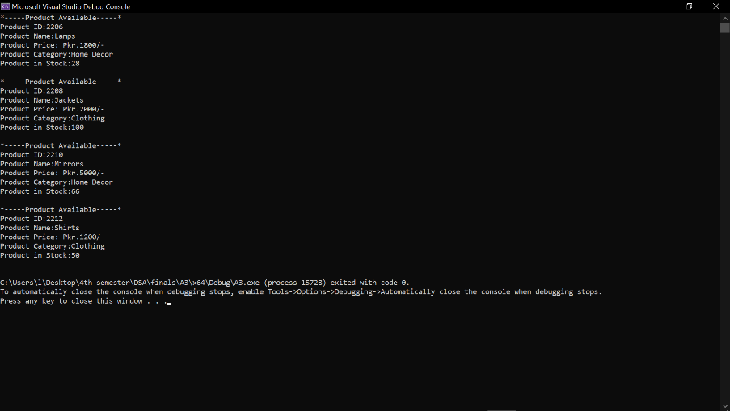
CATEGORY
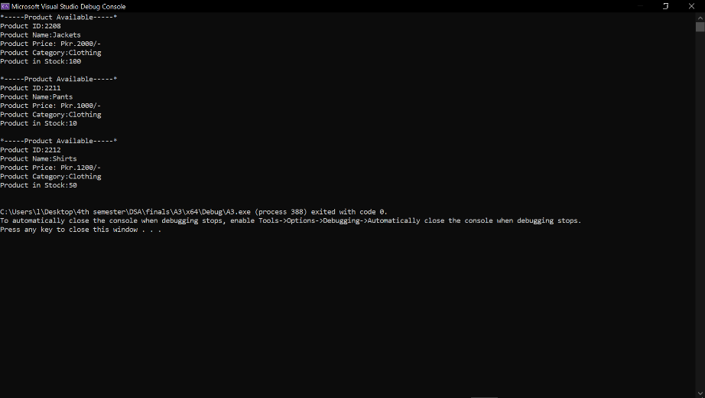
STOCK UPDATION
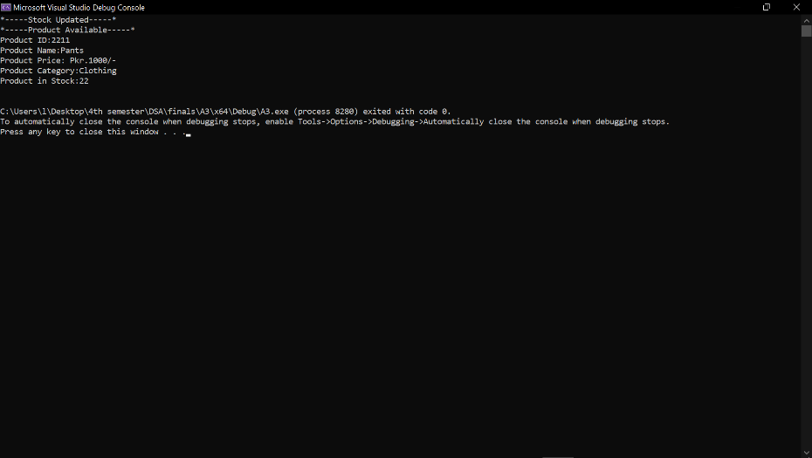

FIND RELATED PRODUCTS
