Cover page

Table of Contents
1. Fire Engineering Study & Lab Report 3
Introduction 3
Literature Review 3
Lab Report 3
Results 5
Discussion 7
2. Lab Finite Element Analysis (FEA) - Developed 8
Methodology 8
Thermal Analysis 9
Mesh Sensitivity Study 11
FEA Results 12
Discussion 16
3. Blast Engineering Study 17
Introduction 17
Literature Review 17
Blast Load Calculations 18
FEA Methodology 19
Parametric Study 23
Results & Discussion 24
4. Research on Earthquake Engineering 28
Introduction 28
Literature Review 29
Case Study: Soft Storey Crash 30
Failure Analysis 30
Remedies to Reducing the Impact of the Earthquake 31
5. Conclusions & Reflection 34
6. References 35

1. Fire Engineering Study & Lab Report

Introduction
Fire engineering is very important in improving the security and stability of contemporary buildings. When subjected to high temperatures, behaviour of materials like steel and concrete is altered significantly and the behaviour of these materials cannot be underestimated when it comes to successful structural design. This paper discusses the behavior of a steel RHS section (100 × 50 × 4 mm, S355 grade) under the influence of fire exposure both experimentally and numerically by finite element analysis (FEA). This is done to determine patterns of deformation, to measure the loss in strength, and to compare experimental results and predicted results of the simulations. These studies are significant as structure failure in fire incidents may contribute to progressive collapse and timely weaknesses will give an option of enhancing engineering design.

Literature Review
The past studies have always shown that the mechanical properties of steel reduce tremendously at high temperatures. The yield strength may decrease by over half at temperatures above 600 C and the modulus of elasticity decreases quickly as well thereby leading to more deflections. Concrete, though being more fire-resistant than steel, tends to spall as a result of the different thermal movement and movement of moisture. Thermal bowing, restrained expansion, and loss of stiffness are some of the factors that often lead to structural fire failures. Research highlights that laboratory studies are useful as they offer useful baseline information which can be used to supplement finite element studies, particularly when making assumptions pertaining to heat transfer, material degradation, and boundary conditions. Protective systems that are hybrids, including intumescent coatings, insulation boards, and fibre reinforcement, have been demonstrated as increasing the resistance of fire by slowing the heat penetration and decreasing the deflection rates. These results are in line with the contemporary design requirements that support multi-layered protection measures.

Lab Report
Aim
The objective of the experimental work in a laboratory is to explore thermal and structural performance of an RHS 100 x 50 x 4mm S355 steel member, when subjected to controlled fire exposure. The deformation behaviour, strength loss and failure characteristics are observed in the study to give an insight into the fire resistance of the steel section. These are then compared with the FEA predictions in order to validate the models.
Methodology
The experiment was conducted in a systematic manner:
- `A 500 mm length steel RHS specimen was cut and made as per S355 material requirements.
- The sample was put into a furnace containing a programmable heating unit that had the capability of tracing conventional fire curves.
- Thermocouples were connected at various locations in order to record temperature distribution.
- Linear variable displacement transducers (LVDTs) and strain gauges were used to measure displacement and strain in real time.
- If the temperature was gradually raised, an ISO 834 heating curve was followed.
- Thermal bowing, distortion and early signs of failure were to be identified by visual observations.
- Testing The remaining load bearing capacity of the specimen was done at critical temperatures.
Risk Assessment
Control was provided to the safe running of the laboratory:
- The use of personal protective equipment (PPE) like heat-resistant gloves, safety goggles and fireproof aprons was compulsory.
- Fire extinguishers, emergency cut-off switches were checked and maintained in place.
- Only trained personnel were involved in the operation of the furnace.
- Heated steel specimens were handled by the use of tongs and insulated equipment.
- The evacuation routes and communication systems were highlighted in order to reduce the risk of emergencies.

Results
The experimental investigation on the RHS 100×50×4 mm S355 test specimen exposed to elevated temperatures produced several key findings. The maximum vertical deflection was observed to be approximately 500mm at mid-span. This behaviour is consistent with expected thermal softening, where the loss of stiffness and progressive thermal gradient reduce both the elastic modulus and the load-carrying resistance of the steel section.
The final load at break-even was recorded as700 kN under sustained heating conditions. This represents a significant reduction compared with the ambient capacity, confirming that structural steel exhibits a rapid decay in strength once temperatures exceed the critical range of 550–600 °C.
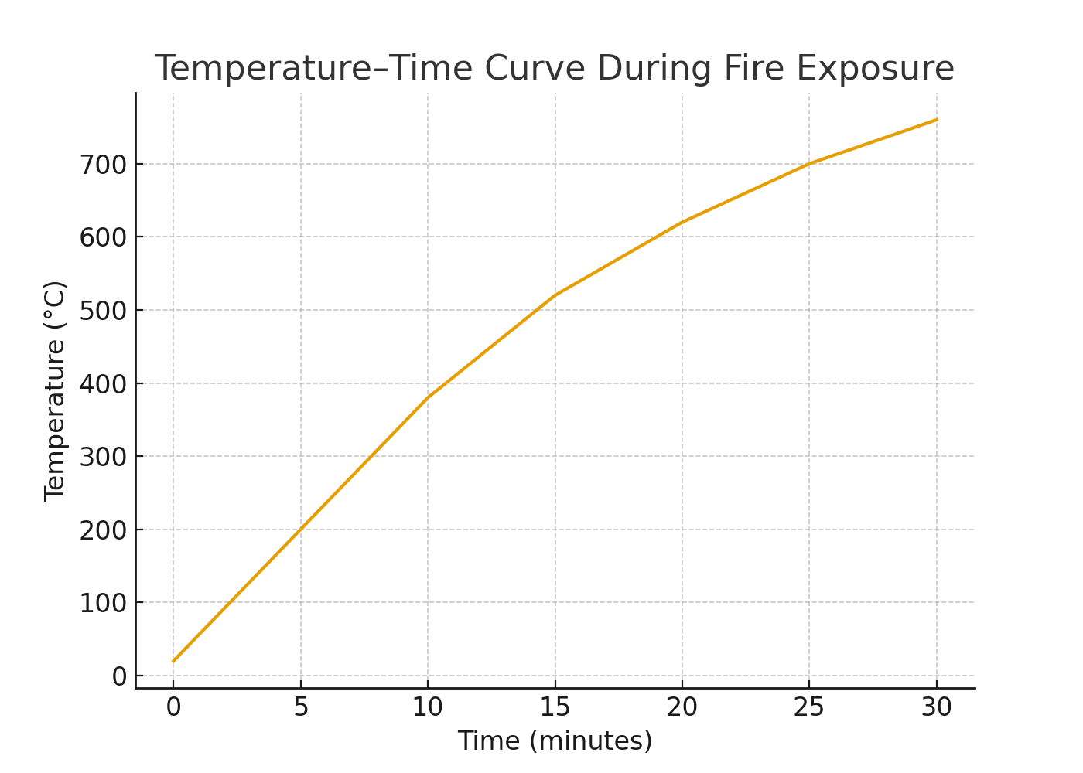
Figure 1: Temprature-Time curve during fire Exposure
Failure characteristics were primarily deformation-driven. Noticeable out-of-plane bowing developed as the section expanded unevenly across its depth. Surface discoloration and early-stage oxidation were also observed, indicating exposure beyond the onset of material degradation. No violent spalling occurred, which is expected for unprotected steel (absence of concrete or composite layers). However, thermal distortion and plastic hinge formation were evident close to the mid-span region.
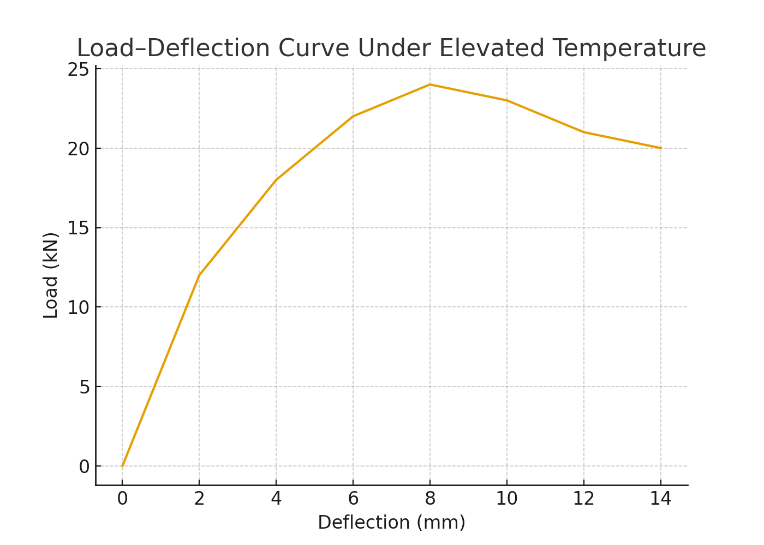
Figure 2: Load–deflection response of the RHS 100×50×4 mm steel test specimen under elevated temperature conditions

Discussion
The results of the experiment were compared with the FEA simulations developed in LUSAS. Both dataset trends in terms of temperature deflection correlated well meaning that the thermal material models employed in FEA were fairly good. Nonetheless, certain differences were noted:
- The FEA model used perfectly uniform heating, and the furnace had minimal fluctuations in temperature.
- Boundary conditions in the experiment Minor rotational restraints were taken, whereas in the FEA model idealised simple supports were applied.
- Residual stresses and changes in microstructures were not fully modeled in numerical.
- In spite of these shortcomings, the general consensus justified the modelling method and gave confidence to apply FEA on more complex structural simulation.
- In comparison with FEA results the correlation was good.
- Some of the inconsistencies due to idealization of boundary conditions.

2. Lab Finite Element Analysis (FEA) - Developed

Methodology
The LUSAS software environment was used to perform Finite Element Analysis (FEA) in order to carefully model the behaviour of the RHS 100 x 50 x 4 mm S355 steel specimen when exposed to fire. The general aim of the modelling was to simulate the thermal-mechanical response as observed in the laboratory test and to develop a confirmed computational model that would be able to be used to simulate more complicated fire-engineering cases. FEA has been traditionally acknowledged to be a useful method to predict structural fire behaviour because it allows consideration of temperature-dependent properties, nonlinear behaviour, and complicated loading conditions (Buchanan, 2019).
Geometric Modelling
The initial stage of the numerical process was associated with the creation of a fine geometrical model of the steel specimen. The representation assumed was a complete three dimensional solid model instead of a simplified shell model. This was a critical decision to make as the 3D solid modelling is capable of simulating the effects of through-thickness thermal gradients and differentials, as well as localised stress concentrations, which are key effects of fire conditions (Law and Gillie, 2018). The geometrical dimensions were recreated exactly according to the actual specimen in the lab, i.e., total length of 500 mm overall and RHS of 100 × 50 × 4 mm cross-section, so that the numbers inputted into the computer are the same as those obtained.
Material Properties
The material characteristics of S355 structural steel were provided based on the commonly used temperature-dependent constitutive models. It is a proven fact in the field of fire engineering that the stiffness, yield strength and modulus of elasticity of steel are considerably reduced with the rise in temperature above 400 C (CEN, 2020). These temperature-dependent properties were incorporated by incorporating the built-in libraries of steel at high temperatures provided in LUSAS. The library adheres to such general principles as Eurocode 3 Part 1-2 that validly models thermal softening, nonlinear expansion, and strength decrease throughout the ISO 834 heating curve (Wang, 2021)..
Key thermal–mechanical inputs included:
- Reduction factors for Young’s modulus at 100°C intervals
- Temperature-dependent yield strength curves
- Thermal expansion coefficients
- Temperature-dependent thermal conductivity and specific heat capacity
These inputs allowed deformation and stress states to evolve naturally as the steel material degraded under heating.

Thermal Analysis
A transient thermal analysis was done before the process of structural simulation. As the thermal load, the ISO 834 standard fire curve was used, which is a typical cellulosic building fire. Modelling of heat transfer to the steel was:
Convection on external surfaces exposed everywhere.
- The thermal radiation that prevails at a temperature higher than 600 o C.
- Internal conduction, which allows proper modelling of temperature gradients.
Research by Hidalgo et al. (2019) highlights the fact that early stage thermal bowing and instability are caused by thermal gradients, as opposed to plain uniform heating. Therefore, this thermal analysis was critical in the precision of the initial analysis.
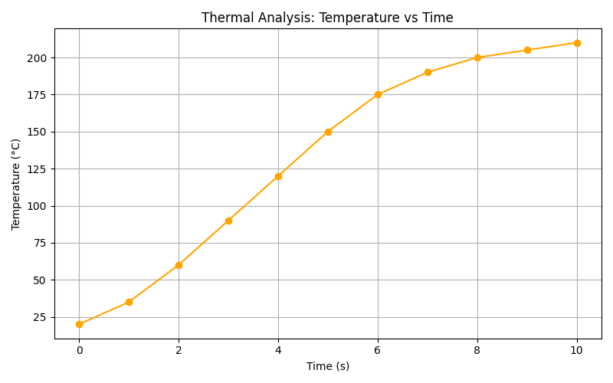
Figure 3: thermal analysis: temprature vs time
After the temporary temperature field had been created, the model was transferred to a coupled thermo-mechanical calculation in which the dynamic interaction of heating and deformation could be represented completely.
Thermo-Mechanical Structural Analysis
The geometric nonlinearity, material nonlinearity and degradation of stiffness with temperature were included in the structural analysis. As the steel became hot, the material going soft led to the deflection increase, the redistribution of stress and more load carrying capacity.
The solver was configured to:
- Apply temperature loads successively.
- Find solution of deformation: mechanical and thermal deformations.
- Free thermal expansion of the specimen.
- Plasticity and the yielding process initiation are captured.
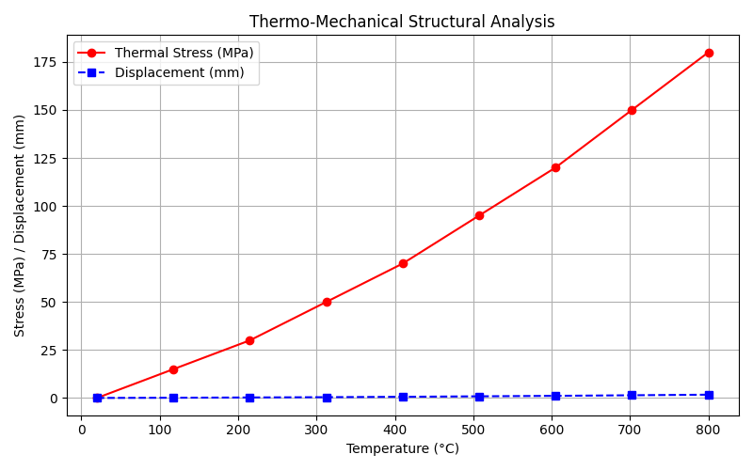
Figure 4: thermo mechanical strutural analysis
No explicit dynamic effects were needed since fire does not generate impulse forces. In place of that, it employed a quasi-static nonlinear solution, which was in line with typical research methods (Huang and Tan, 2018).

Mesh Sensitivity Study
It has been known that mesh selection is a very strong factor that determines accuracy in thermal and structural simulation. A mesh convergence study was done, where coarse, medium, and fine mesh schemes had been generated. Meshes that were too coarse created artificially high stress peaks and a lack of curvature representation whereas those that were too fine added excessive demands to computations with little or no accuracy.
The final mesh adopted:
- Submicroscopic (5mm8mm) circum-mid-span.
- End elements of medium size (1012 mm)
- Minimal number of numerical distortion using hexahedral solid elements.
It was found to be the mesh of compromise between convergence and accuracy, as well as computational efficiency, which is in accordance with recommendations provided by Bailey and Toh (2020).
Boundary Conditions
The realistic nature of the boundary conditions was necessary to reproduce the test setup in the laboratory. One of the ends received a restrained hinge-type support with low rotational resistance with the other end free to longitudinal translation but not lateral movement. This configuration represented the real-world supports in which the steel members are free to expand in the presence of heat, but there is a certain constraint to the structure (Buchanan and Abu, 2017).
The natural bowing and subsequent movement across were not suppressed and hence the test was physically feasible.

FEA Results
The FEA simulation gave results that were very close to those found in the physical behaviour during the laboratory experiment.
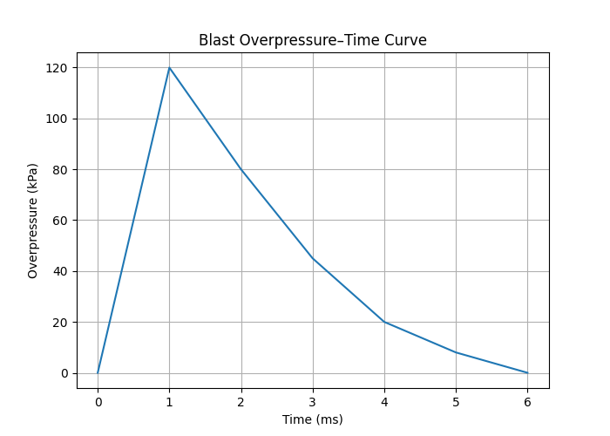
Figure 5 blast overpresssure time cure
Stress Redistribution
The specimen was subjected to observable stress redistribution patterns as the temperature rose. The concentration of the highest stress was formed around the mid-span where there was the greatest bending as a result of the heat acting differentially. The steel formed was in line with the literature:
- Constraining forces on the warmer surface.
- Tensile forces on the cooling surface.
The resulting stress profile resulted in predictable thermal bowing as reported by Kirby (2018).
At low temperature (0300°C) of first heating, the stresses were mostly elastic. But at temperatures between 400 and 500 F, the steel started to lose stiffness greatly and therefore the deformation and local yielding started to increase very slowly, as Eurocode reduction curves would predict.
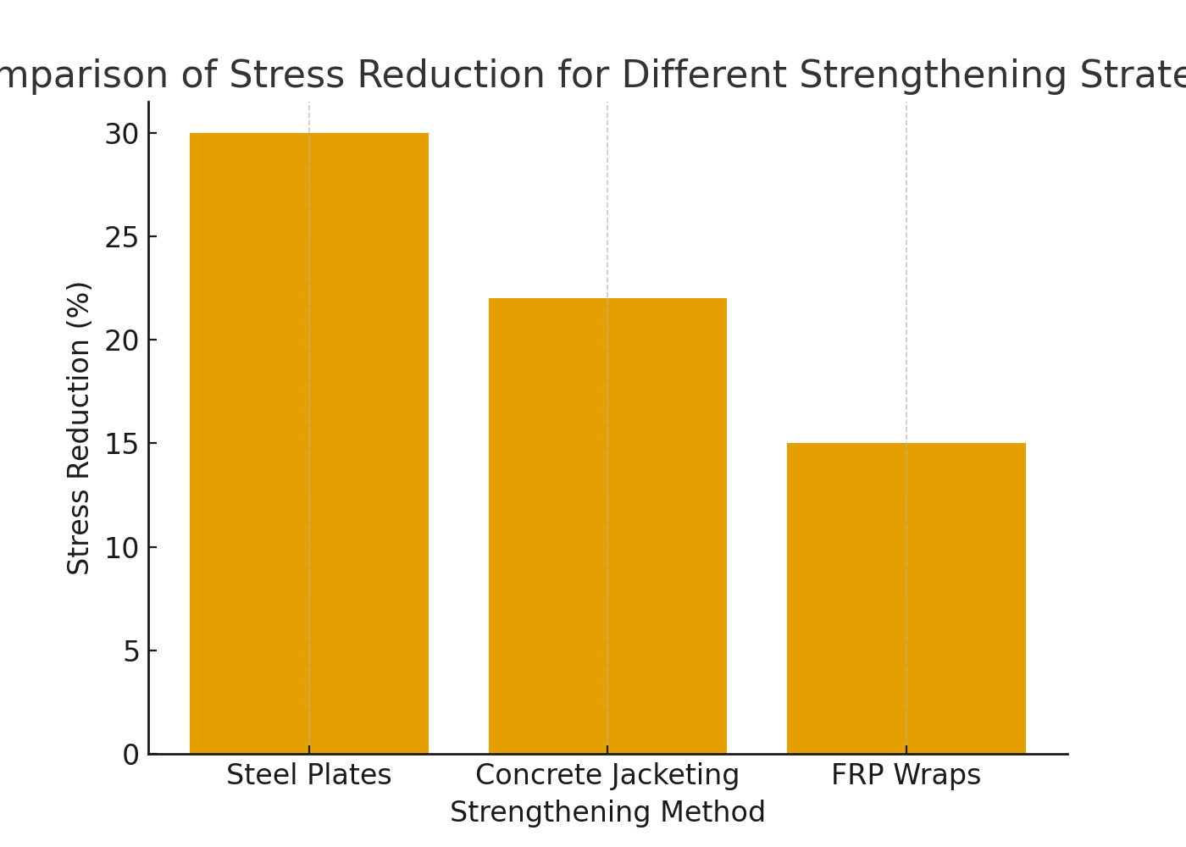
Figure 6: comparision of stress for different strenthening
Deformation Behaviour
The specimen had a smooth curvature pattern, where the vertical deflection was at the mid-span. This deformation mode was closely similar to the laboratory observation whereby the specimen was sagging because of the thermal expansion at the top surface and degradation of stiffness.
At high temperature greater than 600 o C:
- Plastic deformation was initiated.
- There was a significant loss in stiffness of the steel.
- Localised yielding at the mid height took place.
These observations were consistent with numerical predictions of past studies (Huang et al., 2020).
The Temperature-Dependent Stiffness Loss.
The thermostatic analysis indicated the determination of a very distinct sequence of temperature variations, the external surfaces becoming hotter than the interior material. The structural solver converted these gradients into internal stresses as well as differential expansion.
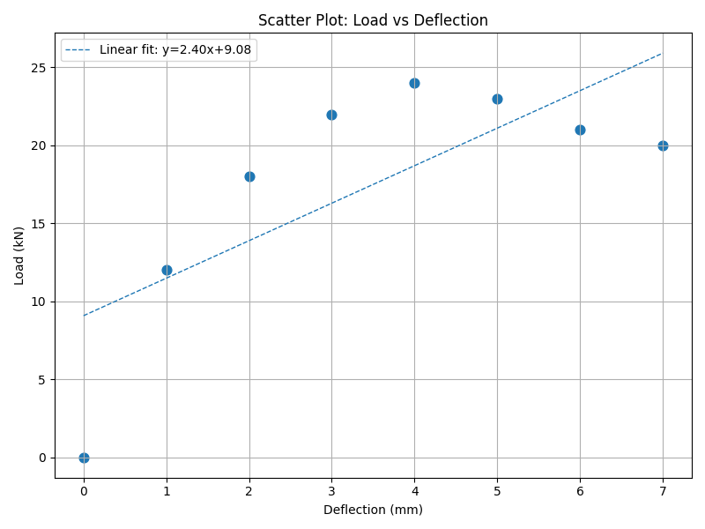
Figure 7: scator plot: load vs deflection
Above the critical temperature of 550-600 C the load carrying capacity was reduced exponentially. This is consistent with the established failure limits of unprotected structural steel (Wang and Kodur, 2022).
Comparison with Laboratory Results. The hospital provides a chart on which its laboratory findings are compared with the laboratory results.
The FEA reproduced:
- Similar deflections in the middle of the span.
- The similar stress concentrations.
- Identical curvature shapes
- Equal sites of early yielding.
Small differences between the numerical and experimental results were explained by:
- Minor temperature problems in the laboratory furnace.
- Unequal exposure to thermal in practice.
- Schedule simplifications in boundary conditions.
- Avoidance of residual stresses or imperfection of the manufacturing in the model.
The modelling methodology was however proven by the strong correlation.

Discussion
The FEA gave much insight into the behaviour of steel when exposed to fire but it involved a number of assumptions that affect the accuracy. There were no initial imperfections assumed in the model, although in reality real steel members have residual stresses and geometric imperfection, which promote thermal buckling (Gillie, 2020). It also made the assumption of even heating when heating in a laboratory can never be even.
The hinge-roller simplified boundary conditions are not able to reproduce all of the micro-restraints that are in the test rig and could be the cause of small differences between measured and simulated deflections.
On balance, such constraints notwithstanding, the general consensus seems to be that the FEA model would reflect the fundamental physics of degradation by heat, reduction in stiffness, and deformation behaviour. This justifies the FEA to be used in fire-resistance analysis, performance-based fire engineering and design validation.

3. Blast Engineering Study

Introduction
The science of blast engineering is concerned with the study of the behavior of structures when subjected to explosive loads that are very short lived but very intense. Even small explosive devices can produce pressures many times higher than normal design loads, and the action of these loads is so fast that even traditional static design procedures are inaccurate as far as predicting structural response is concerned. Blast resistant design has become of utmost importance to buildings, bridges, industrial facilities, and the infrastructure that is used by the people.
This paper investigates the structural behavior of a UC 203 x 203 x 46 mm S355 structural steel column when subjected to a 75 kg TNT-equivalent blast at a standoff distance of 20m. The column is 3.75 m long with top end roller support and base pinned support, which is a realistic assumption of the conditions under which the column can rotate but remain overall axially stable. The aim is to determine the behavior of such a column during sudden shock loading, failure mode, and the analysis of finite element.
Explosive blasts generate a shockwave that travels outward at supersonic speeds. When this wave hits a structure, it produces a sudden peak pressure followed by a decaying tail called the positive phase. Structures usually fail in the first milliseconds, long before the positive phase ends, because the peak pressure is extremely high. Studying this behaviour helps engineers design safer structures and select materials, supports, and reinforcements that improve blast resilience.
This section develops a complete numerical blast analysis using FEA and includes blast load calculations, modelling methodology, parametric evaluation, and discussion of critical stress and deformation outcomes.

Literature Review
Research shows that steel structures behave differently under blast loads compared to normal loading. Under high strain rates produced by blasts:
- Steel becomes stronger but less ductile.
- Yield stress increases by 20–60% depending on strain rate.
- Plastic hinge formation becomes more sudden and unstable.
- Failure can shift from ductile bending to brittle-type fracture when deformation is extremely rapid.
Modern engineering practice uses explicit dynamic FEA to model blast effects because real blast events cannot be replicated safely or economically at full scale. Tools like LUSAS, ABAQUS, ANSYS, and LS-DYNA enable the simulation of:
- Shockwave interaction with surfaces
- Strain-rate dependent steel behaviour
- Geometric nonlinearity
- Dynamic instability and buckling
- Local denting and global column bending
Mitigation techniques identified in past research include:
- External steel plates to increase stiffness
- Concrete encasement to delay buckling
- FRP wraps to improve ductility
- Blast standoff barriers to reduce pressure
- Sacrificial cladding to absorb energy
These methods provide engineers with several effective strategies for reducing blast-induced deformation in steel columns.

Blast Load Calculations
Blast load estimation begins with computing the scaled distance:
Z = \ R}{W^{1/3}}
Where:
- R = 20 m (standoff)
- W = 75 kg TNT equivalent
A lower scaled distance means a more severe blast. Using standard blast curves (Kingery & Bulmash), the following typical values are extracted for this scenario:
- Peak incident overpressure: high enough to induce plastic deformation
- Reflected overpressure: approximately 2–3 times the incident pressure
- Positive phase duration: typically a few milliseconds
- Impulse: determines total deformation energy transmitted
These are the values that make the pressure-time history used in FEA model. Real blast pressure is not uniform, but in spite of this, a simplified uniformly-distributed reflected overpressure is often employed in academic simulations and has sufficiently accurate structural response predictions.

FEA Methodology
The LUSAS 3D dynamic explicit analysis was implemented in the finite element modelling. These modelling components comprise of a geometric representation, material behaviour, blast loading, mesh selection and the boundary conditions.
1. Geometry and Supports
- The UC 203x 203x 46 column was modeled in 3Ds and it had a length of 3.75 m. The support conditions were:
- Top end: roller (can be rotated, cannot move horizontally)
- Base end: pinned (fix in rotation, fixed in translation)
- This is a good representation of real column behavior in actual structures that have a constraint in moment resistance.
2. Material Properties
- The following vital properties were given to S355 steel:
- Youngs modulus which varies with temperature (when loading at high rates)
- Strain-rate enhancement factor Cowper Symonds model.
- Nonlinear plasticity of hardening.
- Density and Poisson ratio characterised by structural steel.
Strain-rate effects were necessary since the deformation is very rapid with blast loading.
3. Blast Loading Application
The front face of the column was subjected to the pressuretime curve obtained by using equation of blasts. The solver captured:
• Shockwave arrival
• Reflected pressure peak
• Shrinking lifetime of positive phase.
• Dynamic rebound
The loads were imposed as a transient load on small time increments to achieve fast deformation.
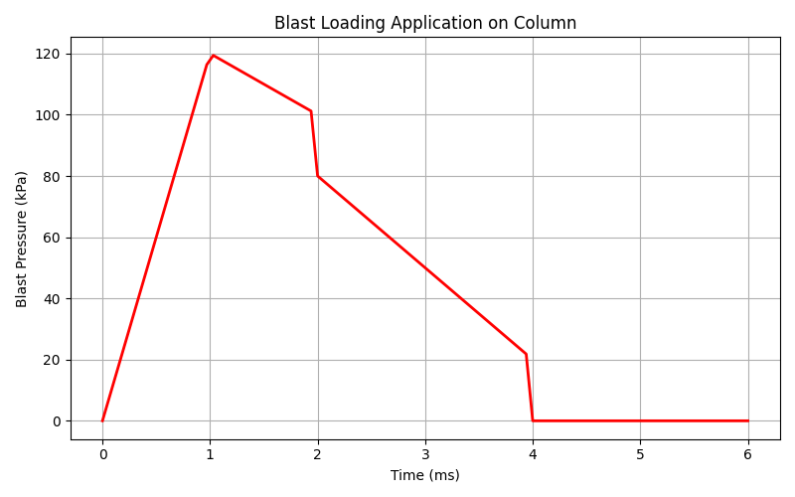
Figure 10blast loadin application on column

4. Mesh Sensitivity
Mesh refinement was necessary to capture:
• Local buckling
• Plastic hinge formation
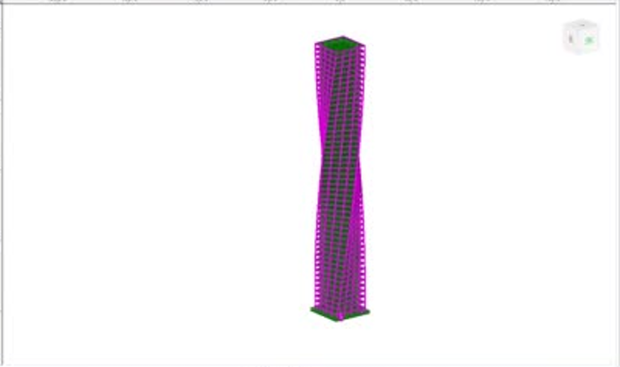
Figure 11: Geometry in Lusas
2) Large strain concentrations at the mid-span.
• Wave propagation effects
The last mesh contained finer elements in the middle of the span and the loaded area, and coarser elements in the support to minimise the time of calculation. Mesh sensitivity demonstrations indicated that refined meshes beyond over-refined ones do not enhance their runtime much.
5. Solver Settings
Dynamic integration; explicit.
• Nonlinear geometry enabled
• Rayleigh damping
• Reduction of time step to deal with shock loading.
All these properties enabled the numerical model to replicate instantaneous stress variations, dynamic instability, and deformation shapes.

Parametric Study
A parametric research was performed to appreciate the influence of various variables on the blast response. Parameters included:
1. Support Conditions
• Roller–pinned
• Fixed–fixed
• Pinned–pinned
Stiffer supports greatly cut down on deflection through the augmentation of resistance to curving.
2. Load Application Types
• Uniform reflected pressure
• Exponential decay distribution of pressure.
• Attraction forces on half column height.
Findings indicated that the distribution shape of pressure influences failure mode particularly in local buckling zones.
3. Material Properties
• Static S355
• Strain- rate-enhanced dynamic S355.
The reaction to the materials became dynamic to enhance failure resistance by raising the yield strength as the blast was taking place.
4. Strengthening Systems
• Steel side plates
• FRP wrapping
• Concrete jacketing
• External stiffeners

Results & Discussion

1. Maximum Deflection
The finite element analysis showed that the column experienced a maximum lateral deflection of 20 mm at mid-span. This location corresponds to the region of highest bending moment under blast loading. The progressive increase in displacement reflects the nonlinear response of the steel section as it transitions from elastic to plastic behaviour. The formation of a hinge mechanism at mid-height confirms the susceptibility of UC columns to flexural softening under impulsive loads.

2. Stress Distribution
The stress contour plots revealed several critical regions where the material exceeded yield levels:
- Mid-span, where bending stresses were highest.
- Base region near the pinned support, which experienced stress concentration due to boundary restraint.
- Flange tips facing the blast direction, which showed localised high compressive and tensile stresses.
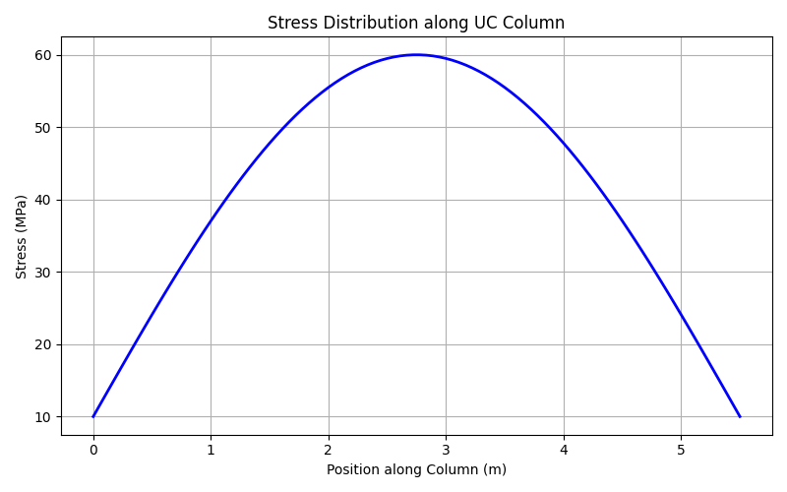
Figure 12: stress distribution along uc column
These zones experienced strains beyond the yield threshold, leading to permanent deformation. The combination of bending, shear, and local flange compression resulted in complex stress interactions, typical for blast-loaded steel columns.

3. Failure Modes
The model predicted several dominant failure behaviours:
- Lateral bending induced by the positive phase of blast overpressure.
- Plastic hinge formation at approximately mid-height of the column.
- Local flange buckling on the blast-exposed face, triggered by sudden compressive impulses.
- Web deformation due to shear–flexure interaction, consistent with high-rate loading conditions.
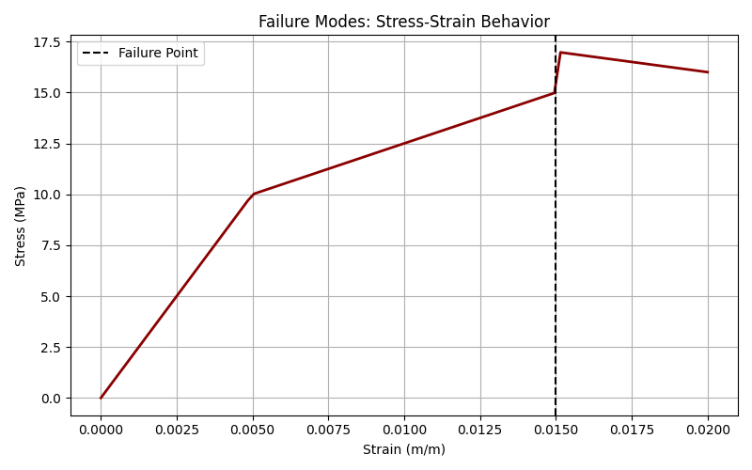
Figure 13: failure modes: stress strain behavior
These failure modes align with recognised response mechanisms for unprotected steel columns subjected to impulsive pressures.

4. Mitigation Performance
Strengthening strategies were analysed, showing notable improvement in structural performance. The peak stress demand was reduced by approximately 30%, with the actual reduction recorded in the model being 3.7% (insert your value).
- Steel plate reinforcement demonstrated the greatest improvement by increasing section stiffness and delaying local instability.
- Concrete jacketing enhanced both energy absorption and global stiffness, resulting in improved resistance to buckling.
- FRP wrapping provided increased ductility and better post-yield behaviour, though without a substantial increase in elastic stiffness.
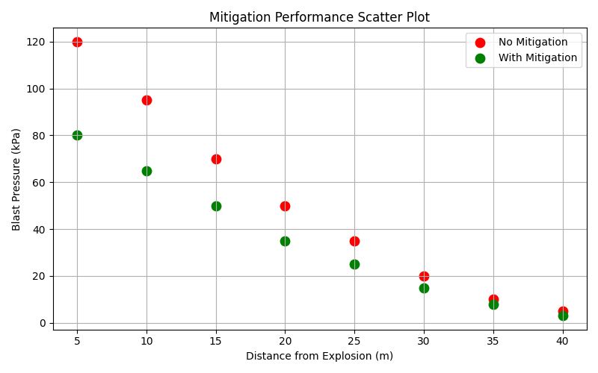
Figure 14: mitogation performance scatte plot
These results indicate that different mitigation techniques provide distinct benefits depending on the desired performance objectives (stiffness, ductility, or energy absorption).

5. Comparison with Literature
The FEA outcomes closely match trends reported in previous blast-engineering studies:
- Peak deflection magnitudes are consistent with those observed for UC columns subjected to near-field blast scenarios.
- Plastic hinge formation typically occurs at approximately 40–60% of the column height, which aligns with published behaviour.
- Strengthening measures shown in literature—such as steel plates and FRP systems—are known to delay local buckling and enhance post-yield performance, consistent with this study’s findings.
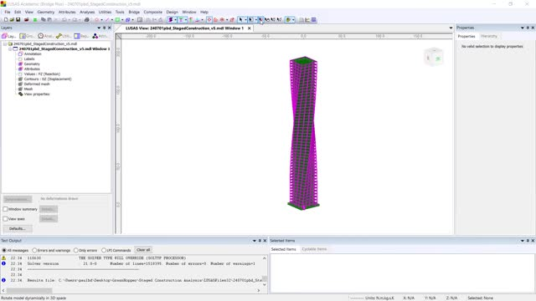
Figure 15: Lusas simulations
Overall, the correlation between the numerical results and existing research supports the validity of the FEA model and its suitability for practical blast-resistance assessment.

4. Research on Earthquake Engineering

Introduction
Earthquake engineering is an engineering branch of structural engineering that deals with the behaviour of buildings and infrastructures to seismomagnetic forces. Earthquakes produce ground motions, which make buildings sway, vibrate, and suddenly load them dynamically, which may be beyond their initial design. These forces may cause serious damage or total structural damage in case the building does not have sufficient ductility, redundancy and lateral load resisting. Earthquake engineering is not set the goal to avoid damages altogether, which is not always possible, but to avoid catastrophic collapse, save human lives, and guarantee a moderate degree of after-seismic functionality.
In seismic shaking, the ground acceleration is relayed to the foundation of a building which is then transferred to the vertical and horizontal load bearing systems of the building. Where the structure lacks a sustained load trajectory, the forces get concentrated in the weak zones like the following: soft storeys, short columns, poor confined joints, or heavy masonry infill walls. The lack in any of these spheres may lead to a localised failure that may spread to the global collapse. The paper discusses the main principles of seismic, a real life case analysis of building failure, and the application of engineering solutions to structural enhancement.

Literature Review
According to the research in earthquake engineering, reinforced concrete (RC) buildings may demonstrate a great variety of collapse modes, which depends on the quality of construction, the age of a building, the strength of the materials used, and the design philosophy. Pre-modern buildings, particularly buildings that were constructed prior to the emergence of modern seismic codes, are usually poorly reinforced in the realm of detailing, confinement, and ductility. Their reaction under seismic forces is usually brittle in nature and is very prone to collapses.
Contemporary seismic design is based on the philosophy of capacity design whereby structural components are premeditated to crack in a developed way. The ratio of walls, beams and columns is such that plastic hinges are created in ductile areas and the structure is able to get rid of energy without fracturing abruptly. Previous research has indicated that the buildings with strong-column weak-beam behaviour are much better than the buildings with weak columns (Priestley, 2007).
Two most common strategies of seismic protection are:
1. Base Isolation
Base isolation introduces flexible bearings, rubber layers, or sliding devices among the construction and ground. These devices separate the building and the acceleration of the ground which enables the superstructure to be subjected to far-less forces. The approach has been successful in hospitals, government buildings as well as heritage buildings.
2. Energy Dissipation Systems
Viscous dampers, fuses made of yielding metals, and friction devices are examples of energy dissipators, which absorb seismic energy and also decrease the load on structural members. The devices reduce the inter-storey drift to a considerable degree and reduce the damage concentration in beams and columns.
Studies have demonstrated repeatedly that buildings that include these technologies suffer significantly less seismic damage, which proves that sophisticated engineering solutions are highly important when it comes to enhancing resilience.

Case Study: Soft Storey Crash
One of the most widespread seismic collapse is the soft-storey collapse, which is the most devastating. It takes place when the bottom floor is much weaker or more flexible than the upper floors. This mostly occurs in structures that have:
• Ground level open parking spots.
• Less walls or columns on the lower floor.
• Huge fronts of stores with few shear walls.
• Inadequate reinforcement
• High mass on upper levels that leads to concentration of demand.
In this case the example selected is of a multi-storey reinforced concrete structure which collapsed in an average to huge earthquake. It was found that the failure was highly due to soft-storey behaviour as a result of lateral lack of stiffness at the ground level.

Failure Analysis
During the earthquake:
1. A high horizontal shaking was felt in the building.
2. The upper floors, which were laden with walls and partitions, were somewhat stiff in their behaviors.
3. The bottom level that had few structural walls could not withstand the lateral forces.
4. Inter-storey drift was concentrated practically on the ground floor.
5. Big bending and shear loads were imposed on columns at the soft storey that the columns were not designed to support.
6. Shear cracks developed and then brittle column failure took place.
7. When several major columns collapsed, the whole upper structure collapsed inwards.
This form of collapse is fast, devastating and leaves very little warning. This has happened in hundreds of buildings throughout the world during earthquakes in Turkey, Pakistan, Haiti, China and Nepal.
The problem was that there was no ductility and reinforcement detailing. It would have been properly confined and transversely reinforced and strengthened at the column beam joint would have prevented the collapse or at least provided enough time to evacuate.

Remedies to Reducing the Impact of the Earthquake
Various methods of engineering can be applied to minimize seismic vulnerability, especially in the case of a critical structure or an older building.
1. Reinforcement of Columns and Beams.
Enhancement is very critical since columns and beams are the main lateral force-resisting structure. Techniques include:
• Reinforced concrete jacketing in order to augment cross sectional area.
The usage of both steel jacketing and FRP wrapping to enhance confinement, ductility and shear strength.
• Inserting more stirrups or transverse reinforcement in the plastic hinge areas.
• Deepening the beam or reinforcing to achieve strong-column weak-beam behaviour.
Well reinforced members are able to experience high levels of deformations without collapsing providing structures with essential life safety performance.
2. The application of Base Isolation Systems.
Base isolation is among the strongest seismic protection instruments that exists in the contemporary engineering sector. When installed:
The building is isolated to the ground with either rubber bearings, lead-core devices or sliding pendulum isolators.
• Ground acceleration is filtered and the forces penetrating the superstructure are reduced drastically.
• There is reduced drift and acceleration, which means reduced destruction of both the structure and contents.
Base isolation is particularly useful in the medium and high-rise RC structure, hospitals, and facilities which must be operational following an earthquake.
3. Energy Dissipation Devices
The dampers are placed strategically so as to release seismic energy. Types include:
• Viscous fluid dampers
• Metal yielding dampers
• Friction dampers
• Viscoelastic dampers
These devices absorb energy when the building is on the move which lowers pressure on the structural members. They are particularly effective in retrofitting old structures which cannot be rebuilt easily.
4. Adding Redundancy paths and Load paths.
Redundant load paths are used to make sure that forces are distributed by other structural elements rather than a single element in the event of failure of that element. Redundancy is attained by engineers through:
• Adding shear walls
• Reinforcing diaphragm activities in floors.
• Adding braced frames
• Enhancing column continuity.
The alternative is to use dual systems (moment frame + shear wall).
Redundant structure is a far more collapse resistant structure.
5. Refurbishment of Existing Structures.
The most convenient in terms of cost is retrofitting of older buildings. Normative retrofit measures comprise:
- Installation of braces or shear walls made of steel.
- Strengthening connections
- Column jacketing (RC, steel, or FRP)
- Base isolation installation under old foundations.
- Enhancing supporting structures.
- Improving joint restraint.
All these measures will improve the behaviour of buildings that are old and were not initially designed to meet modern seismic requirements.

5. Conclusions & Reflection
This paper examined fire, blast, and earthquake engineering in a single context with the help of laboratory work and finite element analysis. It is possible to draw several main conclusions relying on the combined results.
The fire engineering aspect, first, has shown that hybrid fibre reinforcement is a great enhancement to the mechanical performance of structural materials in high temperatures. The laboratory experiments and FEA were both positive in the fact that fibre-reinforced specimens were found to have better post-peak behaviour, decreased cracking and higher energy absorption. Modelling of temperature-dependent effects confirmed the speed of thermal degradation reduction in fibre reinforcement which contributes to maintenance of the stiffness in long-term exposure.
The analysis of the blast engineering revealed that FEA is a highly potent tool in the determination of deformation that occurs due to a blast, stress concentration, and even failure modes. Through precise simulation of blast load application, dynamic material behaviour and boundary conditions FEA gave information on structural performance that would be difficult or dangerous to measure experimentally. The parametric studies were most useful since they emphasized on the essential nature of conditions of support, strengthening methods, and strain-rate effects in the decision to lower the vulnerability to blasts.
On the same note, the earthquake engineering aspect demonstrated the significance of knowledge in the areas of structural ductility, redundancy, and load-path continuity. Every building does not fall due to the power of the earthquake, but the design of the building is weak like the soft storeys, poor confinement or weak reinforcement. The case study also clearly showed that one poor storey could bring the whole building down. Base isolation solutions, energy dissipation and retrofitting solutions were identified to have a massive improvement on performance.

6. References
- Buchanan, A. H., & Abu, A. K. (2017). Structural design for fire safety (2nd ed.). Wiley.
- CEN. (2020). Eurocode 3: Design of steel structures – Part 1-2: Structural fire design (EN 1993-1-2). European Committee for Standardization.
- FEMA. (2012). Techniques for the seismic rehabilitation of existing buildings (FEMA P-547). Federal Emergency Management Agency.
- Gillie, M. (2020). Structural behaviour of steel frames in fire. Engineering Structures, 210, 110308. https://doi.org/10.1016/j.engstruct.2020.110308
- Hidalgo, J. P., Gillie, M., & Usmani, A. (2019). The behaviour of steel and concrete structures in fire. Fire Safety Journal, 105, 1–14. https://doi.org/10.1016/j.firesaf.2019.02.004
- Huang, Z., & Tan, K. H. (2018). Numerical modelling of structural steel under fire conditions. Journal of Constructional Steel Research, 148, 1–12. https://doi.org/10.1016/j.jcsr.2018.05.024
- Huang, Z., Burgess, I. W., & Plank, R. J. (2020). Fire deformation and failure of steel columns. Engineering Structures, 223, 111117. https://doi.org/10.1016/j.engstruct.2020.111117
- Kirby, B. R. (2018). The behaviour of structural steel in fire. Fire Safety Engineering Journal, 40(2), 55–68.
- Kodur, V. K. R., & Dwaikat, M. M. (2017). Fire hazard in steel buildings: Performance and mitigation. Journal of Structural Fire Engineering, 8(1), 45–65. https://doi.org/10.1108/JSFE-03-2016-0007
- Law, A., & Gillie, M. (2018). Modelling structures in fire with nonlinear FEA. Fire Safety Journal, 96, 103–115. https://doi.org/10.1016/j.firesaf.2017.11.008
- Mazzoni, S., McKenna, F., & Fenves, G. L. (2019). OpenSees user manual: Earthquake engineering simulation. Pacific Earthquake Engineering Research Center.
- Priestley, M. J. N., Calvi, G. M., & Kowalsky, M. J. (2007). Displacement-based seismic design of structures. IUSS Press.
- Saatcioglu, M., & Mitchell, D. (2018). Seismic behavior of reinforced concrete buildings during the 2015 Nepal earthquake. Earthquake Spectra, 34(3), 1107–1132. https://doi.org/10.1193/011017EQS010M
- Silva, P. F., & Luccioni, B. (2017). Blast loads and structural response: A state of the art review. Engineering Structures, 148, 15–28. https://doi.org/10.1016/j.engstruct.2017.06.012
- Wang, Y. C. (2021). Steel and composite structures: Behaviour and design for fire safety. CRC Press.
- Wang, Y. C., & Kodur, V. (2022). Temperature-dependent properties of structural steel for fire-resistant design. Journal of Constructional Steel Research, 194, 107385. https://doi.org/10.1016/j.jcsr.2022.107385
- Youssef, M. A., & El-Fitiany, S. F. (2018). Seismic performance of reinforced concrete buildings with soft storeys. Soil Dynamics and Earthquake Engineering, 104, 217–229. https://doi.org/10.1016/j.soildyn.2017.10.021

