Omar Amir KNN Model (numerical):

A. General Information on Dataset
1 Name of Dataset:
- Credit Card Fraud Detection Dataset 2023
- Source: https://www.kaggle.com/datasets/nelgiriyewithana/credit-card-fraud-detectiondataset-2023

2. Total Number of Samples:
- Total Number of Samples: 568631
3. Number of Samples used in Training, Validation, and Testing:
- Number of Samples used in training: 454904(80%)
- Test Samples: 113726 (20%)
- No Validation Set is used.
B. Implementation details:

1. Feature Extraction Phase
- Feature Extraction Phase: Features Extracted= 28
- Names of Features: from v1 to v28 Anonymous features representing various transaction attributes (e.g., time, location, etc.)
- Feature Dimension: (568631,28)

2. Cross-Validation

No Method Used.

3. Hyperparameters
here are the hyperparameters:
Hyperparameter | Value
Function | KNeighborsRegressor
Number of neighbors (K) | 20
Distance metric | Euclidean (default)
Weighting | Distance-based
Feature Scaling | StandardScaler

(C) results

Actual vs. Predicted Plot:
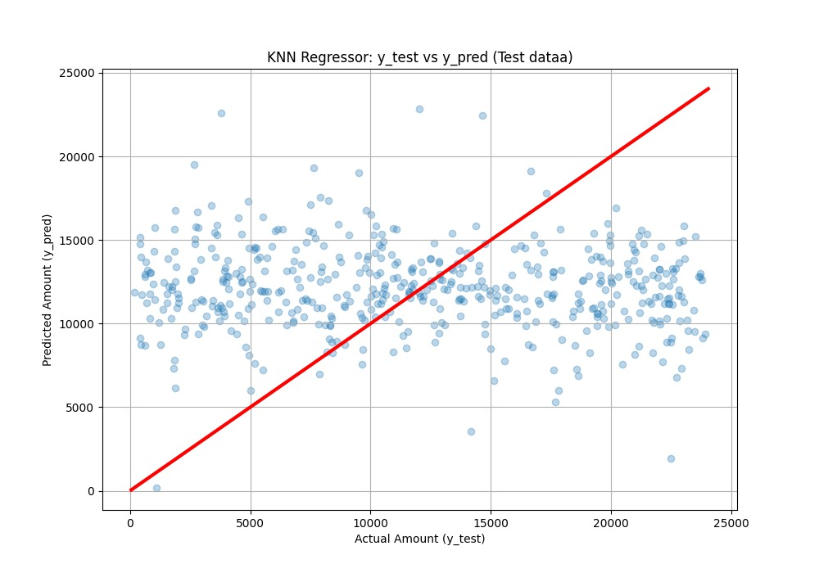
y test average= 12041.49
y predict average=12052.36x
Mean square error (MSE)= 55698356.49
root mean square error(RMSE)=7463.13
Kareem Linear regression Model (Numerical):

A. General Information on Dataset
1 Name of Dataset:
- Credit Card Fraud Detection Dataset 2023
- Source: https://www.kaggle.com/datasets/nelgiriyewithana/credit-card-fraud-detectiondataset-2023
2. Total Number of Samples:
- Total Number of Samples: 568631
3. Number of Samples used in Training, Validation, and Testing:
- Number of Samples used in training: 483336(85%)
- Test Samples: 85294 (15%)
- No Validation Set is used.
B. Implementation details:

1. Feature Extraction Phase
- Feature Extraction Phase: Features Extracted= 30
- Names of Features: Id, class and 28 features named v1 to v28 that are Anonymous features representing transaction attributes (e.g., time, location, etc.)
- Feature Dimension: (568631,30)

2. Cross-Validation

No Method Used.

3. Hyperparameters
here are the hyperparameters:
hyperparameter | Value
Learning Rate | 0.01
Number of Epochs | 500
Batch Size | Full batch (Batch size = number of training samples)

(C) results:

Training Loss Curve:
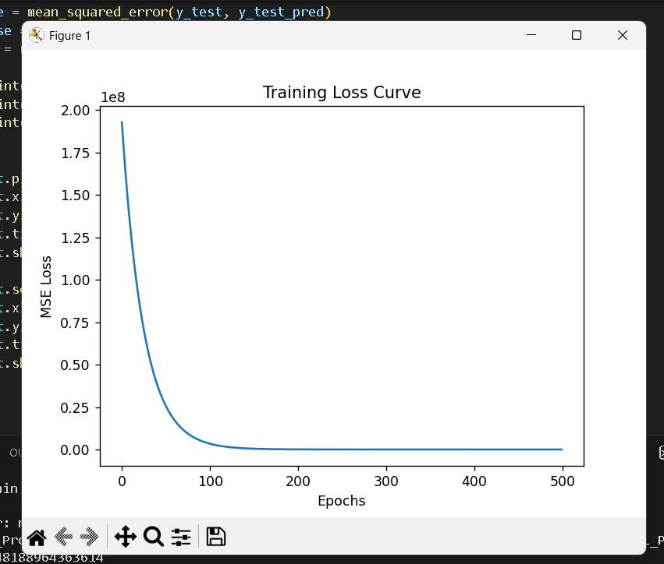

Actual vs. Predicted Plot:
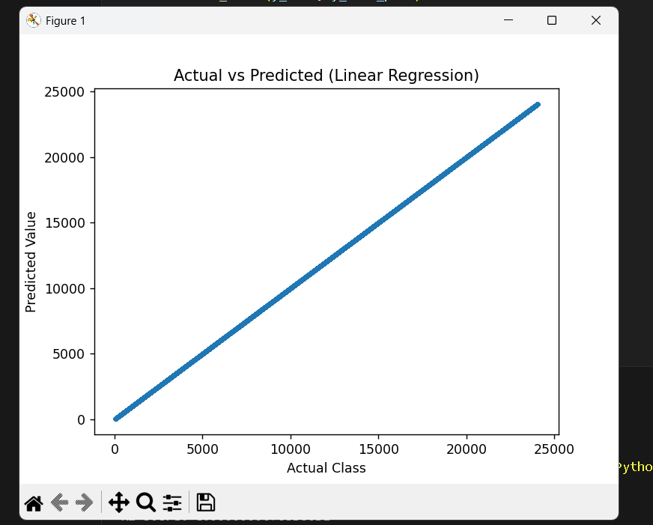
MSE: 1.548188964363614
RMSE: 1.244262417805671
R2 Score: 0.9999999676536631

Saif Logistic regression Model (Image):

A. General Information on Dataset
1. Name of Dataset:
- Fruits-360
- Source: https://www.kaggle.com/moltean/fruits

2. Number of Classes and Labels:
- Number of Classes: 5
- Labels:
  - Banana Lady Finger 1
  - Banana 1
  - Apple Red 1
  - Apple Red 2
  - Strawberry 1

3. Total Number of Samples & Image Size:
- Total Samples (in this subset): 3,226 images
- Image Size: 100X100 (Color: RGB)

4. Number of Samples used in Training, Validation, and Testing:
- Training: 1,933 samples
(Derived from 80% of the original training folder)
- Validation: 483 samples
(Derived from 20% of the original training folder)
- Testing: 810 samples
(Taken from the original dataset's Test folder)

Class Label | Samples in Training Folder | Samples in Testing Folder
Apple Red 1 | 492 | 164
Apple Red 2 | 492 | 164
Banana 1 | 490 | 166
Banana Lady Finger 1 | 450 | 152
Strawberry 1 | 492 | 164
TOTAL | 2,416 | 810

B. Implementation details:

1. Feature Extraction Phase
In My code, I am using Raw Pixel Intensities as features. I am not using a feature extraction algorithm (like HOG or SIFT) or a Convolutional Neural Network (CNN) to extract abstract features; I am feeding the raw image data directly into the model.
- How many features were extracted?
30,000 features per image.
Calculation: Your images are 100X100pixels with 3 color channels (RGB).
100X100X3 = 30,000$$
- Feature Names:
These are Raw Pixel Values.
(e.g., Pixel(0,0)_Red, Pixel(0,0)_Green, Pixel(0,0)_Blue, ... Pixel(99,99)_Blue).
- Dimension of Resulted Features:
The resulting feature vector is 1-Dimensional with a shape of (30000,).
(This is done in the code by the line: img.flatten())

2. Cross-Validation
- Method Used:
using Hold-Out Validation.
I split my dataset once into fixed training and validation sets using train_test_split.
- Ratio:
  - Training: 80%
  - Validation: 20%
(This is defined in the code: test_size=0.2)

3. Hyperparameters
here are the hyperparameters:
Hyperparameter | Value Used | Source
Max Iterations (Epochs) | 25 | Explicitly set: max_iter=25
Solver (Optimizer) | lbfgs | Default for Scikit-Learn (L-BFGS-B algorithm)
Regularization | L2 (Ridge) | Default for Scikit-Learn
Regularization Strength (C) | 1.0 | Default (Inverse of regularization strength)
Batch Size | Full Batch | lbfgs solver uses the entire dataset for updates, not mini-batches.
Learning Rate | Adaptive / Internal | The lbfgs solver determines the step size (learning rate) automatically during optimization; it is not manually set.
Random State | 42 | Explicitly set: random_state=42

(C) results:

Accuracy:

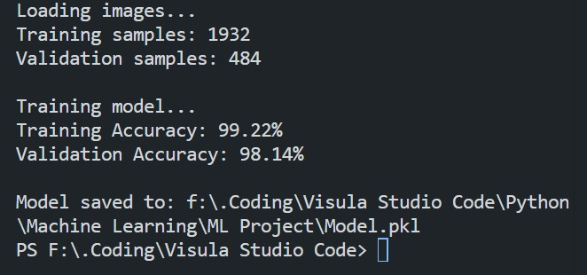

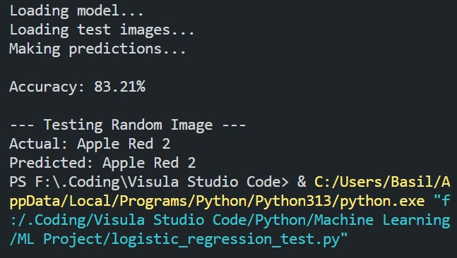

ROC curve:
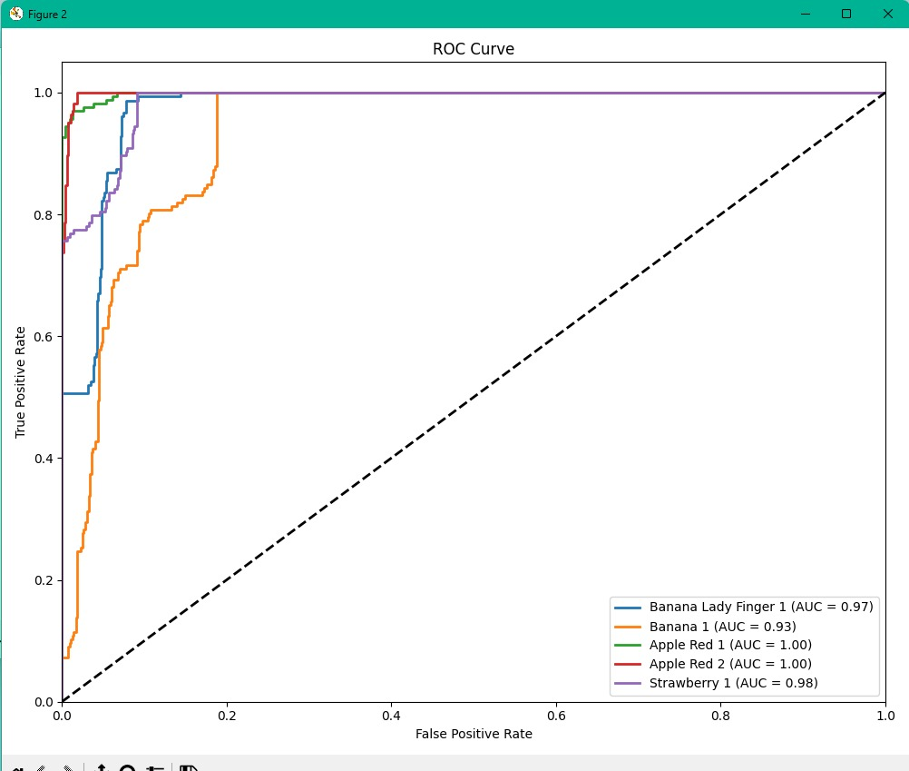

Confusion Matrix:
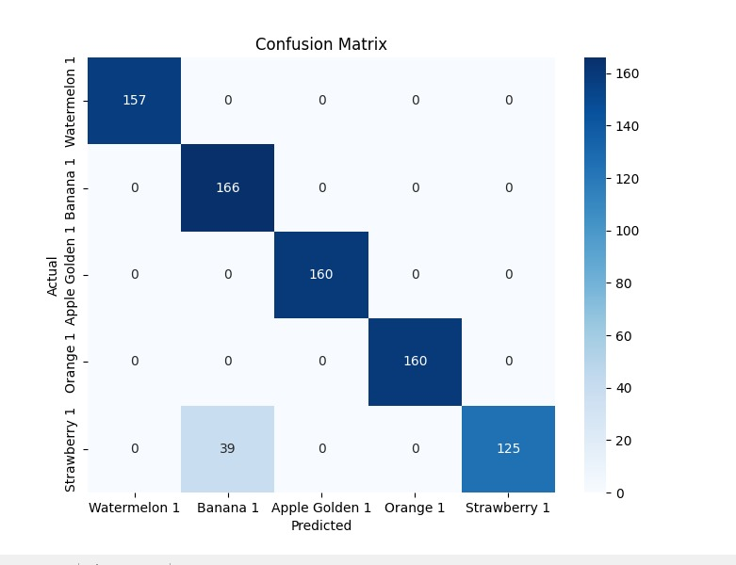
Learning Curve:
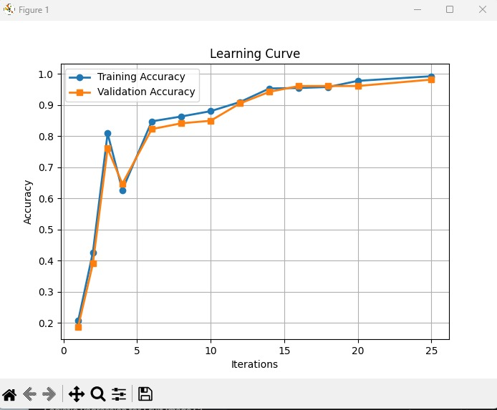
Omar Ahmed K-Means Model (Image):

A. General Information on Dataset

1. Name of Dataset:
- Fruits-360
- Source: https://www.kaggle.com/moltean/fruits
2. Number of Classes and Labels:
- Number of Classes: 5
- Labels:
  - Apple
  - Avocado
  - Banana
  - Blueberry
  - Nut
3. Total Number of Samples & Image Size:
- Total Samples: 778
- Image Size: 100X100 (Color: RGB)
4. Number of Samples used in Training, Validation, and Testing:
- Number of Samples used in training: 770(98.97%)
- Test Samples: 8 (1.02%)
- No Validation Set is used.
B. Implementation details:

1. Feature Extraction Phase
- Feature Extraction Phase: Features Extracted= 3
- Names of Features: R_mean, G_mean, B_mean (mean of Red, Green, Blue)
- Feature Dimension: 3 Per Image

2. Cross-Validation

No Method Used.

3. Hyperparameters
here are the hyperparameters:
Hyperparameter | Value
Number of clusters (n_clusters) | 5
Random state (random_state) | 33
(C) results:

Accuracy:
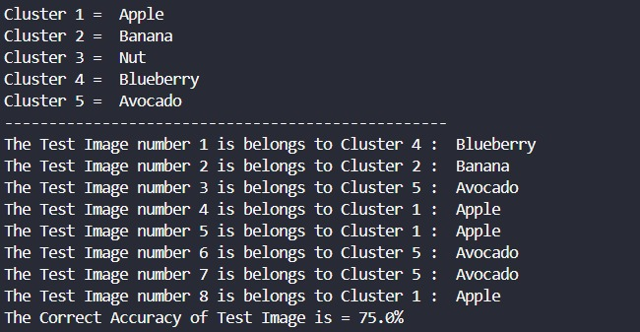

Confusion Matrix:
