PIZZA SALES SQL QUERIES

**A. KPI’s**

**1. Total Revenue:**

-- Total Revenue

SELECT ROUND(SUM(total_price), 2) AS Total_Revenue

FROM pizza_sales;

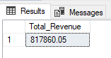

**2. Average Order Value**

-- Average Order Value or Price

SELECT ROUND(SUM(total_price) / COUNT(DISTINCT order_id), 2) AS Average_Order_Price

FROM pizza_sales;

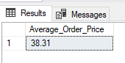

**3. Total Pizzas Sold**

-- Total Pizza Sold

SELECT SUM(quantity) AS Total_Pizza_Sold

FROM pizza_sales;

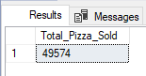

**4. Total Orders**

-- Total Orders

SELECT COUNT(DISTINCT order_id) AS Total_orders

FROM pizza_sales;

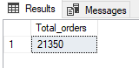

**5. Average Pizzas Per Order**

-- Average Pizza Per Order

SELECT

CAST((SUM(quantity) / CAST(COUNT(DISTINCT order_id) AS DECIMAL(10,2))) AS DECIMAL(10,2)) AS Average_pizza_per_order

FROM pizza_sales;

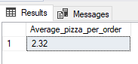

**B. Daily Trend for Total Orders**

-- Daily Trend (How many pizzas sales in each weekday?)

SELECT

DATENAME(DW, order_date) AS Week_day,

COUNT(DISTINCT order_id) AS Total_order

FROM pizza_sales

GROUP BY DATENAME(DW, order_date)

ORDER BY Total_order DESC;

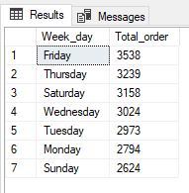

**C. Monthly Trend for Orders**

-- Monthly Trend (What is the frequency of pizza sales in each month?)

SELECT

DATENAME(MONTH, order_date) AS Name_of_month,

COUNT(DISTINCT order_id) AS Total_order

FROM pizza_sales

GROUP BY DATENAME(MONTH, order_date)

ORDER BY Total_order DESC;

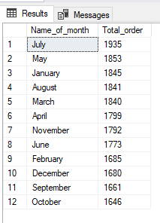

**D. % of Sales by Pizza Category**

-- Percentage of sales by pizza category

SELECT

pizza_category AS Pizza_category,

ROUND(SUM(total_price) * 100 / (SELECT SUM(total_price) FROM pizza_sales), 2) AS Percentage_of_sales

FROM pizza_sales AS ps

GROUP BY pizza_category

ORDER BY Percentage_of_sales DESC;

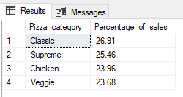

**E. % of Sales by Pizza Size**

-- Percentage of sales by pizza size

SELECT

pizza_size AS Pizza_size,

ROUND(SUM(total_price) * 100 / (SELECT SUM(total_price) FROM pizza_sales), 2) AS Percentage_of_sales

FROM pizza_sales AS ps

GROUP BY pizza_size

ORDER BY Percentage_of_sales DESC;

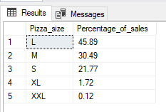

**F. Total Pizzas Sold by Pizza Category**

-- Total pizza sold by pizza category

SELECT

pizza_category AS Pizza_category,

COUNT(quantity) AS Total_quantity_sold

FROM pizza_sales

GROUP BY pizza_category

ORDER BY Total_quantity_sold;

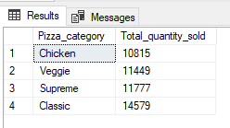

**G. Top 5 Pizzas by Revenue**

-- Top 5 pizza by revenue

SELECT

TOP 5 pizza_name AS Pizza_name,

CAST(SUM(total_price) AS DECIMAL(10,2)) AS Total_revenue

FROM pizza_sales

GROUP BY pizza_name

ORDER BY Total_revenue DESC;

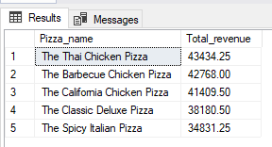

**H. Bottom 5 Pizzas by Revenue**

-- Bottom 5 pizza by revenue

SELECT

TOP 5 pizza_name AS Pizza_name,

CAST(SUM(total_price) AS DECIMAL(10,2)) AS Total_revenue

FROM pizza_sales

GROUP BY pizza_name

ORDER BY Total_revenue ASC;

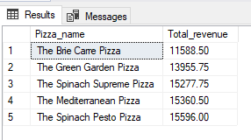

**I. Top 5 Pizzas by Quantity**

-- Top 5 pizza by quantity

SELECT

TOP 5 pizza_name AS Pizza_name,

SUM(quantity) AS Total_quantity

FROM pizza_sales

GROUP BY pizza_name

ORDER BY Total_quantity DESC;

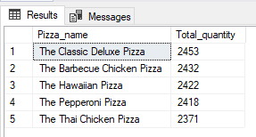

**J. Bottom 5 Pizzas by Quantity**

-- Bottom 5 pizza by quantity

SELECT

TOP 5 pizza_name AS Pizza_name,

SUM(quantity) AS Total_quantity

FROM pizza_sales

GROUP BY pizza_name

ORDER BY Total_quantity ASC;

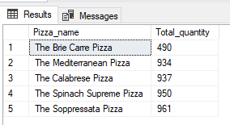

**K. Top 5 Pizzas by Total Orders**

-- Top 5 pizza by total_order

SELECT

TOP 5 pizza_name AS Pizza_name,

COUNT(DISTINCT order_id) AS Total_order

FROM pizza_sales

GROUP BY pizza_name

ORDER BY Total_order DESC;

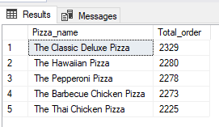

**L. Borrom 5 Pizzas by Total Orders**

-- Bottom 5 pizza by total_order

SELECT

TOP 5 pizza_name AS Pizza_name,

COUNT(DISTINCT order_id) AS Total_order

FROM pizza_sales

GROUP BY pizza_name

ORDER BY Total_order ASC;

