

#### This is to certify that

* Saifullah
* Muhammad Usman
* Muhammad Umar
* Syed Hasan Ali

**Completed this e-project on Date**

**4-july-2025**

**Star Securities – Summary for Website Development:**

Star Securities, established in 2000, is a leading private security company in India. It offers services like manned guarding, investigations, electronic security systems, and cash handling to over 250 clients across 24 states. With more than 2800 trained staff and ISO 9001:2000 certification, the company is known for its quality and professionalism.

Now, the company wants to build a modern ERP-based **website** with the following key features:

1. **About Us** – Company history, Chairman’s profile, and Board of Directors
2. **Our Services** – Details of Manned Guarding, Cash Services, Recruitment & Training, and Electronic Security Systems
3. **Branch Network** – Contact details of Star branches across North, South, East, and West regions
4. **Careers** – Display of current job openings (removed once filled)
5. **Clients** – Names of clients, services they use, and assigned staff
6. **Employee Login** – Only employees can log in, with access control based on roles
7. **Admin Panel** – Admins can add/edit/delete employees, clients, services, and vacancies
8. **Employee Details** – Display of each employee’s name, contact, role, qualifications, department,

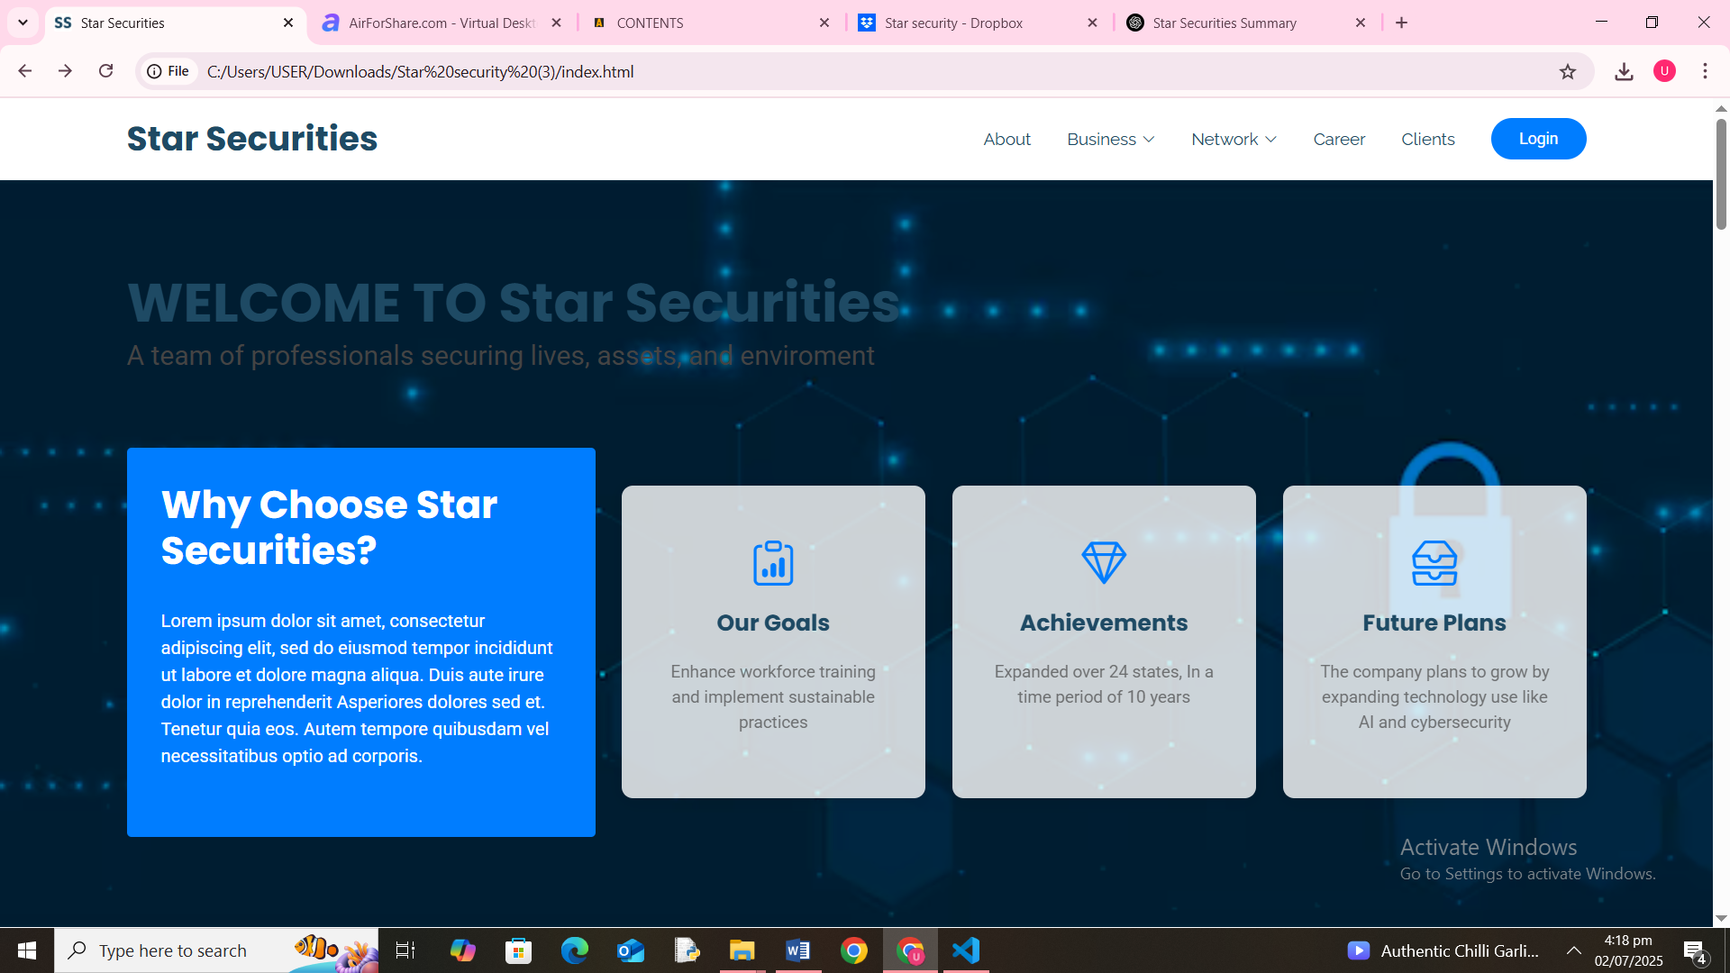**Home Page**

