A

PROJECT REPORT ON

**ONLINE COURSE REGISTRATION SYSTEM**

SUBMITTED BY

**Miss. Saifa Samir Kazi**

SUBMITTED TO

## SAVITRIBAI PHULE PUNE UNIVERSITY, PUNE

IN PARTIAL FULFILLMENT OF DEGREE

### MASTER OF COMPUTER APPLICATION (SEM-III)

UNDER THE GUIDANCE OF

**Mrs.Neeta Raskar**

Through,



**Sadhu Vaswani Institute of Management Studies for Girls,**

**Koregoan Park, Pune-411001**

**2023-24**

**CERTIFICATE**

This is to certify that **Saifa Samir Kazi** **,Seat No.** of **MCA II**

**SEM – III** has been completed the Mini Project entitled **“**Online Course Registration System **“**for the fulfilment of **MASTER OF COMPUTER APPLICATION** under **Savitribai Phule Pune University, Pune.** This is the result of the original project work under the supervision and guidance of **“Ms. Neeta Raskar”** to the best of my knowledge and belief.

The project is completed to our satisfaction and is submitted in partial fulfillment of requirement for Master of Business Administration Program as per the rules of the Savitribai Phule Pune University.

Ms. Neeta Raskar Ms. Neeta Raskar Dr. B H Nanwani

Project Guide HOD Director

Date:

Place: Pune

____________________ ____________________

Sign of External Examiner Sign of Internal Examiner

**DECLARATIOBY STUDENT**

To,

The Director,

SVIMS, Koregaon Park, Pune

I, undersigned hereby declare that this project titled, “**Online Course Registration System”** written and submitted by me to SPPU, Pune, in partial fulfillment of the requirement of the award of the degree of **MASTER OF COMPUTER APPLICATION (MCA-II)** under the guidance of **Ms** **Neeta Raskar,** is my original work.

I further declare that to the best of my knowledge and belief, this project has not been submitted to this or any other University or Institution for the award of any

Degree.

|  |  |
| --- | --- |
| **Place: Pune** |  |
| **Date:** | **(SAIFA SAMIR KAZI )** |

**ACKNOWLEDGEMENT**

I am overwhelmed in all humbleness and gratefulness to acknowledge all those who have helped me to put the ideas, well above the level of simplicity and into something concrete.

I owe a great debt to my guide **Ms. Neeta Raskar** who provided wholesome direction and support to me at every stage of this work. Her wisdom, knowledge and commitment to the highest standards inspired and motivated me. My gratitude is also due to our Director **Dr. B H Nanwani**, for her unconditional support and guidance.

**Place: Pune**

**Date:  Saifa Samir Kazi**

**INDEX**

|  |  |  |
| --- | --- | --- |
| **CHAPTER** | **DETAILS** | **PAGE NO** |
| 1 | CHAPTER 1: INTRODUCTION  1.1 Client/Organization Profile  1.2 Need for System  1.3 Scope & Feasibility of Work  1.4 Operating Environment – H/w & S/w  1.5 Architecture of system  1.6 Detail Description of Technology Used |  |
|  |
|  |
|  |
|  |
|  |
| 2 | PROPOSED SYSTEM  2.1 Proposed System  2.2 Objectives of System  2.3 User Requirements |  |
|  |
|  |
|  |
| 3 | ANALYSIS & DESIGN  3.1 DFD  3.2 Table specifications (Database)  3.3 ERD  3.4 Object Diagram  3.5 Class Diagram  3.6 Use Case Diagrams  3.7 Web Site Map Diagram (if Website) |  |
|  |
|  |
|  |
|  |
|  |
|  |
|  |
| 4 | USER MANUAL  4.1 User Interface Design (Screens etc.)  4.2 Limitations  4.3 Future enhancement |  |
|  | BIBLIOGRAPHY  ANNEXURE: SAMPLE PROGRAM CODE  Synopsis  Progress Report |  |
|  |
|  |
|  |

**CHAPTER 1: INTRODUCTION**

**1.1 Client Profile:**

Online Course Registration System is Web-based registration software that helps you to register courses online. It is ideal for schools, educational camps, corporate training programs, and online training programs. It also provides time to time current status information related to courses. It can help for the student need to register by giving necessary details, for the desired course.

In Online Course Registration we use PHP and MySQL database. It is web-based registration software that helps you to register courses online. It is ideal schools, educational camps, and corporate training program. It has two modules i.e. Admin and Student.

**Admin:**

Admin will register the student and provide username; password and pincode.Pincode will be used when a student enrolls for the course. Admin can manage session, semester, departments, course, students, students log Admin Panel. Admin can also add/ delete latest news and updates related to students.

**Student:**

Student can log in with valid reg no and password provided by admin. Student can enroll for any course and can printout of the registered course.

**1.2 Need for System:**

An online course registration system is need for system :

• **Efficiency and Accessibility:** It simplifies the registration process for students, making it more convenient and accessible from anywhere with an internet connection.

• **Automation:** Automates many administrative tasks, reducing the workload for staff and minimizing errors.

• **Centralized Database:** Provides a centralized database for managing student information, course offerings, and enrollment data.

• **Real-time Updates:** Offers real-time updates on course availability and enrollment status, ensuring students have the most current information.

• **Integration:** Can be integrated with other systems, such as learning management systems (LMS) and payment gateways, for a seamless experience.

• **Cost-Effective:** Reduces the need for paper-based processes and physical infrastructure, leading to cost savings.

***1.3* Scope of the System:**

Online Course Registration project is developed as a web application and it will work over web.

The scope of an online course registration system includes:

* **Student Registration:** Allowing students to create accounts, search for courses, and enroll in desired classes.
* **Course Management:** Managing course offerings, including details like instructor, description, prerequisites, and capacity.
* **Enrollment Management:** Tracking enrollment numbers, waitlists, and cancellations.
* **Reporting and Analytics:** Generating reports on enrollment trends, course popularity, and student demographics.
* **Integration:** Integrating with other systems like learning management systems (LMS) and student information systems (SIS).
* **Security:** Implementing security measures to protect student data.
* **Scalability:** Ensuring the system can accommodate growth in student numbers and course offerings.

**1.3 Feasibility Study:**

• **Technical Feasibility:** Evaluating the availability of technology, compatibility with existing systems, and the resources required for development and implementation.

• **Economic Feasibility:** Assessing the potential cost savings, return on investment, and long-term benefits compared to manual registration processes.

• **Operational Feasibility:** Examining how the system will fit into the institution's currentworkflow and processes, as well as its impact on staff and students.

**1.4 Operating Environment – H/W & S/W:**

**Hardware Configuration :**

**Client Side:**

|  |  |
| --- | --- |
| RAM | 512 MB |
| **Hard disk** | 10 GB |
| **Processor** | 1.0 GHz |

**Server side:**

|  |  |
| --- | --- |
| **RAM** | **1 GB** |
| **Hard disk** | **20 GB** |
| **Processor** | **2.0 GHz** |

**Software Requirement:**

**Client Side:**

|  |  |
| --- | --- |
| **Web Browser** | Google Chrome or any compatible browser |
| **Operating System** | Windows or any equivalent OS |

**Server Side:**

|  |  |
| --- | --- |
| **Web Server** | APACHE |
| **Server side Language** | PHP5.6 or above version |
| **Database Server** | MYSQL |
| **Web Browser** | Google Chrome or any compatible browser |
| **Operating System** | Windows or any equivalent OS |

* 1. **Use case diagram:**

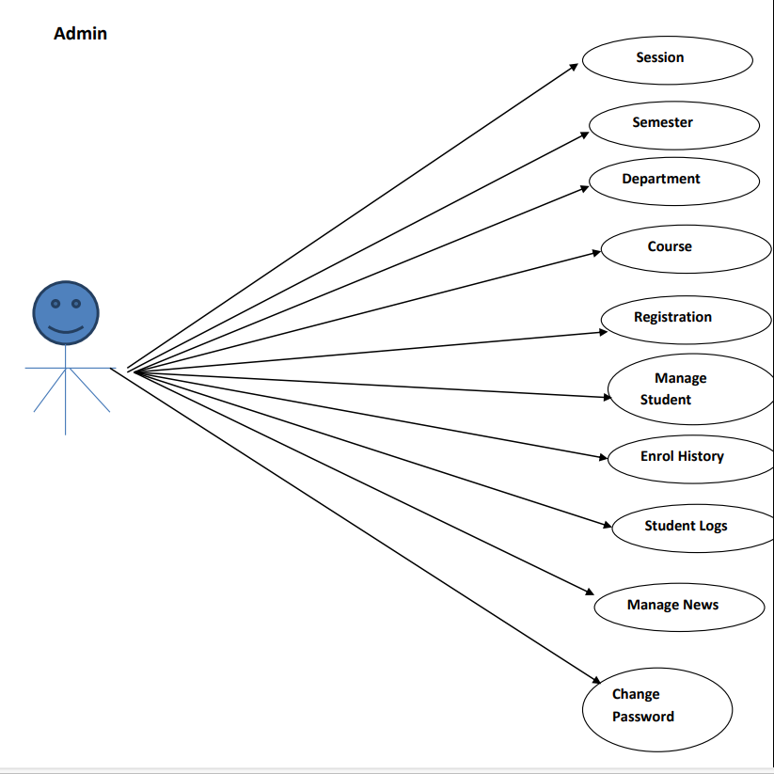

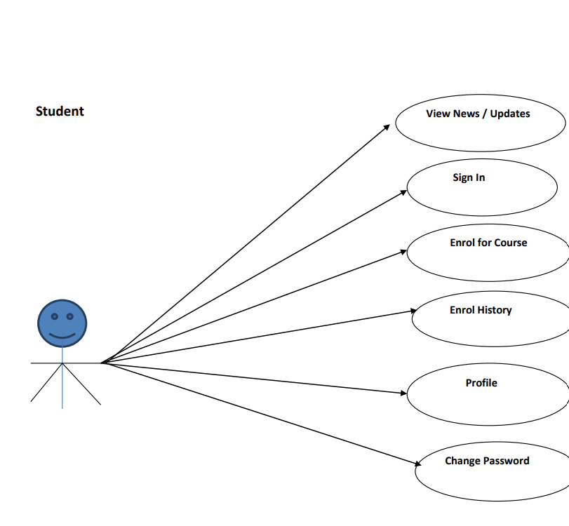

* 1. **Detail Description of Technology Used:**

**APACHE**

The Apache HTTP Server Project is an effort to develop and maintain an open-source HTTP server for modern operating systems including UNIX and Windows. The goal of this project is to provide a secure, efficient and extensible server that provides HTTP services in sync with the current HTTP standards.

The Apache HTTP Server ("httpd") was launched in 1995 and it has been the most popular web server on the Internet since April 1996. It has celebrated its 20th birthday as a project in February 2015.

**PHP**

* PHP stands for PHP: Hypertext Preprocessor.
* PHP is a server-side scripting language, like ASP.
* PHP scripts are executed on the server.
* PHP supports many databases (MYSQL, Informix, Oracle, Sybase, Solid, Generic ODBC, etc.).
* PHP is an open-source software.
* PHP is free to download and use.

**MYSQL**

* MYSQL is a database server
* MYSQL is ideal for both small and large applications
* MYSQL supports standard SQL
* MYSQL compiles on a number of platforms
* MYSQL is free to download and use
* How to access MySQL: <http://localhost/phpmyadmin>

#### CHAPTER 2: PROPOSED SYSTEM

**2.1Proposed System**

The purpose of project is to build an application program to reduce manual work for managing the course through internet. This application has good appearance and easy to operate. It is very simple and easy to access. This project provides lots of features to manage in very well manner. This project contains advance modules which make the backend system very powerful.

**2.2 Objectives of System**

The project objective will be focused on developing an online course registration to ensure the effectiveness of the flow of registration. Moreover the system will offer a complete management system that integrated with the online course registration to help the students for maintaining the flow process of the course.

The registration process can be done online without the need of paperwork anymore. It is also help the student to get more information about the course process while they enrolled.

**2.3 User Requirements:**

### ****1. User Roles and Authentication:****

* The system should support two types of users: Admin and Student.
* Admin should be able to register students and provide a username, password, and pincode for student authentication.
* Students should log in using their registration number and password.

### ****2. Admin Functionalities:****

* Admin should be able to manage:
  + **Sessions** (academic or training sessions).
  + **Semesters** (if applicable).
  + **Departments** (different academic or training departments).
  + **Courses** (create, update, or delete course offerings).
  + **Student records** (add, update, or delete student information).
* Admin should be able to manage the student log, tracking student activities within the system.
* Admin should have the ability to add or delete news and updates relevant to students.

### ****3. Student Functionalities:****

* Students should be able to:
  + **Log in** with the registration number and password.
  + **Enroll in courses** by providing the required pincode given by the admin.
  + **View and print** their registered courses.

### ****4. Course Management:****

* The system should allow for adding, updating, and deleting course information.
* Each course should have relevant details such as course name, department, duration, credits (if applicable), and prerequisites.

### ****5. Registration and Enrollment:****

* Students should be able to search and register for available courses.
* The system should validate the pincode for enrollment.
* Once enrolled, students should receive a confirmation.

**6.Reporting and Printouts:**

* Students should be able to generate and print reports of their registered courses.
* Admin should be able to generate reports on student enrollments and course statistics.

### ****7.Security and Data Integrity:****

* The system should have secure authentication mechanisms to protect student data.
* Data integrity should be maintained during course enrollment and updates.

**CHAPTER 3: ANALYSIS & DESIGN**

**3.1 Table Specifications (Database) Admin:**

|  |  |  |  |
| --- | --- | --- | --- |
| **NAME** | **DATA TYPE** | **CONSTRAINTS** | **DESCRIPTION** |
| id | int(11) | None | Id |
| username | varchar(255) | NULL | Username |
| email | varchar(255) | NULL | Email |
| password | varchar(100) | NULL | Password |
| creationDate | timestamp | Current_timestamp() | creationDate |
| updationDate | timestamp |  | updationDate |

**Course:**

|  |  |  |  |
| --- | --- | --- | --- |
| **NAME** | **DATATYPE** | **CONSTRIANTS** | **DESCRIPTION** |
| Id | int(11) | None | Id |
| courseCode | varchar(255) | NULL | courseCode |
| courseName | varchar(255) | NULL | courseName |
| courseUnit | varchar(255) | NULL | courseUnit |
| noofSeats | int(11) | NULL | noofSeats |
| creationDate | timestamp | Current_timestamp | creationDate |
| updationDate | varchar(255) | NULL | updationDate |

**Course_Enrolls:**

|  |  |  |  |
| --- | --- | --- | --- |
| **NAME** | **DATATYPE** | **CONSTRAINTS** | **DESCRIPTION** |
| Id | Int(11) | NULL | Id |
| studentRegno | varchar(20) | NULL | studentRegno |
| pincode | varchar(20) | NULL | pincode |
| session | Int(11) | NULL | session |
| department | Int(11) | NULL | department |
| Level | Int(11) | NULL | level |
| semester | Int(11) | NULL | semester |
| course | Int(11) | NULL | course |
| enrollDate | Int(11) | NULL | enrollDate |

**Department:**

|  |  |  |  |
| --- | --- | --- | --- |
| **NAME** | **DATATYPE** | **CONSTRIANTS** | **DESCRIPTION** |
| id | int(11) | None | Id |
| department | Varchar(255) | NULL | department |
| creationDate | timestamp | current-timestamp() | creationDate |

**Level:**

|  |  |  |  |  |
| --- | --- | --- | --- | --- |
| **NAME** | **DATATYPE** | **CONSTRIANTS** | **DESCRIPTION** | |
| Id | int(11) | None | | Id |
| level | varchar(30) | NULL | | level |
| creationDate | timestamp | current-timestamp() | | creationDate |

**News:**

|  |  |  |  |
| --- | --- | --- | --- |
| **NAME** | **DATATYPE** | **CONSTRIANTS** | **DESCRIPTION** |
| id | int(11) | None | Id |
| newstitle | varchar(30) | NULL | newstitle |
| newsDescription | mediumtext | NULL | newsDescription |
| postingDate | Timestamp | Current-timestamp() | postingDate |

**semester:**

|  |  |  |  |
| --- | --- | --- | --- |
| **NAME** | **DATATYPE** | **CONSTRIANTS** | **DESCRIPTION** |
| id | int(11) | None | Id |
| semester | varchar(30) | NULL | semester |
| creationDate | Timestamp | Current-timestamp() | creationDate |
| updationDate | varchar(255) | NULL | updationDate |

**Session:**

|  |  |  |  |
| --- | --- | --- | --- |
| **NAME** | **DATATYPE** | **CONSTRIANTS** | **DESCRIPTION** |
| id | int(11) | None | Id |
| session | Varchar(250) | NULL | session |
| creationDate | Timestamp | current_timestamp() | creationDate |

**Students:**

|  |  |  |  |
| --- | --- | --- | --- |
| **NAME** | **DATATYPE** | **CONSTRIANTS** | **DESCRIPTION** |
| StudentRegno | varchar(255) | None | StudentRegno |
| studentPhoto | varchar(255) | NULL | studentPhoto |
| password | varchar(255) | NULL | password |
| studentName | varchar(255) | NULL | studentName |
| pincode | varchar(255) | NULL | pincode |
| session | varchar(255) | NULL | session |
| department | varchar(255) | NULL | department |
| semester | varchar(255) | NULL | semester |
| cgpa | decimal(10,2) | NULL | cgpa |
| creationdate | timestamp | current_timestamp() | creationdate |
| updationDate | varchar(255) | NULL | updationDate |

**userlog:**

|  |  |  |  |
| --- | --- | --- | --- |
| **NAME** | **DATATYPE** | **CONSTRIANTS** | **DESCRIPTION** |
| id | int(11) | None | Id |
| studentRegno | varchar(200) | NULL | studentRegno |
| userip | binary(16) | NULL | userip |
| loginTime | timestamp | current_timestamp() | loginTime |
| logout | Varchar(255) | NULL | logout |
| status | Int(11) | NULL | status |

##### 3.2 ERD

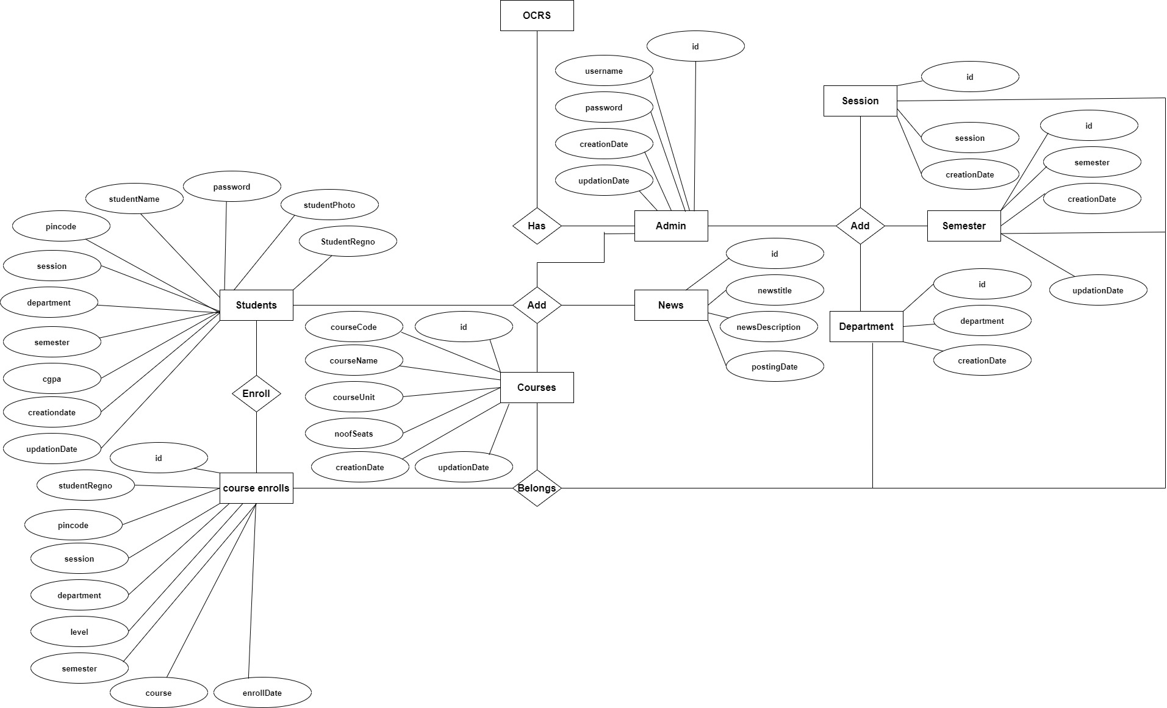

***3*.3 Object Diagram**

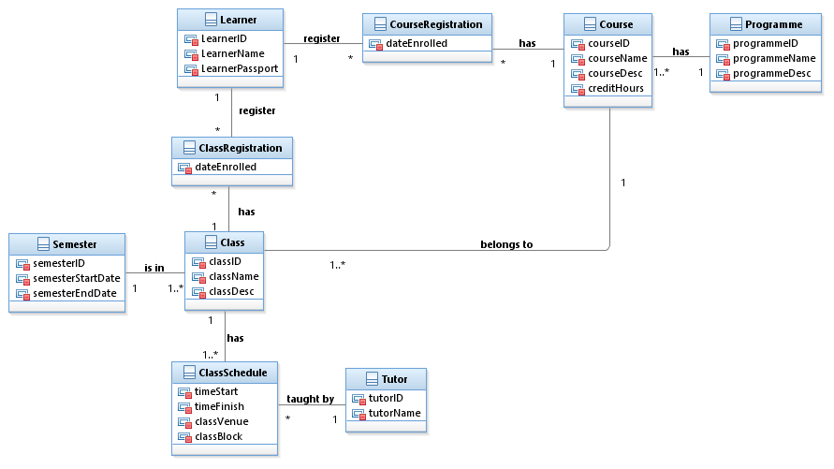

##### 3.4 Class Diagram

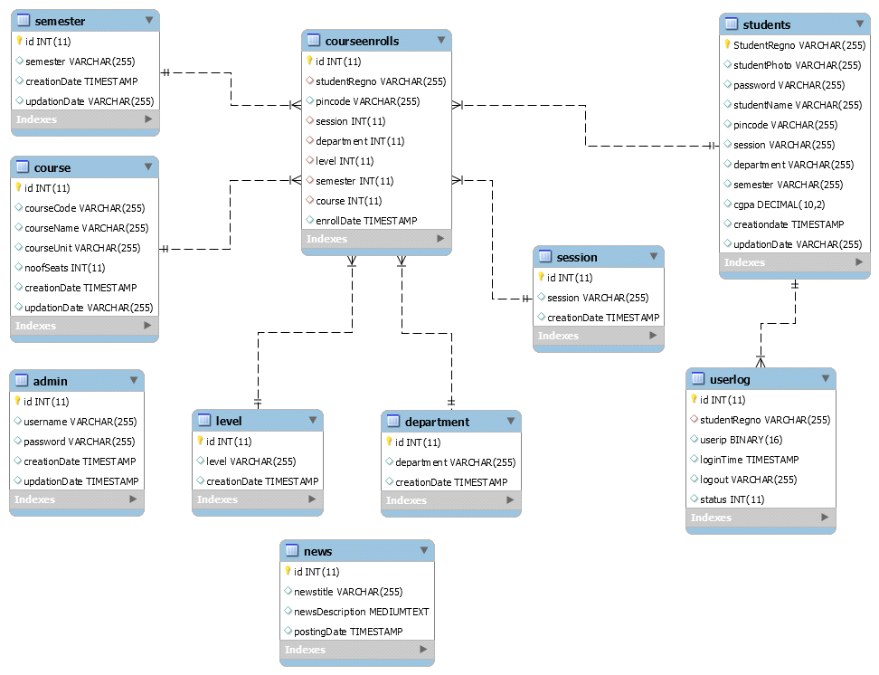

***3.5* Architecture of system:**

***3.6* Activity diagram:**

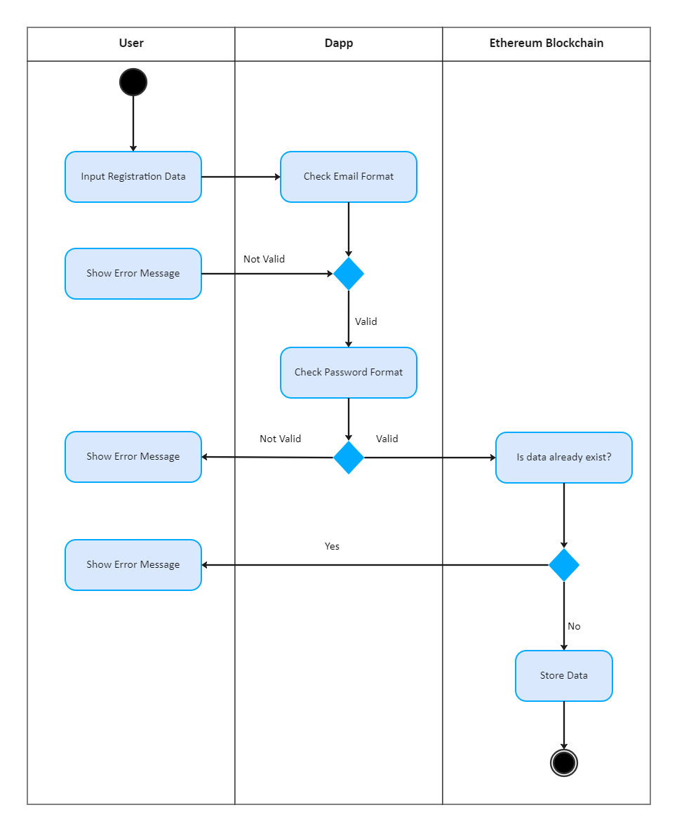

#### CHAPTER 4: USER MANUAL

**4.1 User Interface Design:**

**Admin Login Page** 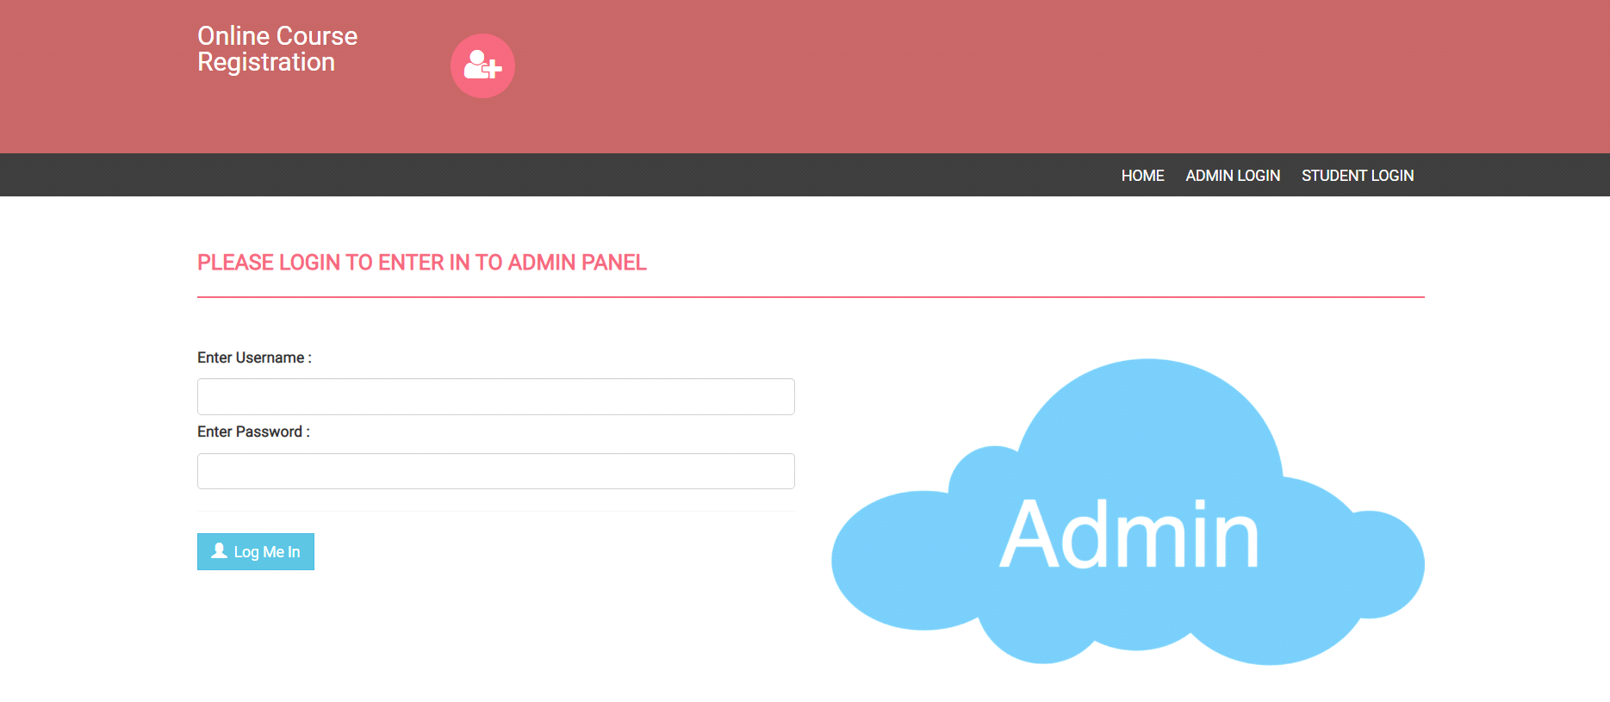

**Change Password:**

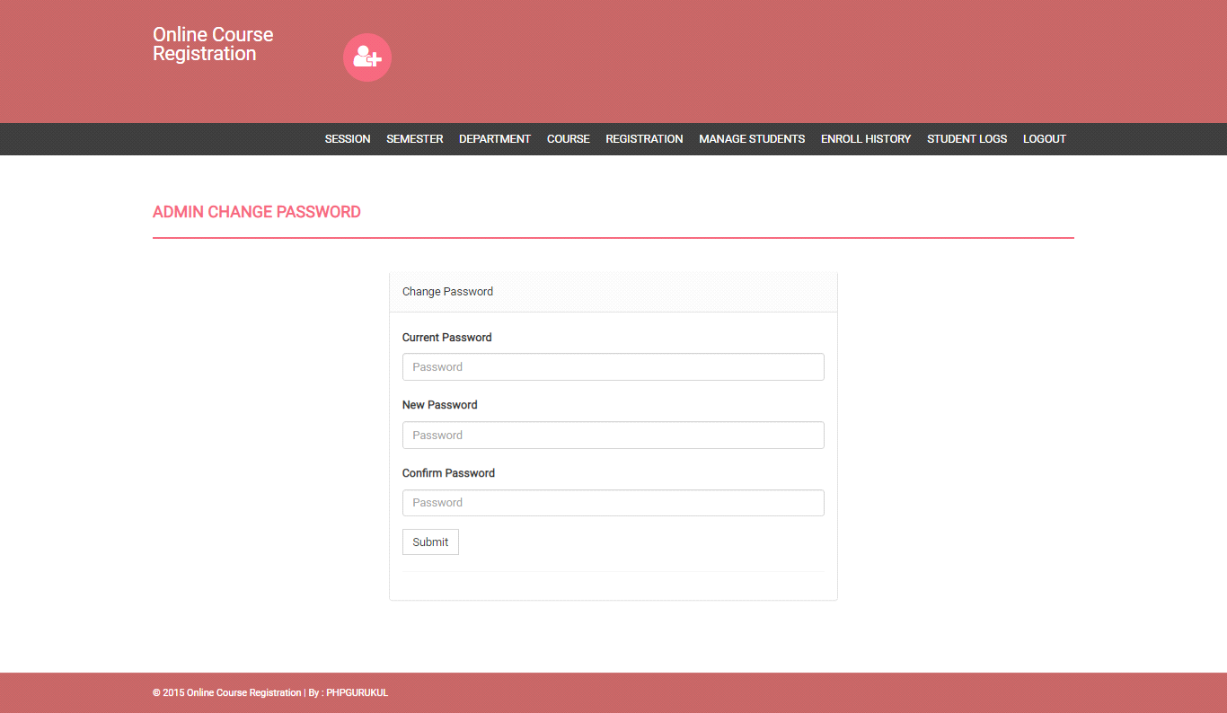

**Add/Manage Session:**

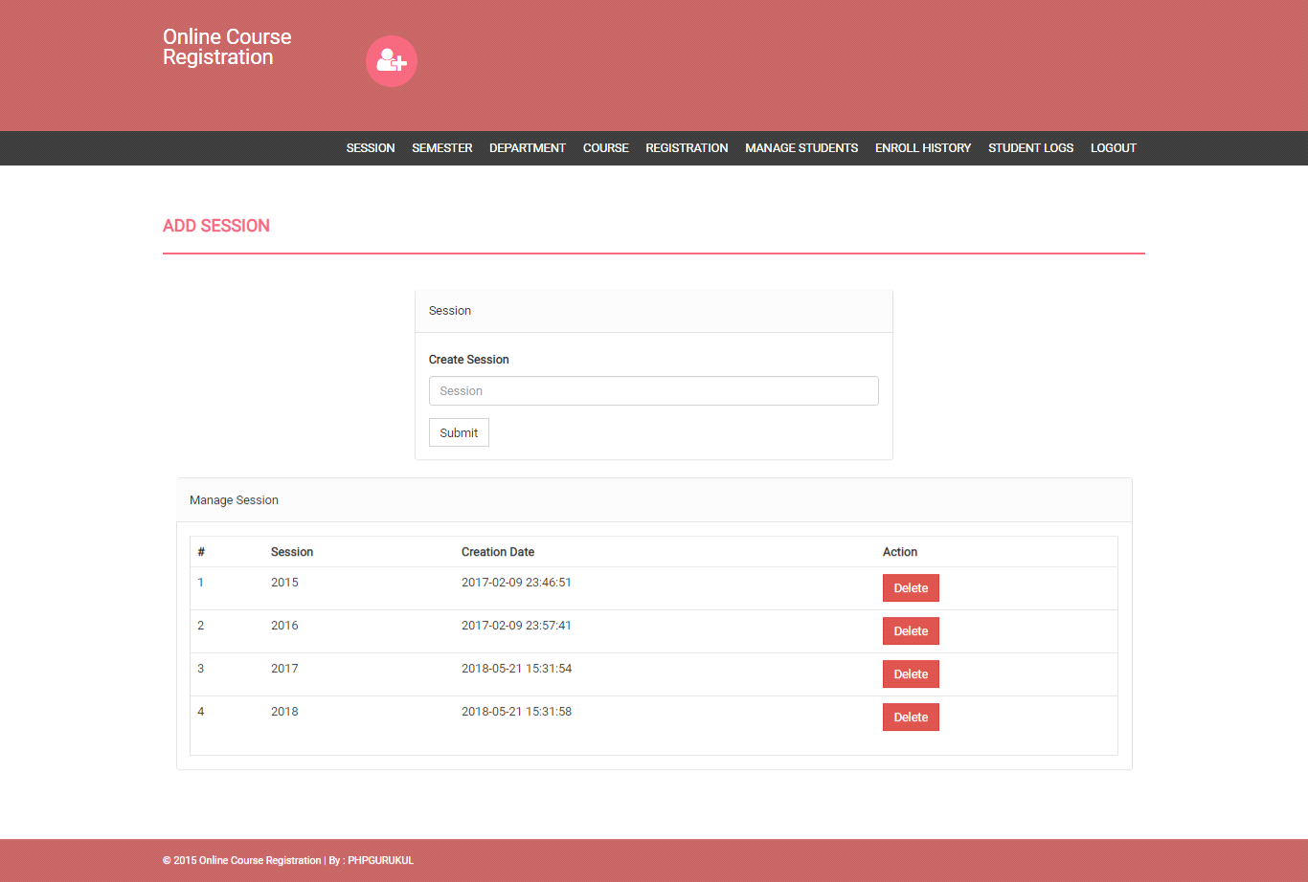

**Add/Manage Semester:**

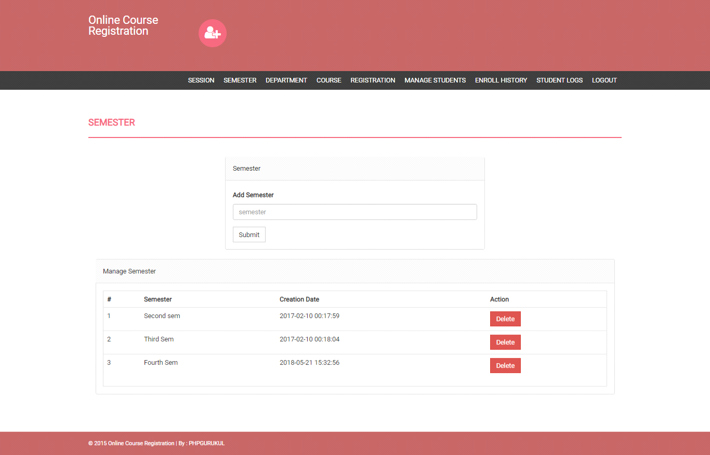

**Add/Manage Department:**

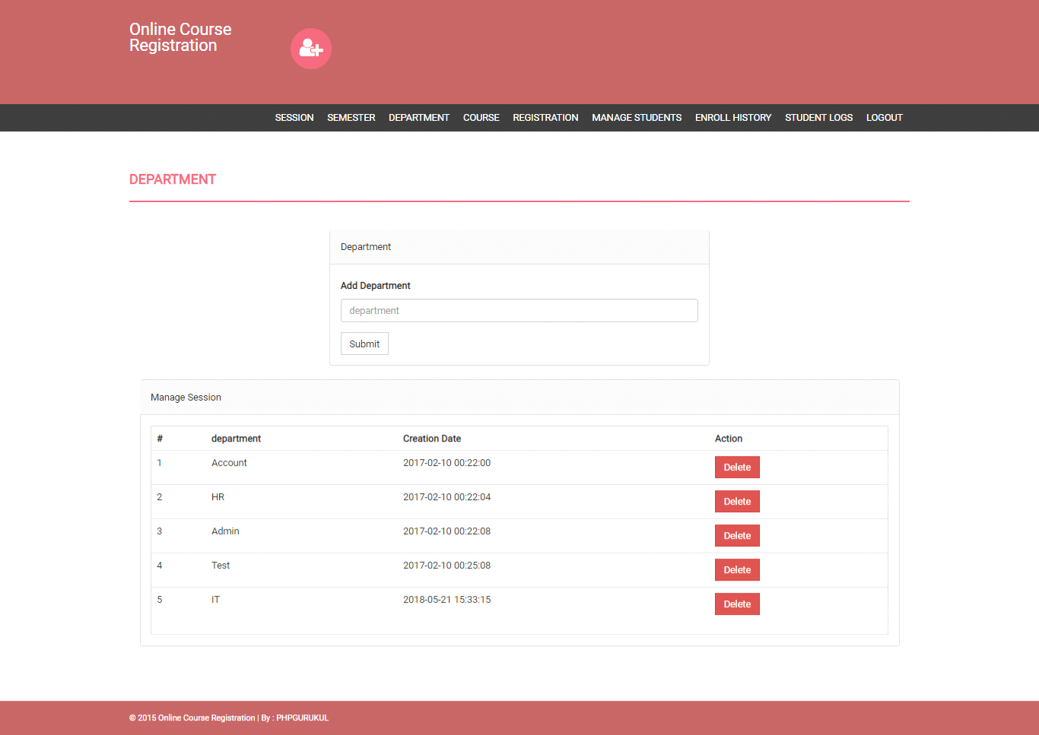

**Add/Manage Course:**

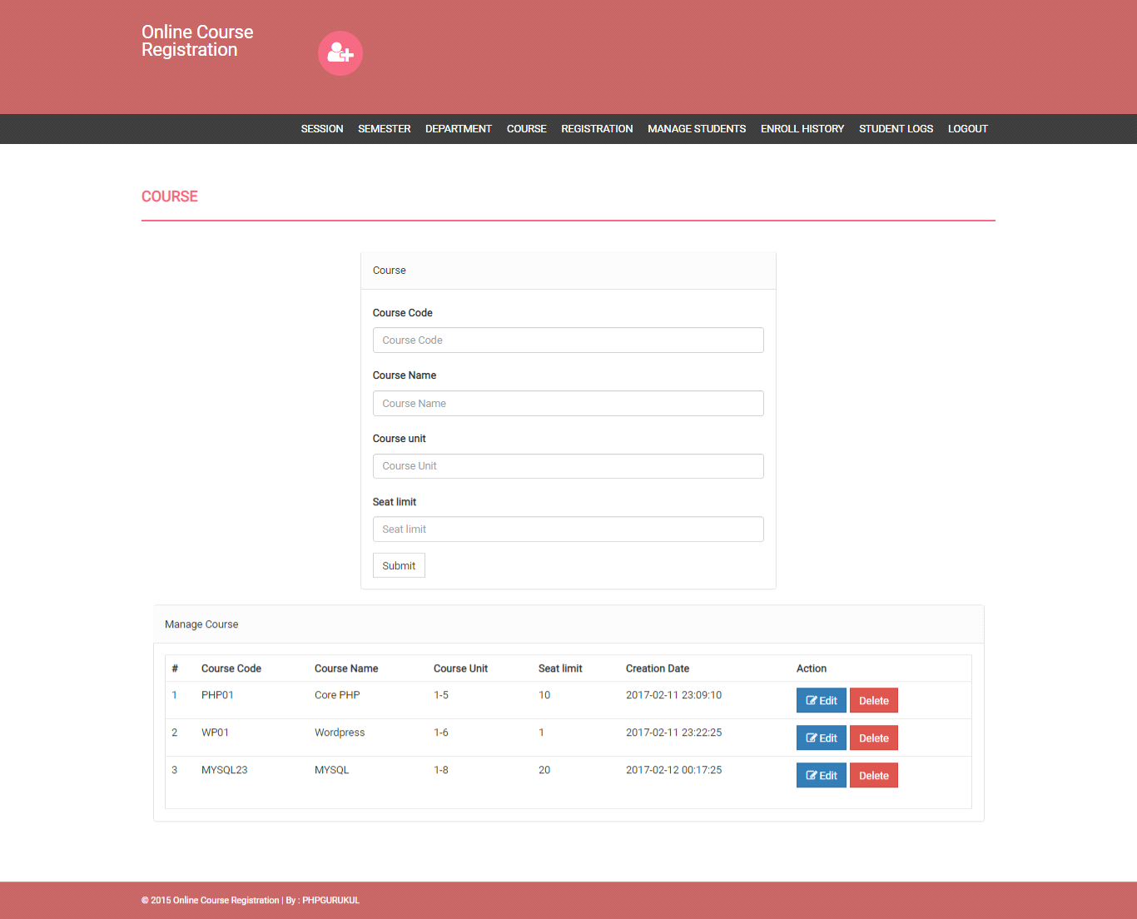

**Student Registration:**

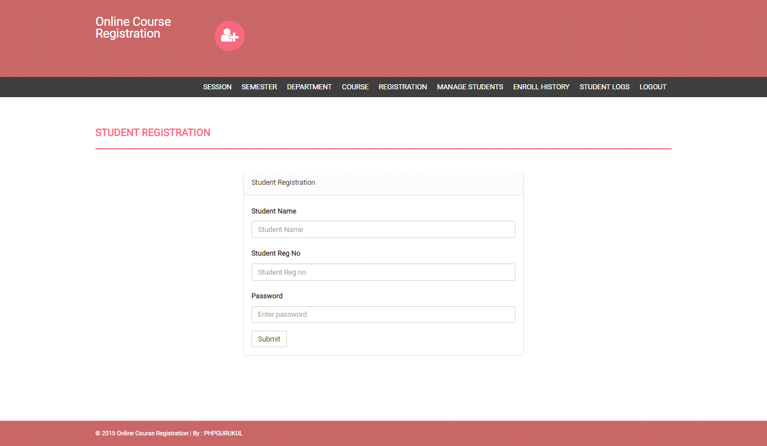

**Manage Student:**

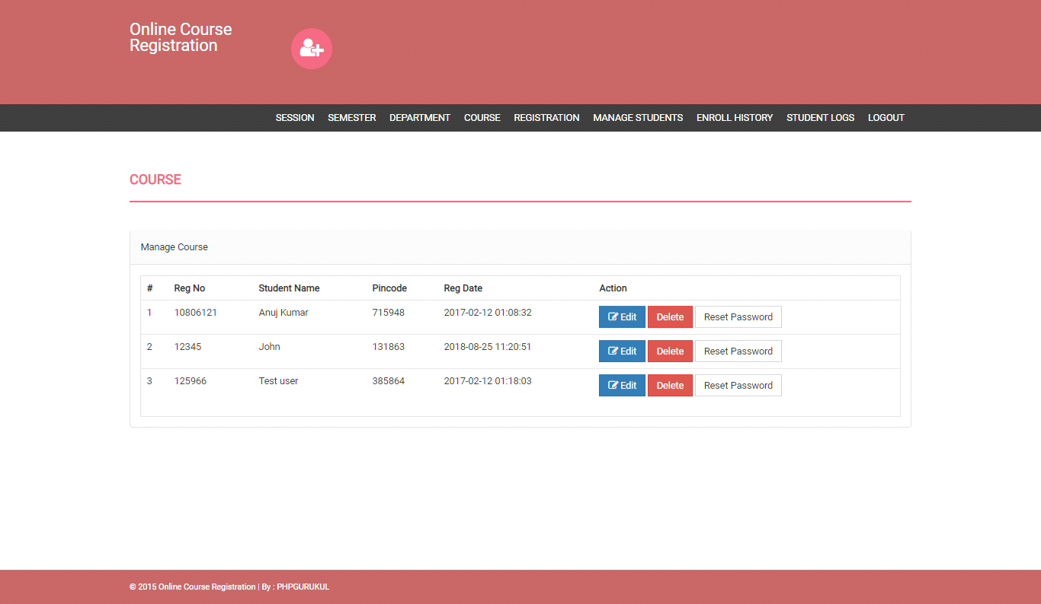

**Student Enroll History:**

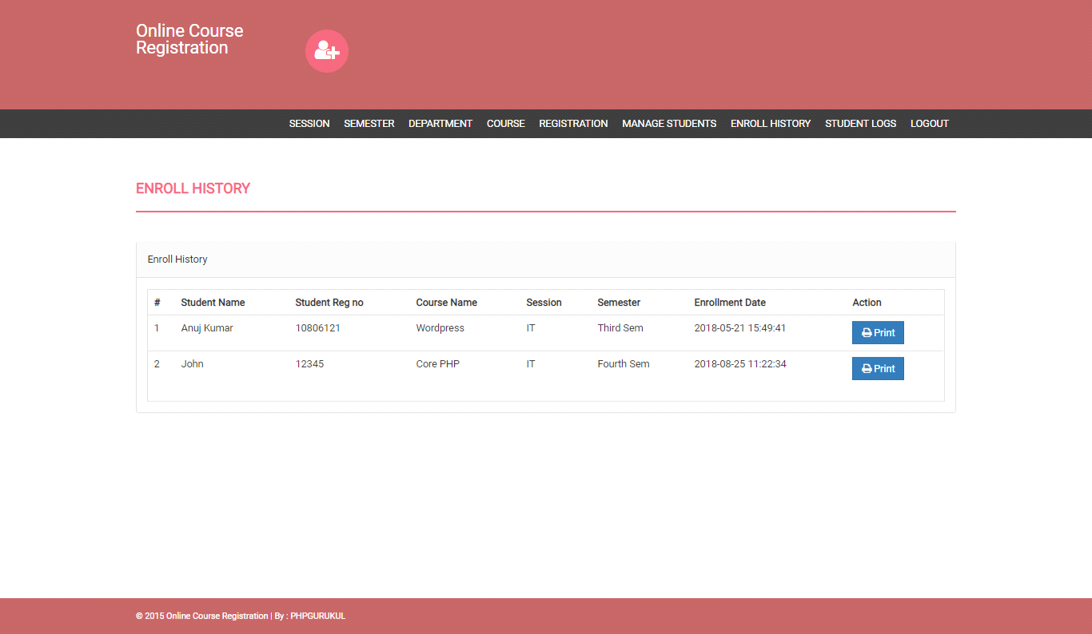

**Student Logs:**

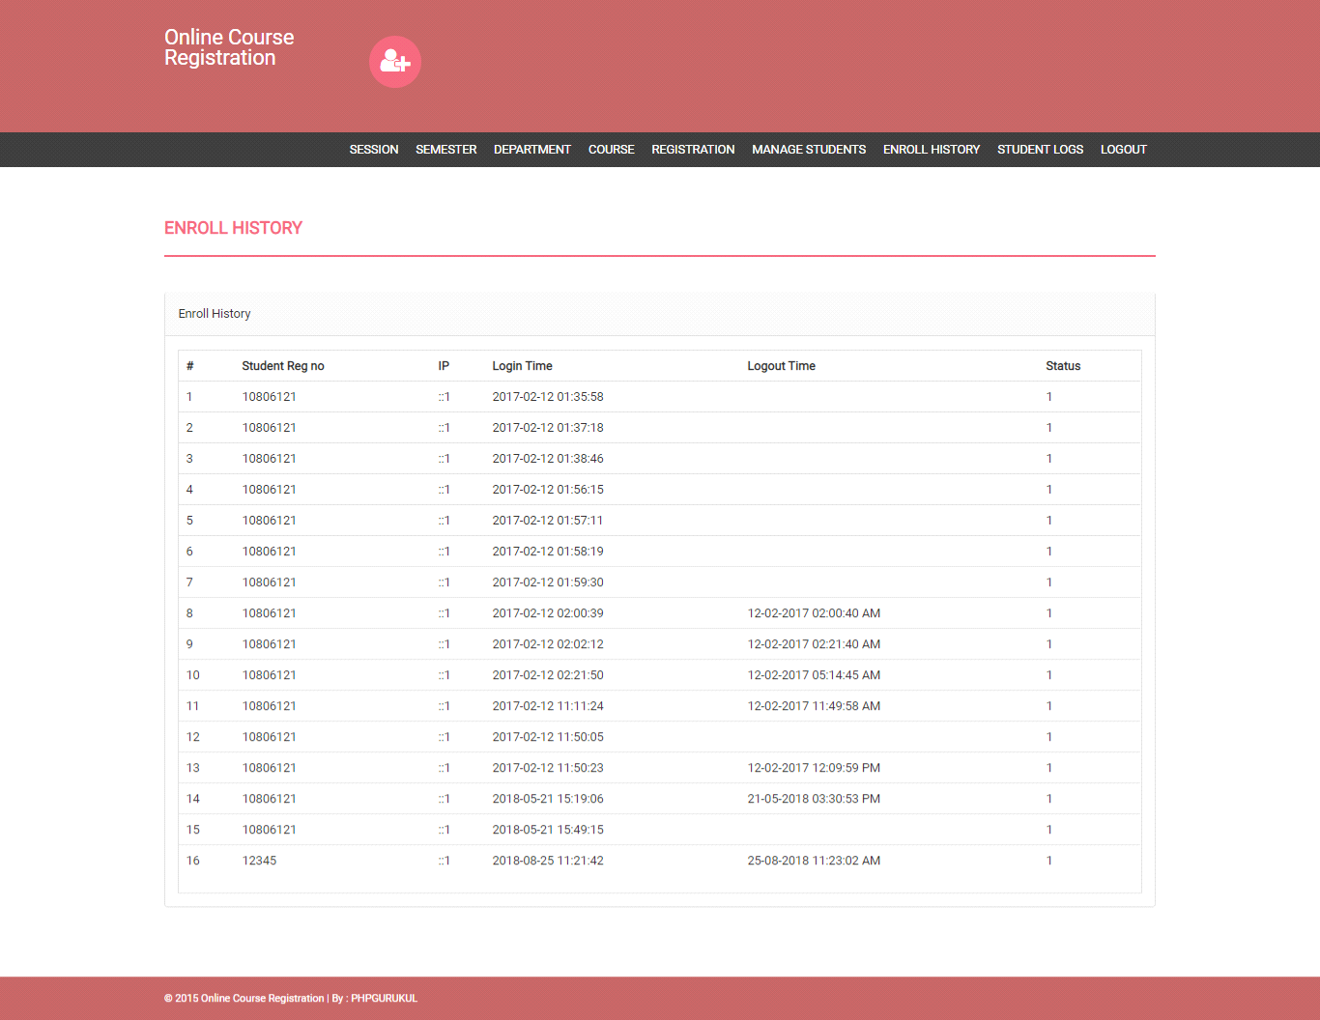

**News:**

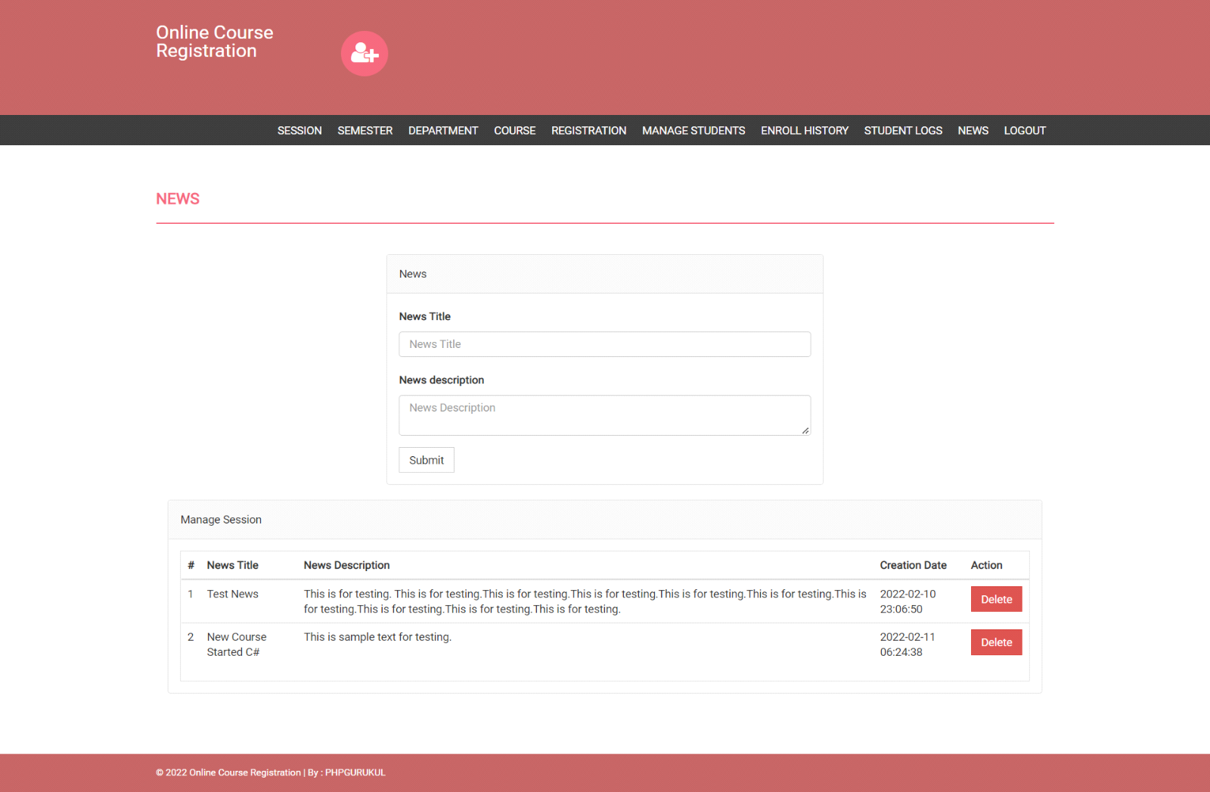

**Student Login Page:**

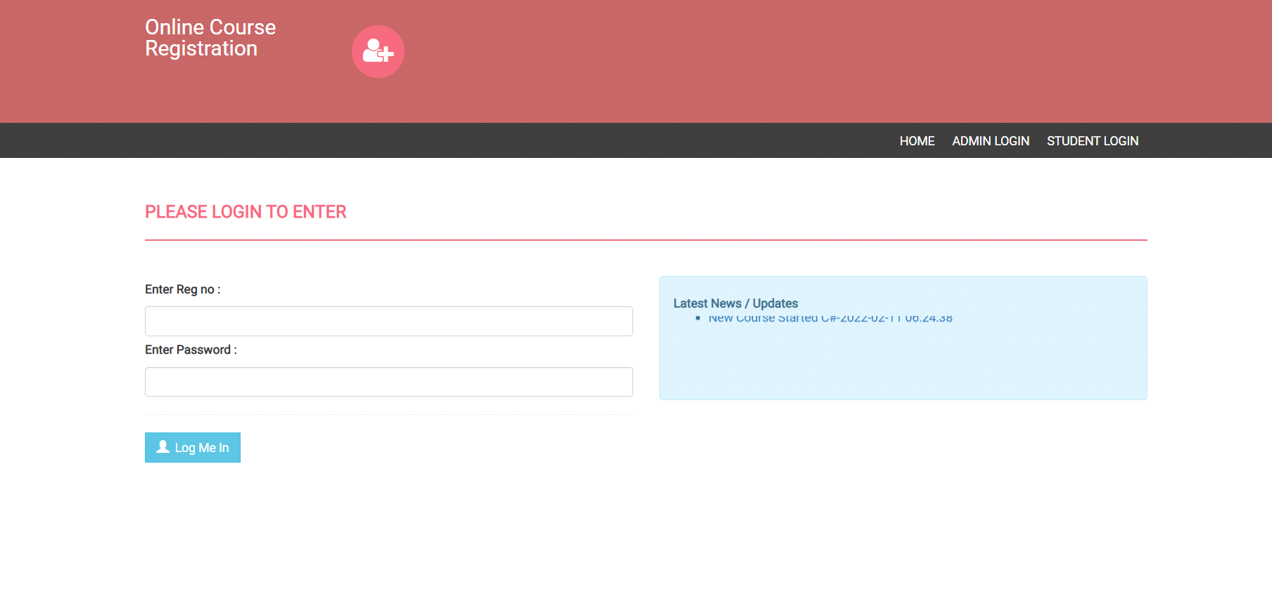

**Change Password:**

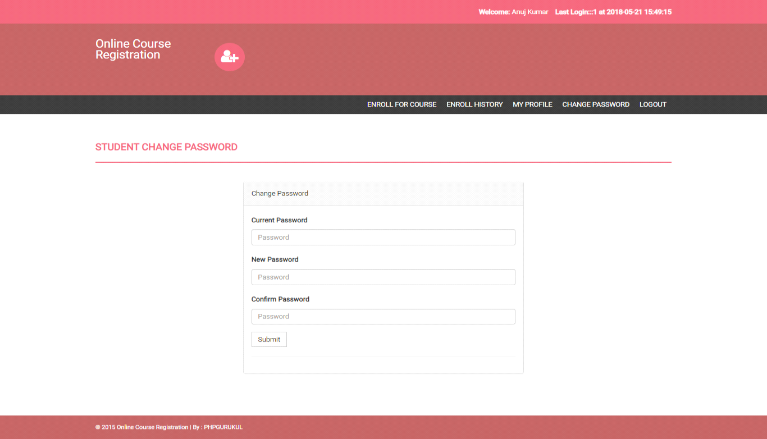

**STUDENT PINCODE VERIFICATION:**

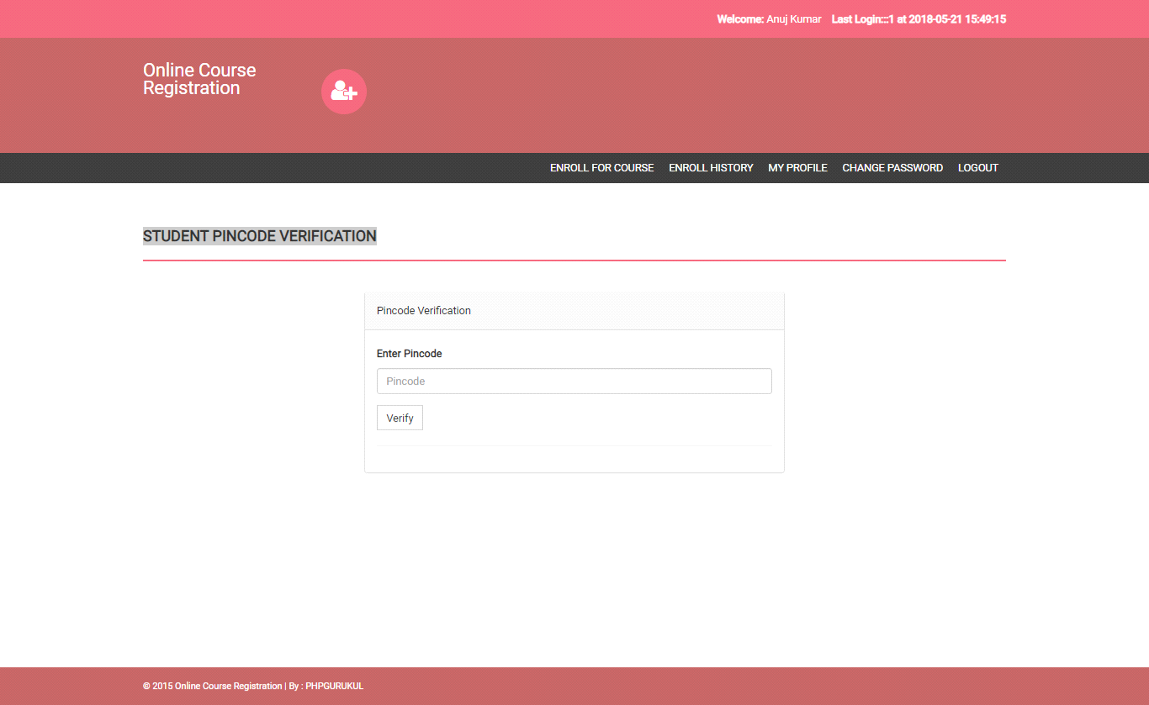

**Course Enroll:**

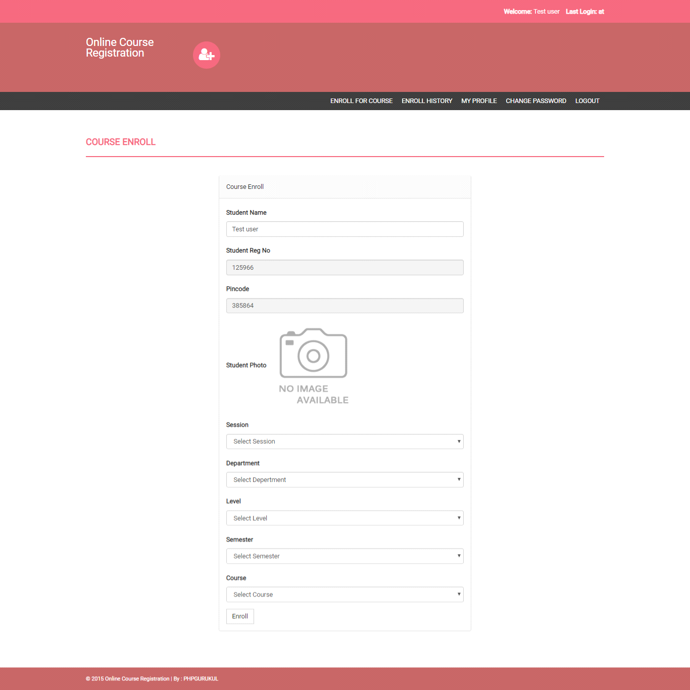

**Enroll History:**

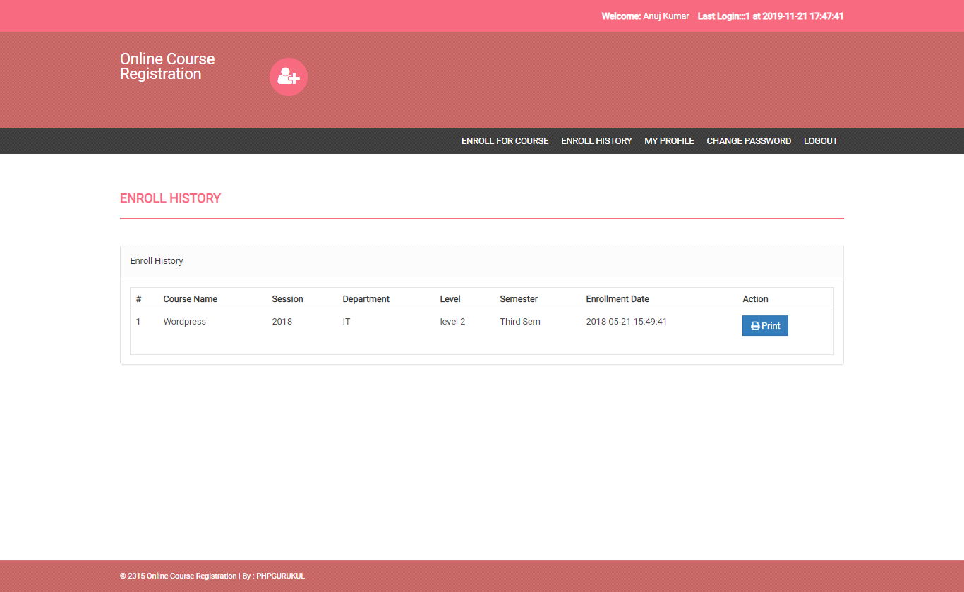

**My Profile:**

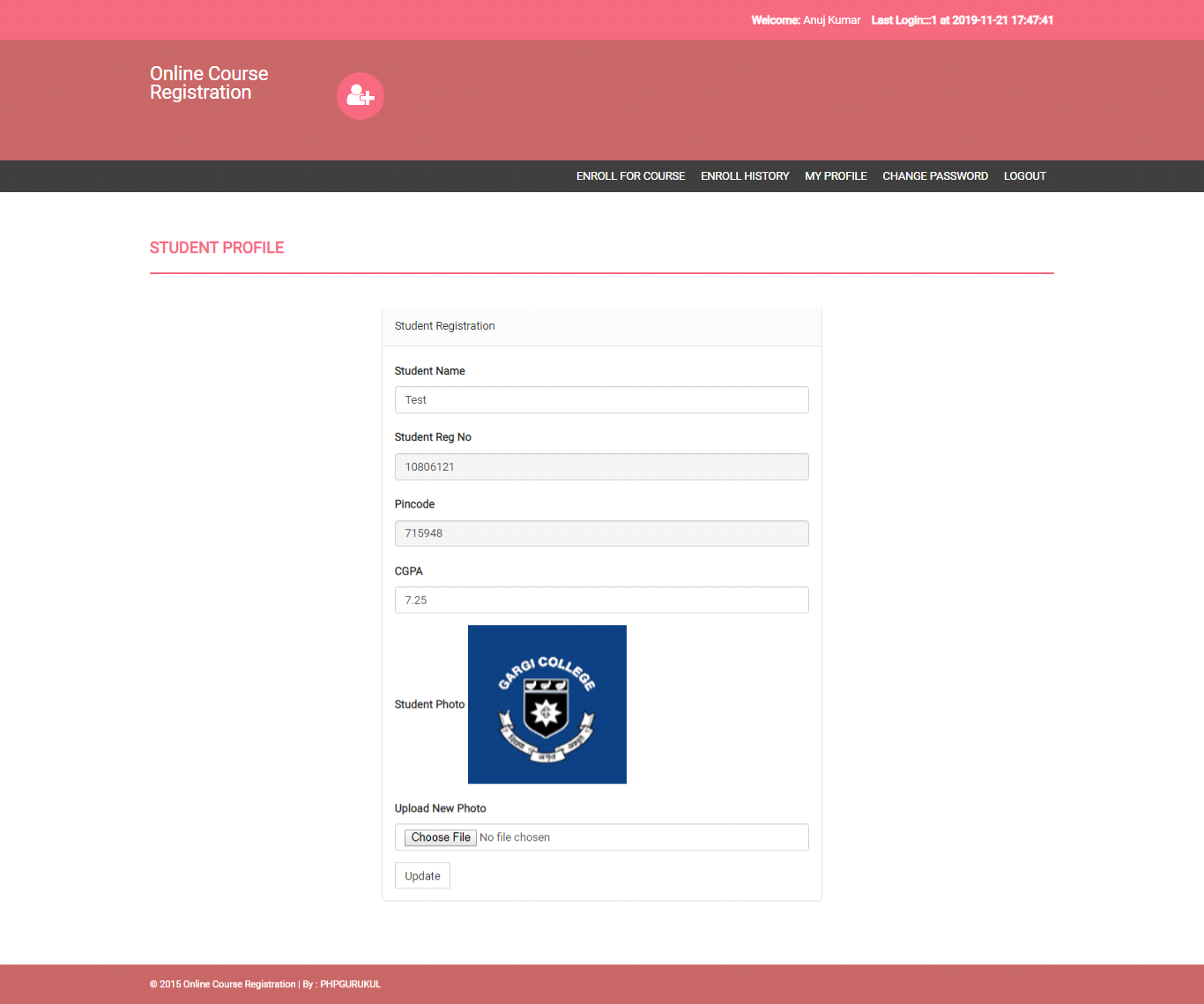

##### 4.2 Limitations

• **Limited User Roles**:

* The system only supports two user roles: Admin and Student. It lacks roles for instructors, course coordinators, or other administrative staff who may need to access or manage course-related information.

• **Manual Registration of Students by Admin**:

* The registration process is dependent on the admin manually registering each student and providing them with login credentials. This can be time-consuming and prone to human error, especially with a large number of students.

• **Basic Course Enrollment Functionality**:

* While students can enroll in courses, there is no mention of additional features like course prerequisites, automated course recommendations, waitlists, or class capacity management, which are common in more advanced registration systems.

• **Limited Course Management Options**:

* The admin can manage courses, but there is no indication of support for complex course structures, such as managing different sections, varying schedules, or multiple instructors for a single course.

• **No Automated Communication Features**:

* The system does not seem to include automated notifications or reminders for students about course registration deadlines, changes in schedules, or important updates.

• **Lack of Advanced Security Measures**:

* While the system uses a pincode for enrollment, there is no mention of multi-factor authentication, encryption for sensitive data, or other advanced security features to protect user data.

• **Limited Reporting and Analytics**:

* There is no indication of robust reporting or analytics features that could provide insights into student enrollment patterns, course popularity, or system usage.

BIBLIOGRAPHY:-

**For PHP**

<https://www.w3schools.com/php/default.asp>

<https://www.sitepoint.com/php/>

<https://www.php.net/>

**For MySQL**

* <https://www.mysql.com/>
* [http://www.mysqltutorial.org](http://www.mysqltutorial.org/)

**For XAMPP**

<https://www.apachefriends.org/download.html>