SYSTEM ANALYSIS
ACCOUNTING & HUMAN RESOURCES ERP
TECH STACK • REACT 18 • ASP.NET CORE 10 • EF CORE 10 • SQL SERVER • PLAYWRIGHT
Integrated Enterprise Resource Planning System

CONTENTS
Document Structure
01 Introduction 2
02 Existing System Analysis 3
03 Proposed System 4
04 Requirements Analysis 5
05 Feasibility Study 6
06 Process & Data Flow Analysis 7
07 Use Case Analysis 8
08 Data Analysis & ERD Specification 9
09 Security, Reporting, Risks & Conclusion 10
DOCUMENT  System Analysis | DOMAIN  Accounting + HR | TYPE  ERP | YEAR  2026
1. INTRODUCTION

1. Introduction
Enterprise Resource Planning (ERP) is an integrated information system used to manage and coordinate business processes through a centralized platform and shared database. This project proposes an ERP system focused on two highly connected business areas: Human Resources (HR) and Accounting & Finance.
The proposed system is designed for organizations that currently depend on spreadsheets, paper records, or disconnected applications to manage employees, attendance, leave, payroll, invoices, expenses, payments, and financial records. The system creates a single source of reliable data and automates the movement of information between HR and Accounting.
KEY INSIGHT | Payroll is the central integration point between HR operations and Accounting records.
The key integration point is payroll. HR maintains employee and attendance information, calculates salaries and deductions, and generates payroll. The financial impact of payroll is then transferred to Accounting as journal entries, reducing duplicate data entry and improving financial accuracy.

1.1 Project Vision
The vision is to provide a secure, centralized, user-friendly ERP platform that enables management to monitor human resources and financial operations from one system while maintaining clear responsibilities, approvals, auditability, and reporting.

1.2 Project Goals
- Centralize employee and financial information in a single database.
- Automate repetitive HR and accounting operations.
- Reduce manual data entry and calculation errors.
- Integrate payroll with accounting transactions.
- Provide role-based access to sensitive information.
- Generate timely operational and financial reports.
- Improve traceability through audit logs and approval workflows.

1.3 Scope Summary
In Scope | Out of Scope / Future Extension
Employees, departments, positions | Full manufacturing/MRP
Attendance and leave management | Advanced CRM
Payroll and payslips | Full procurement marketplace
Chart of accounts and journals | Direct banking settlement
Invoices, expenses and payments | Advanced tax authority integration
Reports, dashboards and RBAC | AI forecasting as an optional phase

2. EXISTING SYSTEM ANALYSIS

2. Existing System Analysis
The existing business environment is assumed to use a combination of spreadsheets, paper forms, email communication, and separate accounting or HR tools. Although these methods can support small operations, they become inefficient as the organization grows.

2.1 Existing Process
- HR stores employee records in spreadsheets or separate files.
- Attendance information is collected manually or from a separate device/system.
- Employees submit leave requests through paper, email, or messaging.
- Payroll is prepared by combining employee, attendance, overtime, and deduction data.
- Accountants manually record salary expenses and other transactions.
- Invoices, expenses, and payments are maintained separately.
- Management requests reports that require manual consolidation.

2.2 Problems Identified
Problem | Impact | Priority
Duplicate data entry | Increases workload and inconsistency | High
Manual payroll calculations | Risk of salary errors | High
Disconnected HR and Accounting | Repeated entry of payroll information | High
Spreadsheet dependency | Version conflicts and limited control | High
Weak approval tracking | Difficult to know who approved an operation | Medium
Limited audit trail | Difficult investigation of changes | High
Slow reporting | Management decisions depend on manual preparation | Medium
Broad file access | Sensitive employee/financial data may be exposed | High

2.3 Root Causes
- Lack of a centralized database.
- Manual movement of information between departments.
- Absence of standardized workflows and approval states.
- Limited role-based security.
- No integrated reporting layer.

2.4 Opportunity for Improvement
RECOMMENDATION | Capture data once, validate it centrally, and reuse it across authorized ERP modules.
The organization can improve its processes by replacing fragmented information handling with an integrated ERP architecture. Each department should enter data once, while authorized modules consume the same trusted records. This approach reduces duplication and establishes a consistent flow from operational events to financial results.

3. PROPOSED SYSTEM

3. Proposed System
The proposed Accounting & HR ERP is a centralized web-based information system. It contains separate modules for HR and Accounting while sharing core services such as authentication, authorization, notifications, audit logging, and reporting.

3.1 Main Modules
Module | Main Functions
Employee Management | Employee profiles, departments, positions, contracts, documents
Attendance | Check-in/out, working hours, overtime, absence
Leave Management | Requests, approvals, balances, leave history
Payroll | Salary calculation, deductions, bonuses, payslips
Accounting | Chart of accounts, journals, ledger, periods
Accounts Receivable | Customers, invoices, receipts, outstanding balances
Accounts Payable | Vendors, bills, payments, outstanding liabilities
Expenses | Expense recording, approval, categorization
Reporting | HR, payroll and financial reports
Administration | Users, roles, permissions, audit logs, settings

3.2 User Roles
Role | Primary Responsibilities
System Administrator | Users, roles, configuration and audit monitoring
HR Manager | Employees, attendance, leaves and payroll approval
HR Officer | Employee records and operational HR activities
Accountant | Invoices, expenses, payments, journals and reports
Finance Manager | Financial review, approvals and financial reporting
Employee | Profile, attendance view, leave requests, payslips
Management | Dashboards, KPIs and management reports
Auditor | Read-only review of transactions and audit logs

3.3 System Architecture Concept
At a conceptual level, users access a presentation layer through a web browser. Application services implement business rules and workflows. A centralized relational database stores transactional data. Supporting services may include notification, file storage, reporting, and audit logging.
Conceptual flow: User Interface → Application Services → Business Rules → Database / External Services → Reports & Notifications.

4. REQUIREMENTS ANALYSIS

4. Requirements Analysis

4.1 Functional Requirements
ID | Requirement | Description
FR-01 | Authentication | The system shall authenticate users before granting access.
FR-02 | Role Management | The system shall enforce permissions based on user roles.
FR-03 | Employee Management | Authorized HR users shall create, update, deactivate and search employee records.
FR-04 | Attendance | The system shall record and calculate employee attendance information.
FR-05 | Leave | Employees shall submit leave requests and authorized HR users shall approve or reject them.
FR-06 | Payroll | The system shall calculate payroll using salary, attendance, overtime, bonuses and deductions.
FR-07 | Payslip | The system shall generate a payslip for each processed payroll record.
FR-08 | Chart of Accounts | Authorized accountants shall manage financial accounts.
FR-09 | Journal Entry | The system shall create and post balanced journal entries.
FR-10 | Invoice | Authorized users shall create and track customer invoices.
FR-11 | Expense | The system shall record and route expenses through approval when required.
FR-12 | Payment | The system shall record customer, vendor and employee payments.
FR-13 | Integration | Approved payroll shall generate the corresponding accounting impact.
FR-14 | Reports | The system shall generate HR, payroll and financial reports.
FR-15 | Audit | The system shall log important changes and financial actions.

4.2 Non-Functional Requirements
Category | Requirement
Security | Use authentication, authorization, secure password handling and least-privilege access.
Performance | Common operations should respond within an acceptable business-user response time.
Availability | The system should remain available during defined business hours with controlled maintenance.
Scalability | Architecture should support growth in users, employees and transactions.
Usability | Interfaces should be understandable to HR, Accounting and non-technical employees.
Maintainability | Business rules should be modular and documented.
Reliability | Transactions should preserve data integrity and consistency.
Auditability | Sensitive operations should retain user, timestamp and action information.

5. FEASIBILITY STUDY

5. Feasibility Study
A feasibility study evaluates whether the proposed system is practical from technical, economic, operational, legal and schedule perspectives.

5.1 Technical Feasibility
The system is technically feasible using established web technologies, a relational database, secure authentication, role-based authorization, and a reporting layer. The required capabilities—CRUD operations, workflows, calculations, relational data management and reporting—are standard enterprise application functions.

5.2 Operational Feasibility
The proposed system directly supports daily activities performed by HR, Accounting and Management. Adoption is facilitated because the system mirrors familiar business concepts such as employees, attendance, invoices, expenses, payments and journal entries.

5.3 Economic Feasibility
The main costs include development, hosting/infrastructure, training, maintenance and support. Expected benefits include reduced administrative effort, fewer data-entry errors, faster reporting, improved control, and reduced duplication between HR and Accounting.
Cost / Benefit Area | Expected Effect
Development | Initial investment in analysis, design and implementation
Infrastructure | Hosting, database, backups and monitoring
Training | User onboarding and process training
Maintenance | Bug fixes, security updates and enhancements
Time savings | Less manual data entry and report preparation
Error reduction | Fewer payroll and transaction inconsistencies
Control | Better permissions, approvals and auditability

5.4 Legal & Compliance Considerations
The system will handle sensitive employee and financial information. Therefore, access should follow least privilege, data should be protected in transit and at rest where appropriate, and retention and deletion policies should be defined according to the organization's legal and regulatory obligations.

5.5 Schedule Feasibility
A phased implementation is recommended: requirements analysis → system design → core HR → payroll → accounting → integration → reporting → testing → deployment. This reduces project risk and allows each major module to be validated before integration.

6. PROCESS & DATA FLOW ANALYSIS

6. Process & Data Flow Analysis

6.1 Context Diagram – Conceptual Description
The ERP System is the central process. External actors exchange information with it. Employees submit leave requests and access personal information. HR manages employee and attendance data. Accounting manages financial transactions. Management consumes reports and KPIs. The System Administrator controls users and permissions.
Context Flow:
Employee → Leave Request / Personal Data → ERP
HR → Employee / Attendance / Payroll Data → ERP
Accountant → Financial Transactions → ERP
Management ← Reports / KPIs ← ERP
Administrator → Users / Roles / Configuration → ERP

6.2 DFD Level 0 – Major Processes
Process | Input | Output | Main Data Store
1.0 HR Management | Employee/HR data | Profiles, attendance, leave status | Employee & HR DB
2.0 Payroll | Salary, attendance, overtime, deductions | Payroll & payslips | Payroll DB
3.0 Accounting | Invoices, expenses, payments, journals | Ledger and balances | Accounting DB
4.0 Integration | Approved payroll/transactions | Journal entries and reconciled data | Integration/Accounting DB
5.0 Reporting | HR and accounting records | Dashboards and reports | Reporting/Data Layer

6.3 Key Business Process: Payroll to Accounting
- HR maintains the employee's salary and employment information.
- Attendance and overtime are collected for the payroll period.
- Approved bonuses and deductions are added.
- The payroll engine calculates gross and net salary.
- Payroll is reviewed and approved.
- The system generates payslips.
- The approved payroll produces accounting entries.
- Accounting posts the entries to the General Ledger.
- Management can view payroll and financial reports.

6.4 Business Rules
- An inactive employee cannot receive a new payroll record unless explicitly authorized.
- A leave request must have a valid date range and leave type.
- Payroll cannot be finalized twice for the same employee and payroll period.
- A journal entry must be balanced before posting.
- Only authorized roles may approve payroll or financial transactions.
- Posted financial transactions should not be silently deleted; correction should use controlled reversal/adjustment procedures.

7. USE CASE ANALYSIS

7. Use Case Analysis

7.1 Main Actors
- Employee – interacts with self-service functions.
- HR Officer / Manager – manages employees, attendance, leave and payroll.
- Accountant – records and manages financial transactions.
- Finance Manager – reviews and approves financial operations.
- Management – consumes dashboards and reports.
- System Administrator – manages users, roles and configuration.
- Auditor – reviews logs and transactions.

7.2 Major Use Cases
Actor | Use Cases
Employee | Login, View Profile, View Attendance, Submit Leave, View Payslip
HR | Manage Employees, Manage Attendance, Approve Leave, Process Payroll
Accountant | Manage Accounts, Create Invoice, Record Expense, Record Payment, Post Journal
Finance Manager | Approve Financial Transactions, Review Reports
Management | View Dashboard, View HR Reports, View Financial Reports
Admin | Manage Users, Roles, Permissions, System Settings
Auditor | View Audit Logs, Review Transactions

7.3 Detailed Use Case: Submit Leave Request
Item | Description
Use Case | Submit Leave Request
Primary Actor | Employee
Precondition | Employee is authenticated and active.
Trigger | Employee needs approved leave.
Main Flow | Select leave type → enter dates → add reason → submit → system validates balance → request is created → HR is notified.
Alternative Flow | If balance is insufficient or dates are invalid, system rejects submission and displays the reason.
Postcondition | A pending leave request exists for HR review.
Business Rule | Approved leave updates the employee's available leave balance.

7.4 Detailed Use Case: Process Payroll
Item | Description
Use Case | Process Payroll
Primary Actor | HR Manager
Precondition | Payroll period exists and employee data is valid.
Main Flow | Load employees → calculate salary → apply overtime/bonuses/deductions → validate → approve → generate payslips → send accounting impact.
Alternative Flow | Validation errors are listed and payroll remains unfinalized until corrected.
Postcondition | Approved payroll is locked for the period and accounting entries are generated according to policy.

8. DATA ANALYSIS & ERD SPECIFICATION

8. Data Analysis & ERD Specification
The database should follow a relational design that separates master data from transactional data and preserves referential integrity. The following entities represent the core logical data model.

8.1 Main Entities
Entity | Key Attributes / Purpose
Employee | EmployeeID, Name, DepartmentID, PositionID, HireDate, Status
Department | DepartmentID, Name, ManagerID
Position | PositionID, Title, DepartmentID, SalaryGrade
Attendance | AttendanceID, EmployeeID, Date, CheckIn, CheckOut, Hours
LeaveRequest | LeaveID, EmployeeID, LeaveTypeID, StartDate, EndDate, Status
Payroll | PayrollID, EmployeeID, PeriodID, Gross, Deductions, Net, Status
Customer | CustomerID, Name, Contact, Balance
Vendor | VendorID, Name, Contact, Balance
Invoice | InvoiceID, CustomerID, Date, Total, Status
Expense | ExpenseID, VendorID, AccountID, Amount, Date, Status
Payment | PaymentID, PartyType, PartyID, Amount, Date, Method
Account | AccountID, Code, Name, Type
JournalEntry | JournalEntryID, Date, Reference, Status
JournalLine | LineID, JournalEntryID, AccountID, Debit, Credit
User | UserID, Username, PasswordHash, EmployeeID, Status
Role | RoleID, Name
AuditLog | LogID, UserID, Action, Entity, EntityID, Timestamp

8.2 Core Relationships
- One Department can contain many Employees.
- One Position can be assigned to many Employees over time, subject to organizational rules.
- One Employee can have many Attendance records.
- One Employee can submit many Leave Requests.
- One Employee can have many Payroll records across payroll periods.
- One Customer can have many Invoices and Payments.
- One Vendor can have many Expenses and Payments.
- One Journal Entry contains one or more Journal Lines.
- One Account can appear in many Journal Lines.
- One User can have one or more Roles depending on the authorization model.
- One User can generate many Audit Log records.

8.3 Data Integrity Rules
- Primary keys uniquely identify each entity.
- Foreign keys enforce valid relationships.
- Required financial fields cannot be null when posting transactions.
- Debit and credit totals must balance for a posted journal entry.
- Historical financial transactions should remain traceable.
- Sensitive fields must be accessible only to authorized roles.

9. SECURITY, REPORTING, RISKS & CONCLUSION

9. Security, Reporting, Risks & Conclusion

9.1 Security Analysis
- Authentication for all protected functions.
- Role-Based Access Control (RBAC).
- Least-privilege permissions.
- Secure password hashing and session/token management.
- Input validation and server-side authorization.
- Audit logs for important HR and financial actions.
- Database backups and controlled restoration procedures.
- Encryption in transit and appropriate protection of stored sensitive data.

9.2 Reporting Requirements
Area | Reports
HR | Employee List, Department Summary, Attendance, Absence, Leave Balance
Payroll | Payroll Register, Payslips, Salary Summary, Deductions
Accounting | General Ledger, Trial Balance, Income Statement, Balance Sheet
Receivables | Customer Invoices, Outstanding Balances, Payment History
Payables | Vendor Bills, Outstanding Liabilities, Payment History
Management | HR KPIs, Payroll Cost, Revenue, Expenses, Cash Position

9.3 Risk Analysis
Risk | Probability | Impact | Mitigation
Incorrect requirements | Medium | High | Stakeholder validation and use-case review
Data migration errors | Medium | High | Validation, backups and staged migration
Unauthorized access | Medium | High | RBAC, MFA where appropriate, audit logs
Payroll calculation error | Low/Medium | High | Automated tests and approval workflow
System downtime | Medium | Medium | Backups, monitoring and recovery plan
User resistance | Medium | Medium | Training and gradual rollout
Integration inconsistency | Medium | High | Transactional controls and reconciliation

9.4 Expected Outcomes
EXPECTED VALUE | The ERP should improve control, traceability, reporting speed, and consistency across HR and Finance.
The proposed ERP is expected to provide a unified operational environment for HR and Accounting. The main value is not only replacing spreadsheets but establishing controlled business processes in which data is captured once, validated, approved, reused, and reported consistently.

9.5 Conclusion
The System Analysis demonstrates that an integrated Accounting & HR ERP can address the main limitations of fragmented business processes. The proposed solution centralizes data, automates HR and financial workflows, improves security and auditability, and connects payroll operations with accounting records. The analysis also defines the system boundary, stakeholders, requirements, processes, use cases, data entities, business rules, security considerations and implementation risks. These outputs provide a strong foundation for the next phase: System Design, including detailed UI design, database schema, API architecture, DFD/Use Case diagrams, sequence diagrams and implementation planning.
PROJECT TYPE  Integrated ERP | FOCUS  Accounting + HR | YEAR  2026
Prepared for | System Analysis Course
Prepared by | ________________________

SYSTEM MODELS & VISUAL ANALYSIS
Standard System Analysis models are provided below as supporting artifacts for the complete report.
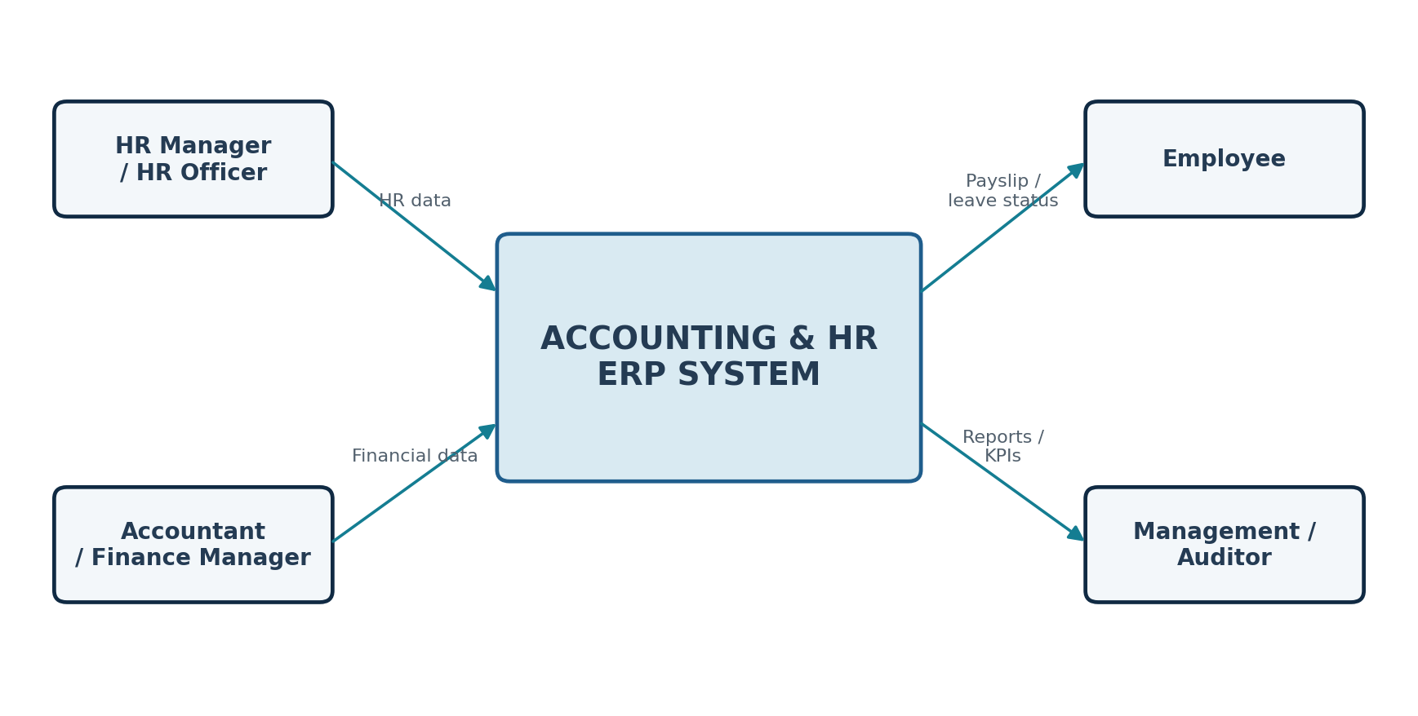
Figure 1. Context Diagram — External Actors and ERP Boundary

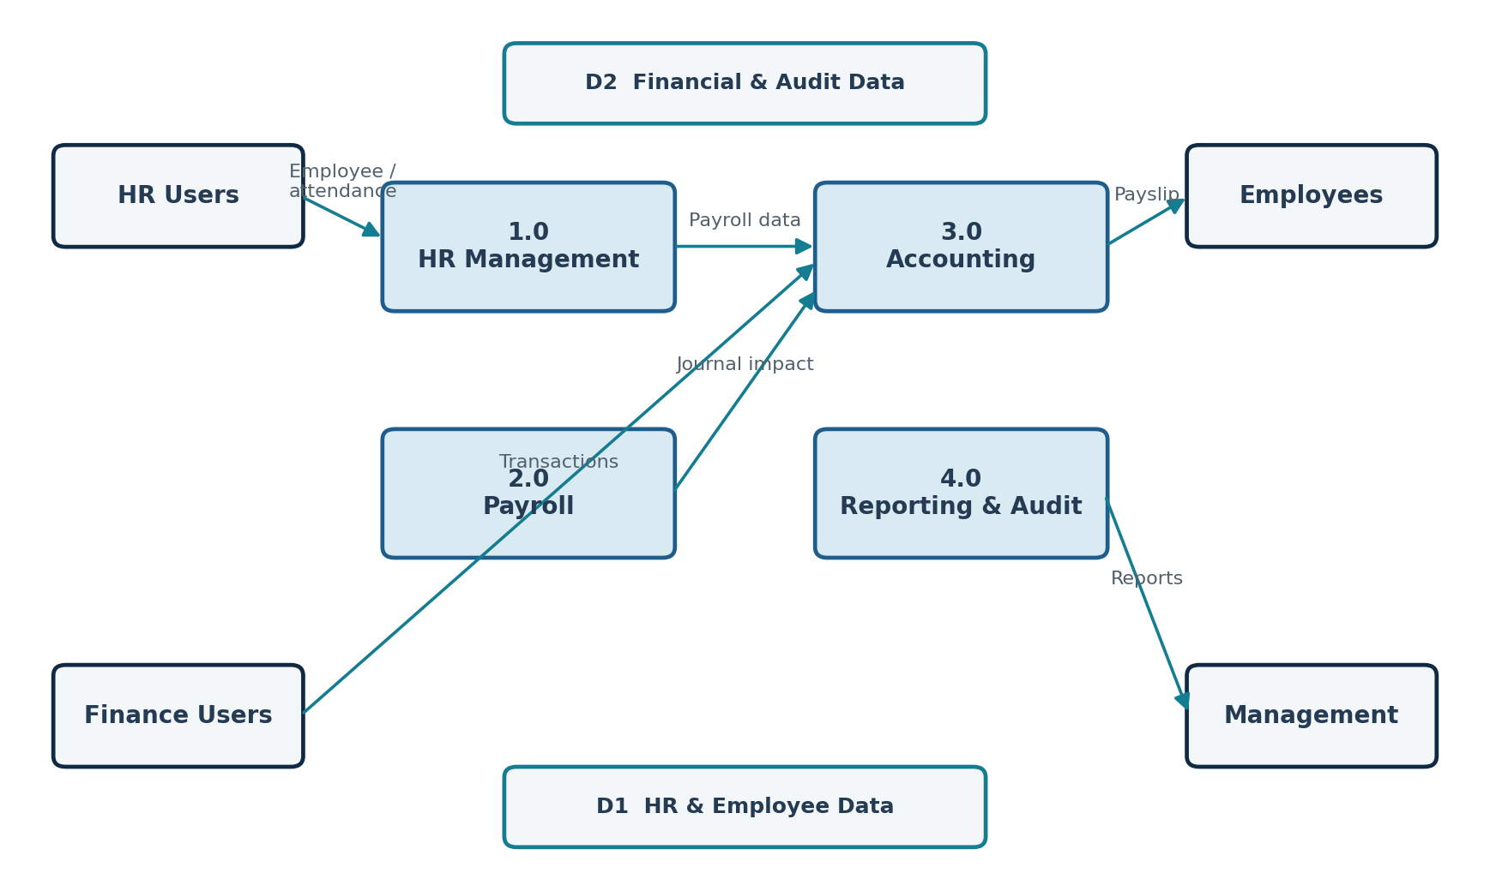
Figure 2. DFD Level 0 — Core Processes and Data Stores

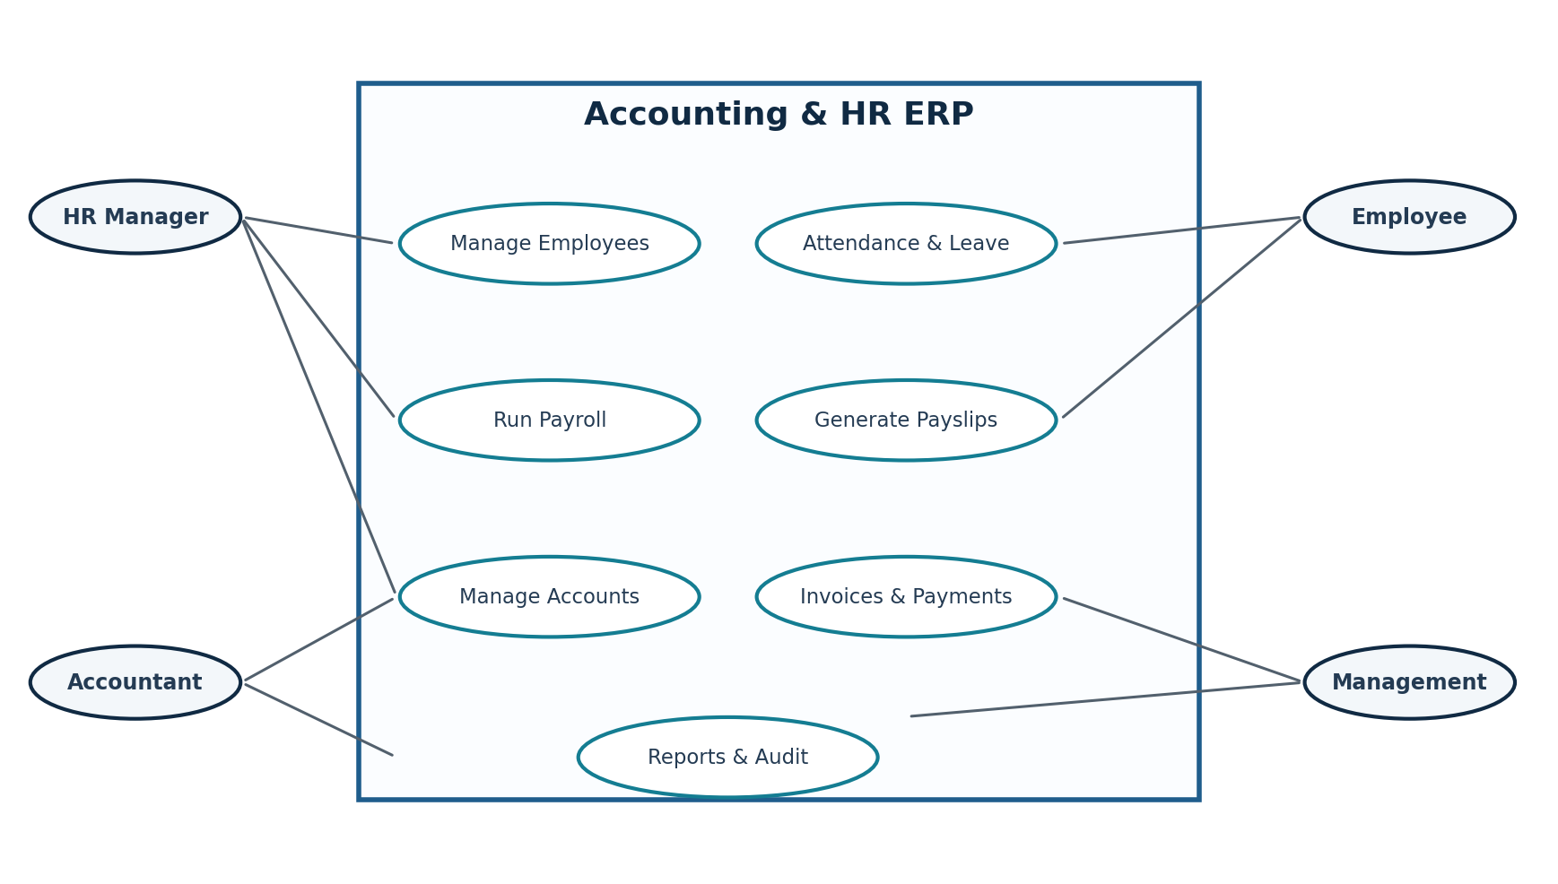
Figure 3. Use Case Diagram — Core ERP Interactions

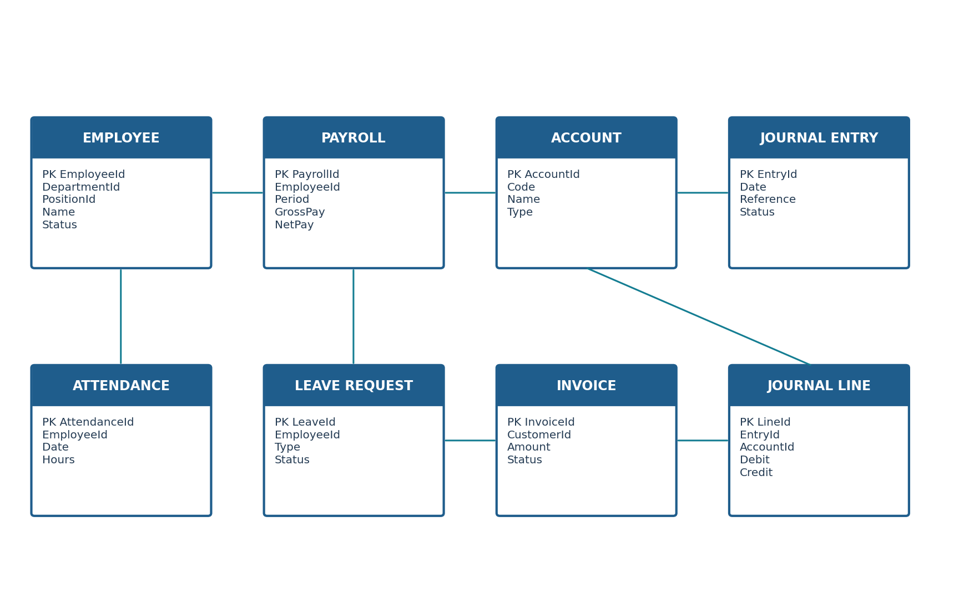
Figure 4. Simplified Entity Relationship Diagram — Core ERP Entities

REQUIREMENTS TRACEABILITY & BUSINESS LOGIC
The matrix connects key business needs with system functions, outputs, and expected business value.
Business Need | System Function | Primary Output | Business Value
Employee lifecycle | Employee Management | Employee profile, contract, status | HR accuracy
Workforce time | Attendance & Leave | Attendance records, leave balance | Payroll readiness
Compensation | Payroll | Gross pay, deductions, net pay | Accurate payroll
Financial control | Accounting | Journal entries, invoices, payments | Balanced ledger
Integration | Payroll → Accounting | Automated journal impact | Data consistency
Governance | RBAC & Audit | Authorized actions and audit trail | Accountability
Decision support | Reports & KPIs | HR and financial reports | Management visibility
Table 1. Requirements Traceability and Business Value

TECHNOLOGY STACK & TOOLS USED
The ERP is implemented using a modern full-stack environment covering frontend development, backend services, database management, security, API documentation, testing, and source control.
Category | Tool / Technology | Purpose in the System
Frontend | React 18 | Component-based ERP interface and reusable UI modules
Frontend Tooling | Vite | Development server and optimized production builds
UI / Styling | Tailwind CSS | Responsive utility-first styling and design system
UI Components | Bootstrap | Reusable layout and interface components
Backend | ASP.NET Core 10 Web API | RESTful APIs and application/business services
Data Access | Entity Framework Core 10 | ORM, LINQ queries, entities, and database access
Database | Microsoft SQL Server | Relational storage and transactional data
Authentication & Authorization | ASP.NET Core Identity + JWT | Authentication, RBAC, and secure API access
API Documentation | OpenAPI / Swagger | API documentation and endpoint testing
End-to-End Testing | Playwright | Browser-based workflow and E2E validation
Development | Visual Studio / VS Code | Coding, debugging, and project development
Version Control | Git + GitHub | Source control, collaboration, and project history
DEVELOPMENT WORKFLOW
React + Vite → ASP.NET Core Web API → Entity Framework Core → SQL Server → Identity/JWT → Swagger/OpenAPI → Playwright → Git/GitHub

