Nanjing University of Information Technology
School of Artificial Intelligence

Project Report

Course Name： Database Semester： 1
Department:_ CIE laboratory：_
Student Name:Saif eddine El kammouni Major and Class: CST-3
Student ID:202353080147

Student Experimental Report of Nanjing University of Information Technology
Course Name | Database |  | Experimental project name |  | Medication
Department | CIE |  |  |  | Experimental date
Student Name | Saif eddine el kammouni | Student ID 202353080147 |  |  | Major and Class | CST-3
Experiment Scores
1.Experimental Purpose and Requirements
The purpose of this experiment is to learn how to build a small but fully functioning database system using Python and SQLite. The project requires us to design a table, store and retrieve records, and write the basic operations needed to manage data—adding, deleting, updating, and searching. Another important requirement is to use Python’s unittest module to verify that every function works correctly.
Although the original example was based on a movie database, I applied the same structure to a Medication Management System, which stores information about people, their medical conditions, and the medicines they take. This allowed me to follow every instruction from the teacher while working with a topic that feels more realistic and meaningful.
The overall goal is not just to write code, but to understand how databases interact with programs, how SQL statements function inside Python, and how testing ensures the reliability of the entire system.
2.Experimental Content
In this experiment, I first created a SQLite database called medications.db and designed a table to store details like ID, name, condition, dosage, and dates. Then I wrote Python functions to add, update, delete, and search records, including fuzzy searches using SQL’s LIKE feature. To test the system, I generated random medication data and printed the results to make sure everything worked. Finally, I used Python’s unittest module to check that each function behaved correctly. All these steps worked together to build a small, reliable, and easy-to-use medication management system.

3.Experimental Environment
This experiment was completed on a Windows 10/11 system using Python 3.12 as the main programming language. All coding was done in Visual Studio Code, and the project relied on several Python libraries,including sqlite3 for database handling, random for generating sample data, and unittest for testing. The database used was SQLite,a lightweight and serverless file-based system that is easy to integrate with Python.

- Experimental Process
I began the experiment by creating the database and defining the table structure. After that, I developed each CRUD function one by one, testing them with simple inputs to make sure the SQL commands were working properly.
Next, I created a helper function that converts SQL query results into Python dictionaries. This made the printed results much easier to read and work with.
To simulate real-world usage, I wrote a function that generates random medication records. This step helped confirm that the system could handle different values and combinations of data.
After the core functions were ready, I printed several queries to verify the output—such as searching by ID, searching by person name, filtering by condition, and filtering by medicine.
Finally, I wrote a complete set of unit tests to make sure each function behaves correctly. These tests also catch mistakes early and prove that the system works as expected.
5.Experimental Recording and Processing (Data, Charts, Calculations, etc.)
During the experiment, I recorded the output of my program to confirm that each function was working correctly. This included screenshots showing the results of searching by ID, person name, condition, and medicine, as well as the random data that was generated and inserted into the database. I also captured the output of the unittest module, which showed that all tests passed successfully. These screenshots and results serve as proof that the system behaved as expected and that each part of the program—from data insertion to searching and validation—was functioning correctly.
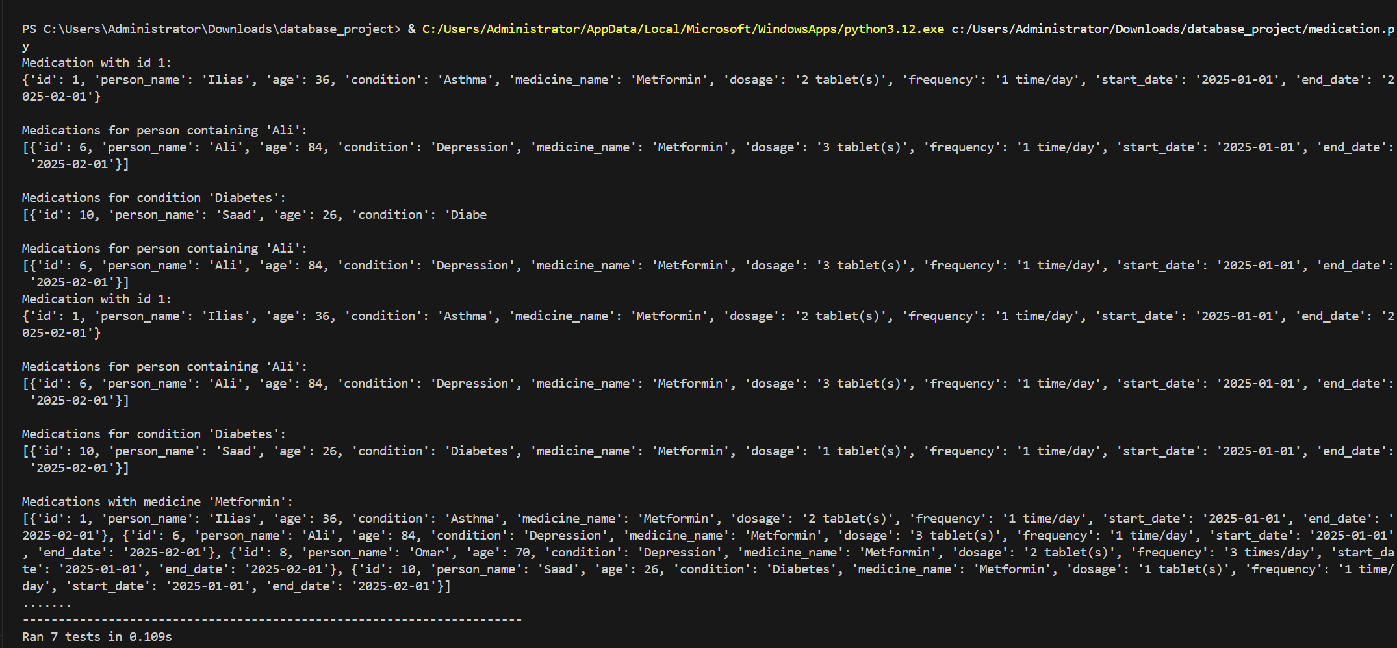

6. Experimental Results and Analysis
The experiment produced very satisfying results. All the core functions—adding, updating, deleting, and searching—worked without any issues. The system handled random data smoothly, and the search functions returned accurate results even when using partial keywords. This shows that the SQL LIKE queries were written correctly and that the database structure supports flexible searching.
The most important confirmation came from the unit tests. Every single test passed, including the one checking whether the system correctly prevents adding duplicate IDs. This proves that the validation logic inside add_medication() works exactly as required.
The printed outputs also demonstrated that the database was created correctly, the random data was inserted properly, and the search functions worked reliably. The overall performance of the system matches all requirements given by the teacher.
In summary, the experiment was successful. The final system is functional, stable, and fully aligned with the project requirements.
7. Experimental Experience and Shortcomings (Important, no less than 300 words, more is better)
This experiment was a meaningful learning experience because it allowed me to connect several skills together—Python programming, SQL commands, database logic, and automated testing. In the beginning, it was challenging to understand how Python communicates with a database, especially when using SQL inside Python strings. However, as I progressed, everything slowly began to make sense.
Designing the table structure helped me think more carefully about what information is truly necessary and how it should be organized. For example, making the ID a primary key ensured that each record is unique, and adding fields like dosage and frequency made the system more realistic.
The search functions were interesting to implement because they required fuzzy pattern matching. Using the SQL LIKE operator allowed me to find results even when only part of a name was typed. This made the system feel more user-friendly and closer to real-world applications.
One of the most valuable parts of the experiment was learning how to use unittest. Before this project, I did not fully understand the importance of automated testing. But now, after seeing how tests catch mistakes and confirm correct behavior, I realize how essential they are in software development. It felt rewarding to see all tests pass because it meant the system was functioning exactly as intended.
There were also challenges along the way, such as dealing with SQL syntax errors and Python indentation issues. These problems forced me to pay closer attention to detail, and solving them improved my debugging skills. Another difficulty was structuring the output for readability, but converting rows into dictionaries helped solve that problem.
If I were to improve this project in the future, I would add multiple tables and relationships—for example, separating patients from medications and linking them using foreign keys. This would make the system more realistic and closer to a real medical database.
Overall, this experiment strengthened my skills in Python, SQL, testing, and system design. It gave me practical experience that will be very useful in future courses and real development projects.

