**Part 1 : Augmented Reality Book Tracking and Movie Overlay**

This project implements a simple augmented reality pipeline that overlays a movie onto a book detected in a video stream. Using feature detection, homography estimation, and image warping, the content of one video (a movie) is dynamically projected onto the cover of a book as it appears in another video.

**Algorithm Explanation**

1. **Feature Matching with SIFT :** We use Scale-Invariant Feature Transform (SIFT) to detect and describe local keypoints on both the reference book image and the current video frame.
2. **A book with a picture of a moose

   AI-generated content may be incorrect.Lowe’s Ratio Test & Match Selection:** We apply Lowe’s ratio test to filter good matches and select the top 50 most reliable ones.
3. **A group of books on a table

   AI-generated content may be incorrect.Homography Estimation** Using the matched keypoints, we estimate a homography matrix H that transforms points from the book image to the current frame.
4. 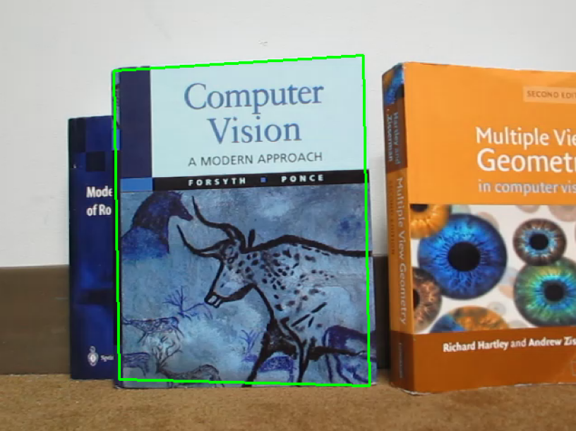**Book Localization:** With the homography matrix, we warp the corners of the reference book image to locate it in the frame.
5. A group of books on a blue surface

   AI-generated content may be incorrect.**Movie Cropping and Overlaying:** To maintain aspect ratio and remove top/bottom artifacts from the movie, we crop it accordingly before projection. The cropped movie frame is warped to match the shape and perspective of the detected book using another homography, then blended into the video frame.

We then looped over both videos and performed these steps to produce the final overlayed video.

**Part 2**