Software Requirements
Specification
for

<wordle-Game>

Version 1.0 approved

Prepared by <author>

<organization>

<date created>

Copyright © 1999 by Karl E. Wiegers. Permission is granted to use, modify, and distribute this document.

Introduction

Purpose

The purpose of this document is to describe the requirements of the Wordle Game System. It explains the system functions and constraints and serves as a reference for development.

Document Conventions

All requirements in this document are written using the format "The system shall" to clearly define system behavior. Each requirement is uniquely identified for easy reference.

Intended Audience and Reading Suggestions

This document is intended for developers, testers, project managers, and instructors. Developers should focus on the functional requirements, while testers should focus on validating the system behavior. Project stakeholders can review the overall description and system features.

Product Scope

The Wordle Game System is a simple word guessing application where users attempt to guess a hidden word within a limited number of attempts. The system provides feedback after each guess to help the user identify correct and incorrect letters. The goal of the system is to provide an interactive and enjoyable gameplay experience.

References

- IEEE 830 Software Requirements Specification Standard

Overall Description

Product Perspective

The Wordle Game System is a standalone application that does not depend on external systems. It is designed as a simple game that runs independently on a user’s device.

Product Functions

The system provides the following main functions:
- Start a new game session
- Generate a random hidden word
- Accept user guesses
- Validate user input
- Provide feedback after each guess
- Display the final result (win or lose)

User Classes and Characteristics
The system is designed for general users who enjoy word games. Users are expected to have basic computer skills and be able to input text using a keyboard. No advanced technical knowledge is required.

Operating Environment
The system operates on personal computers using a standard operating system such as Windows. It requires a keyboard for input and a screen to display output.

Design and Implementation Constraints

- The hidden word must have a fixed length (e.g., 5 letters).
- The number of attempts is limited (e.g., 6 attempts).
- The system should be implemented using a programming language suitable for simple applications.

User Documentation

The system will include basic user instructions that explain how to play the game and understand the feedbackprovided.

Assumptions and Dependencies
- The user has access to a keyboard and display.
- The system uses a predefined list of words.

System Features

This feature allows the user to play the Wordle game by guessing a hidden word.

System Features

FR1: The system shall allow the user to Log in.

FR2: The system shall allow the user to start a new game.

FR3: The system shall generate a random hidden word at the beginning of each game.

FR4: The system shall ensure that the hidden word has a fixed length (e.g., 5 letters).

FR5: The system shall allow the user to enter a guess .

FR6: The system shall validate that the entered guess matches the required word length.

FR7: The system shall reject invalid input and display an error message.

FR8: The system shall compare the user’s guess with the hidden word.

FR9: The system shall provide feedback for each letter in the guess indicating:
- Correct letter in the correct position.
- Correct letter in the wrong position.
- Incorrect letter.

FR10: The system shall display the feedback clearly to the user after each guess.

FR11: The system shall keep track of the number of attempts made by the user.

FR12: The system shall limit the number of attempts to a maximum of six.

FR13: The system shall end the game when the user guesses the correct word.

FR14: The system shall end the game when the user reaches the maximum number of attempts.

FR15: The system shall display a success message when the user wins.

FR16: The system shall display a failure message when the user loses.

FR17: The system shall allow the user to restart the game after it ends.

Other Nonfunctional Requirements

Performance Requirements

NFR1: The system shall respond to user input within 1 second.

NFR2: The system shall process each guess and display feedback immediately.

NFR3: The system shall handle multiple game sessions without noticeable delay

Usability Requirements

NFR4: The system shall provide a simple and easy-to-use interface.
NFR5: The system shall display clear instructions for gameplay.
NFR6: The system shall provide understandable feedback after each guess.
NFR7: The system shall be usable by users with basic computer skills.

Software Quality Attributes

NFR8: The system shall be maintainable and easy to update.
NFR9: The system shall be modular to allow future enhancements.
NFR10: The system shall be testable using predefined test cases.

Business Rules

BR1: The system shall use words from a predefined list of valid words.

BR2: The hidden word shall have a fixed length (e.g., 5 letters).

BR3: The user is allowed a maximum of 6 attempts per game.

BR4: Each guess must be a valid word from the predefined list.

BR5: The system shall evaluate each guess according to the Wordle rules:
- Correct letter in the correct position.
- Correct letter in the wrong position.
- Incorrect letter.

BR6: The game shall end immediately when the correct word is guessed.

BR7: The game shall end when the maximum number of attempts is reached.

BR8: The user shall be allowed to start a new game after finishing the current one.

USE CASE DIAGRAM

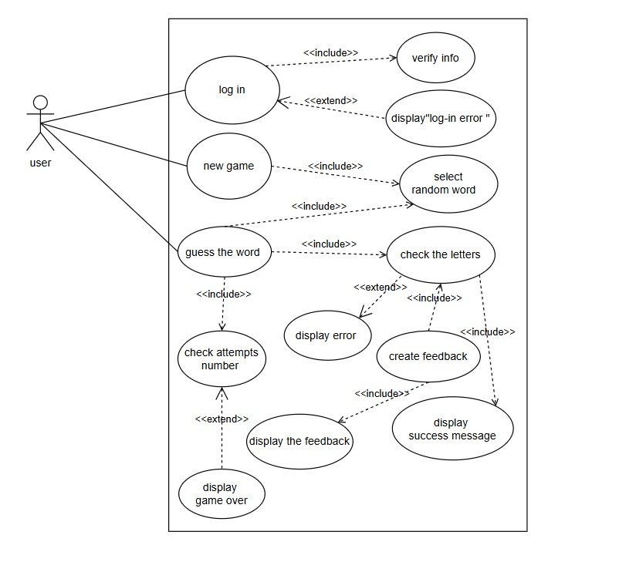

Appendix A: Glossary

Guess: A word entered by the user as an attempt to match the hidden word.

Attempt: A single try made by the user to guess the word.

Hidden Word: The randomly generated word that the user must guess.

Feedback: The response provided by the system after each guess indicating correct and incorrect letters.

Correct Position: A letter that is correct and placed in the right position.

Wrong Position: A correct letter placed in the wrong position.

Invalid Input: Any input that does not meet the required conditions (e.g., wrong length).

Game Session: A single round of the game from start to end.

Win: When the user correctly guesses the hidden word.

Lose: When the user fails to guess the word within the allowed attempts.

Appendix B: Analysis Models

This section includes the analysis models used to describe the system structure and behavior.

The following models are included:

- Use Case Diagram: Represents the interaction between the user and the system, including starting a game, entering guesses, and viewing results.

- Entity Relationship Diagram (ERD): Describes the main entities in the system such as User, Game, and Attempt, and their relationships.

These models help in understanding the system design and behavior.

