# Table of Contents

Table of Contents 1

Table of Figures 2

Chapter 1 3

Introduction 3

Chapter 2 4

Feasibility Studies and Requirement Analysis 4

2.1 Users 4

2.2 Feasibility Studies 5

2.3 Requirement Analysis 5

Chapter 3 6

Design and Implementation 6

3.1 Design 6

3.1.1 Context Diagram 6

3.1.2 Activity diagram 7

3.2 Implementation 8

Chapter 4 17

Future Works 17

4.1 Show status of cleaning process 17

4.2 Rating system 17

4.3 Settings 17

Chapter 5 18

Conclusions 18

# Table of Figures

Figure 1: Context Diagram 6

Figure 2: Activity Diagram 7

Figure 3: Log In 8

Figure 4: Sign Up 8

Figure 5: Home Fragment (Laundry User) 9

Figure 6: Schedule Pickup 9

Figure 7: Scheduling Date 10

Figure 8: Scheduling Time 10

Figure 9: Profile Fragment 11

Figure 10: Hello Fragment 11

Figure 11: Hello Fragment (Rotate) 12

Figure 12: Showing Location of Laundry 12

Figure 13: FAQs 13

Figure 14: Pickup Request Activity 13

Figure 15: Pickup Request Activity (Showing Laundryman) 14

Figure 16: Getting Laundry 14

Figure 17: Home (Laundry Partner) 15

Figure 18: Getting Request 15

Figure 19: Showing distance 16

# Chapter 1

# Introduction

Laundry system is a very common thing in our society. Laundry means cleaning clothes and some other household accessories. There are a lot of laundry around us where laundrymen work as professionals. Though it’s a widely used system, unfortunately the system is still analog and hasn’t seen any touch of digitalization. As a result, the efficiency of this system is not so good. Bringing this system under a digitalized process will highly increase the efficiency of this system.

In this modern world we are watching that every part of our life is getting digitalized. We have seen apps like Uber, Pathao, Food Panda etc. which are making our everyday life easier day by day. We are using mobile and computer to do some of our daily activities in a much better and efficient way by using these apps. Our idea was to digitalize the laundry system by making an app like Uber which will help us to get the laundry system in our doorstep. Digital Laundry will bring different types of user of laundry system under a digitalized process which will help all of them and also create a new employment source in our society. All types of user can use this app for their own purpose. We have used Android Studio, XML, Java, Firebase and Google Map API to build this mobile app.

# Chapter 2

# Feasibility Studies and Requirement Analysis

## 2.1 Users

There are four kinds of users in this app:

* Laundry Partners
* Laundry Users
* Laundry Freelancers
* Admins

#### Laundry Partners

Laundry partners are professional cleaners in real life. They clean clothes in their own laundry shop in exchange of money. Our app will take them under a contract. They will take order from Laundry Users and clean their clothes in exchange of money.

#### Laundry Users

Laundry users are general people. They will clean their clothes with the help of

Digital Laundry. They will give orders to Laundry Partners and later pay them for

cleaning their clothes.

#### Laundry Freelancers

Laundry Freelancers are special type of users who can earn money by using this app

by doing some freelancing work. They can either work as a deliveryman or a

freelancer cleaner.

#### System Admins

System Admins are responsible for the operation and maintenance of the system. They will always keep the system updated with the latest technologies. They will keep updated the contents and the design. They will occasionally measure the search accuracy and update the system as per the requirement.

### 2.2 Feasibility Studies

Feasibility study is the assessment of the practicality of a project. Before starting any project, one has to assess that the project is practical or not. We have studied the feasibility of our project and our judgements are expressed in all the four dimensions of feasibility studies below.

* Technology: The project is technically feasible as we have all the hardware and software capabilities.
* Finance: It is a financially feasible project as most of the resources are free and we have a large group of potential customers who are willing to use this type of services if offered.
* Time: This project is supposed to be completed within time.
* Resources: All the resources to build the system are also available free of costs except the Google Maps API which has also a free version with limited accessibility.

### 2.3 Requirement Analysis

For this project requirement analysis has been done from each of the user’s perspective.

#### 2.3.1 User’s perspective:

* The search option must be fast and accurate.
* The system should be self-explanatory.
* Response time must not exceed 5 seconds.
* System must not disclose users’ personal information to outsiders.
* There must be embedded virtual maps for identifying the locations accurately.

#### 2.3.2 Admin’s perspective:

* The system must be easy to maintain.
* The system must provide monthly usage data.
* The system must always be ready for the new technology incorporations.
* The user membership requests should be auto processed.

#### 2.3.3 Other requirement:

* The system must be able to distinguish each user with a unique user id.
* The system must support up to 5,000 simultaneous users and up to 100,000 users overall.

# Chapter 3

# Design and Implementation

## 3.1 Design

In the design of the system we finalized how each stakeholder will interact with the system. And for this purpose, context diagram and activity diagram have been drawn.

### 3.1.1 Context Diagram

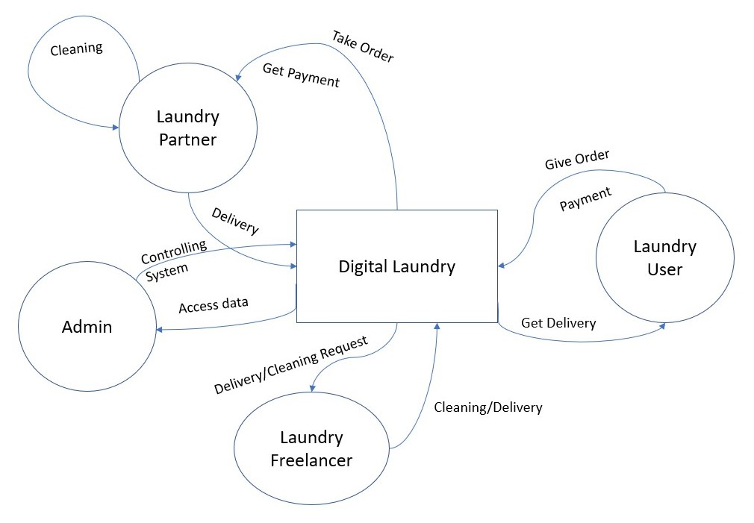

Figure : Context Diagram

### 3.1.2 Activity diagram

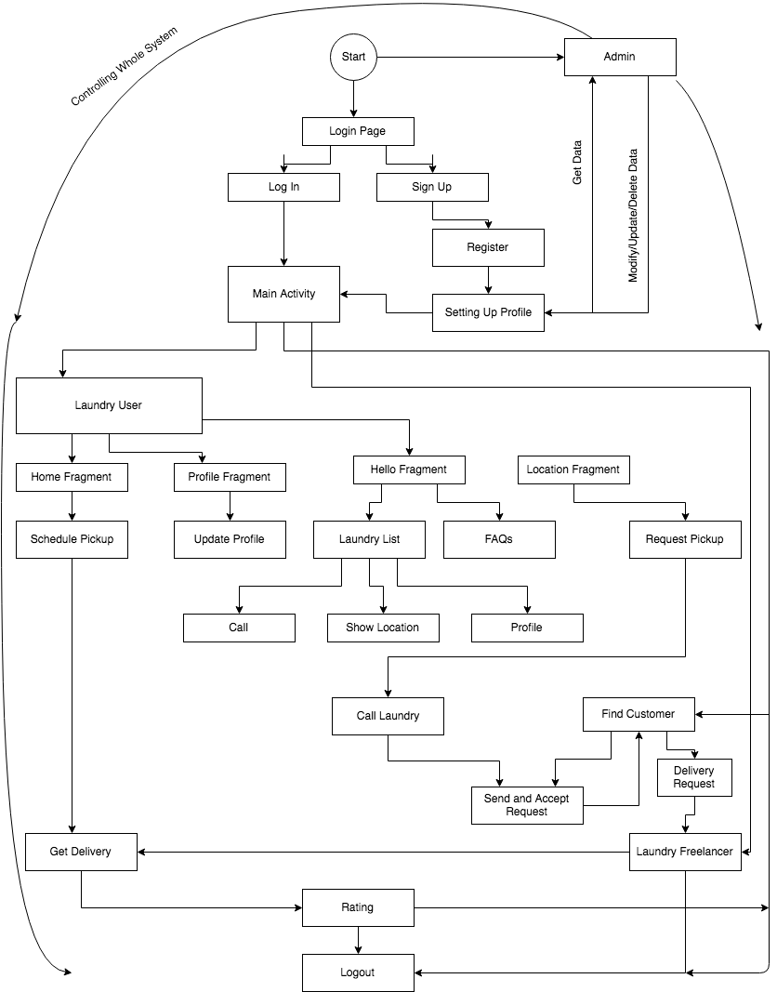

Figure : Activity Diagram

## 3.2 Implementation

We have built the mobile interfaces for our system.

Considering the user number and availability we have chosen android as our go to platform to build the mobile app. We have used Android Studio, XML, Java, firebase and Google Map API.

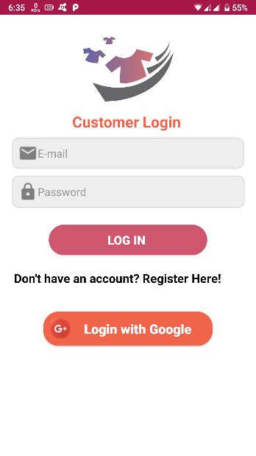

Figure : Log In

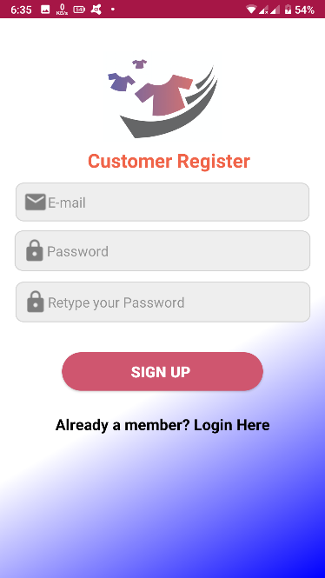

Figure : Sign Up

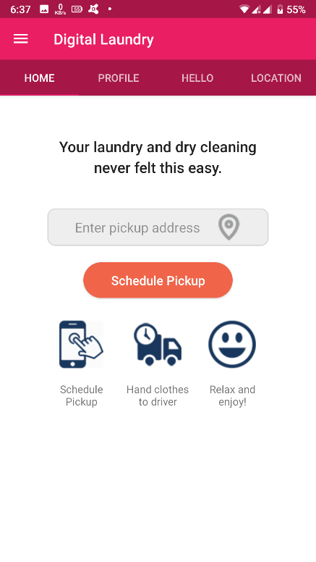

Figure : Home Fragment (Laundry User)

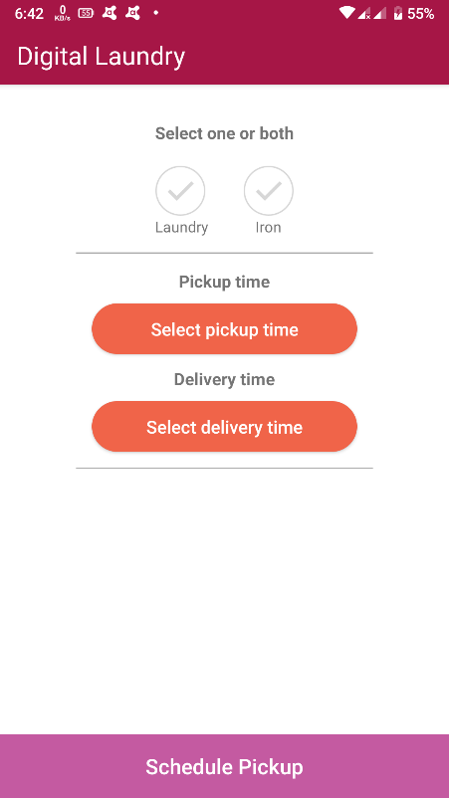

Figure : Schedule Pickup

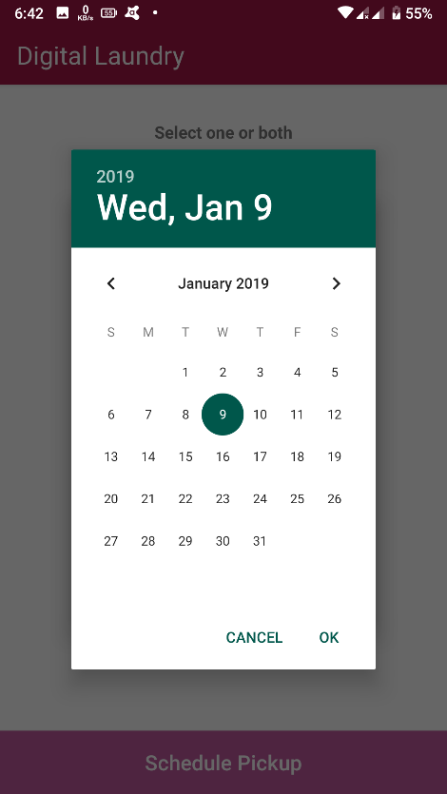

Figure : Scheduling Date

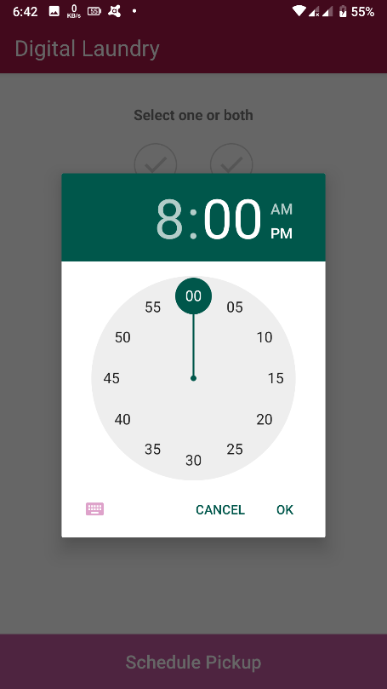

Figure : Scheduling Time

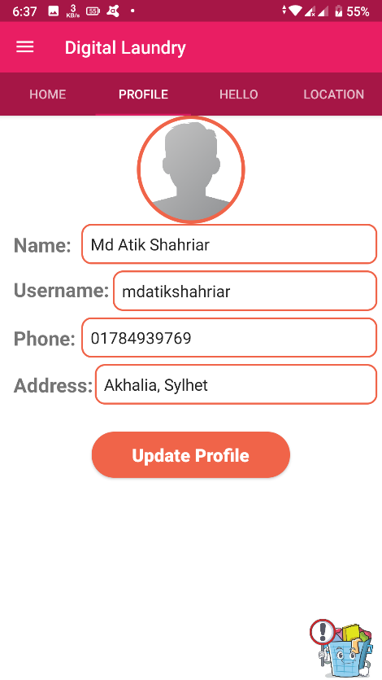

Figure : Profile Fragment

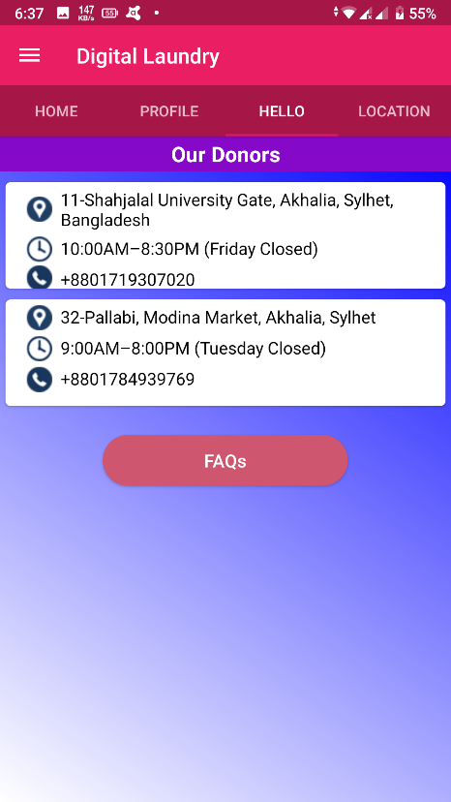

Figure : Hello Fragment

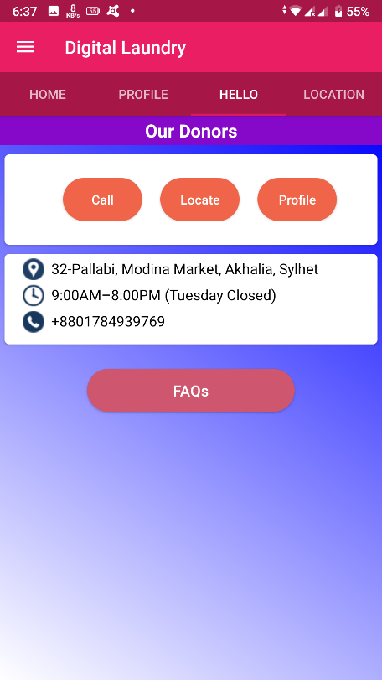

Figure : Hello Fragment (Rotate)

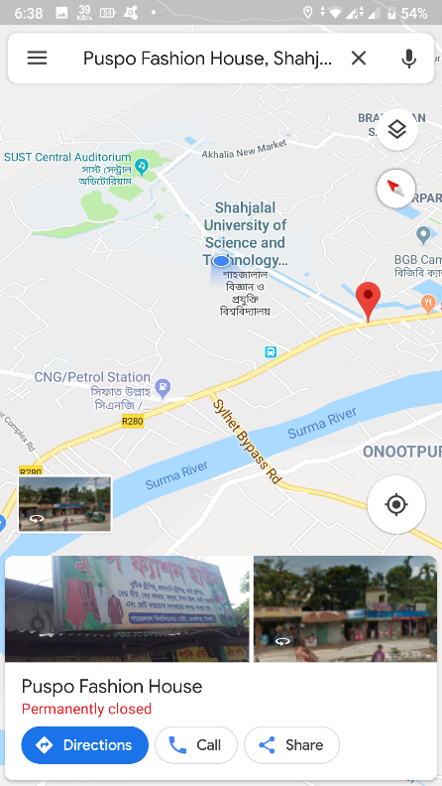

Figure : Showing Location of Laundry

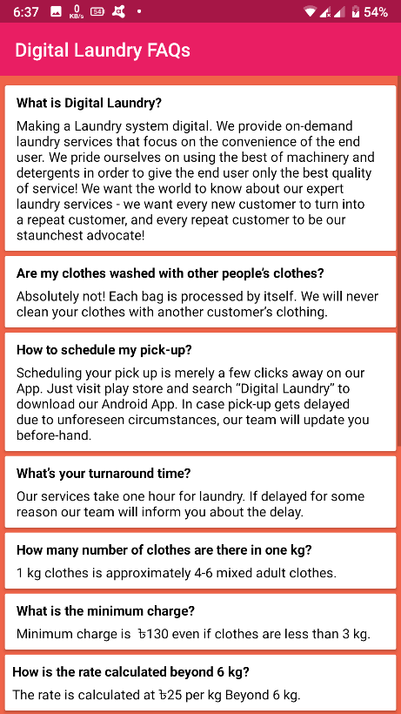

Figure : FAQs

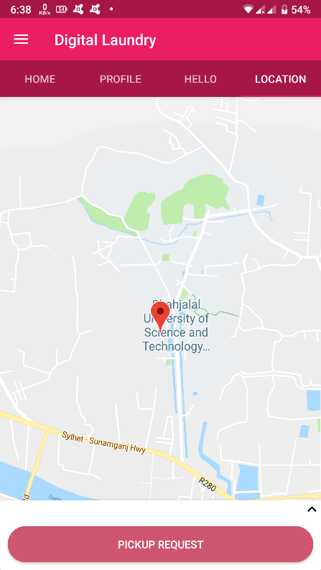

Figure : Pickup Request Activity

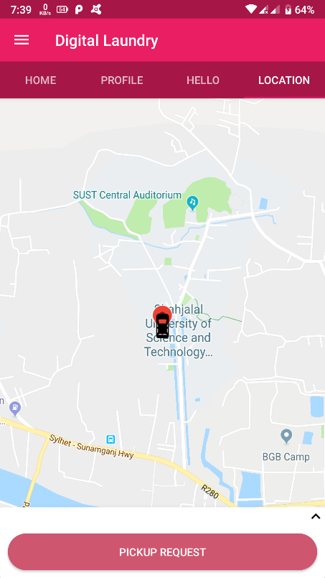

Figure : Pickup Request Activity (Showing Laundryman)

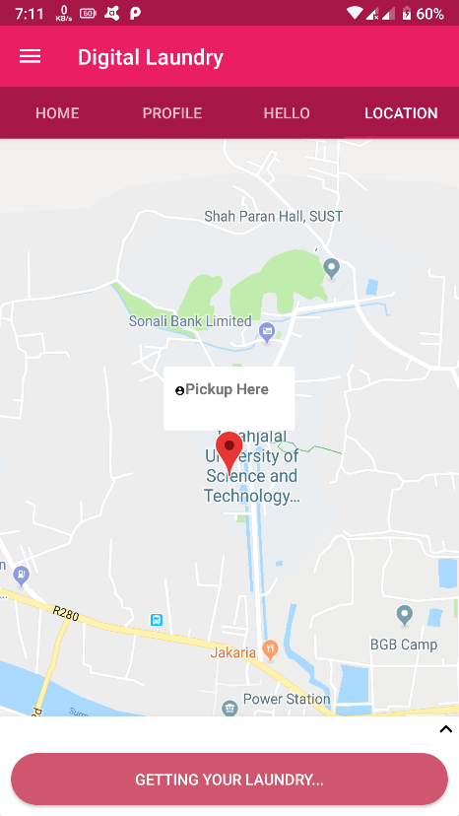

Figure : Getting Laundry

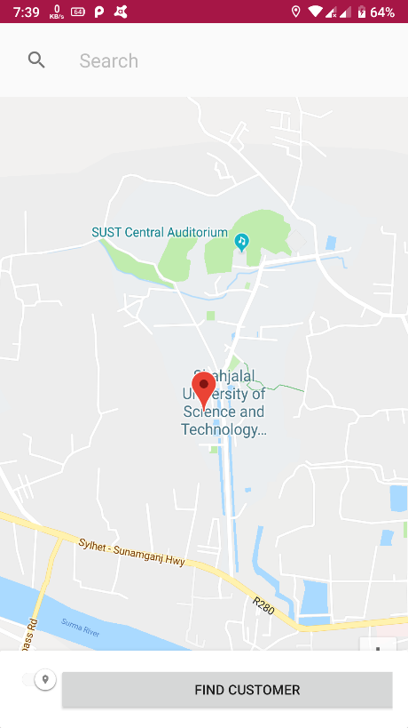

Figure : Home (Laundry Partner)

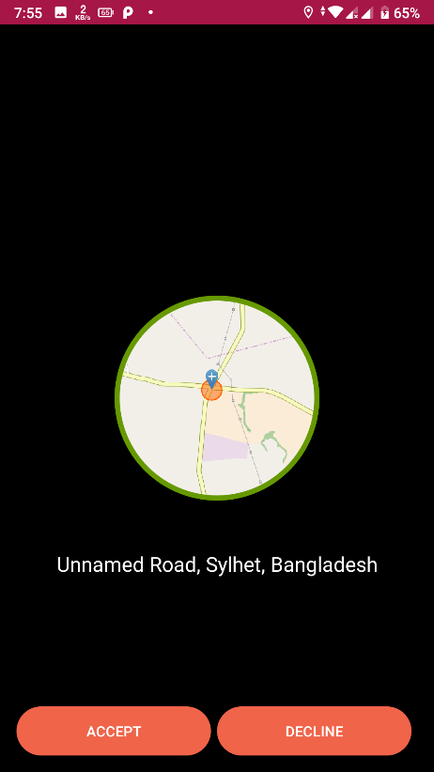

Figure : Getting Request

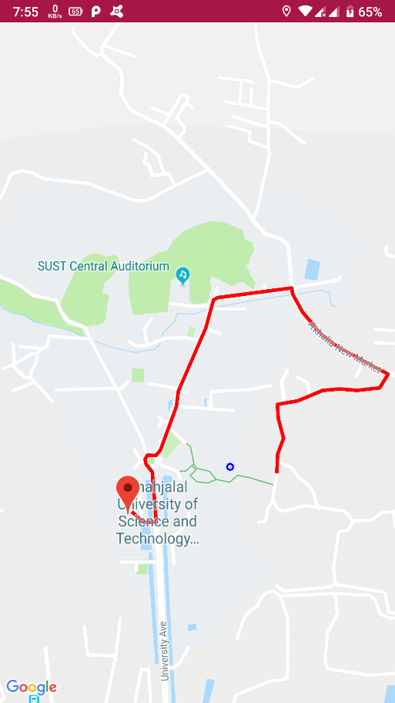

Figure : Showing distance

# Chapter 4

# Future Works

## 4.1 Show status of cleaning process

In the future, we will add real time update of cleaning process. By this user will be able to know what’s the current status of cleaning.

## 4.2 Rating system

User will be able to rate the cleaning of a Laundry Partner. For every partner there will be a rating which will be updated regularly on the basis of user’s feedback.

## 4.3 Settings

Every type of user will be able to change the settings of the app.

# Chapter 5

# Conclusions

In this world of digital revolution, most people of our country are still dependent on the old traditional way for laundry. Most people in our country still go to laundry moving physically here and there by wasting time and energy. Most laundry still use small notice boards and leaflets to advertise. But we are hopeful. We think, with the increasing number of internet users and increasing digital literacy in our country the conditions will change very soon. And we truly believe that, this type of projects can bring about changes in this market.