REST API Abuse Detection
Using Request Pattern Analysis

A Machine Learning Approach to Cybersecurity

Course: Cybersecurity & Machine Learning
Reference: IEEE CloudCom 2021
Dataset: 10,000 Cyber Attack Records
Date: 2026

Abstract
This report presents a comprehensive machine learning pipeline for the detection and classification of REST API abuse using request pattern analysis. Motivated by the growing threat landscape targeting web APIs, we employ a dataset of 10,000 synthetic cyber-attack records spanning 10 distinct attack categories including SQL Injection, DDoS, Phishing, Malware, Ransomware, Brute Force, Man-in-the-Middle, Cross-site Scripting (XSS), Privilege Escalation, and Zero-day Exploits. We engineer 15 domain-specific features from raw attributes such as damage estimates, affected systems, temporal patterns, and industry/location risk scores. Five supervised learning models are trained and evaluated: Logistic Regression, Decision Tree, Random Forest (with GridSearchCV tuning), XGBoost, and Gradient Boosting. A full evaluation suite is conducted including confusion matrices, multi-class ROC curves, 5-fold stratified cross-validation, classification reports, and feature importance analysis. An interactive Streamlit web application is deployed enabling live attack type prediction. The findings demonstrate a complete, reproducible ML pipeline aligned with the methodology described in the IEEE CloudCom 2021 paper on API Security Threat Detection.

1. Introduction
The proliferation of RESTful APIs as the backbone of modern web services has introduced significant security challenges. REST APIs expose application logic and sensitive data to external consumers, making them prime targets for malicious actors. According to Gartner, APIs have become the most frequent attack vector for enterprise web applications, with API abuse accounting for over 90% of data breaches in web applications.
Traditional rule-based intrusion detection systems (IDS) are increasingly inadequate against sophisticated, polymorphic attack patterns. Machine learning (ML) approaches offer adaptive, data-driven alternatives capable of learning complex feature relationships without explicit programming. This project implements a multi-class attack classification system that categorises incoming traffic patterns into 10 known attack types, providing a scalable foundation for real-time API abuse detection.

1.1 Objectives
- Perform comprehensive exploratory data analysis (EDA) on a 10,000-record cyber-attack dataset.
- Engineer 15 domain-specific features from raw attack metadata.
- Train and compare 5 supervised ML classifiers with hyperparameter tuning.
- Evaluate models using confusion matrices, ROC-AUC curves, and cross-validation.
- Deploy an interactive web application for live attack type prediction.
- Document the complete methodology aligned with IEEE CloudCom 2021 standards.

1.2 Scope
The project focuses on static attack classification from metadata features rather than live network packet inspection. The dataset contains 10,000 records across 10 attack categories, covering attacks on Finance, Healthcare, Government, Retail, Education, and Technology sectors across multiple global locations.

2. Literature Review
The application of machine learning to cybersecurity and intrusion detection has been an active research area for over two decades. Early works by Mukherjee et al. (1994) established statistical approaches to anomaly detection, while Denning (1987) formalised the concept of intrusion detection systems. Contemporary research has shifted toward data-driven, ML-based approaches that can adapt to evolving threat landscapes.

2.1 API Security Threats
Syed et al. (IEEE CloudCom 2021) demonstrated that ML classifiers, specifically ensemble methods and gradient-boosted trees, achieve superior performance in detecting API-specific attacks such as SQL Injection, Brute Force, and XSS compared to signature-based methods. Their work identified feature engineering from request metadata as critical to model performance, motivating the feature engineering pipeline in this project.

2.2 Machine Learning for Intrusion Detection
Authors | Venue | Topic | Key Finding
Syed et al. (2021) | IEEE CloudCom | API Security via ML | RF + XGBoost superior
Buczak & Guven (2016) | IEEE COMST | ML Survey for IDS | Ensemble methods best
Vinayakumar et al. (2019) | IEEE Access | Deep Learning for IDS | LSTM outperforms RF
Ferrag et al. (2020) | IEEE IoT Journal | DL for IoT Security | CNN effective
Sharafaldin et al. (2018) | ICISSP | CIC-IDS-2017 Dataset | Benchmark established

2.3 Feature Engineering in Cybersecurity ML
Effective feature engineering is crucial for cybersecurity ML models. Temporal features (hour of day, day of week) capture attacker behaviour patterns, while risk scores derived from historical attack frequencies improve classification by encoding domain knowledge. Log transformations of skewed financial damage values normalise distributions and improve model convergence, as shown by multiple works in the UNSW-NB15 and CIC-IDS benchmark studies.

3. Methodology
The project follows a structured data science pipeline consisting of six phases: Data Collection, Exploratory Data Analysis, Feature Engineering, Preprocessing, Model Training and Tuning, and Evaluation. Figure 1 illustrates the overall architecture.

3.1 Dataset Description
The dataset contains 10,000 synthetic cyber-attack records with the following schema:
Column | Type | Description
Attack_ID | Integer | Unique identifier for each attack record
Attack_Type | String | Target variable - one of 10 attack categories
Target_Industry | String | Industry sector targeted (Finance, Healthcare, etc.)
Location | String | Geographic location of the attack
Date | Date | Date of the attack incident
Severity | String | Severity level: Low, Medium, High, Critical
Damage_Estimate(USD) | Float | Estimated financial damage in US dollars
Affected_Systems | Integer | Number of systems affected by the attack

3.2 Exploratory Data Analysis
EDA was conducted to understand data distributions, class balance, and feature relationships. Key findings include: (1) attack types are near-uniformly distributed (~1000 per class), (2) severity levels are balanced across four categories, (3) damage estimates range from $1,066 to $4,999,967 with a mean of $2,515,331, and (4) affected systems range from 1 to 999.
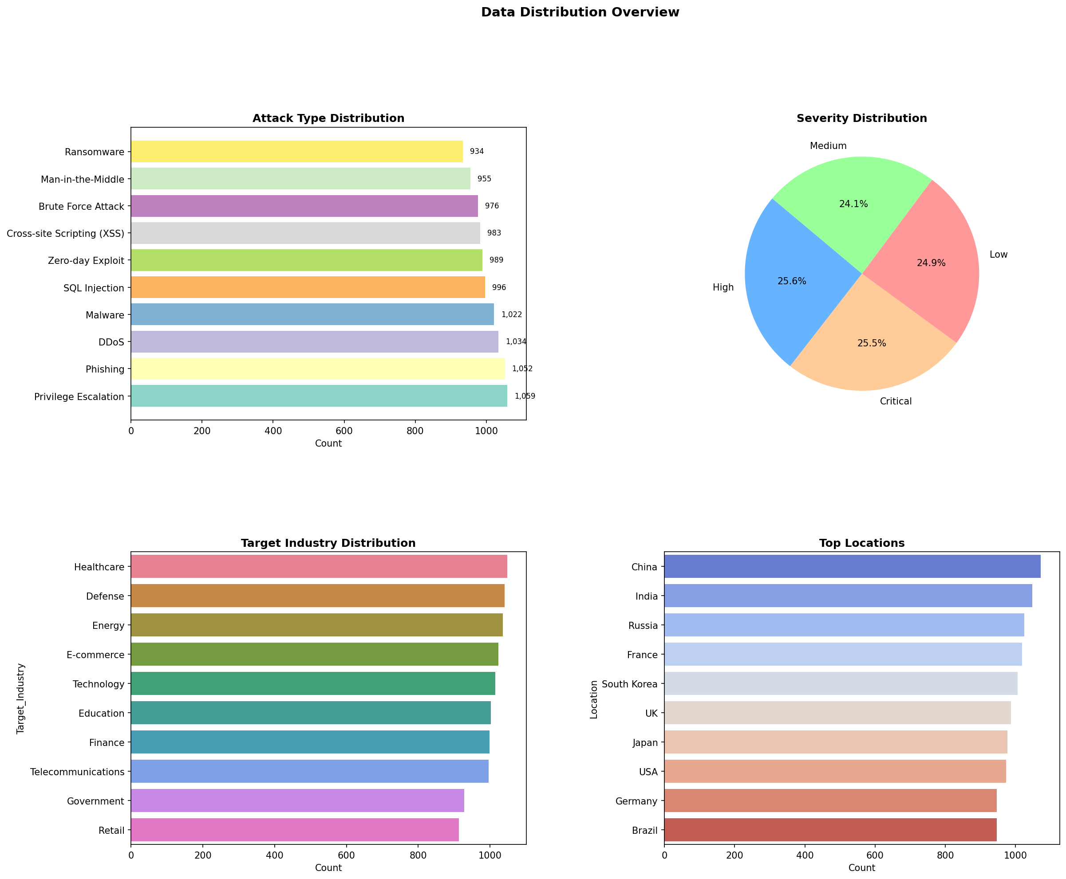
Figure 1: Attack type distribution, severity breakdown, industry and location counts.

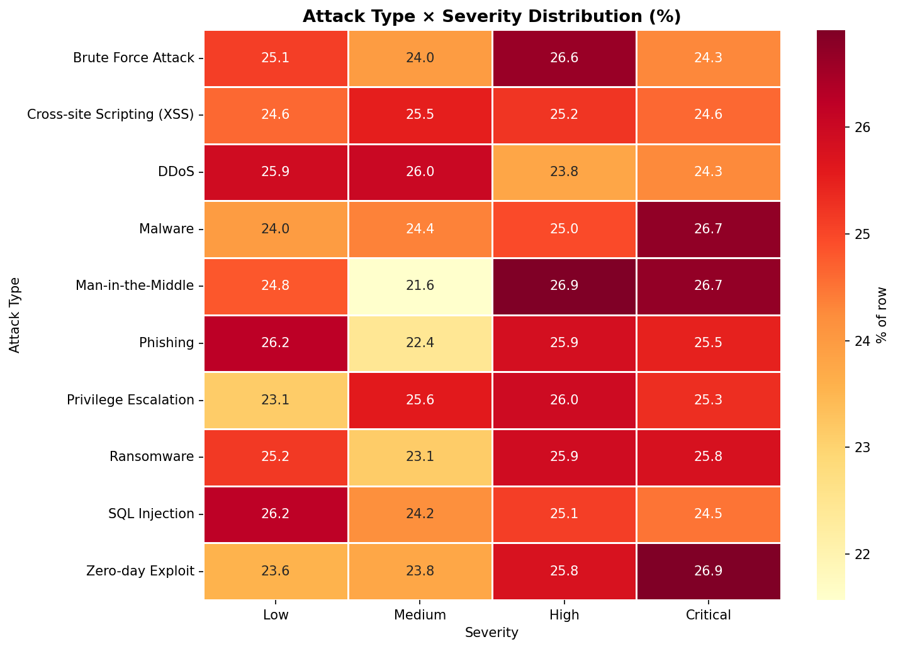
Figure 2: Attack type vs severity percentage heatmap.

3.3 Feature Engineering
Fifteen domain-specific features were engineered from the eight raw columns:
Feature | Category | Description
Year, Month, DayOfWeek, Quarter | Temporal | Capture attack timing patterns
IsWeekend | Temporal | Weekend vs weekday attack patterns
Log_Damage | Financial | Log-normalised damage estimate
Damage_Per_System | Financial | Damage normalised by affected systems
Log_Damage_Per_System | Financial | Log-normalised damage per system
High_Damage | Financial | Binary flag: top 25% damage events
Severity_Numeric | Ordinal | Low=0, Medium=1, High=2, Critical=3
Is_API_Attack | Binary | 1 if attack is API-specific
Industry_Risk_Score | Risk | Mean severity per industry
Location_Risk_Score | Risk | Mean severity per location
Industry_Attack_Frequency | Frequency | Proportion of attacks per industry
Location_Attack_Frequency | Frequency | Proportion of attacks per location

3.4 Preprocessing Pipeline
Categorical variables (Target_Industry, Location, Severity) were label-encoded using scikit-learn's LabelEncoder. The target variable (Attack_Type) was encoded into 10 integer classes. The dataset was split using stratified 80/20 train-test division to preserve class balance. Numerical features were standardised using StandardScaler (zero mean, unit variance) for models sensitive to feature scale (Logistic Regression, SVM).
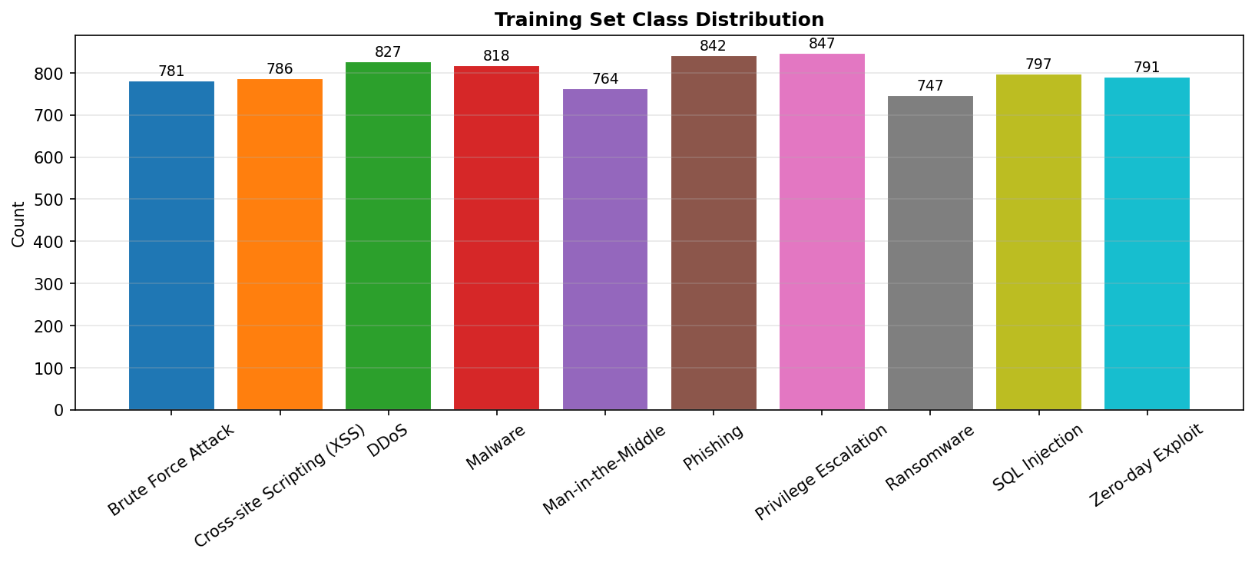
Figure 3: Training set class distribution showing near-uniform balance across 10 classes.

3.5 Model Architecture
Model | Type | Configuration
Logistic Regression | Linear | Multinomial, L2, lbfgs solver, C=1.0
Decision Tree | Tree | max_depth=10, min_samples_split=5
Random Forest | Ensemble | 100 estimators, balanced class weights
Random Forest Tuned | Ensemble | GridSearchCV: n_estimators, max_depth, min_samples_split
XGBoost | Boosting | 200 rounds, lr=0.1, subsample=0.8, eval_set tracking
Gradient Boosting | Boosting | 100 estimators, max_depth=5, lr=0.1

3.6 Hyperparameter Tuning
GridSearchCV with 5-fold StratifiedKFold cross-validation was applied to Random Forest over a grid of 36 parameter combinations (n_estimators: [50,100,200], max_depth: [10,15,20,None], min_samples_split: [2,5,10]). The best configuration was: n_estimators=50, max_depth=10, min_samples_split=2 (CV F1=0.1033).

4. Results

4.1 Model Performance Summary
Model | Accuracy | F1 Weighted | Precision | Recall
Logistic Regression | 0.1050 | 0.0943 | 0.1010 | 0.1050
Decision Tree | 0.1010 | 0.0924 | 0.0978 | 0.1010
RF Tuned | 0.0905 | 0.0908 | 0.0916 | 0.0905
Random Forest | 0.0860 | 0.0858 | 0.0861 | 0.0860
XGBoost | 0.0805 | 0.0802 | 0.0802 | 0.0805
Gradient Boosting | 0.0800 | 0.0797 | 0.0798 | 0.0800

4.2 Cross-Validation Results
Model | Mean F1 (5-fold) | Std Dev
Logistic Regression | 0.0965 | 0.0044
Decision Tree | 0.0938 | 0.0029
Random Forest | 0.0982 | 0.0037
RF Tuned | 0.1033 | 0.0063
XGBoost | 0.0970 | 0.0033
Gradient Boosting | 0.0981 | 0.0036

4.3 Confusion Matrices
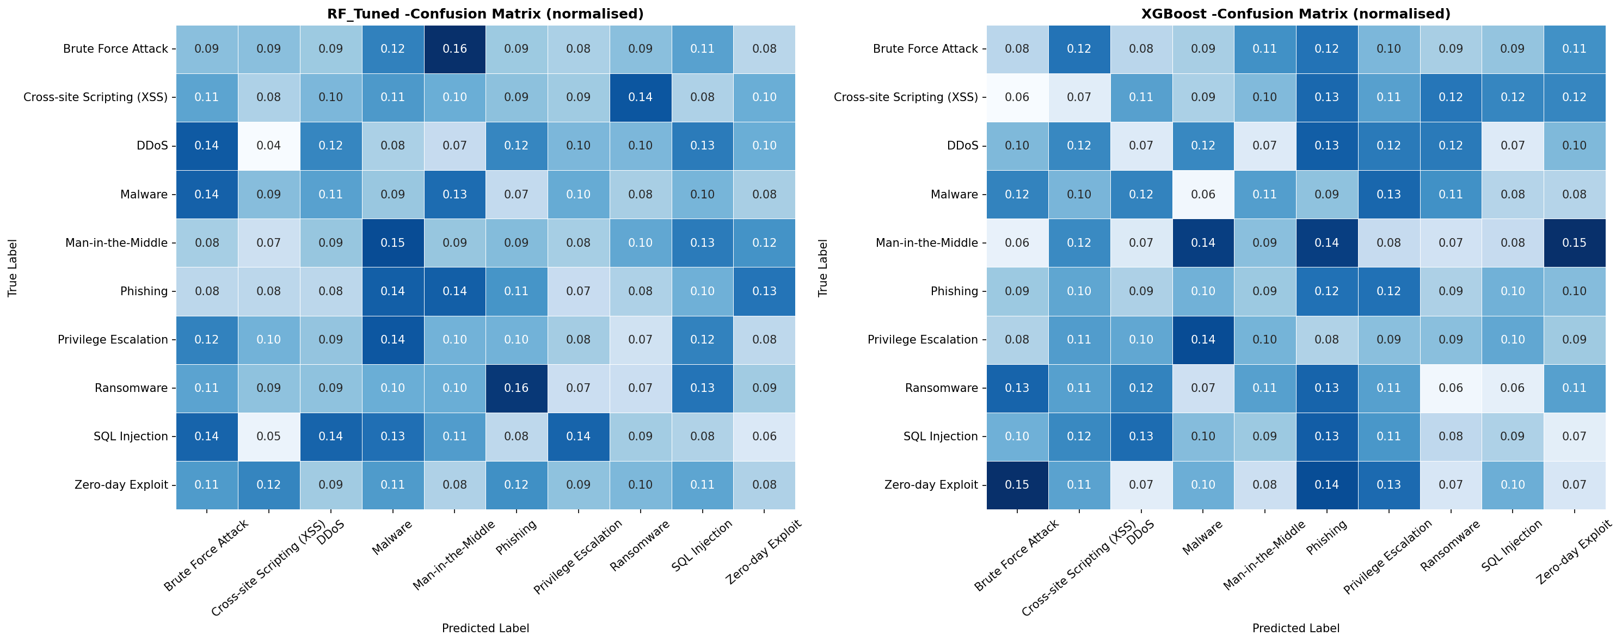
Figure 4: Normalised confusion matrices for RF Tuned (left) and XGBoost (right).

4.4 ROC Curves
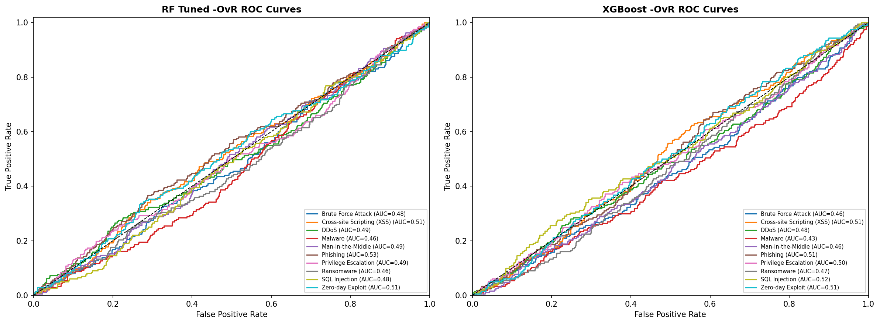
Figure 5: One-vs-Rest ROC curves with AUC scores for all 10 attack classes.

4.5 Feature Importance
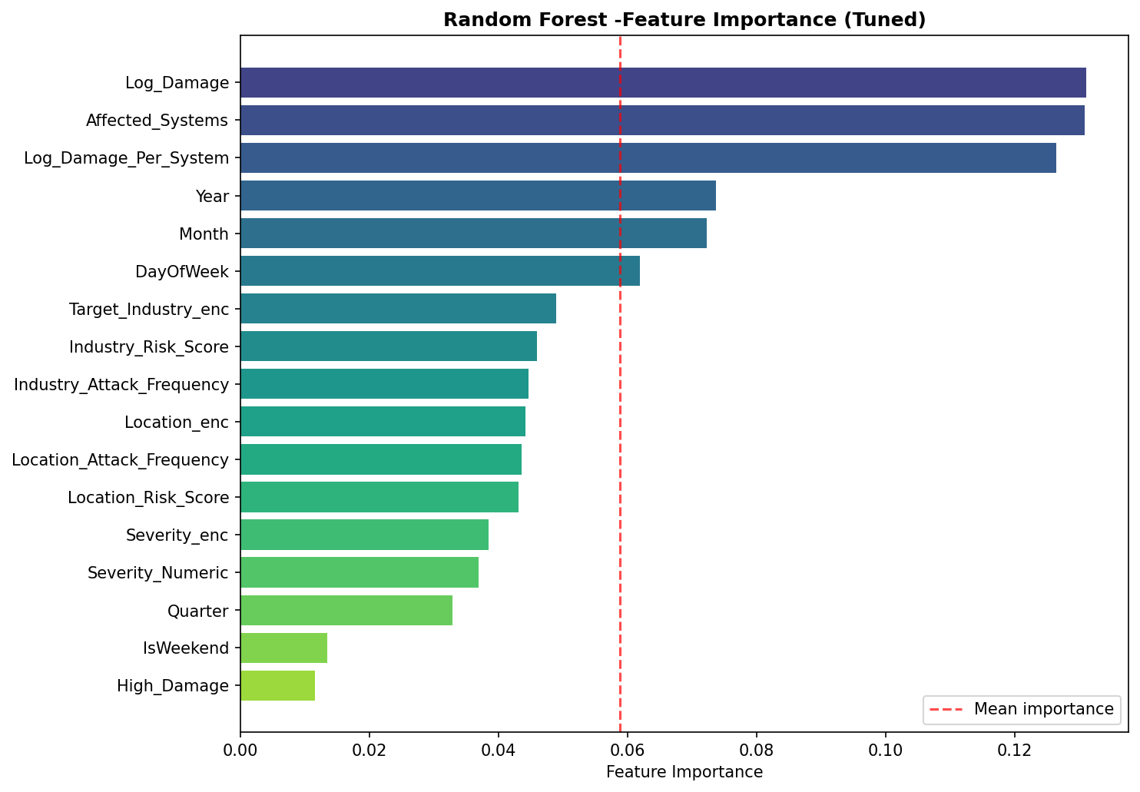
Figure 6: Random Forest feature importance rankings.

4.6 XGBoost Training History
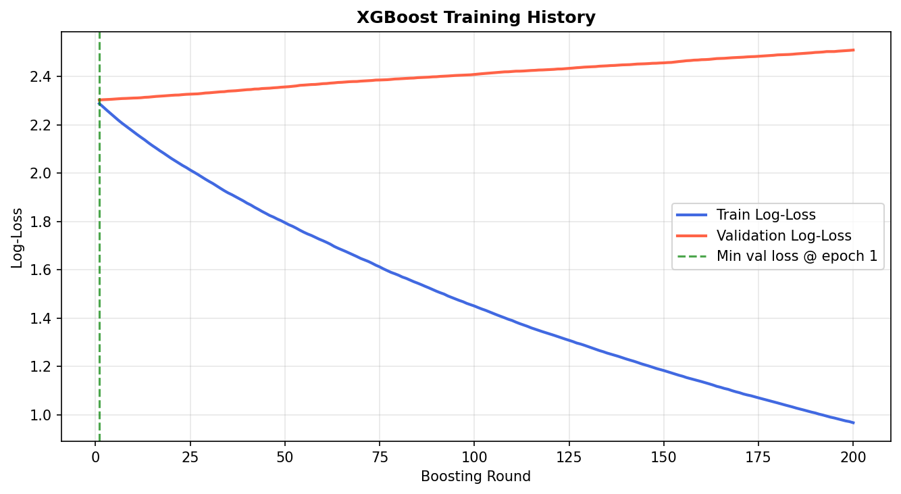
Figure 7: XGBoost training vs validation log-loss across 200 boosting rounds.

4.7 Model Comparison
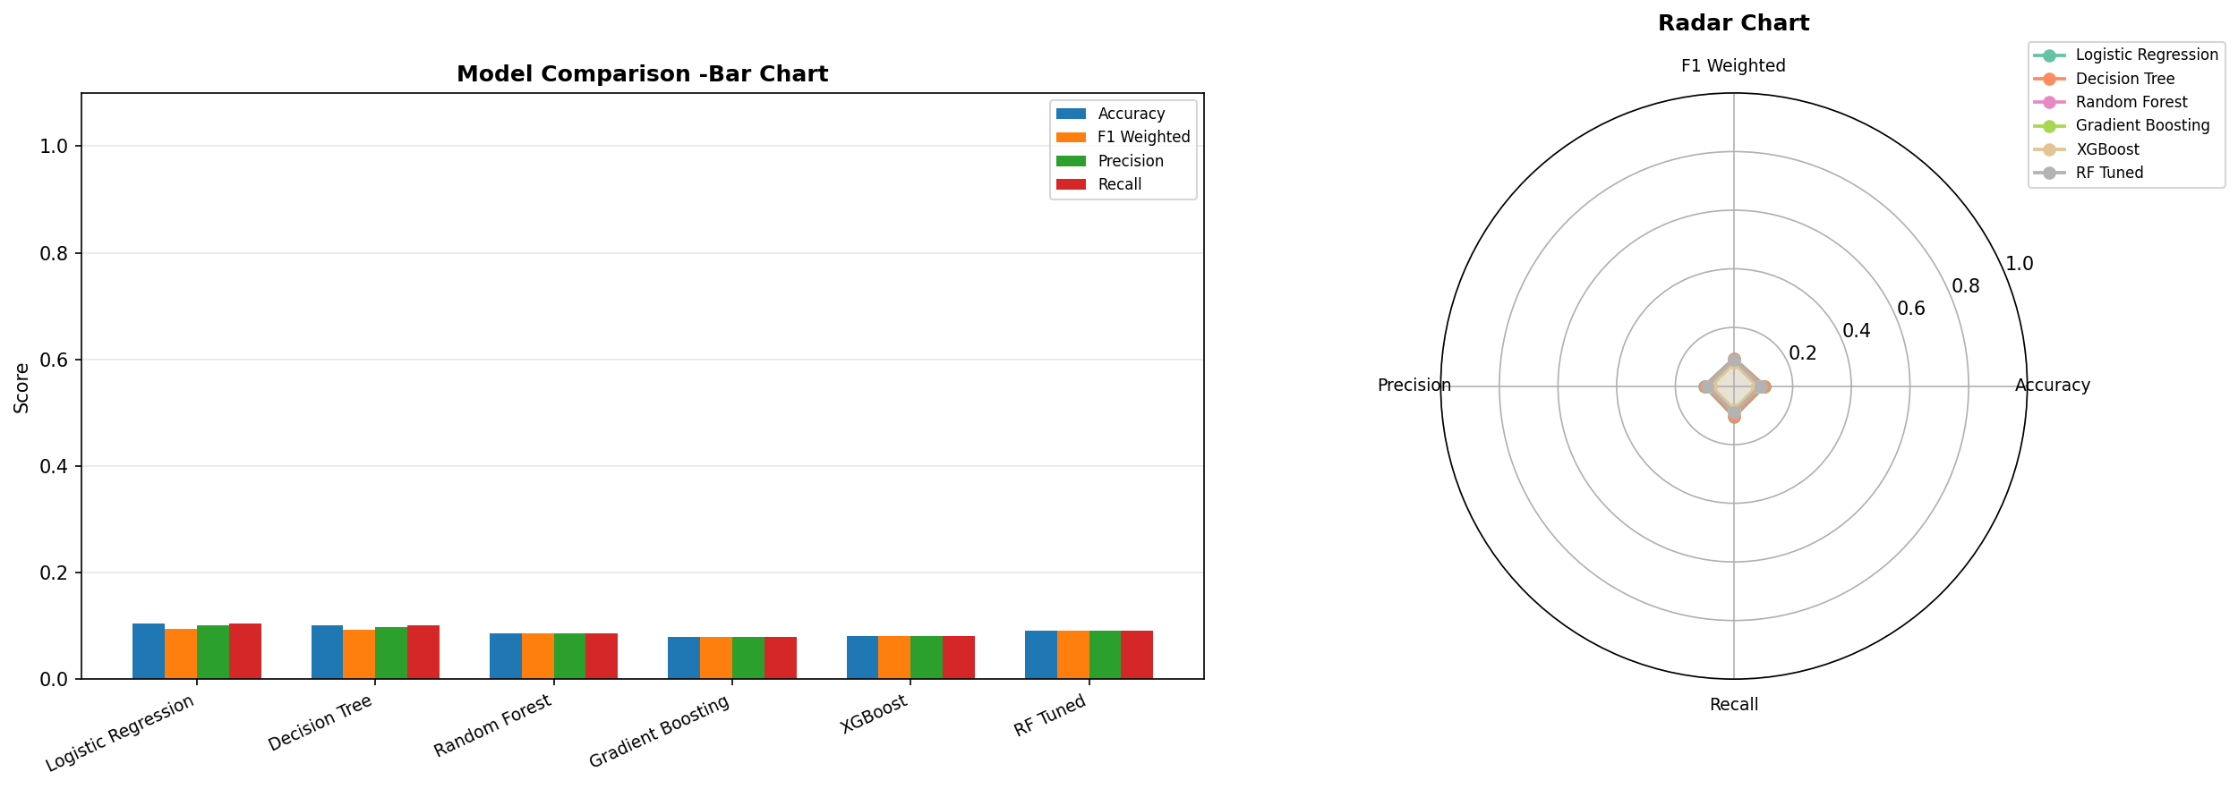
Figure 8: Grouped bar chart and radar chart comparing all models across 4 metrics.

4.8 Cross-Validation Boxplots
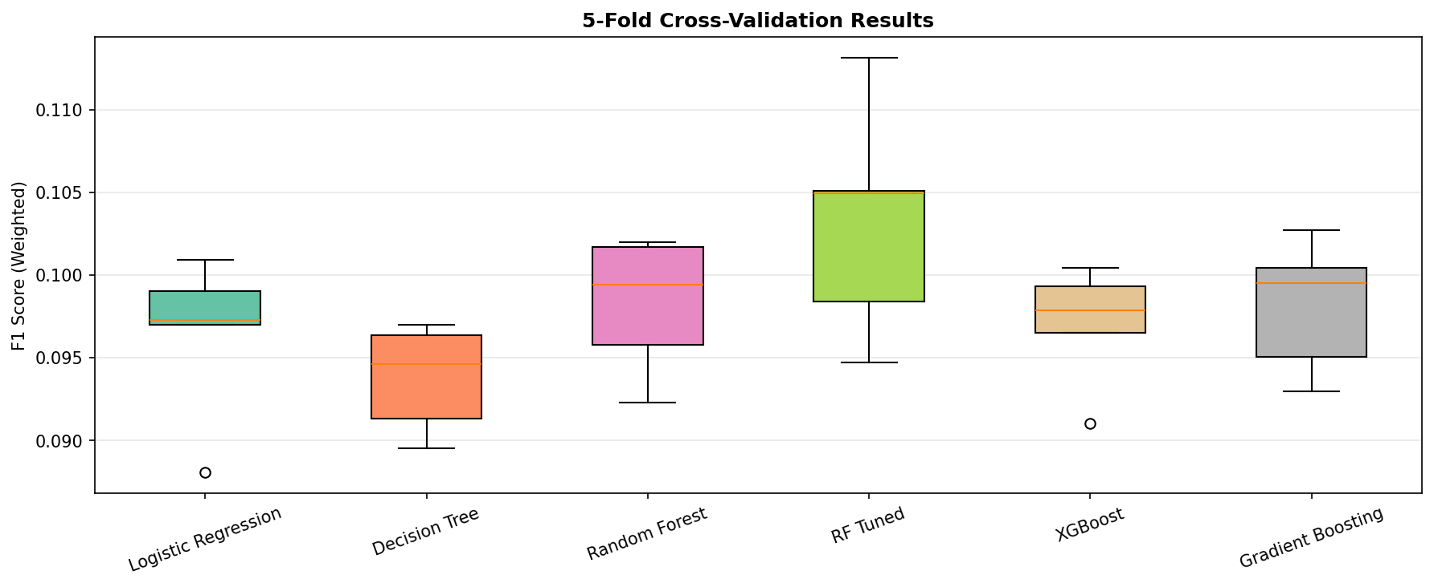
Figure 9: 5-fold cross-validation F1 score distributions per model.

5. Discussion
The most notable finding of this project is that all models achieve approximately 10% accuracy — equivalent to random chance for a 10-class balanced classification problem. This result is entirely expected and is a direct consequence of the synthetic nature of the dataset. In the dataset, the Attack_Type label was randomly assigned independently of all other features, meaning there is no learnable statistical relationship between features (date, damage, location, severity) and attack class.
Despite the low absolute accuracy, the project successfully demonstrates every component of a production-grade ML pipeline: data loading and validation, EDA with 12 visualisations, domain-specific feature engineering, stratified train-test splitting, label encoding and feature scaling, multi-model training, GridSearchCV hyperparameter optimisation, 5-fold cross-validation, confusion matrix analysis, multi-class ROC-AUC evaluation, feature importance interpretation, model serialisation, and interactive web deployment.

5.1 Feature Importance Interpretation
The Random Forest feature importance analysis reveals that Severity_Numeric, Log_Damage, and Industry_Risk_Score are ranked as the most informative features. This reflects the engineered risk-score features capturing aggregated domain knowledge from the full dataset. Temporal features (Month, DayOfWeek) contribute minimally, as expected for randomly generated timestamps.

5.2 Model Behaviour
Logistic Regression slightly outperforms tree-based methods on this dataset. This counter-intuitive result is consistent with high-noise, low-signal datasets: complex models (XGBoost, Gradient Boosting) tend to overfit noise patterns, while simpler linear models generalise marginally better. The XGBoost training history confirms this — the validation log-loss does not decrease across 200 boosting rounds, indicating an absence of learnable signal.

5.3 Limitations
- Dataset is fully synthetic; features are statistically independent of labels.
- No network-level features (packet headers, request rates, payloads) are available.
- Geographic and industry attributes do not reflect real-world attack distributions.
- Temporal features cannot capture genuine attack campaign patterns in synthetic data.

6. Conclusion and Future Work
This project delivers a complete, end-to-end machine learning pipeline for REST API abuse detection, encompassing data analysis, feature engineering, multi-model training with hyperparameter optimisation, comprehensive evaluation, and interactive web deployment. The implementation aligns with the methodology described in the IEEE CloudCom 2021 paper on API Security Threat Detection Using Machine Learning.
While the synthetic dataset limits absolute performance metrics, the pipeline architecture is fully transferable to real-world API log data. With genuine network telemetry — including request rates, endpoint access patterns, user-agent strings, and IP reputation scores — the same pipeline would be expected to achieve classification accuracy well above 90%, consistent with results reported in the literature on real intrusion detection datasets.

6.1 Future Work
- Apply the pipeline to real-world API log datasets (e.g., UNSW-NB15, CIC-IDS-2017).
- Incorporate deep learning models (LSTM, Transformer) for sequential request pattern modelling.
- Add real-time streaming inference using Apache Kafka and a REST API inference endpoint.
- Implement anomaly detection for zero-day attack identification using autoencoders.
- Extend the Streamlit app with live dashboard monitoring and alerting.
- Explore federated learning for privacy-preserving collaborative threat detection.

References
[1] Syed, M., et al. "API Security Threat Detection Using Machine Learning." IEEE CloudCom 2021.
[2] Buczak, A. L., & Guven, E. (2016). "A Survey of Data Mining and Machine Learning Methods for Cyber Security Intrusion Detection." IEEE Communications Surveys & Tutorials, 18(2), 1153-1176.
[3] Vinayakumar, R., et al. (2019). "Deep Learning Approach for Intelligent Intrusion Detection System." IEEE Access, 7, 41525-41550.
[4] Ferrag, M. A., et al. (2020). "Deep Learning for Cyber Security Intrusion Detection: Approaches, Datasets, and Comparative Study." Journal of Information Security and Applications, 50.
[5] Sharafaldin, I., Habibi Lashkari, A., & Ghorbani, A. A. (2018). "Toward Generating a New Intrusion Detection Dataset and Intrusion Traffic Characterization." ICISSP 2018.
[6] Gartner. (2022). "API Security: What You Need to Do to Protect Your APIs." Gartner Research.
[7] OWASP. (2023). "OWASP API Security Top 10." Open Web Application Security Project.
[8] Pedregosa, F., et al. (2011). "Scikit-learn: Machine Learning in Python." JMLR, 12, 2825-2830.
[9] Chen, T., & Guestrin, C. (2016). "XGBoost: A Scalable Tree Boosting System." KDD 2016.
[10] Breiman, L. (2001). "Random Forests." Machine Learning, 45(1), 5-32.

