GEO TOLL

Abstract – With the increase of digitalization of currency in India, waiting in line for paying toll at Toll Plazas seems redundant. This project proposes a solution to this issue by automatically generating e-receipts by enabling online payments. On entry of a km zone of the toll plaza the user is notified to proceed with the payments.
Keywords—Toll Plaza, e-Receipt.

Introduction
This application enables the user to make online payments for Toll. This is made possible by notifing the user about this arrival into Toll Plaza area. The payment is done using Razorpay, which is followed by QR code generation(e-Receipt) which is verified by Toll boot operator. This proposed application will be built using Android Studio. This website heavily relies on Firebase for storing and retrival of realtime data. The application purposes will be tested using Android Stimulator and after testing the application will be launched. For authenticating Firebase Auth is used.

LITERATURE SURVEY.
The first paper that we studied before implementation stated that developing countries like India needs a significant improvement in infrastructure such as Roads or Highways. The toll collection system, especially in India faces some problems such as long queue lines, escaping from toll plazas etc. These systems can service only 300 vehicles per hour, and if more than those numbers of vehicles arrive at that plaza, server traffic jams may occur. To solve this we are proposing to create geo-fences using GPS by giving latitude and longitude of the corner of the toll plaza. By comparing the position of the vehicle and toll plaza, the owner of the vehicle can be charged from the account. [1]

Another paper stated that, nowadays almost all highways toll plazas are manually operated, where an operator collects cash from the driver and provides a receipt. Since this procedure can be slow, we often encounter traffic jams at the toll plazas on busy highways. Automatic process of toll collection will save time, effort, and manpower. The owner receives a SMS message on his/she mobile about the details of the payment and there is no need for him to stop the vehicle. How many vehicles passing through the tollgate stored in a database. [2]

Proposed system.

Architecture of the System.
From home page you could go to register or login page.
Registered data is stored in database through server. When user login, its credentials are validated. If user is logged in, he will be shown a map with his current location on it, with markers of nearby tolls. If user enters a 500m radius of the Toll Plaza, a notification is sent to the user. If user clicks on the notification he is directed to payment page with options for his commute. Once the payment is made a QR Code is generated which will be scanned at the Toll Plaza for authentication of payment.

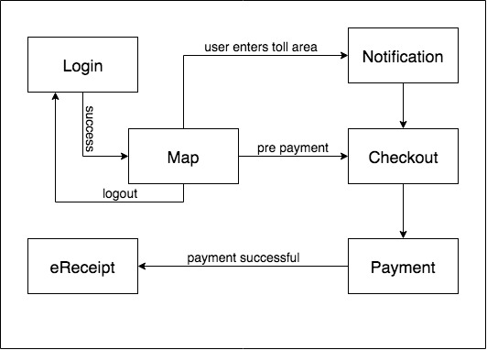
Fig. Architecture of Geo Toll

User Interface.

The user interface first starts with home page where the user will be shown his location on Google Maps along with markers for nearby tolls according to the users real time location. The bottom navigation contains links for maos, qr code, payment, and account. When a user is registered he is redirected to login page. On qrcode page the user will see his current receipt with an option to see this active receipts as well. At the payment page user can manually pay for a toll, by entering their preferences, and journey type. And when user clicks on pay, a qr code is generated.

Data Retreival
Whenever a user opens the QrCode activity, his current transactions are retrieved and displayed in the form of a QR Code. The Firebase sends data in form JAVA objects which is handled by backend JAVA. The retrived data is converted into bitmap image.

User Data Storage.
For storing data Google’s Firebase will be used. Our system employs real time authentication during registration that email is registered or not. All the data retrival and storage is done realtime.

Easy to use.
The proposed system is designed in such a way that it is easy for new user without any knowledge about the system. The user is guided properly via notifications. Rest of the system carries out the payment.

Activity of the User.
User will first register himself if he’s not registered. Then he will login using his own credentials . On payment e-Receipt will be shown.

implementation

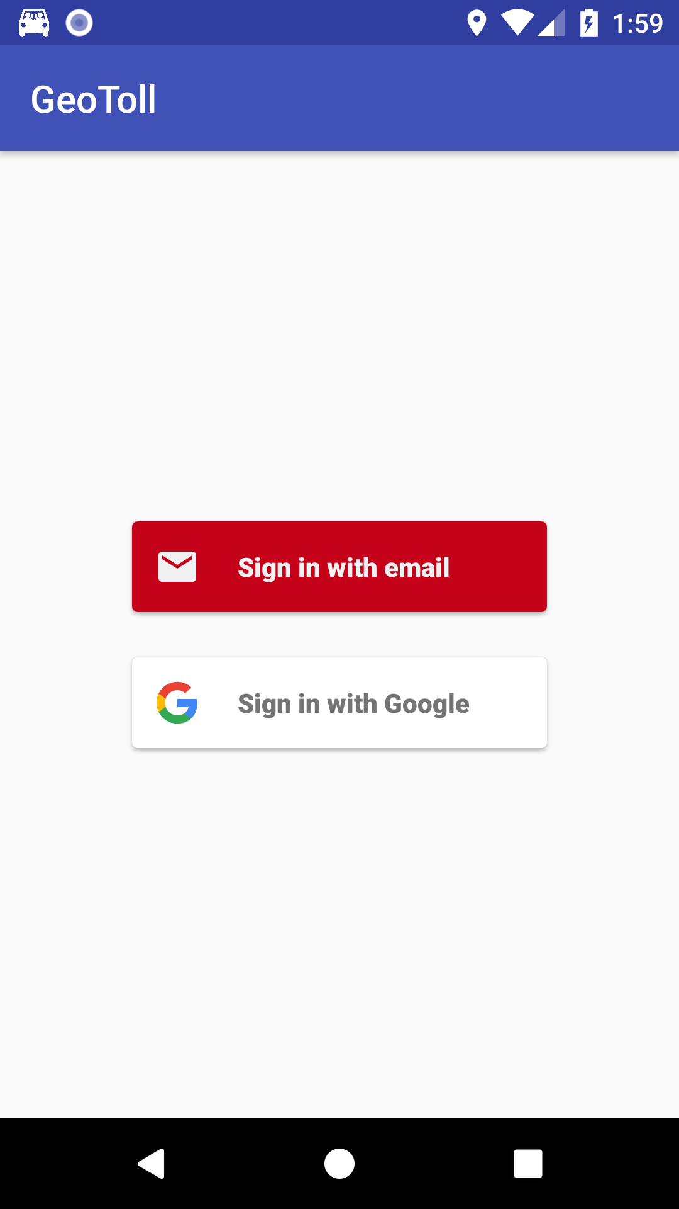

Figure 1

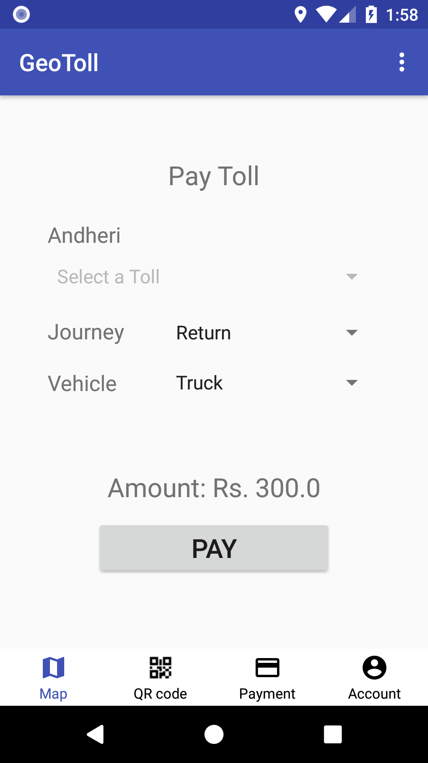
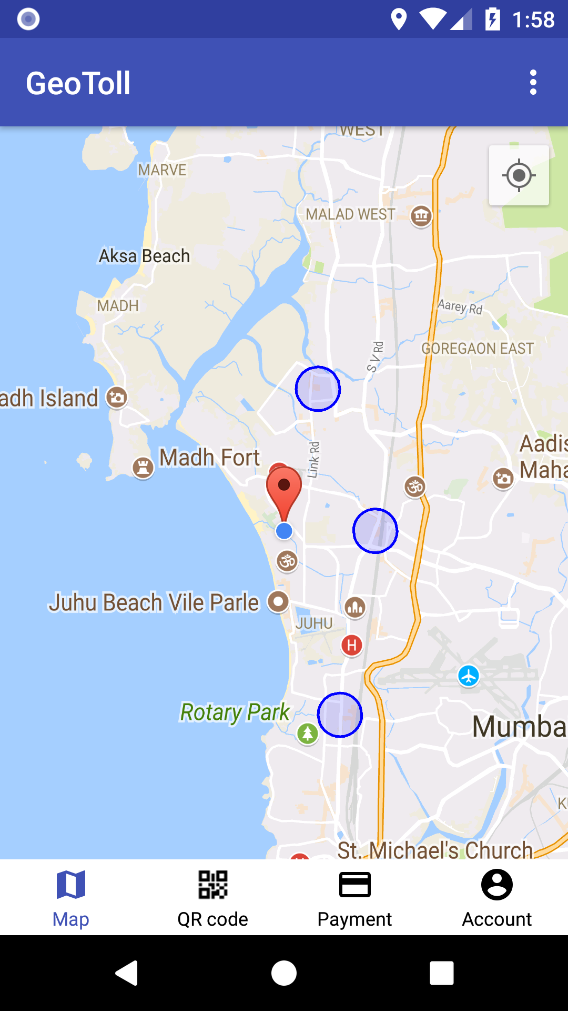

Figure 2

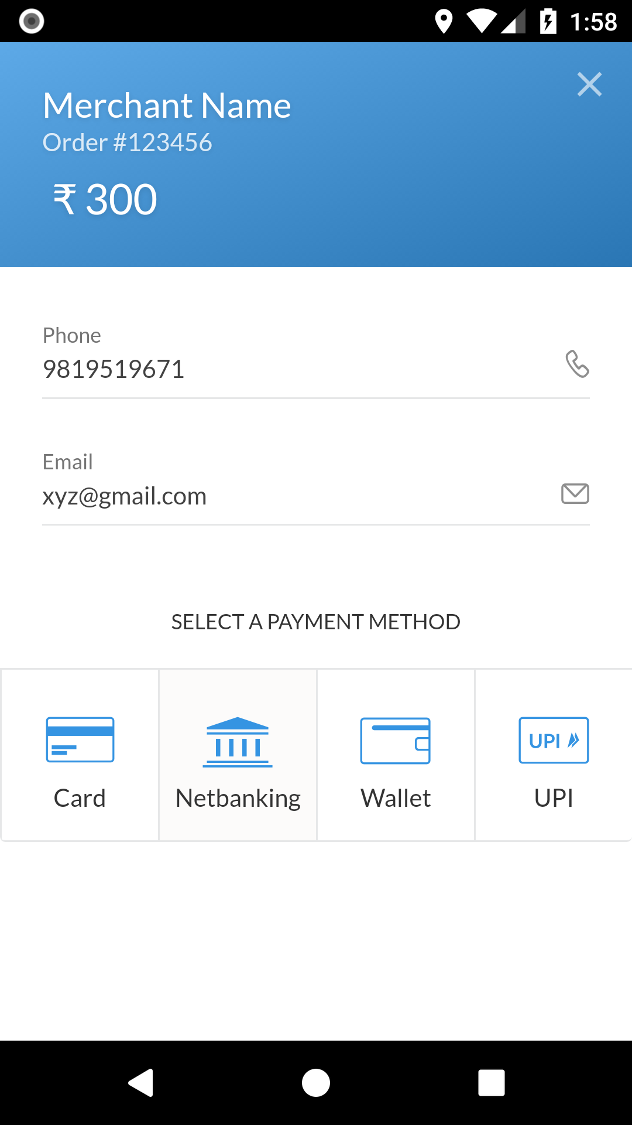
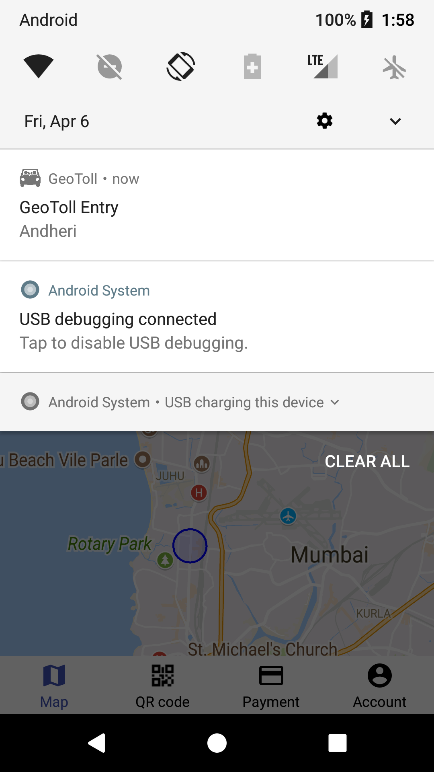

Figure 3

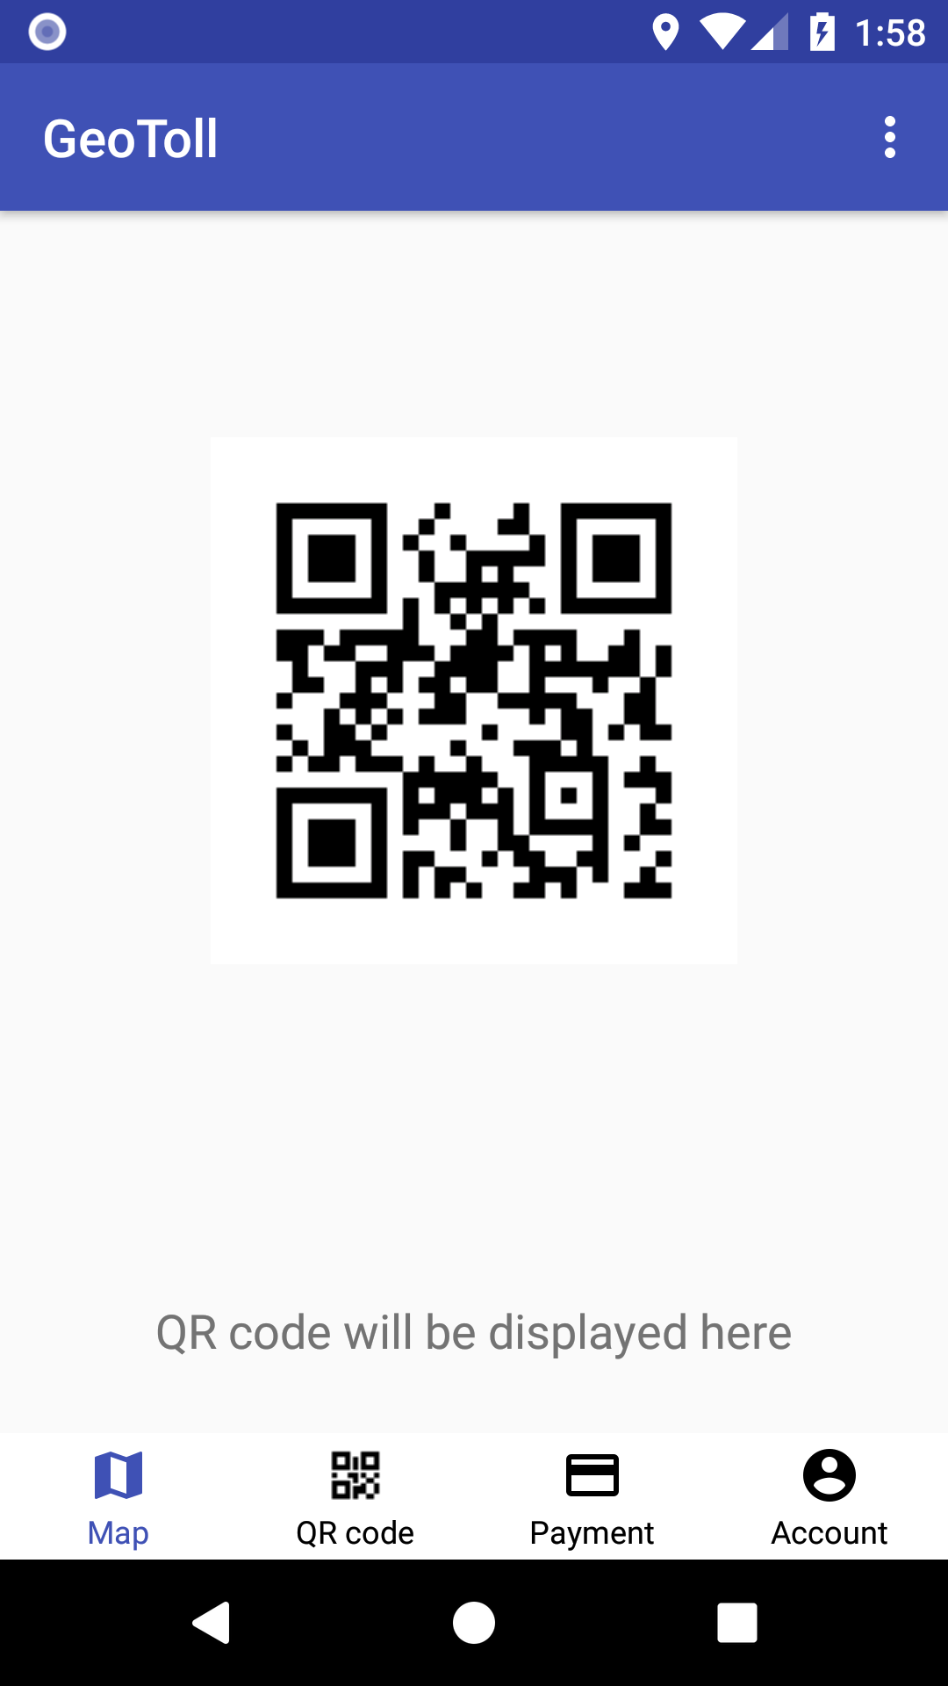

Figure 4 Figure 5 Figure 6

These figures represents [1] login page, [2] map page, [3] notification page, [4] checkout page, [5] payment page, [6] e-Receipt.

CONCLUSION
Referencing from above technical journals, and from other sources we have successfully implemented the proposed application which has all the proposed specifications and is ready to launch on playstore.

References
- http://ieeexplore.ieee.org/document/7754222/

- http://ieeexplore.ieee.org/document/7460382/

