1- How many pods exist on the system?

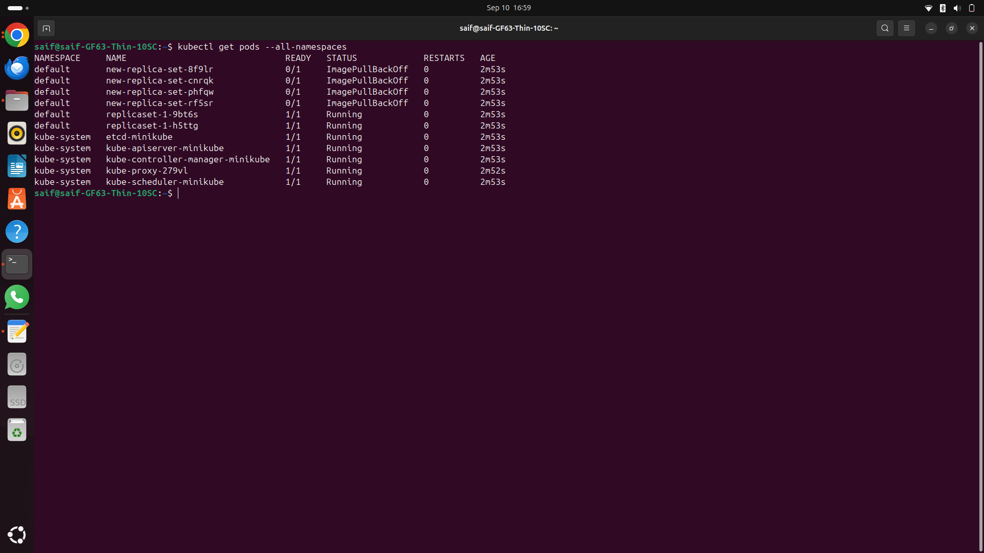  
2- How many Nodes exist on the system?  
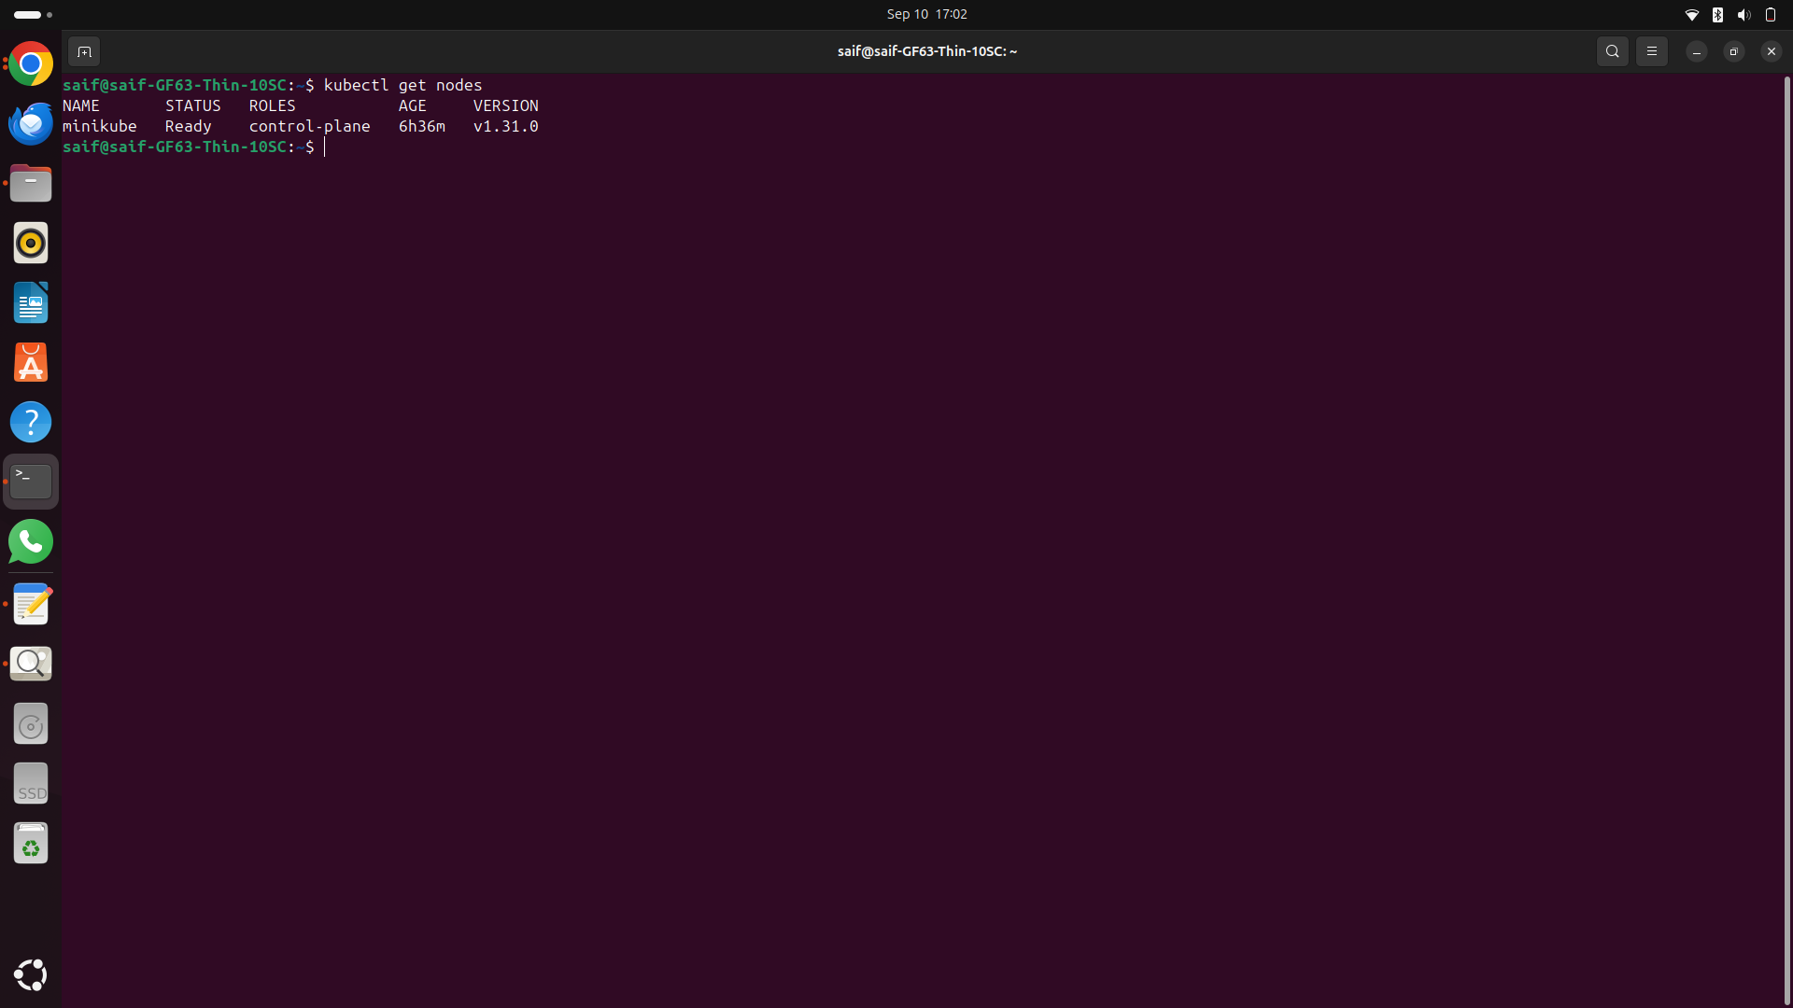

3- Create a new pod with the nginx image.  
 Image name: nginx  
  
4- Which nodes are these pods placed on?  
  
5- Create pod from the below yaml using kubectl apply command  
  
apiVersion: v1  
kind: Pod  
metadata:  
 name: webapp  
 namespace: default  
spec:  
 containers:  
 - image: nginx  
 imagePullPolicy: Always  
 name: nginx  
 - image: agentx  
 imagePullPolicy: Always  
 name: agentx  
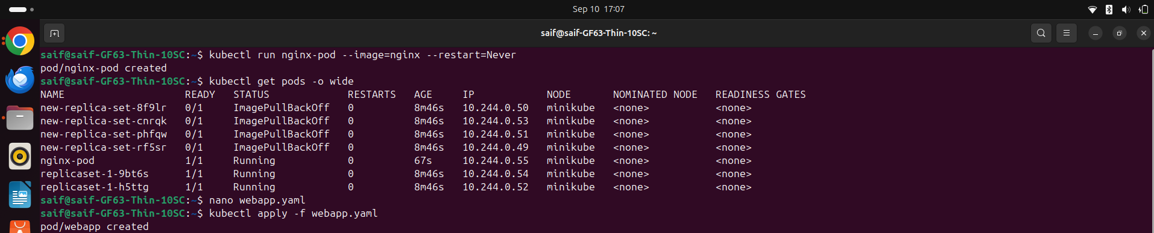

6- How many containers are part of the pod webapp

Two containers nginx and agentx

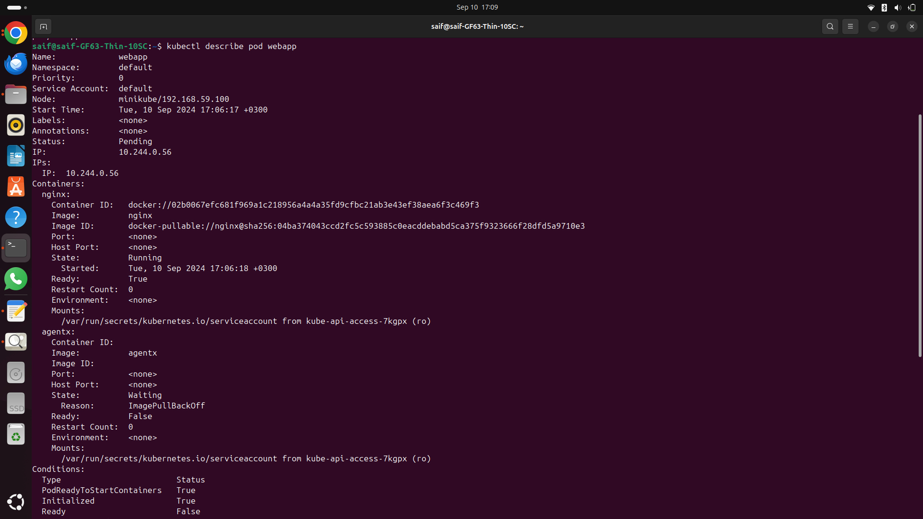

7- What images are used in the new webapp pod?  
8- What is the state of the container agentx in the pod webapp  
9- Why do you think the container agentx in pod webapp is in error?  
10- Delete the webapp Pod.  
11- Create a new pod with the name redis and with the image redis123.  
• Name: redis  
• Image Name: redis123  
12- Now change the image on this pod to redis.  
Once done, the pod should be in a running state.  
13- Create a pod called my-pod of image nginx:alpine  
14- Delete the pod called my-pod

