1-Create a ReplicaSet using the below yaml  
  
apiVersion: apps/v1  
kind: ReplicaSet  
metadata:  
 name: new-replica-set  
 namespace: default  
spec:  
 replicas: 4  
 selector:  
 matchLabels:  
 name: busybox-pod  
 template:  
 metadata:  
 labels:  
 name: busybox-pod  
 spec:  
 containers:  
 - command:  
 - sh  
 - -c  
 - echo Hello Kubernetes! && sleep 3600  
 image: busybox777  
 imagePullPolicy: Always  
 name: busybox-container

----------------------

2-How many PODs are DESIRED in the new-replica-set? 4 DESIRED pods

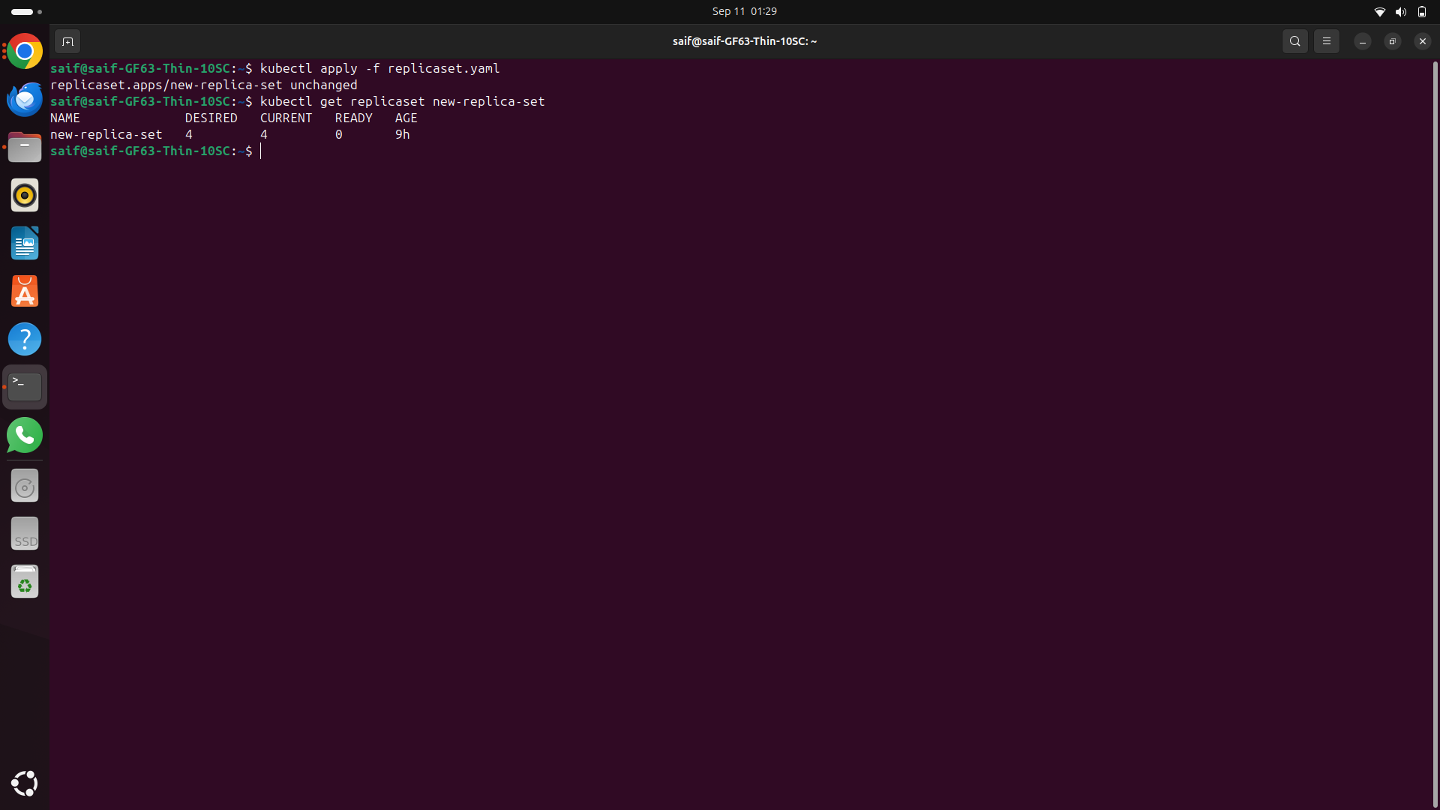

----------------------  
3-What is the image used to create the pods in the new-replica-set?

From the ReplicaSet definition at the YAML the image is busybox777  
---------------------  
4-How many PODs are READY in the new-replica-set?

No pods will be ready due to the incorrect image

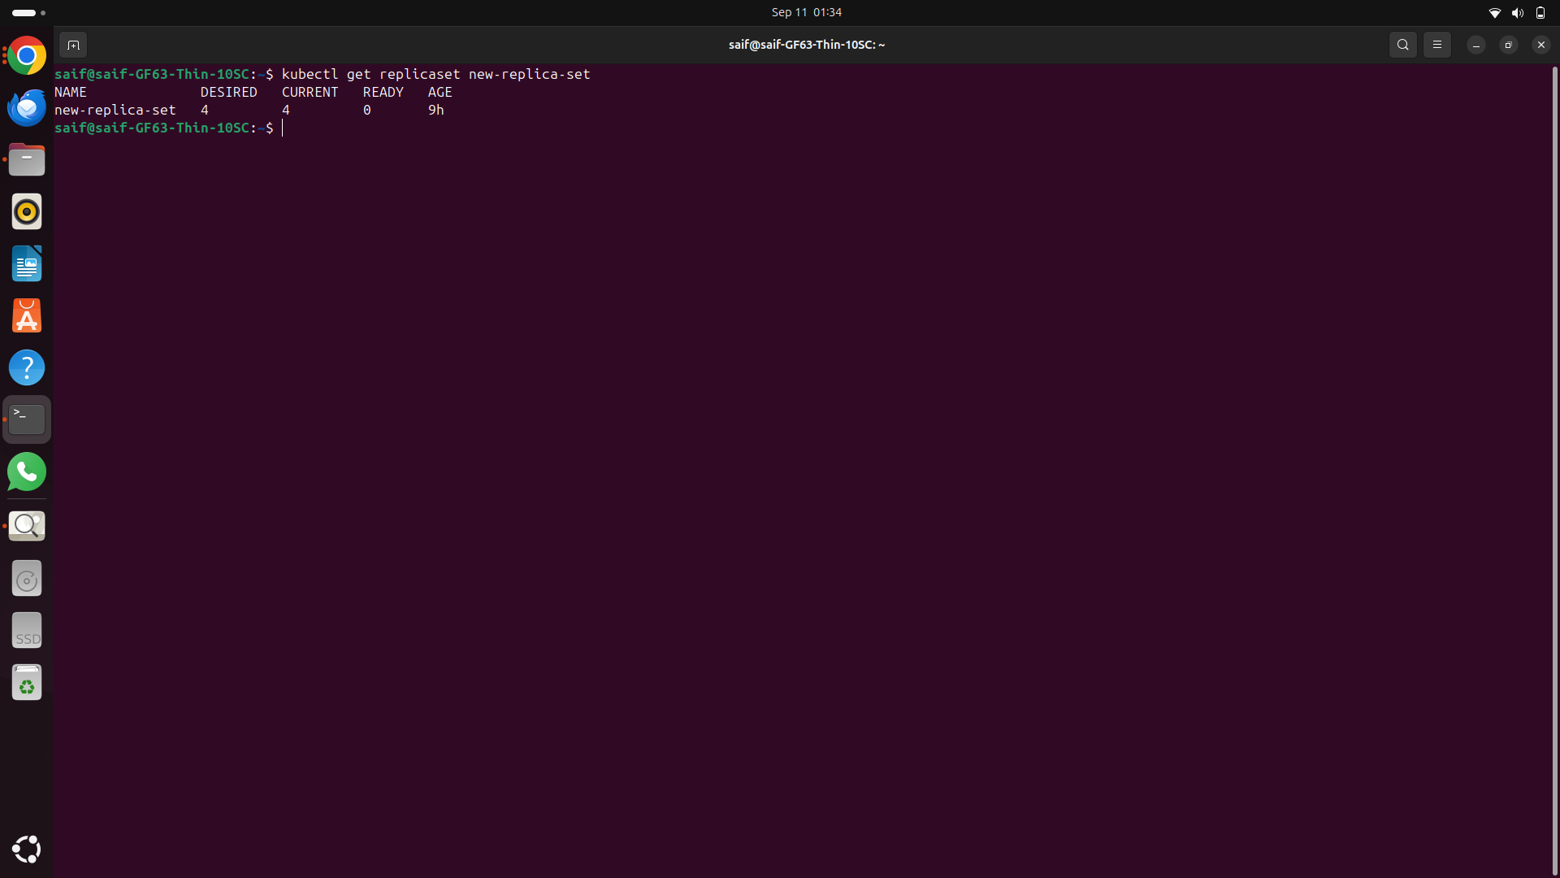  
---------------------  
5-Why do you think the PODs are not ready?

The pods are not ready because the image busybox777 does not exist or cannot be pulled.  
------------------------

6-Delete any one of the 4 PODs.   
How many pods now? There will still be 4 pods.

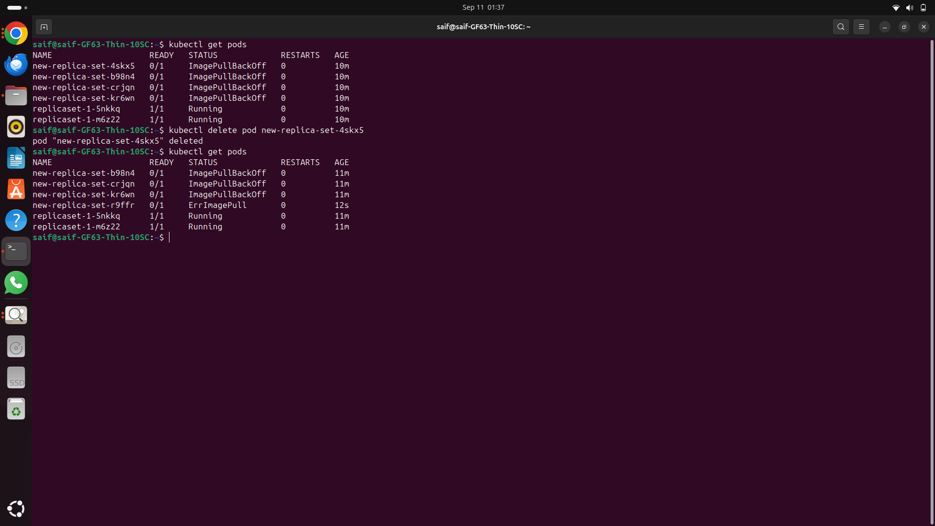  
---------------------  
7-Why are there still 4 PODs, even after you deleted one?

The ReplicaSet automatically creates a new pod to maintain the desired number of replicas (4).  
-----------------  
8-Create a ReplicaSet using the below yaml  
  
There is an issue with the file, so try to fix it.  
  
apiVersion: v1  
kind: ReplicaSet  
metadata:  
 name: replicaset-1  
spec:  
 replicas: 2  
 selector:  
 matchLabels:  
 tier: frontend  
 template:  
 metadata:  
 labels:  
 tier: frontend  
 spec:  
 containers:  
 - name: nginx  
 image: nginx

**Issue:** The apiVersion should be apps/v1, not v1, for a ReplicaSet.

