1-Create a deployment called my-first-deployment of image nginx:alpine in the default namespace.  
Check to make sure the deployment is healthy.

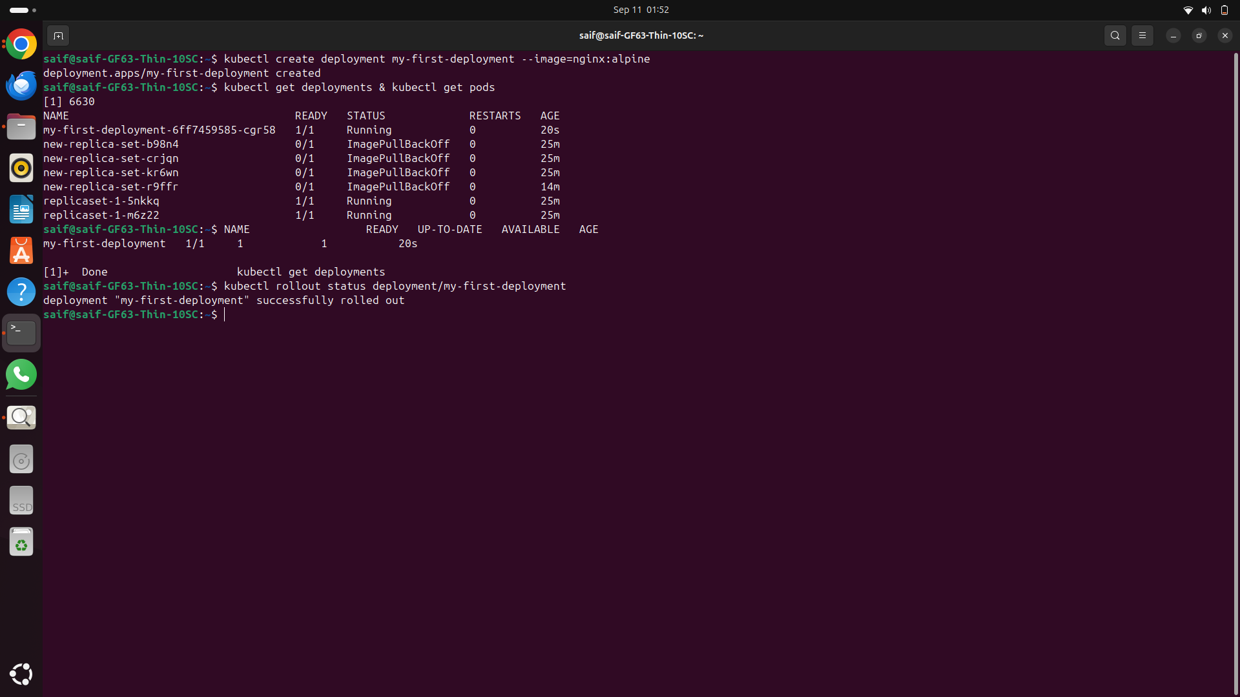----------------  
2-Scale my-first-deployment up to run 3 replicas.  
Check to make sure all 3 replicas are ready.

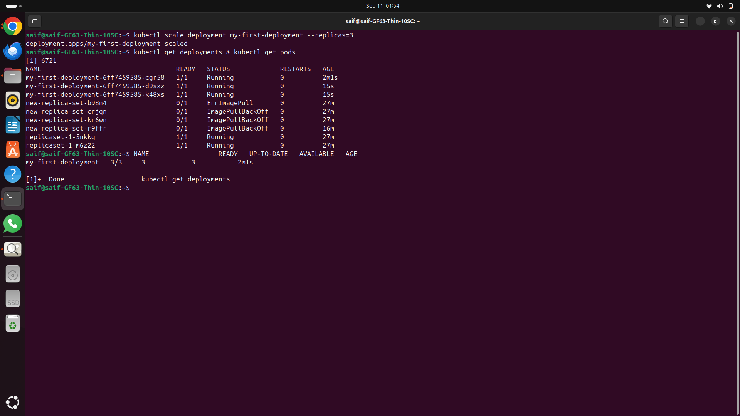  
----------------  
3-Scale my-first-deployment down to run 2 replicas.

---------------  
4-Change the image my-first-deployment runs from nginx:alpine to httpd:alpine .  
--------------------------  
5-Delete the deployment my-first-deployment  
----------------------------  
6-Create deployment from the below yaml  
  
apiVersion: apps/v1  
kind: Deployment  
metadata:  
 name: frontend-deployment  
 namespace: default  
spec:  
 replicas: 4  
 selector:  
 matchLabels:  
 name: busybox-pod  
 strategy:  
 rollingUpdate:  
 maxSurge: 25%  
 maxUnavailable: 25%  
 type: RollingUpdate  
 template:  
 metadata:  
 labels:  
 name: busybox-pod  
 spec:  
 containers:  
 - command:  
 - sh  
 - -c  
 - echo Hello Kubernetes! && sleep 3600  
 image: busybox888  
 imagePullPolicy: Always  
 name: busybox-container  
   
-------------  
7-How many ReplicaSets exist on the system now?

At least one ReplicaSets

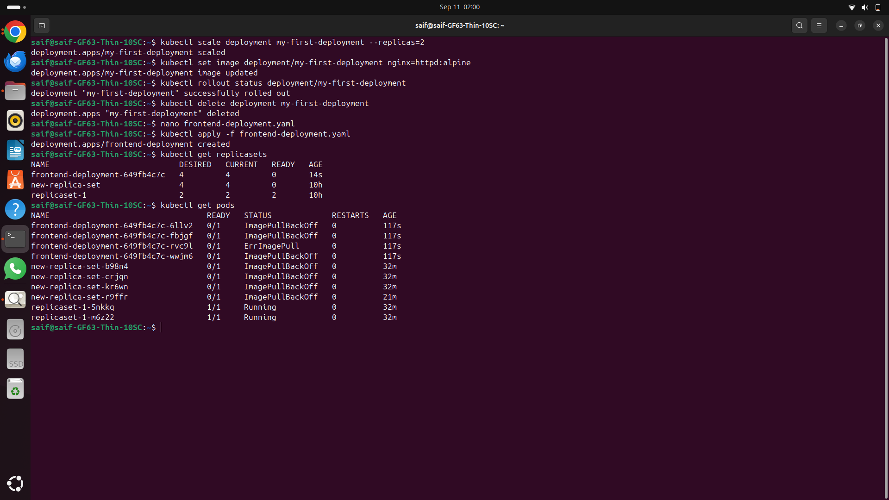------------------------------  
8-How many PODs exist on the system now? 4 Pods  
-----------------  
9-Out of all the existing PODs, how many are ready? no pod  
-----------------

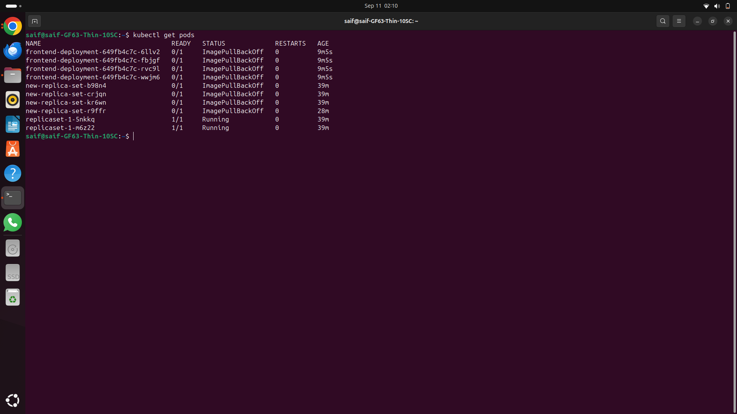

10-What is the image used to create the pods in the new deployment?

busybox888  
---------------------  
11-Why do you think the deployment is not ready?

The image busybox888 may not exist in the container registry, leading to an **ImagePullBackOff** error.  
---------------------  
  
