- Create a YAML file to define a new namespace called dev-environment. Deploy it using kubectl.

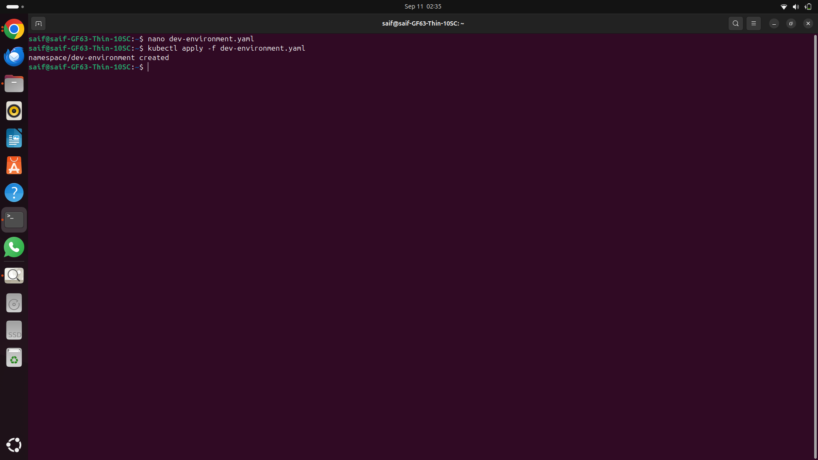

- Write a command to deploy a pod named test-pod running the nginx image into a namespace called testing.

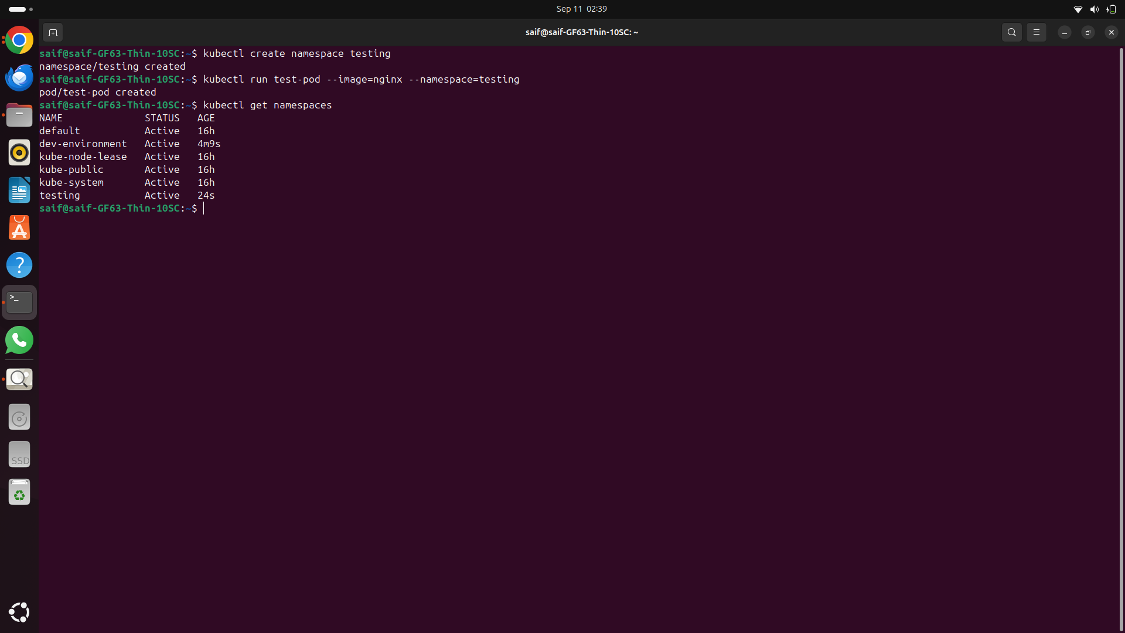

- List all the pods running in a namespace called production.

