Example:
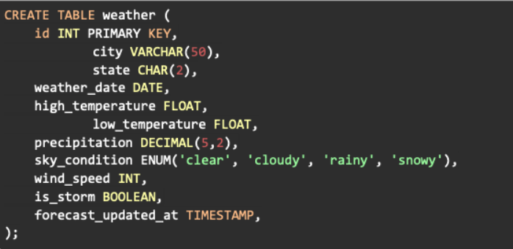
You should use DECIMAL when you need to ensure precise decimal values with no approximation and FLOAT when you have a large range of values and approximation is acceptable.

