|  |
| --- |
| *Ahsanullah University of Science & Technology*logo.jpgDepartment of Computer Science & Engineering |
| Education Website |
| Software Development (CSE 3200) |
|  |
|  |
|  |

|  |
| --- |
|  |

Submitted by:

Md. Reasad Zaman Chowdhury 16.01.04.004

Rafiq Reephat 16.01.04.011

Saiful Islam Sakib 16.01.04.017

**Introduction:**

Renaissance (an online education website) is a website and associated community that features problems and tutorials in science, math, physics, math, programming and many diﬀerent fields. Renaissance is intended to discover and cultivate the mathematical and scientific thinking skills of students, professionals, and hobbyists around the world.

**Objectives:**

There are an endless supply of question. Moreover, people type questions in search all the time. Through this website everyone should be able to fulfill their hunger of knowledge and get the desired result by questioning. People can test themselves through answering some special questions which already has answer. This will brush up their minds.

**Features:**

* There will be a registration form which includes username, email and password. User can add or edit their information after the registration.
* This site will provide the ability to share any thoughts and ideas like a blog post. And anyone will have the ability to comment on the post.
* There will be a quiz section where any user can question for others to answer.
* Everyone will be rewarded by points based on the success rate of answers of the quiz question and the activity on the website.
* People can report any post or question.
* There will be an option to follow anyone to have a personalized set of post or question of specific people.
* User will have the ability to maintain a personal set of topics and ignore the rest.

**Future works:**

* Registered user will be able to rate a tutorial with which system will generate an average rating. Rating of a particular website will determine the quality of that article.
* User will be provided a rating which will be determined by some factors as number of tutorials he/she made, rating of the tutorials, activity on the website etc.
* Connection through server is also possible.

**ERD (Entity Relationship Diagram):**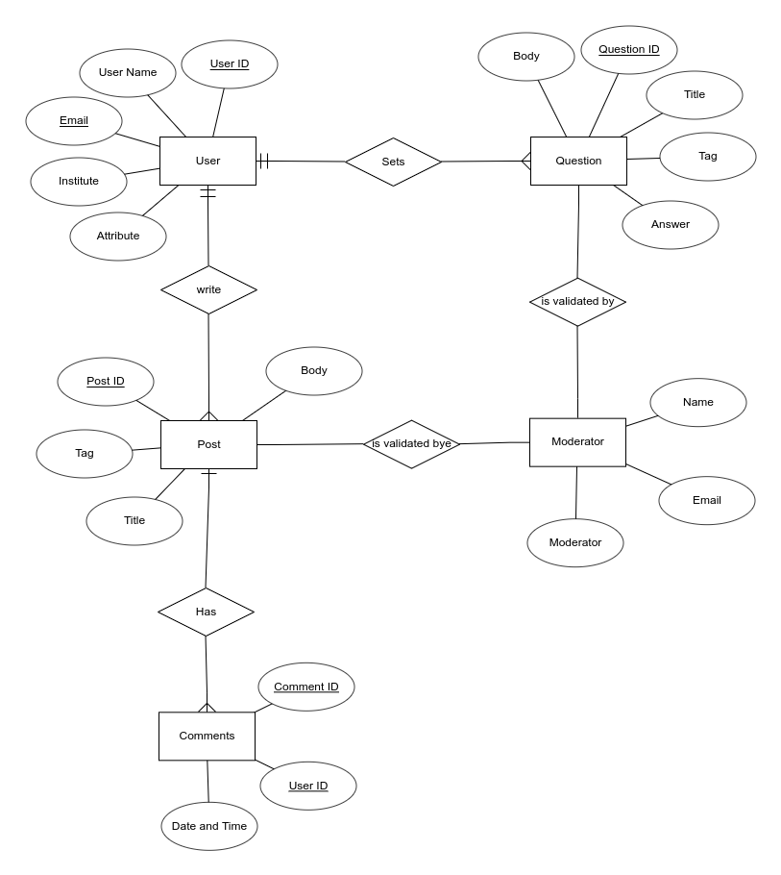

**Technology will be used:**

* Microsoft Visual Studio
* ASP.NET
* C#
* Microsoft SQL server

**Platform:**

The website will run on any web browser on any system.

Future works:

* Registered user will be able to rate a tutorial with which system will generate an average rating. Rating of a particular website will determine the quality of that article.
* User will be provided a rating which will be determined by some factors as number of tutorials he/she made, rating of the tutorials, activity on the website etc.
* Connection through server is also possible.

**Conclusion:**

This is an online platform created to provide well written, well thought and well explained solution on various Computer Science related problems. This project is developed mainly for academic purpose. Therefore, it might lack in professionalism and efficiency. But meets the primary requirements for user to find desired information in a user-friendly manner which is our main goal.