**1 Degree of Freedom Control and 2 Degrees of Freedom Control**

After the identification of the transfer function of the DC motors, the transfer function recorded will be use in order to design the control itself. The focus is around two types of compensators, the complete PID with one degree of freedom (1-DOF) and the PID with two degrees of freedom (2-DOF). With the estimation of each one separately, comparations are made between both the understand the benefits of each method.

The transfer function of the DC motors recorded is showed below.

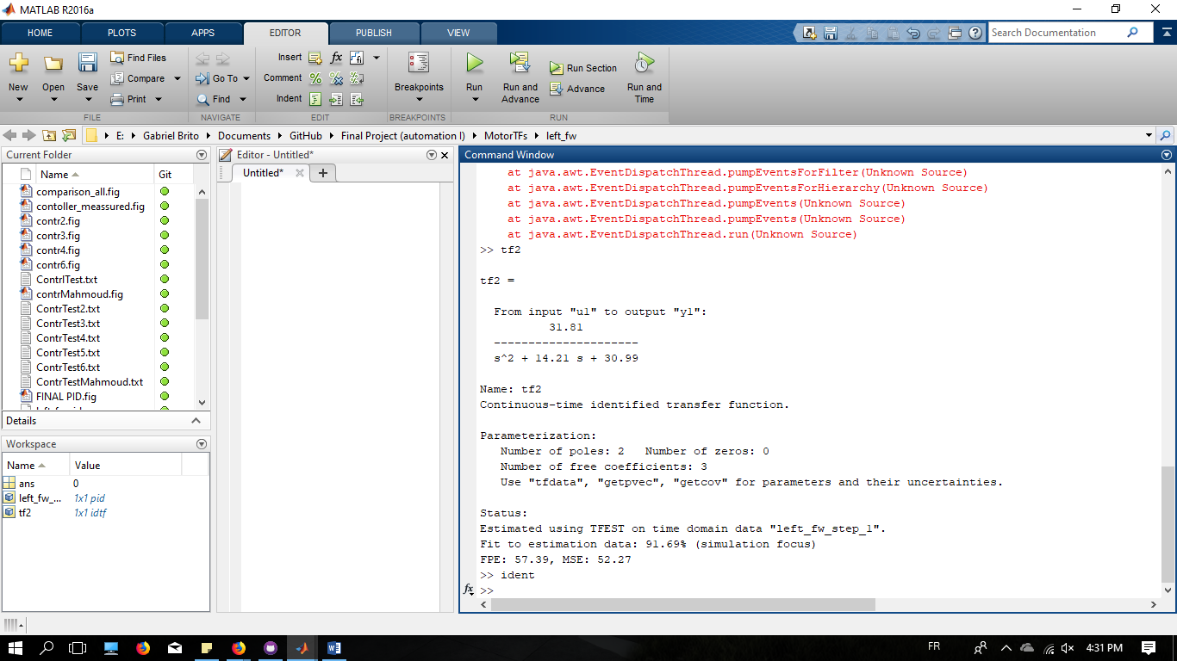

Using the step input over this transfer function, it is possible to obtain the characteristic behavior of the system, and the factors as overshoot, settling time, rise time, steady state error, are visible in the generated graph.

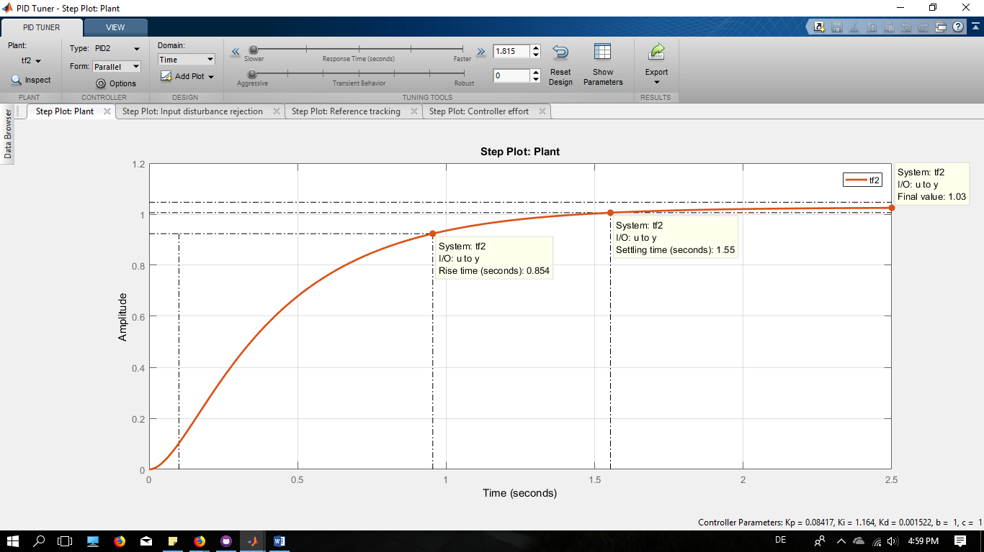

To get a faster system and more robust, two parameters are attempted inside PID Tuner tool, Response Time and Transient Behavior, with regards to complete PID compensators. The first try was the 1-DOF PID controller. After get sactisfatory outcomes in the factors to a good compensator, the values of Kp, Ki, Kd, and the compensator transfer fuction itself are exported to the Matlab workspace. Once it is not possible to generate graph for the Controller Effort (Because number of zeros is higher than number of poles for the transfer function), the only criterion worked to define a suitable controller was the best fitting. The results are showed below.

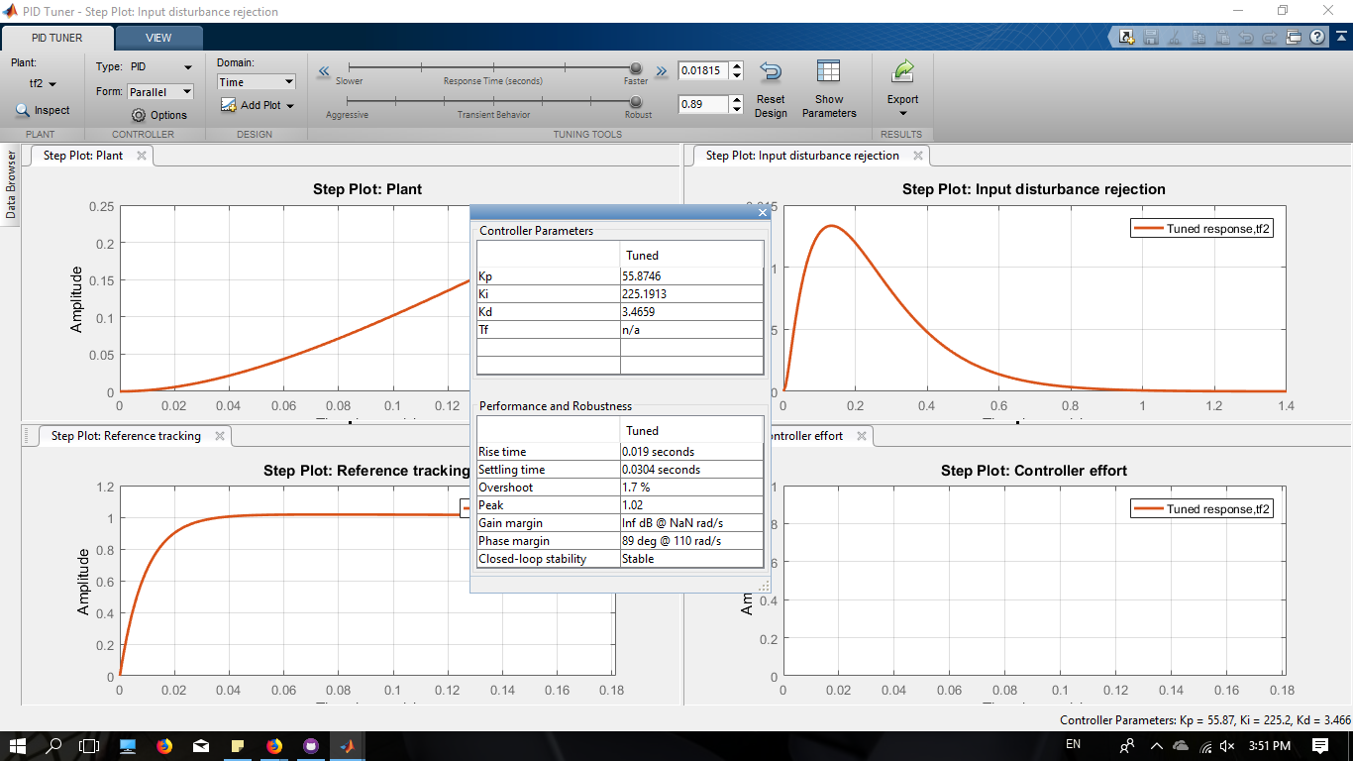

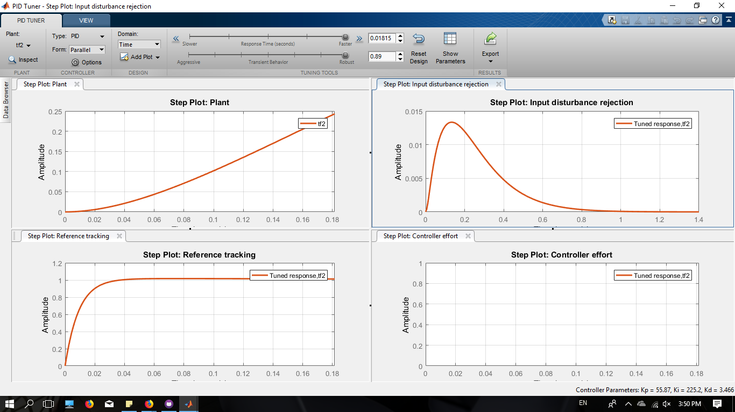

\



For the 2-DOF PID controller, beyond the best fitting criterion, it was also used the characteristics observed in the controller effort graph as a benchmark. The reason is that is necessary to consider the model and the hardware not as a ideal project, but as a real one with limitations. Compensators with high efforts are not suitable to a limited hardware.

The same parameters are attempted in order to get the best fitting and suitable controller. The values of Kp, Ki, Kd are obtained and after they are used in the software of the robot, to work with different input values to the motors after receiving the joystick information. The obtained diagrams are shower in the next figures.

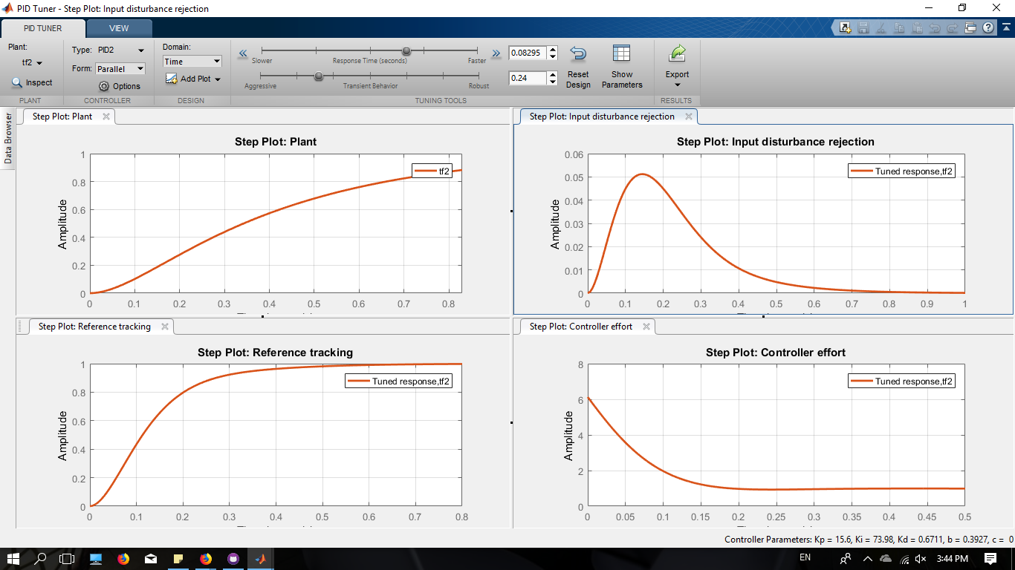







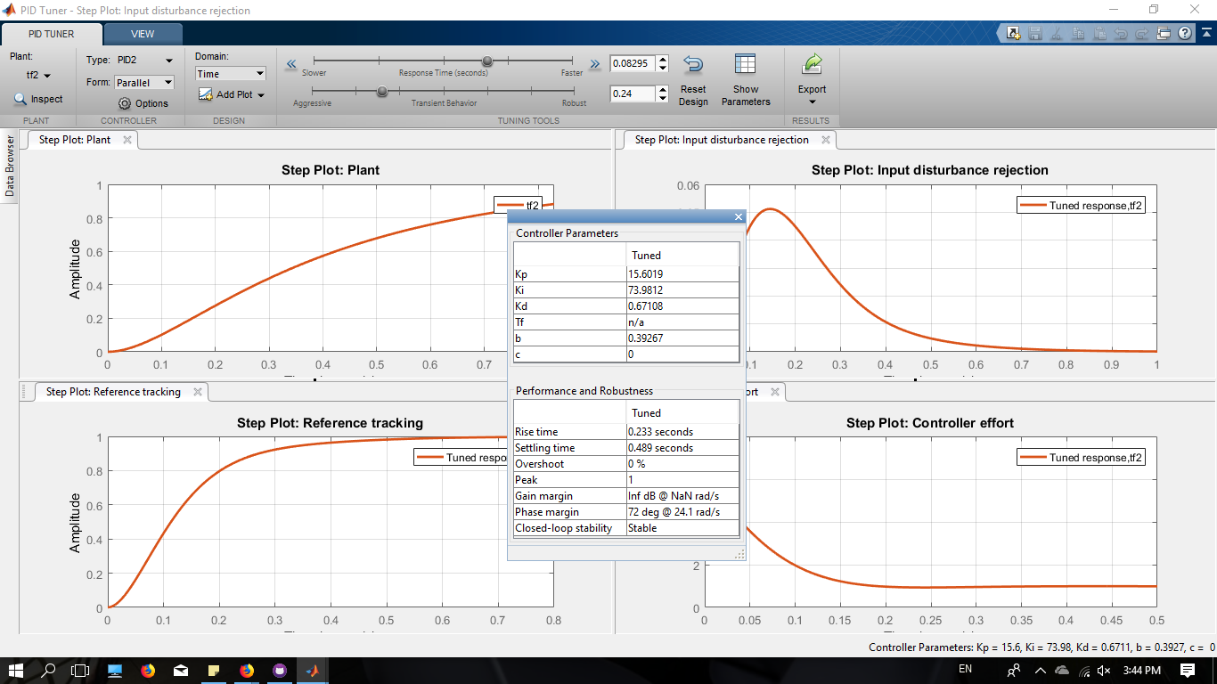

As it is possible to see, when both controllers are compared, indeed 1-DOF controller is faster than the 2-DOF controller. However, the values acquired to kp, ki, and kd for 2-DOF are lower and better applicable to the real hardware. While the difference between the time of both controllers is not much expressive, difference between the kp, ki and kd can be a considerable distinction of performance. In Addition, the 2-DOF controller has no Overshoot while the 1-DOF has an overshoot of 1.7%.

The 2-DOF PID, as a modified form of PID control, proposed to overcome the limitations of PID controllers [2], has the ability of a fast disturbance rejection without any significant increment on the overshoot factor. Supplementary, this controller can also be used as a way to relieve changes influence in the input signal.

[2] Adar, N. G., & Kozan, R. (2016). Comparison between Real Time PID and 2-DOF PID Controller for 6-DOF Robot Arm. Acta Physica Polonica A, 130(1), 269-271.

[3] M. Araki, H. Taguchi, Int. J. Control Automation Syst. 1, 401 (2003).

[4] V.M. Alfaro, R. Vilanova, O. Arrieta, J. Process Contr. 19, 1658 (2009).

[5] V.M. Alfaro, R. Vilanova, O. Arrieta, IFAC Proceedings Volumes 42, 721 (2009).

[6] M.K. Rakesh, R. Satheesh, Thirunavukkarasu, IOSR-JEEE 9, 59 (2014).

[7] R. Sharma, P. Gaur, A.P. Mittal, ISA Trans. 58, 279 (2015).

[8] M. Boujary, A.K. Ghorbani-Tanha, M. Rahimian, H. Rahami, in: Proceedings of the 15th World Conference on Earthquake Engineering 24-28 September, 2012, Sociedade Portuguesa de Engenharia Sismica, Lisbon, Portugal 2012, p. 20065.