Project: MERN E-Commerce Platform
SCRUM Team Roles
- Product Owner: Bilal Rasheed 22i-1337
- Scrum Master: Saif ul Haq 22i-1306
- Development Team:
  - Bilal Rasheed
  - Saif ul Haq

A) Product Backlog (24 User Stories)
ID | User Story | Priority
US1 | As a user, I want to log in securely using my credentials so that I can access my personal dashboard and manage my activities. | 1
US2 | As an admin, I want to view a list of all registered users along with their roles and status so that I can monitor platform usage and manage accounts. | 3
US3 | As an admin, I want to block or unblock user accounts so that I can restrict access to users violating platform policies. | 4
US4 | As a user, I want to update my profile information so that I can keep my account details accurate. | 5
US5 | As a user, I want to reset my password through email verification so that I can regain access if I forget my password and ensure security. | 2
US6 | As an admin, I want to add, update, or remove product details so that I can ensure the product catalog remains accurate. | 1
US7 | As a customer, I want to view product images in high resolution so that I can closely inspect the product before purchasing. | 5
US8 | As a customer, I want to search for products using keywords, filters, and sorting options so that I can find relevant items quickly. | 3
US9 | As an admin, I want to set stock availability status for each product so that customers are aware of whether an item is in stock or out of stock. | 2
US10 | As a customer, I want to add multiple items to my cart so that I can purchase them in one transaction. | 1
US11 | As a customer, I want to save my cart for later so that I can return and complete my purchase at another time. | 5
US12 | As a customer, I want to enter discount codes at checkout so that I can get applicable price reductions. | 4
US13 | As a customer, I want to select a payment method so that I can complete my purchase conveniently. | 1
US14 | As a customer, I want to receive a detailed invoice after making a purchase so that I have proof of my transaction. | 4
US15 | As a customer, I want to track my order status in real time so that I can stay updated on my purchase. | 2
US16 | As an admin, I want to assign delivery personnel to specific orders so that deliveries can be managed efficiently. | 5
US17 | As a customer, I want to cancel my order before it is shipped so that I can avoid unwanted purchases. | 5
US18 | As an admin, I want to notify customers via email and SMS when their order status changes so that they remain informed. | 3
US19 | As a customer, I want to request a return or refund within a specified period so that I can resolve issues with defective or incorrect products. | 4
US20 | As a customer, I want to see ratings and reviews from other buyers so that I can make informed purchase decisions. | 4
US21 | As a customer, I want to chat with customer support for real-time assistance so that I can quickly resolve any order issues. | 3
US22 | As an admin, I want to generate detailed sales reports and analytics so that I can track revenue and make data-driven decisions. | 5
US23 | As a customer, I want to receive personalized product recommendations based on my browsing and purchase history so that I can discover relevant products. | 5
US24 | As an admin, I want to monitor user activity logs so that I can track potential security threats and suspicious behaviour. | 4
B) Sprint Definitions
- Number of Sprints: 3
- Sprint Duration: 2 weeks each
Sprint | Dates | Focus | User Stories (from backlog)
1 | [Start] – [End] | Authentication & Product Management | US1, US2, US3, US4, US5, US6, US7, US8, US9, US10
2 | [Start] – [End] | Cart & Checkout | US11, US12, US13, US14, US15, US16, US18
3 | [Start] – [End] | Reports, Reviews, Admin Extras | US19, US20, US21, US22, US23, US24

Gannt chart
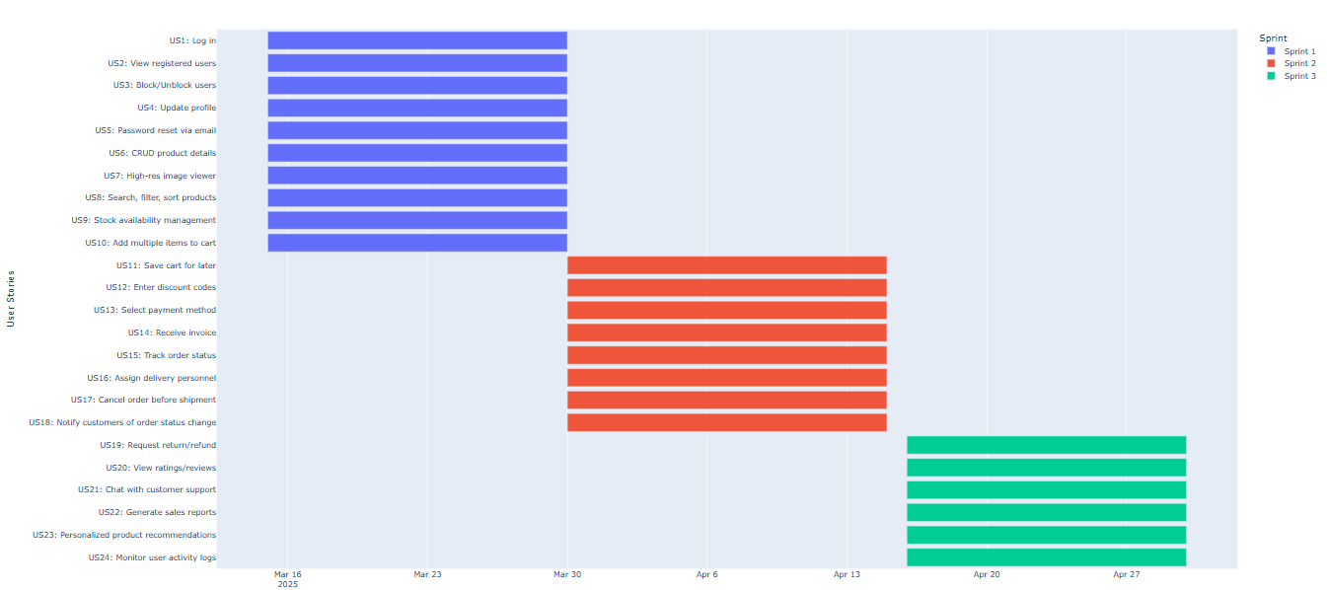
Project planner
User Story | Sprint | Start Date | End Date
US1: Log in | Sprint 1 | 2025-03-15 00:00:00 | 2025-03-30 00:00:00
US2: View registered users | Sprint 1 | 2025-03-15 00:00:00 | 2025-03-30 00:00:00
US3: Block/Unblock users | Sprint 1 | 2025-03-15 00:00:00 | 2025-03-30 00:00:00
US4: Update profile | Sprint 1 | 2025-03-15 00:00:00 | 2025-03-30 00:00:00
US5: Password reset via email | Sprint 1 | 2025-03-15 00:00:00 | 2025-03-30 00:00:00
US6: CRUD product details | Sprint 1 | 2025-03-15 00:00:00 | 2025-03-30 00:00:00
US7: High-res image viewer | Sprint 1 | 2025-03-15 00:00:00 | 2025-03-30 00:00:00
US8: Search, filter, sort products | Sprint 1 | 2025-03-15 00:00:00 | 2025-03-30 00:00:00
US9: Stock availability management | Sprint 1 | 2025-03-15 00:00:00 | 2025-03-30 00:00:00
US10: Add multiple items to cart | Sprint 1 | 2025-03-15 00:00:00 | 2025-03-30 00:00:00
US11: Save cart for later | Sprint 2 | 2025-03-30 00:00:00 | 2025-04-15 00:00:00
US12: Enter discount codes | Sprint 2 | 2025-03-30 00:00:00 | 2025-04-15 00:00:00
US13: Select payment method | Sprint 2 | 2025-03-30 00:00:00 | 2025-04-15 00:00:00
US14: Receive invoice | Sprint 2 | 2025-03-30 00:00:00 | 2025-04-15 00:00:00
US15: Track order status | Sprint 2 | 2025-03-30 00:00:00 | 2025-04-15 00:00:00
US16: Assign delivery personnel | Sprint 2 | 2025-03-30 00:00:00 | 2025-04-15 00:00:00
US17: Cancel order before shipment | Sprint 2 | 2025-03-30 00:00:00 | 2025-04-15 00:00:00
US18: Notify customers of order status change | Sprint 2 | 2025-03-30 00:00:00 | 2025-04-15 00:00:00
US19: Request return/refund | Sprint 2 | 2025-03-30 00:00:00 | 2025-04-15 00:00:00
US20: View ratings/reviews | Sprint 2 | 2025-03-30 00:00:00 | 2025-04-15 00:00:00
US19: Request return/refund (contd.) | Sprint 3 | 2025-04-16 00:00:00 | 2025-04-30 00:00:00
US20: View ratings/reviews (contd.) | Sprint 3 | 2025-04-16 00:00:00 | 2025-04-30 00:00:00
US21: Chat with customer support | Sprint 3 | 2025-04-16 00:00:00 | 2025-04-30 00:00:00
US22: Generate sales reports | Sprint 3 | 2025-04-16 00:00:00 | 2025-04-30 00:00:00
US23: Personalized product recommendations | Sprint 3 | 2025-04-16 00:00:00 | 2025-04-30 00:00:00
US24: Monitor user activity logs | Sprint 3 | 2025-04-16 00:00:00 | 2025-04-30 00:00:00

Sprint 1 (2 weeks)
Planning Meeting Notes
Name: Sprint Planning Meeting
About: Planning Meeting
Date: April 30, 2025, 11:00 AM PKT
Attendees Present
- Bilal Rasheed
- Saif ul Haq
Absent
- None

Topics Discussed and Conclusions Reached:
The team conducted a planning session for Sprint #1 of the MERN E-Commerce Platform. Saif ul Haq, the Scrum Master, led the session, and Bilal Rasheed, the Product Owner, presented the product backlog. The team selected 10 high-priority user stories, focusing on essential user and admin features, product management, and usability enhancements. Responsibilities were divided based on expertise and story complexity.

Conclusions
Team committed to implementing the following for Sprint #1:
- Secure Login (US1) – Assigned to Saif
- View Registered Users (US2) – Assigned to Bilal
- Block/Unblock Users (US3) – Shared
- Password Reset via Email (US5) – Assigned to Saif
- CRUD Product Details (US6) – Assigned to Bilal
- Search, Filter & Sort (US8) – Shared
- Stock Availability Management (US9) – Assigned to Bilal
- Add Multiple Items to Cart (US10) – Assigned to Saif
- Update Profile (US4) – Shared
- High-Res Image Viewer (US7) – Shared
The team will allocate any extra time toward testing or refactoring. All stories include clear acceptance criteria and are ready for development. Daily stand-ups are scheduled at 9:30 AM PKT to monitor progress and address blockers.
1. Sprint Backlog for Sprint 1
Modules:
- User Authentication & Account Management (US1, US2, US4, US5)
- Admin & Product Operations (US3, US6, US9, US8, US10)
User Story ID | User Story
US1 | As a user, I want to log in securely using my credentials so that I can access my personal dashboard and manage activities.
US2 | As an admin, I want to view a list of all registered users along with their roles and status so that I can monitor platform usage and manage accounts.
US3 | As an admin, I want to block or unblock user accounts so that I can restrict access to users violating platform policies.
US4 | As a user, I want to update my profile information so that I can keep my account details accurate.
US5 | As a user, I want to reset my password through email verification so that I can regain access if I forget my password and ensure security.
US6 | As an admin, I want to add, update, or remove product details so that I can ensure the product catalog remains accurate.
US7 | As a customer, I want to view product images in high resolution so that I can closely inspect the product before purchasing.
US8 | As a customer, I want to search for products using keywords, filters, and sorting options so that I can find relevant items quickly.
US9 | As an admin, I want to set stock availability status for each product so that customers are aware of whether an item is in stock or out of stock.
US10 | As a customer, I want to add multiple items to my cart so that I can purchase them in one transaction.
ii. User Stories
US1 – Secure Login
- As a user
- I want to log in securely using my credentials
- So that I can access my personal dashboard and manage my activities
Acceptance criteria
- Given valid credentials, when I submit the login form, then I receive a 200 response and a JWT cookie, and I’m redirected to my dashboard.
- Given invalid credentials, when I submit, then I see an error message and no cookie is set.
- Given empty email or password, when I submit, then client-side validation prevents the request.
Sub-Tasks:
- Frontend: Build LoginForm component
- Backend: Create login API and JWT generation
- Tests: Validate login flow
US2 – View Registered Users
- As an admin
- I want to view all registered users with roles and status
- So that I can monitor platform usage and manage accounts
Acceptance criteria
- Given I’m logged in as an admin, when I navigate to Users List, then I see all users with name, email, role, and status in a paginated table.
- Given no users in the database, when I load the page, then I see “No users found.”
- Given server error, when I load, then I see an error notification.
Sub-Tasks:
- Frontend: Display user list table
- Backend: Create users list API endpoint
- Tests: E2E test for user list
US3 – Block/Unblock Users
- As an admin
- I want to block or unblock user accounts
- So that I can restrict access to violators
Acceptance criteria
- Given a user row, when I click Block, then the status changes to “Blocked” and the row updates without reload.
- Given a blocked user, when I click Unblock, then status returns to “Active.”
Sub-Tasks:
- Frontend: Add block/unblock action
- Backend: Update user status endpoint
- Tests: Integration test for status change
US4 – Update Profile
- As a user
- I want to update my profile information
- So that I can keep my account details accurate
Acceptance criteria
- Given current profile data, when I open ProfileForm, then fields are pre-populated.
- Given valid edits, when I submit, then profile updates, I see success message, and data persists on reload.
Sub-Tasks:
- Frontend: ProfileForm component
- Backend: Profile update API
- Tests: Verify profile update
US5 – Password Reset via Email
- As a user
- I want to reset my password through email verification
- So that I can regain access if I forget my password
Acceptance criteria
- Given registered email, when I request reset, then I receive an email with a valid token link.
- Given valid token and new password, when I submit, then password updates and I’m redirected to login with success alert.
Sub-Tasks:
- Frontend: Forgot/Reset password forms
- Backend: Email token and reset endpoints
- Tests: Token validation tests
US6 – CRUD Product Details
- As an admin
- I want to add, update, or remove product details
- So that I can ensure the catalog is accurate
Acceptance criteria
- Given valid product data, when I create/update in ProductForm, then the product appears/updates in catalog and I see success notification.
- Given missing required fields or invalid data types, when I submit, then client-side validation prevents API calls.
Sub-Tasks:
- Frontend: ProductForm UI
- Backend: CRUD product endpoints
- Tests: CRUD operations tests
US7 – High-Res Image Viewer
- As a customer
- I want to view product images in high resolution
- So that I can inspect products closely
Acceptance criteria
- Given product with multiple images, when I click thumbnail, then the lightbox opens showing high-res image.
- Given zoom controls, when I zoom in/out, then image scales correctly with no distortion.
Sub-Tasks:
- Frontend: ImageGallery component
- Integrate zoom feature
- Tests: Image viewer functionality
US8 – Search, Filter & Sort
- As a customer
- I want to search and filter products
- So that I can find relevant items quickly
Acceptance criteria
- Given a keyword, when I search, then results contain matching names/descriptions.
- Given category or price filter, when I apply, then results update accordingly.
Sub-Tasks:
- Frontend: Search and filter UI
- Backend: Search/filter API support
- Tests: Query functionality tests
US9 – Stock Availability Management
- As an admin
- I want to set stock availability status
- So that customers see accurate inventory
Acceptance criteria
- Given product stock ≥1, when I view product, then badge shows “In Stock.”
- Given stock =0, when I view, then badge shows “Out of Stock” and Add-to-Cart is disabled.
Sub-Tasks:
- Frontend: Stock status field
- Backend: Update stock API
- Tests: Stock update tests
US10 – Add Multiple Items to Cart
- As a customer
- I want to add multiple items to my cart
- So that I can purchase them in one transaction
Acceptance criteria
- Given quantity selector, when I choose quantity and click Add, then cart count updates and items appear in cart summary.
- Given adding beyond stock, when I attempt, then validation blocks action with “Insufficient stock.”
Sub-Tasks:
- Frontend: Add-to-cart UI
- Backend: Cart API endpoints
- Tests: Cart functionality tests

2. Software Testing
2.1 Equivalence Class Partitioning & Test Cases
Field | Equivalence Class | Type | Test Cases (Weak) | Test Cases (Strong)
Email (register) | EC1: valid format | Valid | 1 | 2
 | EC2: missing '@' | Invalid | 1 | 2
 | EC3: empty | Invalid | 1 | 1
 | EC4: >100 chars | Invalid | 1 | 1
Password | EC1: 8–20 chars | Valid | 1 | 2
 | EC2: <8 chars | Invalid | 1 | 1
 | EC3: >20 chars | Invalid | 1 | 1
 | EC4: missing special char/digit | Invalid | 1 | 1
Product Name | EC1: 3–100 chars | Valid | 1 | 2
 | EC2: <3 chars | Invalid | 1 | 1
 | EC3: >100 chars | Invalid | 1 | 1
 | EC4: empty | Invalid | 1 | 1
Price | EC1: >0 && <1e6 | Valid | 1 | 2
 | EC2: 0 | Invalid | 1 | 1
 | EC3: negative | Invalid | 1 | 1
 | EC4: non-numeric | Invalid | 1 | 1
Stock | EC1: 0–10000 | Valid | 1 | 2
 | EC2: <0 | Invalid | 1 | 1
 | EC3: >10000 | Invalid | 1 | 1
 | EC4: non-integer | Invalid | 1 | 1
2.2 Boundary Value Analysis
Field | Min Val | Min+1 | Max-1 | Max | Invalid Low | Invalid High
Email length | 1 | 2 | 99 | 100 | 0 | 101
Password length | 8 | 9 | 19 | 20 | 7 | 21
Product Name | 3 | 4 | 99 | 100 | 2 | 101
Price | 0.01 | 0.02 | 999999.98 | 999999.99 | 0 | 1000000
Stock | 0 | 1 | 9999 | 10000 | -1 | 10001

Name: Sprint Review Final Meeting
About: Review Meeting
Date: April 30, 2025, 4:45 PM PKT
Attendees Present
• Bilal Rasheed
• Saif ul Haq
Absent
• None
Topics Discussed and Conclusions Reached
The team conducted a final review of Sprint 1 deliverables for the MERN E-Commerce Platform. Saif ul Haq, Scrum Master, initiated the session and walked through the checklist to verify completion of all committed user stories.
Saif demonstrated the secure login and password reset functionality, including test validation and error handling for edge cases.
Bilal showcased the admin features: viewing users, blocking/unblocking accounts, and product CRUD operations, confirming the backend routes and UI alignment.
Both team members jointly presented the shared features—search/filter/sort, high-res image viewing, and profile update—validating responsiveness and performance across devices.
The cart functionality (adding multiple items) was tested for session persistence, and product stock availability was reviewed against inventory updates.
Conclusions
All Sprint 1 features were verified against the Definition of Done and have passed both functional and UI/UX validation.
Minor design enhancements for the search UI and cart responsiveness were identified and added to the backlog for Sprint 2.
No major blockers were reported; all committed user stories (US1 to US10) have been successfully completed and accepted.
Trello Board Snapshots (Sprint 1)
- Snapshot 1: Start of Sprint – backlog setup
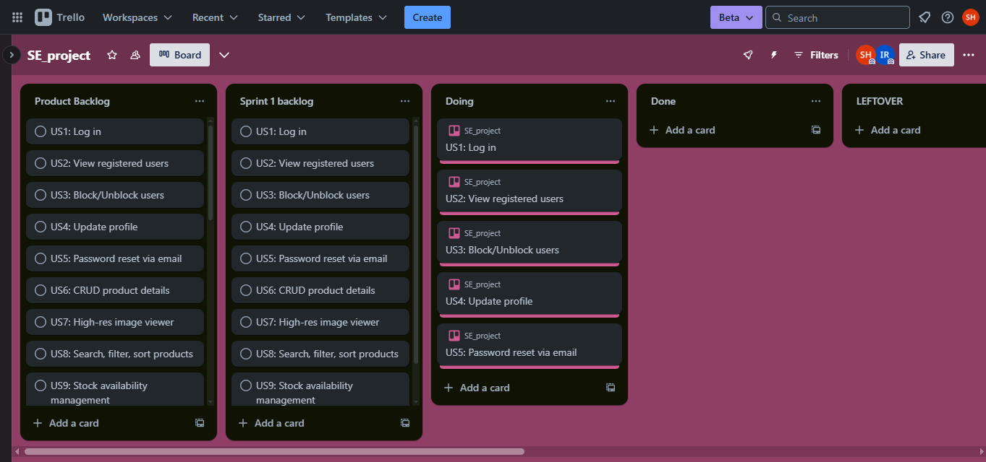
- Snapshot 2: Mid-sprint – ~50% tasks complete
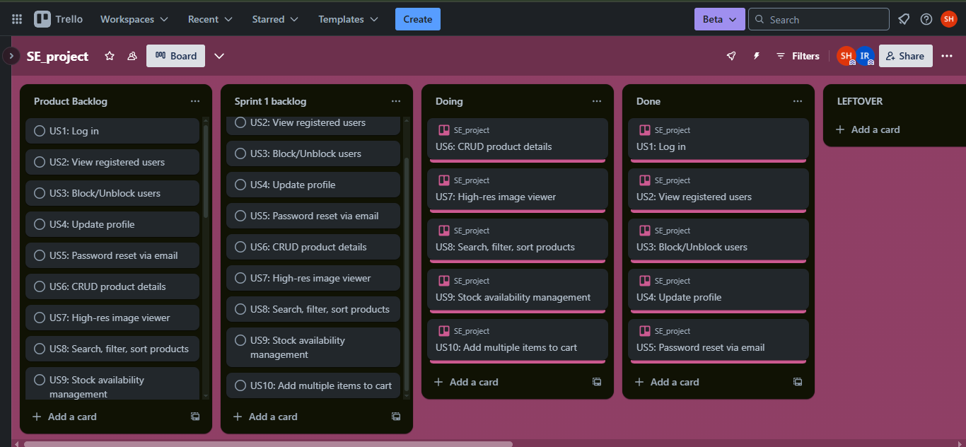
- Snapshot 3: End of Sprint – all tasks done
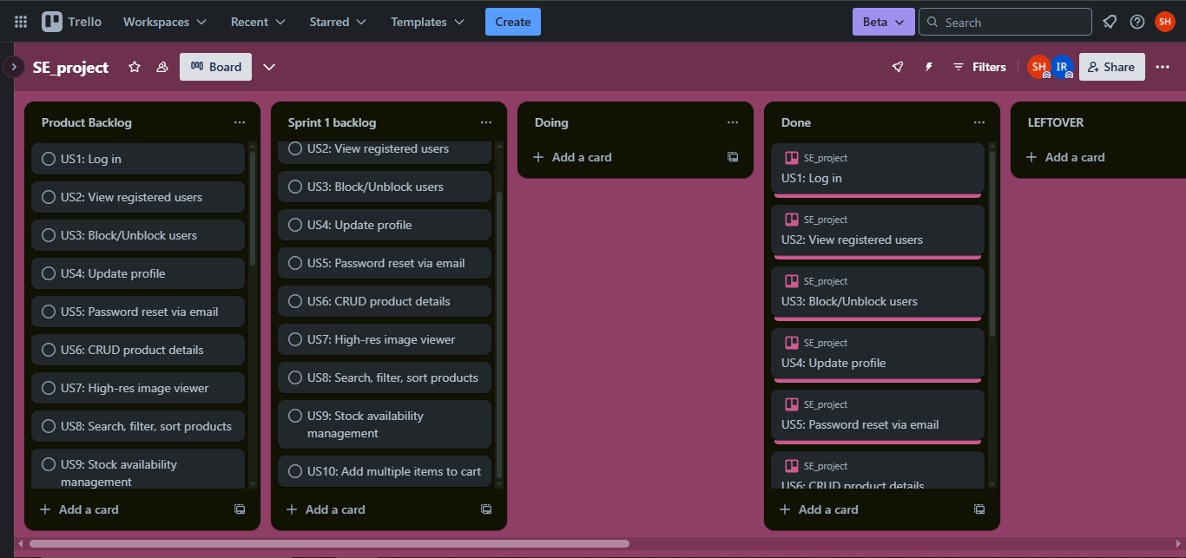
- Snapshot 4: Scrum Master Activities log
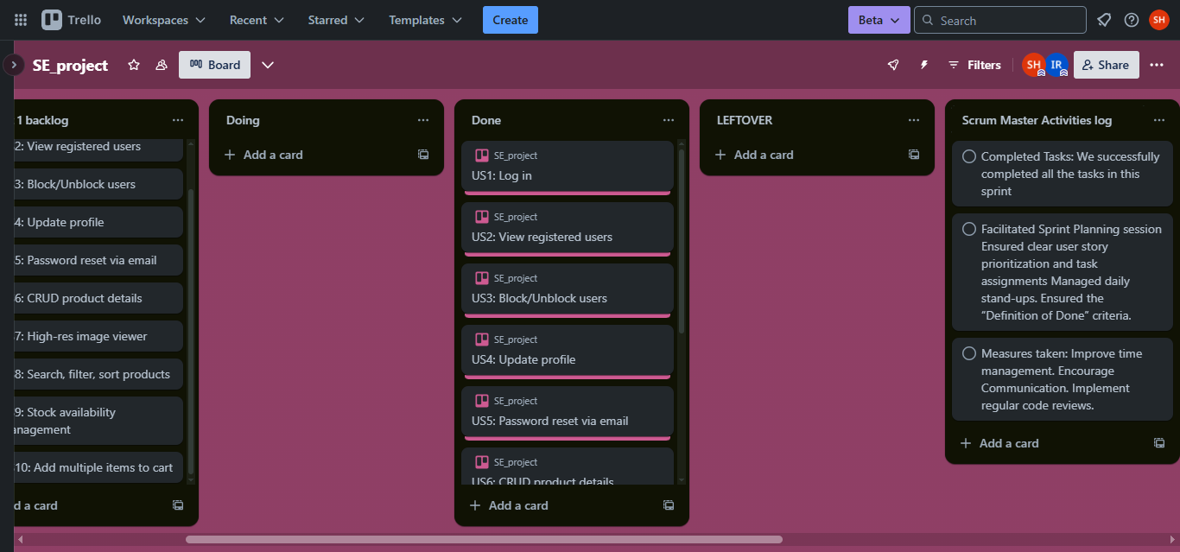
ii. Sprint Burndown Chart (5 Daily Snapshots)
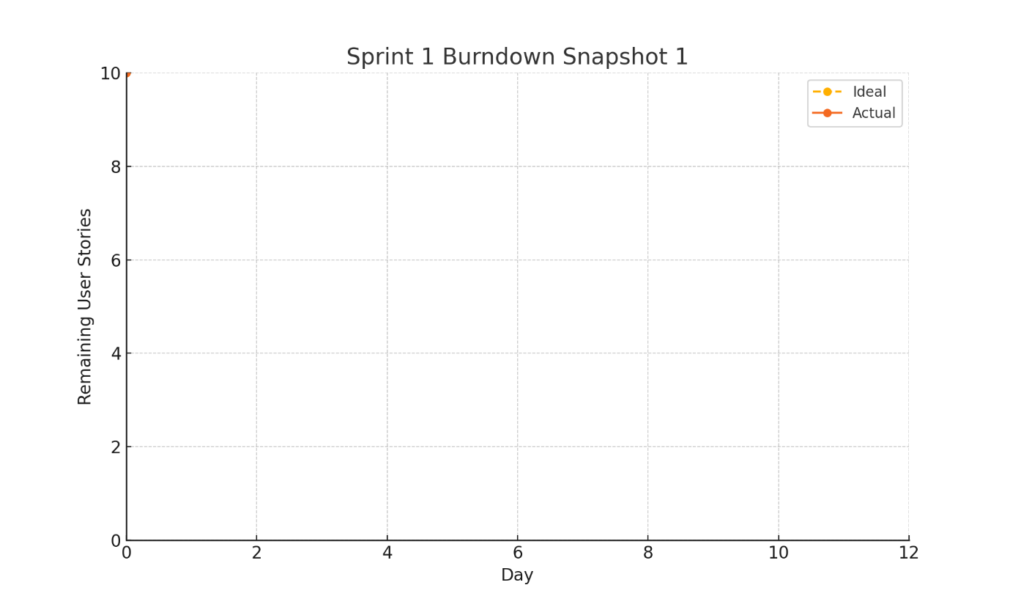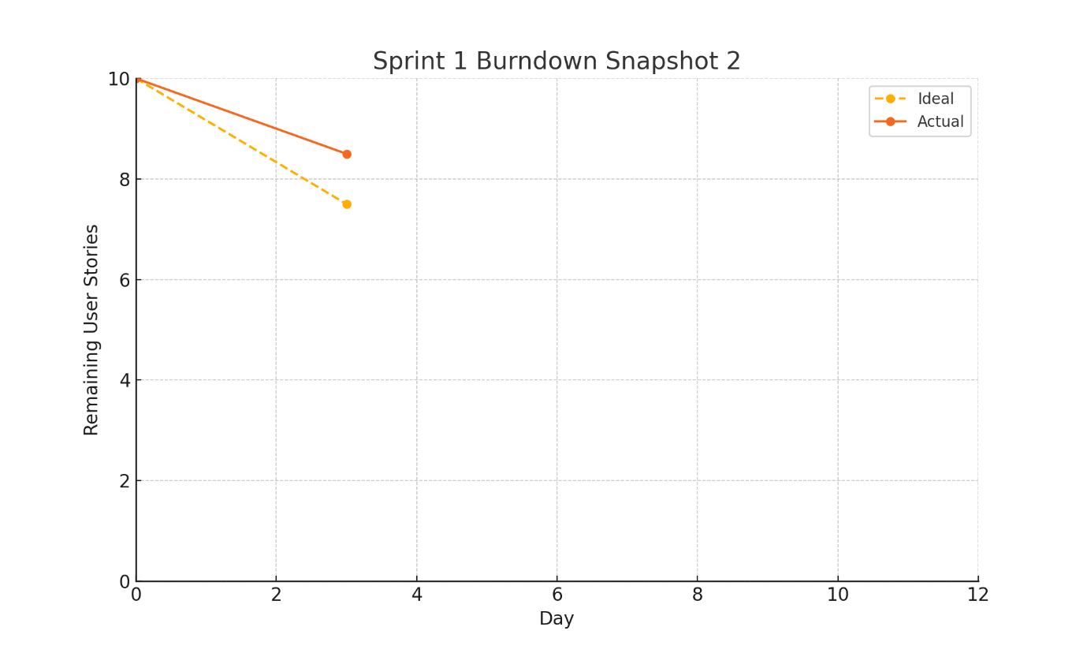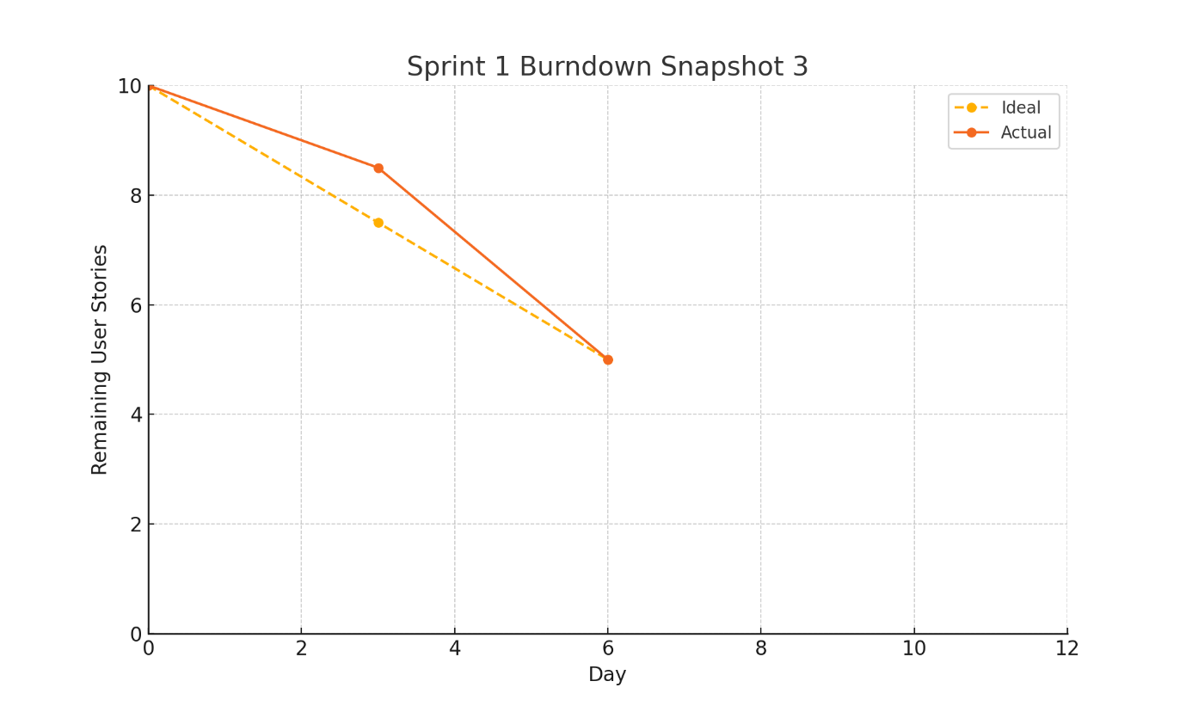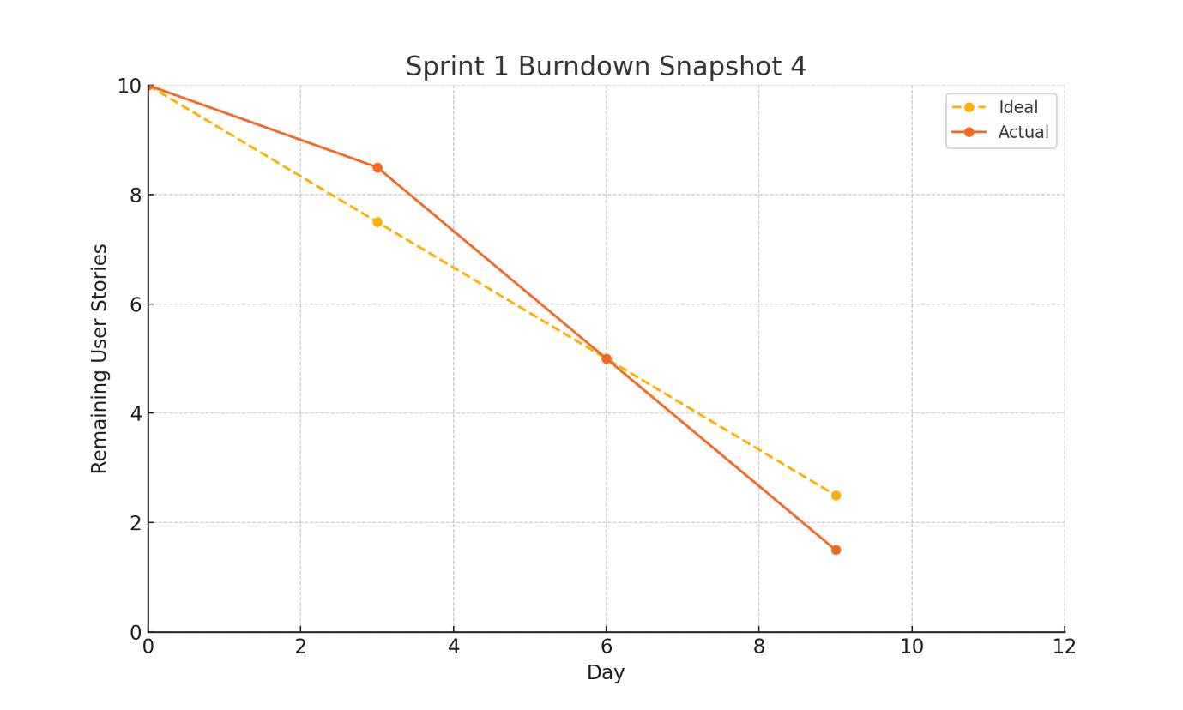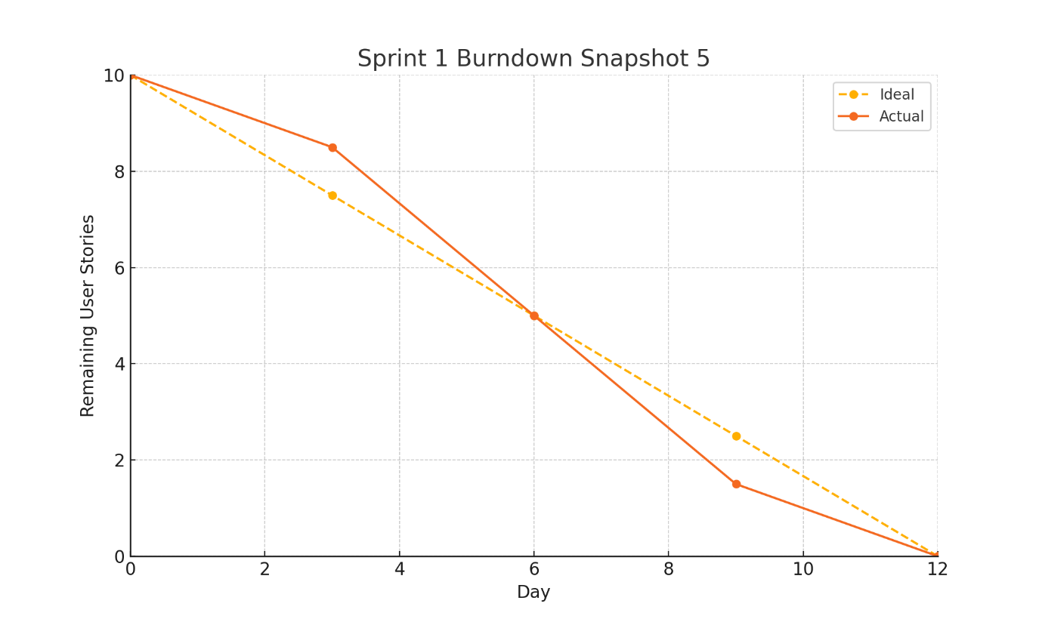
C) Sprint 2 (2 weeks)
Planning Meeting Notes
Name: Sprint Planning Meeting
About: Planning Meeting
Date: May 7, 2025, 11:00 AM PKT
Attendees Present
- Bilal Rasheed
- Saif ul Haq
Absent
- None
Topics Discussed and Conclusions Reached:
The team held a Sprint Planning session for Sprint #2 of the MERN E-Commerce Platform. The meeting was led by Scrum Master Saif ul Haq, with Product Owner Bilal Rasheed presenting the next set of prioritized user stories. The focus of Sprint 2 is on enhancing the customer purchase experience and backend order management.
The team discussed and finalized the inclusion of 8 user stories that cover cart persistence, payment options, order processing, cancellation, invoicing, and delivery management. Short discussions were held regarding potential integration challenges with payment gateways and real-time tracking systems. User stories were estimated and divided for balanced contribution.
Conclusions
The team committed to implementing the following user stories in Sprint #2:
- Save Cart for Later (US11) – Assigned to Saif
- Enter Discount Codes (US12) – Shared Responsibility
- Select Payment Method (US13) – Assigned to Bilal
- Receive Invoice (US14) – Assigned to Bilal
- Track Order Status (US15) – Shared Responsibility
- Assign Delivery Personnel (US16) – Assigned to Saif
- Cancel Order Before Shipment (US17) – Assigned to Bilal
- Notify Customers on Order Status (US18) – Shared Responsibility
Acceptance criteria were confirmed for each user story. The team agreed to use mock data or stubs for payment and SMS/email services if external integration is delayed.
Daily stand-ups scheduled at 9:30 AM PKT to monitor progress and address any blockers promptly.
Sprint 2 Backlog
Modules:
- Cart & Checkout (US11, US12, US13)
- Order Management (US14, US15, US16)
- Admin Notifications & Returns (US17, US18)
User Story ID | User Story
US11 | As a customer, I want to save my cart for later so that I can return and complete my purchase at another time.
US12 | As a customer, I want to enter discount codes at checkout so that I can get applicable price reductions.
US13 | As a customer, I want to select a payment method so that I can complete my purchase conveniently.
US14 | As a customer, I want to receive a detailed invoice after making a purchase so that I have proof of my transaction.
US15 | As a customer, I want to track my order status in real time so that I can stay updated on my purchase.
US16 | As an admin, I want to assign delivery personnel to specific orders so that deliveries can be managed efficiently.
US17 | As a customer, I want to cancel my order before it is shipped so that I can avoid unwanted purchases.
US18 | As an admin, I want to notify customers via email and SMS when their order status changes so that they remain informed.
Carry over to Sprint 3: US19, US20
ii. User Stories
US11 – Save Cart for Later
- As a customer
- I want to save my cart for later
- So that I can return and complete my purchase later
Acceptance criteria
- Given items in cart, when I click “Save Cart,” then cart state is saved to my profile and I see confirmation.
- Given saved cart exists, when I log in later, then I’m prompted to load my saved cart.
Sub-Tasks:
- Frontend: Add "Save Cart" button
- Backend: Persist cart via API
- Tests: Verify save/load flow
US12 – Apply Discount Code
- As a customer
- I want to enter discount codes at checkout
- So that I can get price reductions
Acceptance criteria
- Given valid discount code, when I enter and apply, then order total updates with discount and I see “Code applied.”
- Given expired/invalid code, when I apply, then I see “Invalid code” error and total remains unchanged.
Sub-Tasks:
- Frontend: Discount input field
- Backend: Validate code endpoint
- Tests: Discount application tests
US13 – Select Payment Method
- As a customer
- I want to select a payment method
- So that I can complete my purchase conveniently
Acceptance criteria
- Given multiple methods, when I select one, then it’s highlighted and submitted with my order.
- Given no selection, when I try to proceed, then I see “Please select a payment method.”
Sub-Tasks:
- Frontend: Payment selector UI
- Backend: Store choice on order
- Tests: Payment option tests
US14 – Generate Invoice
- As a customer
- I want to receive a detailed invoice post-purchase
- So that I have proof of transaction
Sub-Tasks:
- Backend: Invoice generation service
- Backend: Email invoice link
- Tests: Invoice format tests
US15 – Real-Time Tracking
- As a customer
- I want to track my order status in real time
- So that I can stay updated
Sub-Tasks:
- Backend: Status endpoint
- Frontend: Tracking UI
- Tests: Tracking update tests
US16 – Assign Delivery Staff
- As an admin
- I want to assign delivery personnel to orders
- So that deliveries are managed efficiently
Sub-Tasks:
- Frontend: Assignment dropdown
- Backend: Assign endpoint
- Tests: Assignment logic tests
US17 – Cancel Order Before Shipping
- As a customer
- I want to cancel my order pre-shipment
- So that I can avoid unwanted purchases
Sub-Tasks:
- Frontend: Cancel button
- Backend: Cancel endpoint
- Tests: Cancel flow tests
US18 – Notify on Status Change
- As an admin
- I want to notify customers when their order status changes
- So that they remain informed
Sub-Tasks:
- Backend: Notification triggers
- Integrate email/SMS services
- Tests: Notification delivery tests

2. Software Testing for Sprint 2
2.1 Equivalence Class Partitioning & Test Cases
Field | Equivalence Class | Type | Test Cases (Weak) | Test Cases (Strong)
Discount Code | EC1: valid active code | Valid | 1 | 2
 | EC2: expired code | Invalid | 1 | 1
 | EC3: malformed format | Invalid | 1 | 1
 | EC4: empty | Invalid | 1 | 1
Payment Method | EC1: supported option | Valid | 1 | 2
 | EC2: unsupported option | Invalid | 1 | 1
 | EC3: empty selection | Invalid | 1 | 1
Cancel Reason | EC1: valid reason text | Valid | 1 | 2
(Order Cancel) | EC2: too long (>200 chars) | Invalid | 1 | 1
 | EC3: empty | Invalid | 1 | 1
2.2 Boundary Value Analysis
Field | Min | Min+1 | Max-1 | Max | Invalid Low | Invalid High
Discount Code Len | 1 | 2 | 19 | 20 | 0 | 21
Payment Methods | 1 option | 2 options | n-1 | n options | 0 | n+1
Cancel Reason Len | 1 | 2 | 199 | 200 | 0 | 201

Name: Sprint Review Final Meeting About:
Review Meeting Date: April 28, 2025, 5:00 PM PKT
Attendees Present: • Bilal Rasheed • Saif ul Haq
Absent: • None
Topics discussed and conclusions reached:
The team conducted the Sprint 2 review meeting to evaluate the delivery of planned user stories and validate their alignment with the acceptance criteria. Saif ul Haq initiated the session by revisiting the sprint goals and user stories committed for implementation.
Bilal presented the implementation of discount code validation (US12), payment method selection (US13), and real-time order tracking (US15). All features were demonstrated with working UI and backend integration.
Saif showcased the cart persistence (US11), invoice generation (US14), and customer notification system (US18), including email and SMS services integrated with status updates.
Both team members tested the admin delivery assignment module (US16) and cancellation logic for unshipped orders (US17). Automated and manual tests were shared, along with sample test results.
Conclusions:
All Sprint 2 user stories have been completed and verified against the Definition of Done. Email and SMS notifications function correctly, though further testing under bulk load conditions was recommended for a future sprint. Minor UX enhancements for the invoice format were discussed and deferred to Sprint 3. The team is satisfied with the sprint outcome and ready to proceed to Sprint 3 with confidence.
Trello Board Snapshots (Sprint 1)
- Snapshot 1: Start of Sprint – backlog setup
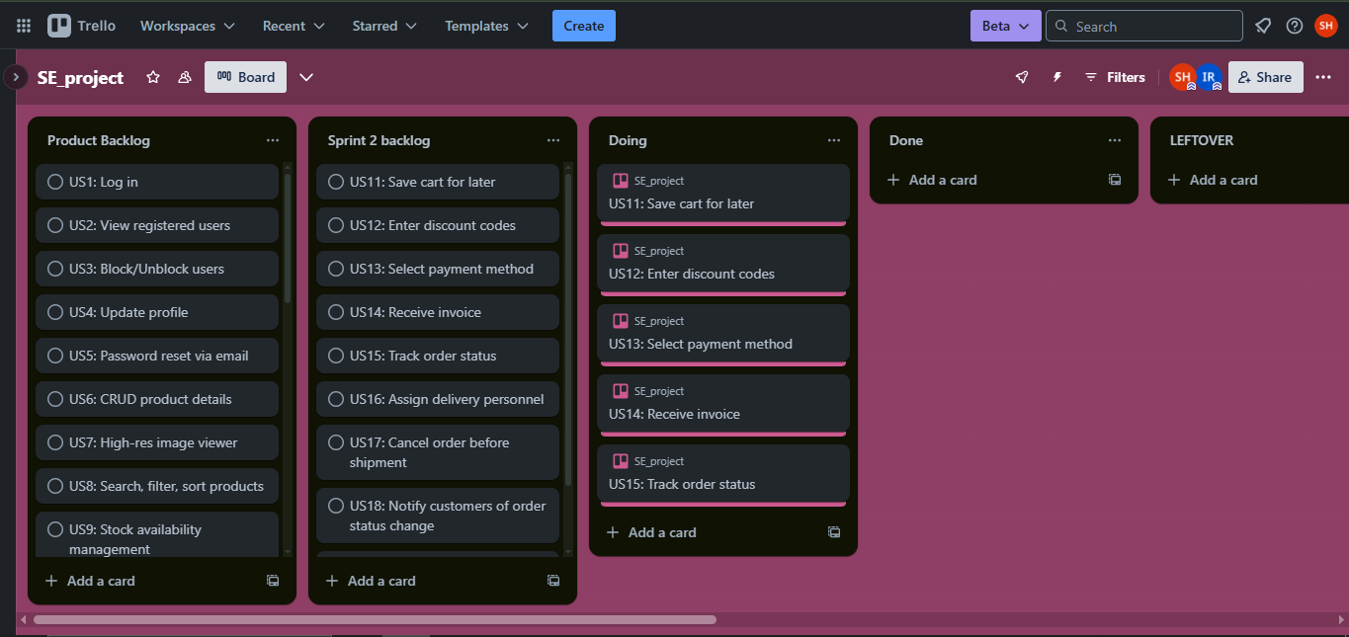
- Snapshot 2: Mid-sprint – ~50% tasks complete
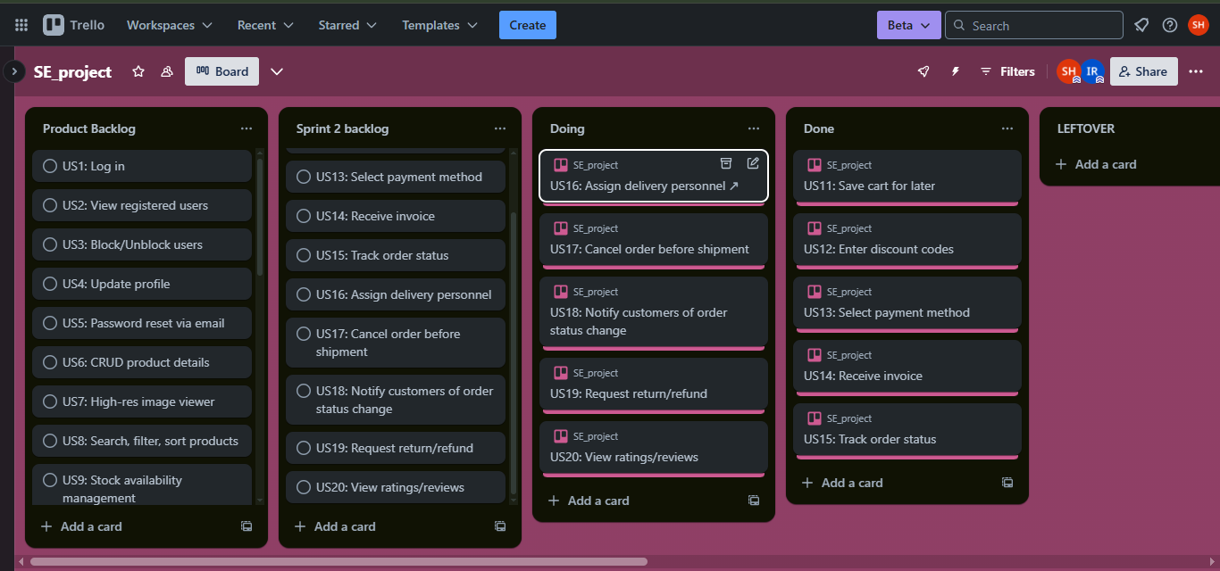
- Snapshot 3: End of Sprint – tasks done
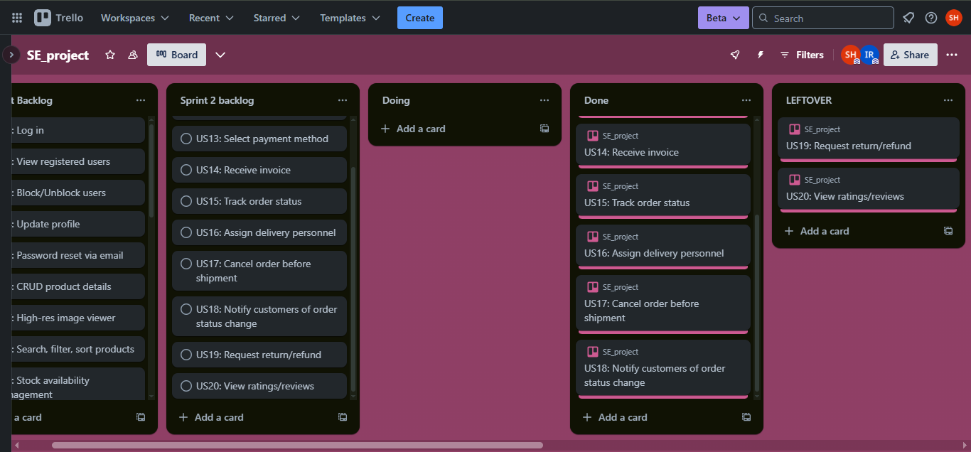
- Snapshot 4: Scrum Master Activities log
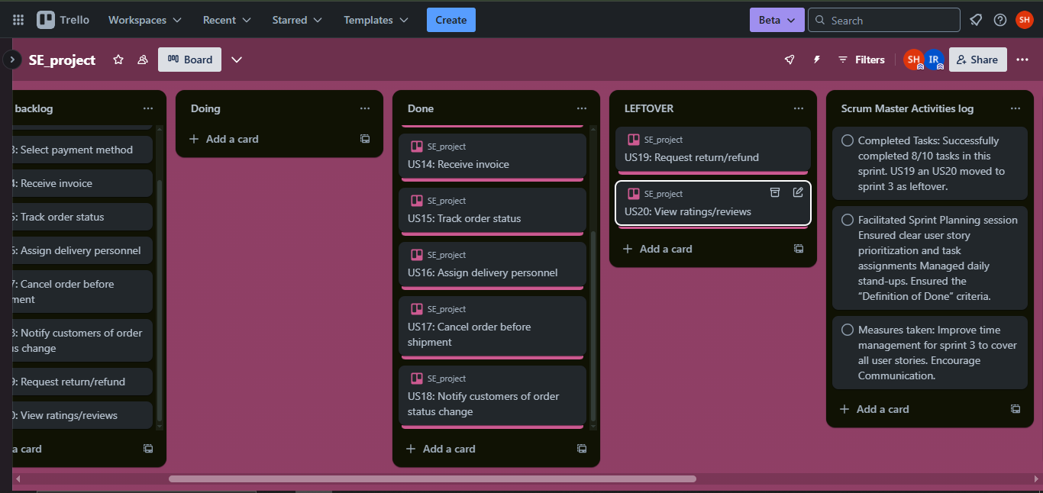
Sprint 2 Burndown Chart (5 Daily Snapshots)
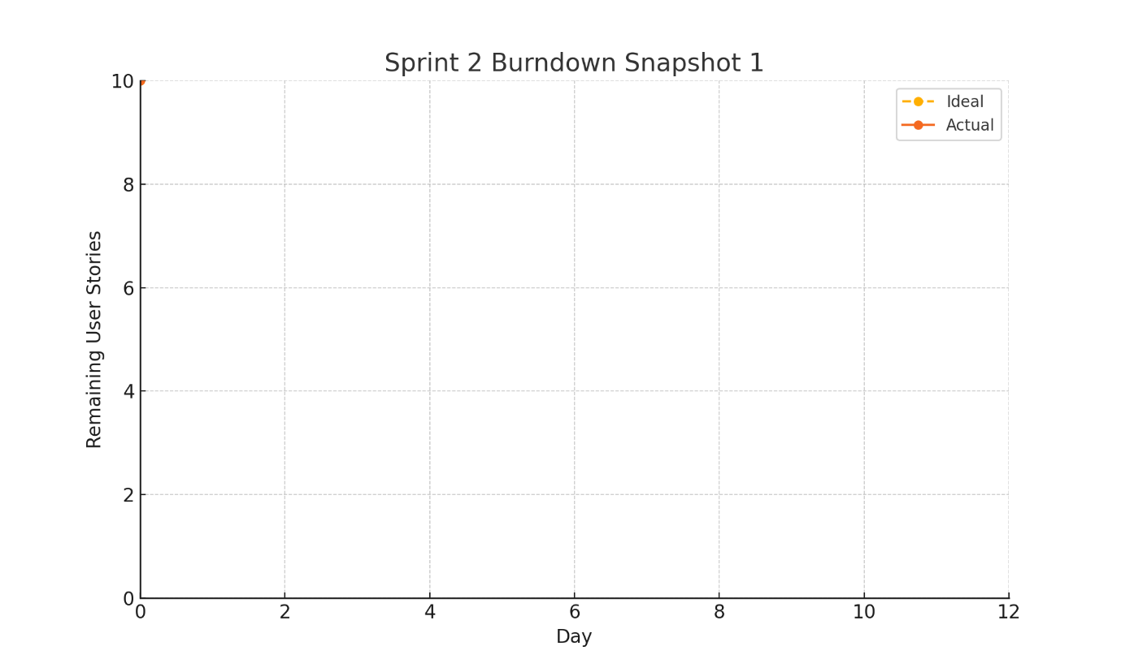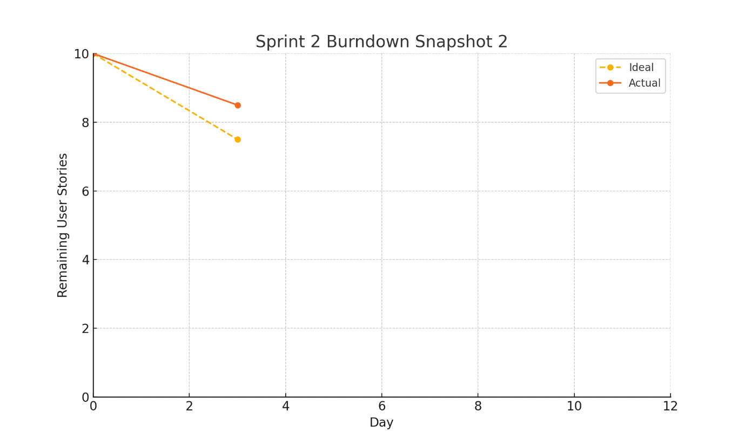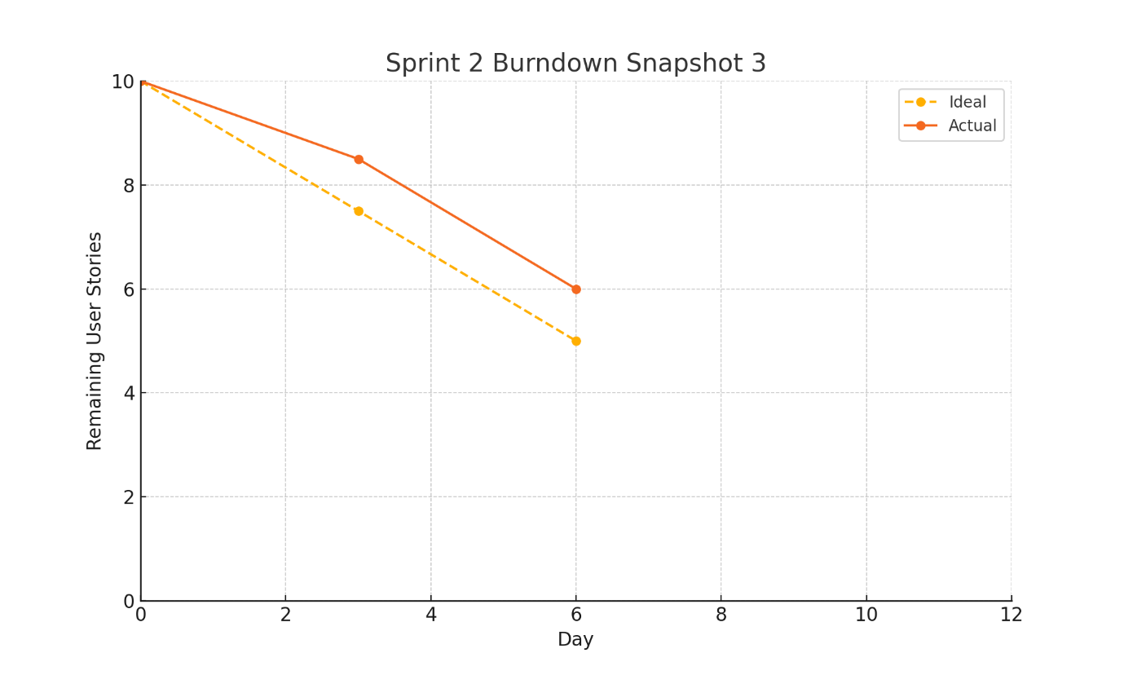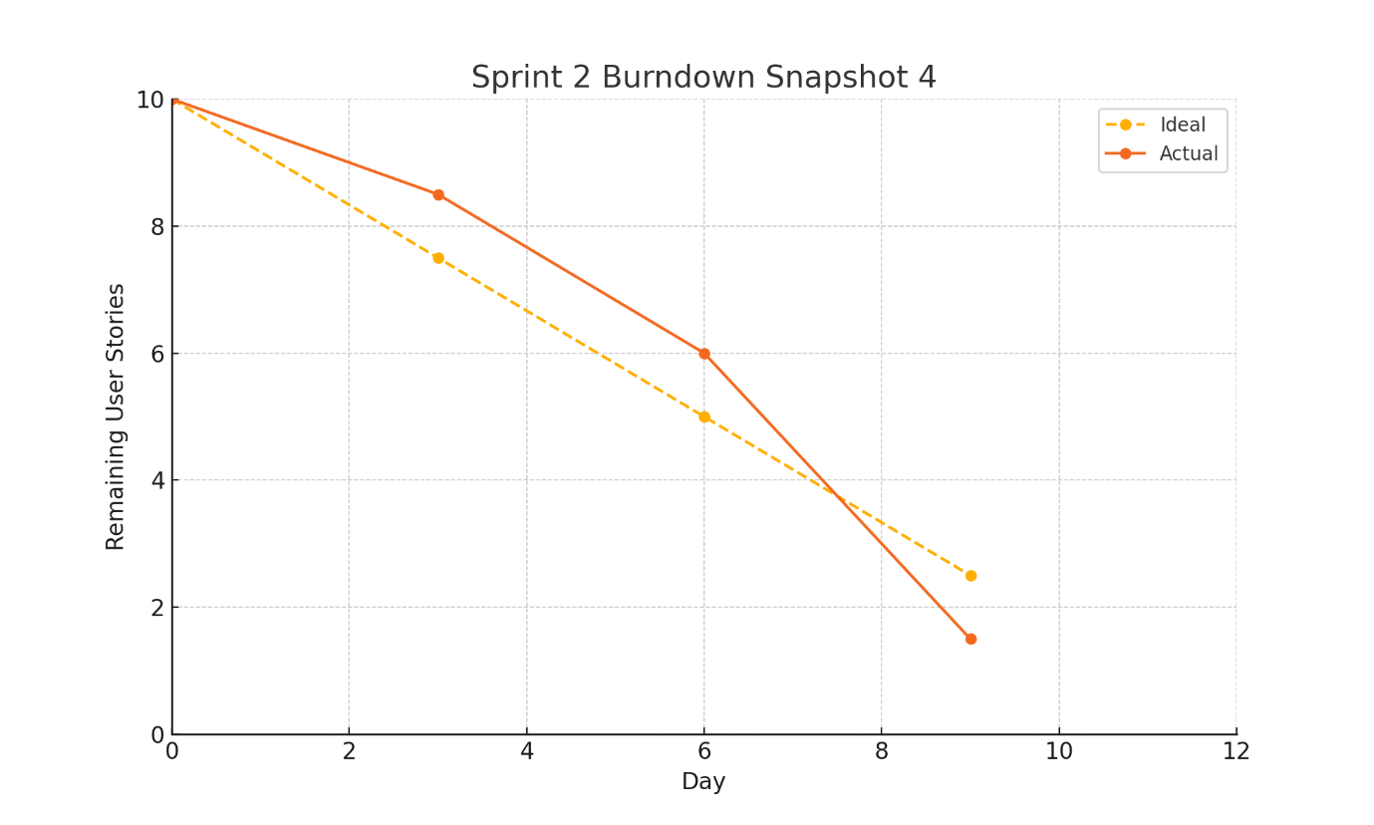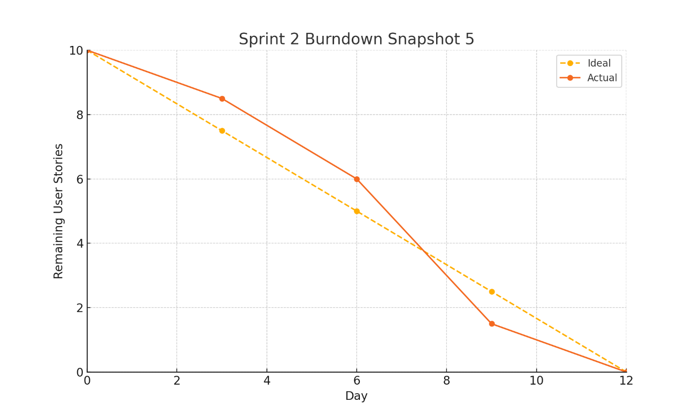

D) Sprint 3 (2 weeks)
Planning Meeting Notes
Name: Sprint Planning Meeting
About: Planning Meeting
Date: May 14, 2025, 10:00 AM PKT

Attendees Present
- Bilal Rasheed
- Saif ul Haq
Absent
- None

Topics Discussed and Conclusions Reached:
The team met for Sprint 3 planning of the MERN E-Commerce Platform. The Scrum Master, Saif ul Haq, facilitated the session. Bilal Rasheed, acting as Product Owner, presented the next set of user stories focused on enhancing user experience, support functionality, and admin reporting tools.
The team prioritized six user stories aimed at improving customer satisfaction, operational insight, and platform reliability. Discussions were kept concise with agreement on which features provide the most value and can realistically be completed in the upcoming sprint.

Conclusions
The team committed to implementing the following user stories for Sprint #3:
- Request Return or Refund (US19) – Assigned to Saif
- View Ratings and Reviews (US20) – Assigned to Bilal
- Live Chat with Support (US21) – Shared
- Sales Reports & Analytics (US22) – Assigned to Bilal
- Personalized Recommendations (US23) – Shared
- Monitor User Activity Logs (US24) – Assigned to Saif
All user stories include clear acceptance criteria and are ready for development.
Daily stand-ups scheduled at 9:30 AM PKT for status updates and resolving blockers.
Sprint 3 Backlog
- Final 6 user stories to complete:
  - US19: As a customer, I want to request a return or refund within a specified period so that I can resolve issues with defective or incorrect products.
  - US20: As a customer, I want to see ratings and reviews from other buyers so that I can make informed purchase decisions.
  - US21: As a customer, I want to chat with customer support for real-time assistance so that I can quickly resolve any order issues.
  - US22: As an admin, I want to generate detailed sales reports and analytics so that I can track revenue and make data-driven decisions.
  - US23: As a customer, I want to receive personalized product recommendations based on my browsing and purchase history so that I can discover relevant products.
  - US24: As an admin, I want to monitor user activity logs so that I can track potential security threats and suspicious behaviour.
ii. User Stories
US19 – Return/Refund Requests
- As a customer
- I want to request a return or refund within a specified period
- So that I can resolve issues with defective or incorrect products
Acceptance criteria
- Given eligible time frame, when I submit a return request, then I see confirmation and status “Requested.”
- Given outside return window, when I attempt, then I see “Return period expired.”
Sub-Tasks:
- Frontend: "Request Return" form in OrderDetail
- Backend: /api/orders/:id/return endpoint
- Tests: Return request flow tests
US20 – Ratings & Reviews Display
- As a customer
- I want to see ratings and reviews from other buyers
- So that I can make informed purchase decisions
Acceptance criteria
- Given reviews exist, when I view ProductDetail, then I see average rating and paginated review list.
- Given no reviews, when I load, then I see “No reviews yet.”
Sub-Tasks:
- Frontend: Show reviews list on ProductDetail
- Backend: /api/products/:id/reviews endpoint
- Tests: Ratings display tests
US21 – Customer Support Chat
- As a customer
- I want to chat with customer support in real time
- So that I can resolve order issues quickly
Acceptance criteria
- Given chat widget loaded, when I send a message, then it appears in the thread immediately.
- Given support offline, when I open chat, then I see “Agent offline” notice.
Sub-Tasks:
- Frontend: Integrate ChatWidget component site-wide
- Backend: Create /api/chat WebSocket endpoint for messaging
- Tests: E2E test for messaging flow
US22 – Sales Reports & Analytics
- As an admin
- I want to generate detailed sales reports and analytics
- So that I can track revenue and make data-driven decisions
Acceptance criteria
- Given valid date range, when I generate report, then I see charts for sales, revenue, and order counts.
- Given start > end, when I submit, then I see “Invalid date range” validation error.
Sub-Tasks:
- Backend: Develop /api/admin/reports/sales endpoint
- Frontend: Build ReportsDashboard component
- Tests: Verify report data accuracy
US23 – Personalized Recommendations
- As a customer
- I want to receive product recommendations based on my browsing and purchase history
- So that I can discover relevant products
Sub-Tasks:
- Backend: Implement recommendation engine endpoint /api/products/recommend
- Frontend: Display recommended products on homepage
- Tests: Validate recommendation results
US24 – Activity Log Monitoring
- As an admin
- I want to monitor user activity logs
- So that I can track potential security threats and suspicious behavior
Sub-Tasks:
- Backend: Log actions to activity_logs collection
- Frontend: Create AdminActivityLog component with filters
- Tests: Verify log retrieval and filtering

2. Software Testing for Sprint 3
2.1 Equivalence Class Partitioning & Test Cases
Field | Equivalence Class | Type | Weak Cases | Strong Cases
Chat Message | EC1: valid non-empty text | Valid | 1 | 2
 | EC2: empty message | Invalid | 1 | 1
 | EC3: >500 characters | Invalid | 1 | 1
Report Date Range | EC1: valid start < end within 1 year | Valid | 1 | 2
 | EC2: start > end | Invalid | 1 | 1
 | EC3: range > 1 year | Invalid | 1 | 1
 | EC4: missing dates | Invalid | 1 | 1
Recommendation Count | EC1: 1–20 recommendations | Valid | 1 | 2
 | EC2: 0 recommendations | Invalid | 1 | 1
 | EC3: >20 recommendations | Invalid | 1 | 1
Log Filter | EC1: single filter (date or user) | Valid | 1 | 2
 | EC2: combined filters | Valid | 1 | 2
 | EC3: invalid filter key | Invalid | 1 | 1
 | EC4: no filters | Valid | 1 | 1
2.2 Boundary Value Analysis
Field | Min | Min+1 | Max-1 | Max | Invalid Low | Invalid High
Chat Message Length | 1 | 2 | 499 | 500 | 0 | 501
Report Range Years | 1 day | 2 days | 364 days | 1 year | 0 days | 366 days
Recommendation Count | 1 | 2 | 19 | 20 | 0 | 21
Log Filter Parameters | 1 param | 2 params | n-1 | n params | 0 | n+1

Name: Sprint 3 Review Final Meeting
About: Review Meeting
Date: May 10, 2025, 4:45 PM PKT
Attendees Present
- Bilal Rasheed
- Saif ul Haq
Absent
- None
Topics discussed and conclusions reached
The team conducted the final review of all implemented features for Sprint 3 to confirm they meet the "Definition of Done" criteria. Saif ul Haq led the review and discussed each feature’s checklist.
Bilal presented the "Request Return/Refund" feature (US19), demonstrating the functionality along with test coverage and documentation.
Saif also presented the "Ratings & Reviews" feature (US20), showing the customer interface for viewing reviews and submitting their own.
Bilal showcased the real-time "Customer Support Chat" feature (US21), which allows customers to chat live with support for quick issue resolution.
Saif confirmed the implementation of "Sales Reports and Analytics" (US22), displaying revenue statistics, trends, and product performance data for admin users.
Both team members reviewed the "Personalized Product Recommendations" (US23) feature, ensuring that recommendations are based on user history and preferences, and working as expected.
The last feature reviewed was "User Activity Logs" (US24), where Bilal demonstrated the admin interface for viewing activity logs and ensuring security.
Conclusions:
- All core features (Return/Refund Request, Ratings & Reviews, Customer Support Chat, Sales Reports, Personalized Recommendations, User Activity Logs) meet the Definition of Done requirements.
- The team identified minor UI enhancements for the "Customer Support Chat" feature that will be addressed in the next sprint.
- No major blockers were identified, and all functionalities passed manual testing.
Trello Board Snapshots (Sprint 1)
- Snapshot 1: Start of Sprint – backlog setup
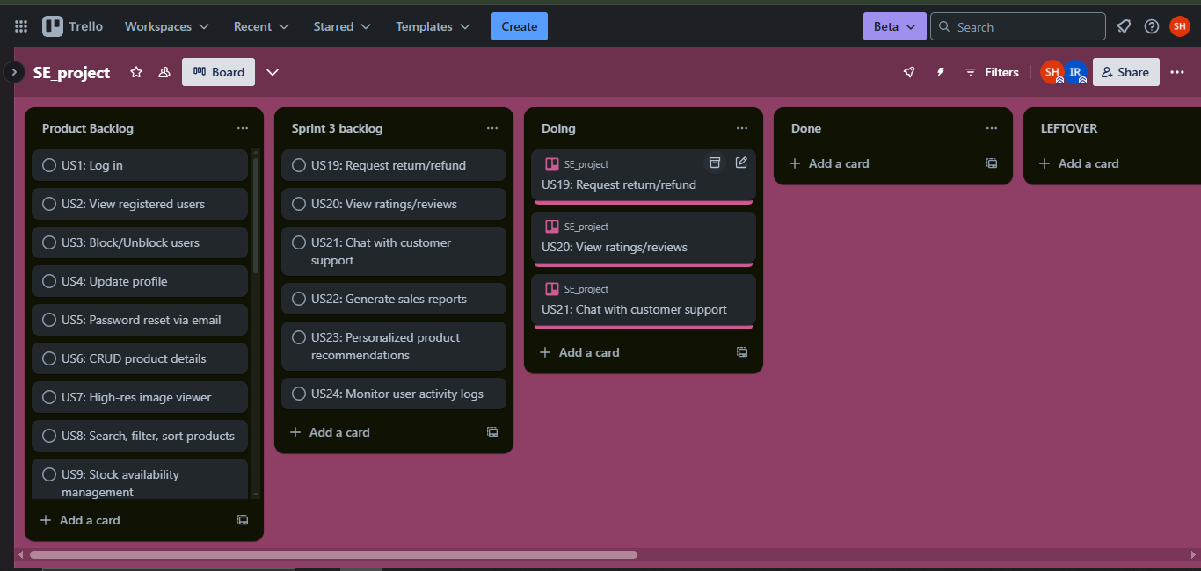
- Snapshot 2: Mid-sprint – ~50% tasks complete
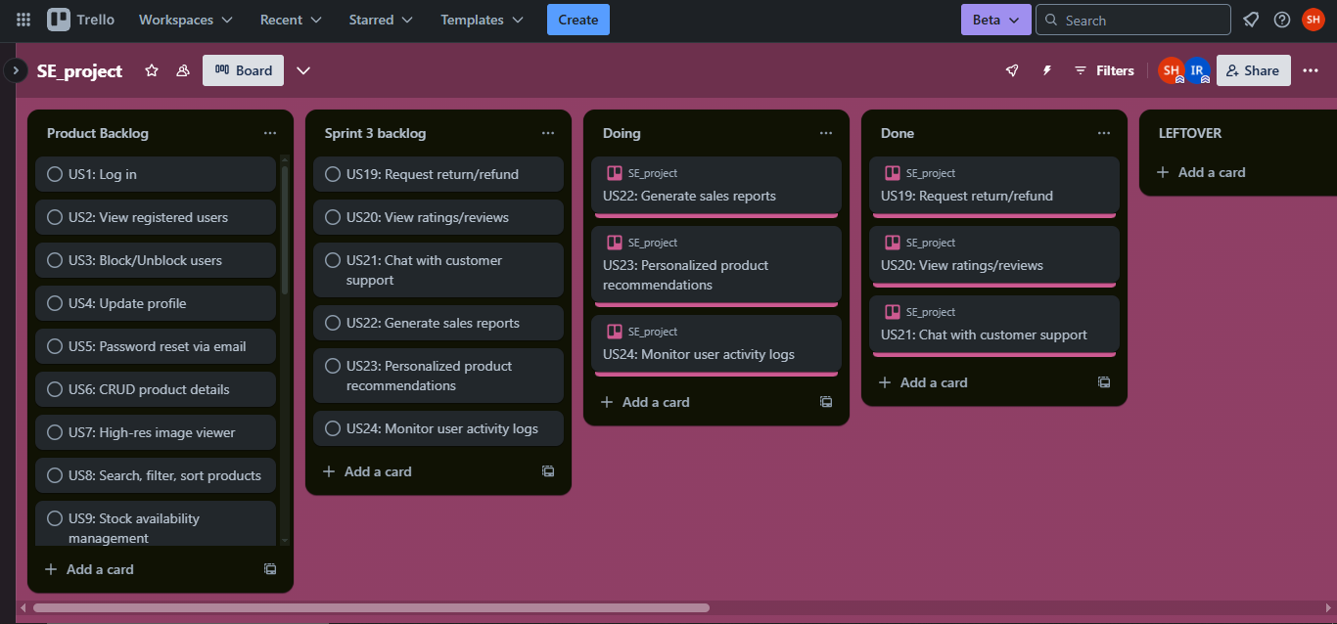
- Snapshot 3: End of Sprint – all tasks done
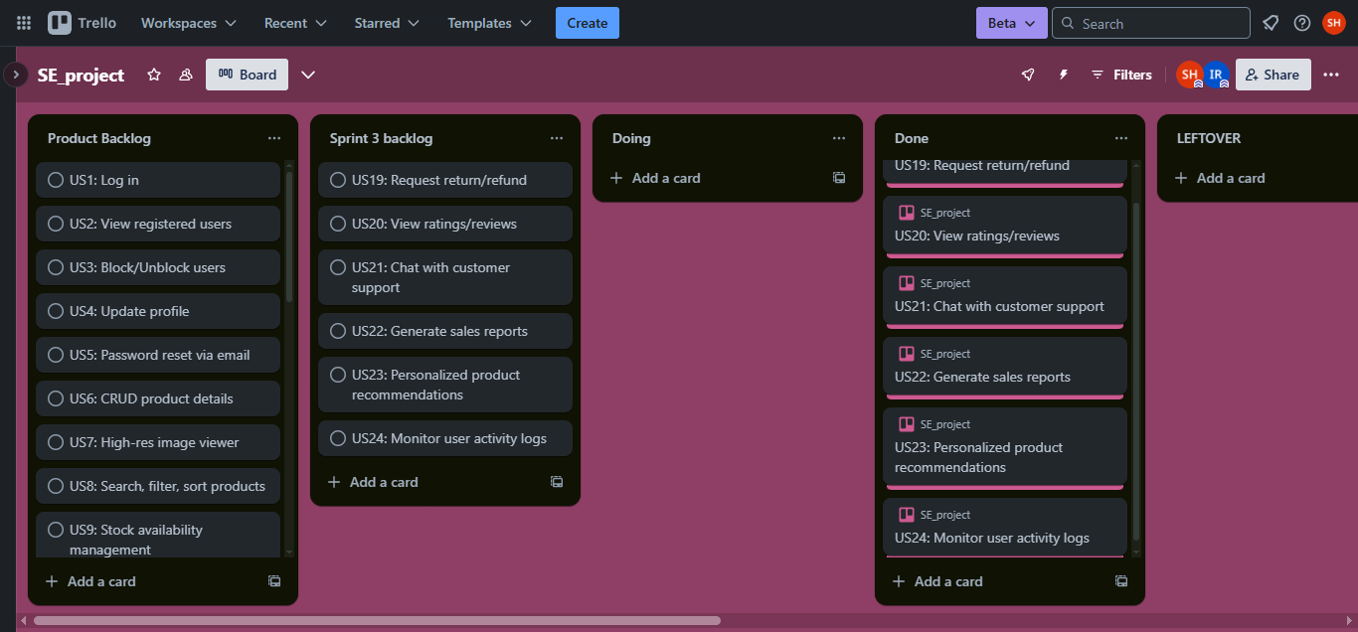
- Snapshot 4: Scrum Master Activities log
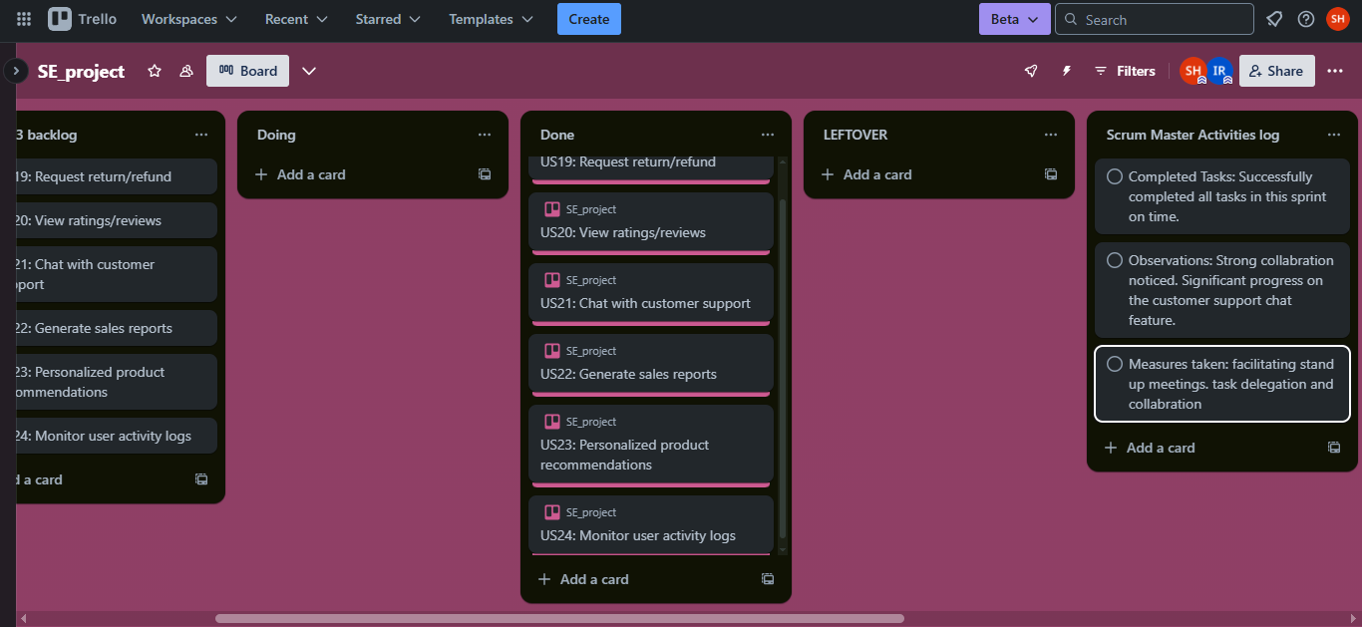
Sprint 3 Burndown Chart (5 Daily Snapshots)
