**Assignment-EDA**

# univariate non graphical : Categorical

> Titanic_Survived_sum<-summary(Titanic$Survived)

> Titanic_Survived_sum

0 1

549 342

> Titanic_Survived_table<-as.matrix(Titanic_Survived_sum)

> Titanic_Survived_table

[,1]

0 549

1 342

> Titanic_Survived_table<-as.matrix(Titanic_Survived_sum,Titanic_Survived_sum/sum(Titanic_Survived_sum))

> Titanic_Survived_table

[,1]

0 549

1 342

> Titanic_Survived_table<-cbind(Titanic_Survived_table,Titanic_Survived_table/sum(Titanic_Survived_table))

> Titanic_Survived_table

[,1] [,2]

0 549 0.6161616

1 342 0.3838384

#Pclass

> Titanic_Pclass_sum<-summary(Titanic$Pclass)

> Titanic_Pclass_table<-as.matrix(Titanic_Pclass_sum)

> Titanic_Pclass_table

[,1]

1 216

2 184

3 491

> Titanic_Pclass_table<-cbind(Titanic_Pclass_table,Titanic_Pclass_table/sum(Titanic_Pclass_table))

> Titanic_Pclass_table

[,1] [,2]

1 216 0.2424242

2 184 0.2065095

3 491 0.5510662

#sex

> Titanic_sex_table<-table(Titanic$Sex)

> Titanic_sex_table

female male

314 577

#Cabin

> Titanic_Cabin_table<-table(Titanic$Cabin)

> Titanic_Cabin_table

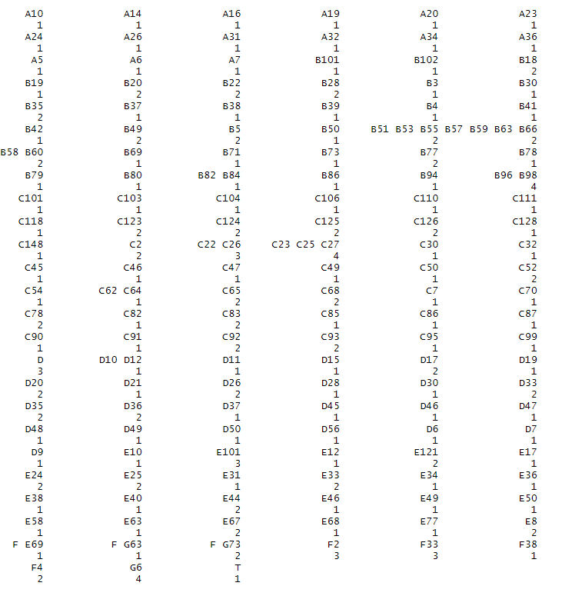

#Ticket

> Titanic_Cabin_table<-table(Titanic$Cabin)

> Titanic_Cabin_table

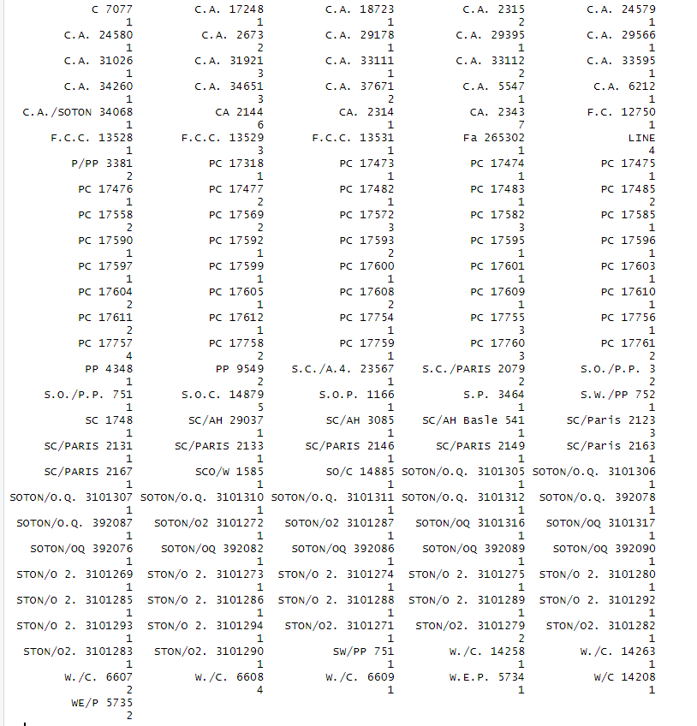

-----------------------Quantitative Data------------------

-------------------Age--------------------------

> Titanic_data_age_mean<-mean(Titanic$Age,na.rm = TRUE)

> Titanic_data_age_mean

[1] 29.69912

> Titanic_data_age_median<-median(Titanic$Age,na.rm = TRUE)

> Titanic_data_age_median

[1] 28

> Titanic_data_age_mode<-mode(Titanic$Age)

> Titanic_data_age_mode

[1] "numeric"

>

> Titanic_data_age_central_tendency<-list(Titanic_data_age_mean,Titanic_data_age_median)

> Titanic_data_age_central_tendency

[[1]]

[1] 29.69912

[[2]]

[1] 28

> Titanic_data_age_variance<-var(Titanic$Age)

> Titanic_data_age_variance

[1] NA

> Titanic_data_age_variance<-var(Titanic$Age,na.rm = TRUE)

> Titanic_data_age_variance

[1] 211.0191

> Titanic_data_age_standard_deviation<-sqrt(Titanic_data_age_variance)

> Titanic_data_age_standard_deviation

[1] 14.5265

--------------Sibsp-----------

> Titanic_data_Sibsp_mean<-mean(Titanic$SibSp)

> Titanic_data_Sibsp_mean

[1] 0.5230079

> Titanic_data_Sibsp_median<-median(Titanic$SibSp)

> Titanic_data_Sibsp_median

[1] 0

> Titanic_data_age_central_tendency

[[1]]

[1] 29.69912

[[2]]

[1] 28

> Titanic_data_Sibsp_variance<-var(Titanic$SibSp,na.rm = TRUE)

> Titanic_data_Sibsp_variance

[1] 1.216043

> Titanic_data_Sibsp_Standard_deviation<-sqrt(Titanic_data_Sibsp_variance)

> Titanic_data_Sibsp_Standard_deviation

[1] 1.102743

------------------Parch----------------------

> Titanic_data_Parch_mean<-mean(Titanic$Parch)

> Titanic_data_Parch_mean

[1] 0.3815937

> Titanic_data_Parch_median<-median(Titanic$Parch)

> Titanic_data_Parch_median

[1] 0

> Titanic_data_Parch_central_tendency<-list(Titanic_data_Parch_mean,Titanic_data_Parch_median)

> Titanic_data_Parch_central_tendency

[[1]]

[1] 0.3815937

[[2]]

[1] 0

> Titanic_data_Parch_variance<-var(Titanic$Parch,na.rm = TRUE)

> Titanic_data_Parch_variance

[1] 0.6497282

> Titanic_data_Parch_standard_deviation<-sqrt(Titanic_data_Parch_variance)

> Titanic_data_Parch_standard_deviation

[1] 0.8060572

-----------------------Fare---------------

|  |
| --- |
| > Titanic_data_Fare_mean<-mean(Titanic$Fare)  > Titanic_data_Fare_mean  [1] 32.20421  > Titanic_data_Fare_median<-median(Titanic$Fare)  > Titanic_data_Fare_median  [1] 14.4542  > Titanic_data_Fare_central_tendency<-list(Titanic_data_Fare_mean,Titanic_data_Fare_median)  > Titanic_data_Fare_central_tendency  [[1]]  [1] 32.20421  [[2]]  [1] 14.4542 |
|  |
| |  | | --- | | > Titanic_data_Fare_variance<-var(Titanic$Fare,na.rm = TRUE)  > Titanic_data_Fare_variance  [1] 2469.437  > Titanic_data_Fare_standard_deviation<-sqrt(Titanic_data_Fare_variance)  > Titanic_data_Fare_standard_deviation  [1] 49.69343  --------------------Univariate graphical method--------  **********************Categorical**********************  -----------------------Survived--------------------  > t<- table(Titanic$Survived,Titanic$Sex)  > barplot(t) | |

******************Pclass**************

> barplot(table(Titanic$Pclass,Titanic$Sex))

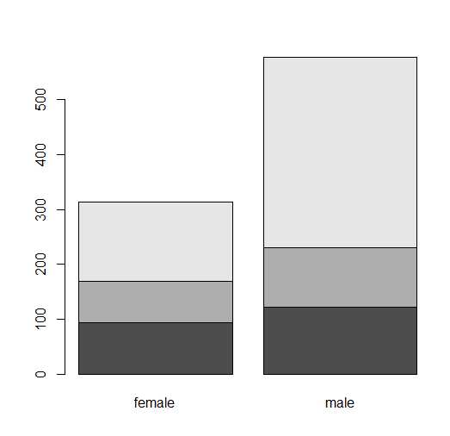

----------------------Quantitative-------------------------------------------------------

****************Age***************

hist(Titanic$Age)

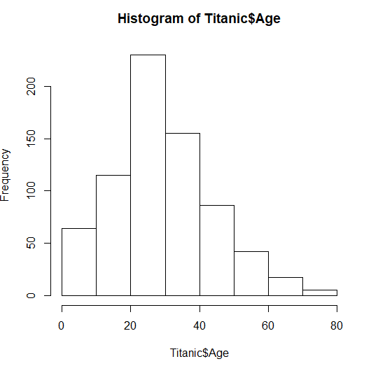

> boxplot(Titanic$Age)

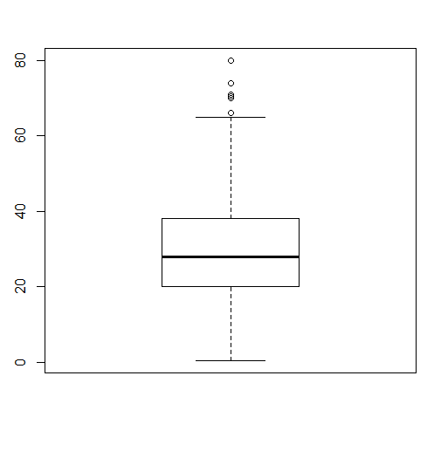

*******************************Sibsp*********************

> hist(Titanic$SibSp)

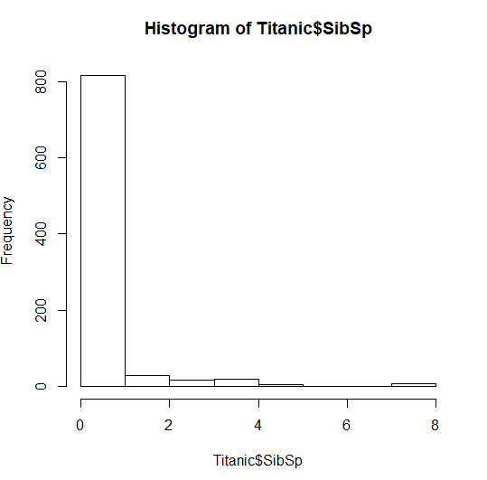

boxplot(Titanic$SibSp)

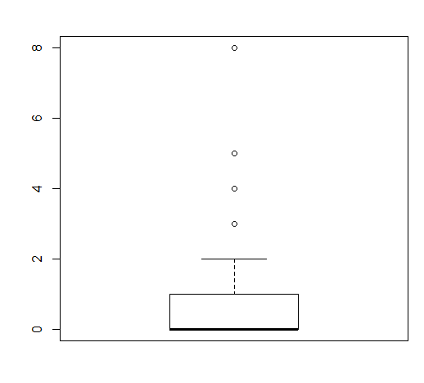

hist(Titanic$Parch)

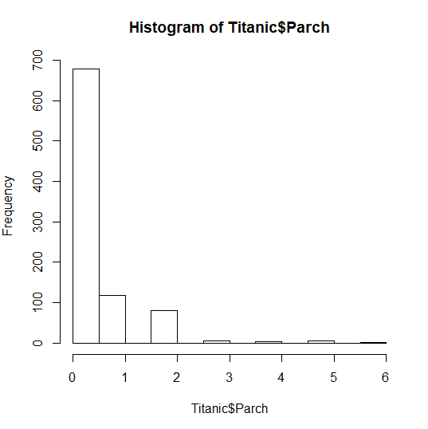

************************Fare******************

> hist(Titanic$Fare)

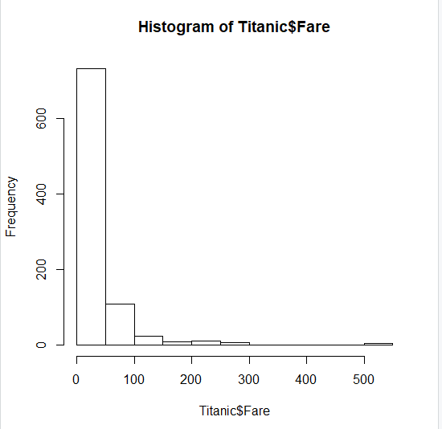

> boxplot(Titanic$Fare)

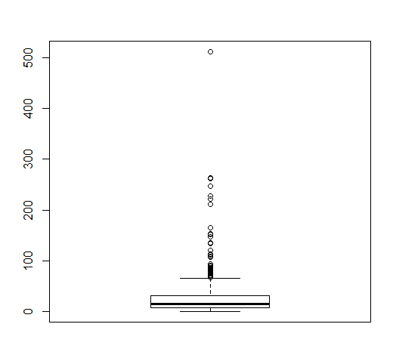

**Multivariate**

-----------------------Survived, Pclass-----------------------

> Titanic_data<- cbind(Titanic$Survived,Titanic$Pclass)

> Titanic_data<-summary(Titanic_data)

> Titanic_data

V1 V2

Min. :1.000 Min. :1.000

1st Qu.:1.000 1st Qu.:2.000

Median :1.000 Median :3.000

Mean :1.384 Mean :2.309

3rd Qu.:2.000 3rd Qu.:3.000

Max. :2.000 Max. :3.000

> Titanic_chisq_test<-table(Titanic$Survived,Titanic$Pclass)

> chisq.test(Titanic_chisq_test)

Pearson's Chi-squared test

data: Titanic_chisq_test

X-squared = 102.89, df = 2, p-value <

2.2e-16

> Titanic_data=data.frame(Titanic$Survived,Titanic$Pclass)

> colnames(Titanic_data)=c("Survived","Pclass")

> library(ggplot2)

Find out what's changed in ggplot2 at https://github.com/tidyverse/ggplot2/releases.

> ggplot(data=Titanic_data,aes(x=Survived,y=Pclass,fill=Survived))+geom_bar(stat="identity")+theme_bw()

> ggplot(data=Titanic_data,aes(x=Survived,y=Pclass,fill=Pclass))+geom_bar(stat="identity")+theme_bw()

