BRACU MONGOL TORI  
-A boat for Mars

Authors Name/s per 1st Affiliation *(Author)*  Authors Name/s per 2nd Affiliation *(Author)*

line 1 (of *Affiliation*): dept. name of organization line 1 (of *Affiliation*): dept. name of organization

line 2: name of organization, acronyms acceptable line 2: name of organization, acronyms acceptable

line 3: City, Country line 3: City, Country

line 4: e-mail address if desired line 4: e-mail address if desired

*Abstract*—This electronic document is a “live” template and already defines the components of your paper [title, text, heads, etc.] in its style sheet. *\*CRITICAL: Do Not Use Symbols, Special Characters, or Math in Paper Title or Abstract*. (***Abstract***)

***Keywords—component; formatting; style; styling; insert (****key words****)***

**I. INTRODUCTION**

“Mongol Tori”, the next generation Mars Rover is created and designed with the touch of new invention to push the boundaries of modern technology. In order to participate in URC2017 a group of enthusiastic undergraduate engineering students and teachers of BRAC University take the enthusiastic steps to build the Rover. The rover can perform **extreme retrieval** and delivery task in 60 minutes in which the rover can easily travel through any type of rough terrain even more than 0.5m vertical drops and steep slopes in excess of 45°. Our rover arm is capable of carrying more than 5 kg and can reach more than 1m from the ground as it has six-degrees of freedom to complete the **Equipment servicing task** like pull a trolley with oil and purring the oil into tank and turn on/off switch etc. For the **autonomous task**, we take the GPS coordinate (latitude, longitude) and generated into UTM coordinate system using java. In **science task**, we have decided to perform onboard and lab experiments. Firstly, our rover will take a high-resolution panorama image of the site with GPS location data and some weather data with related sensor. On the other hand, our sample collector will drill the soil and collect the samples in an air tight container for further tests and decisions.

**II. ROVER DESIGN**

**Chassis:** The chassis of the rover is stimulated from the combination of ladder and tube space frame design. The three-way grid type space frame has been used for chassis. Shape of the chassis is triangular with a square box of 25\*10 inch at the front. The length of the whole chassis is 42 inches. To increase rigidity and stiffness as well as to diminish the possibility of shape distortion due to application of bumpy pressure triangulation has been incorporated in the chassis . The space frame is strong because of rigidity of the triangle. Flexing loads are transmitted as tension and compression loads along the length of each strut. Including the space frame in the rover chassis was the best contribution from team mongol tori , because for that decision the rover body was stable and the chassis works itself as a suspension.

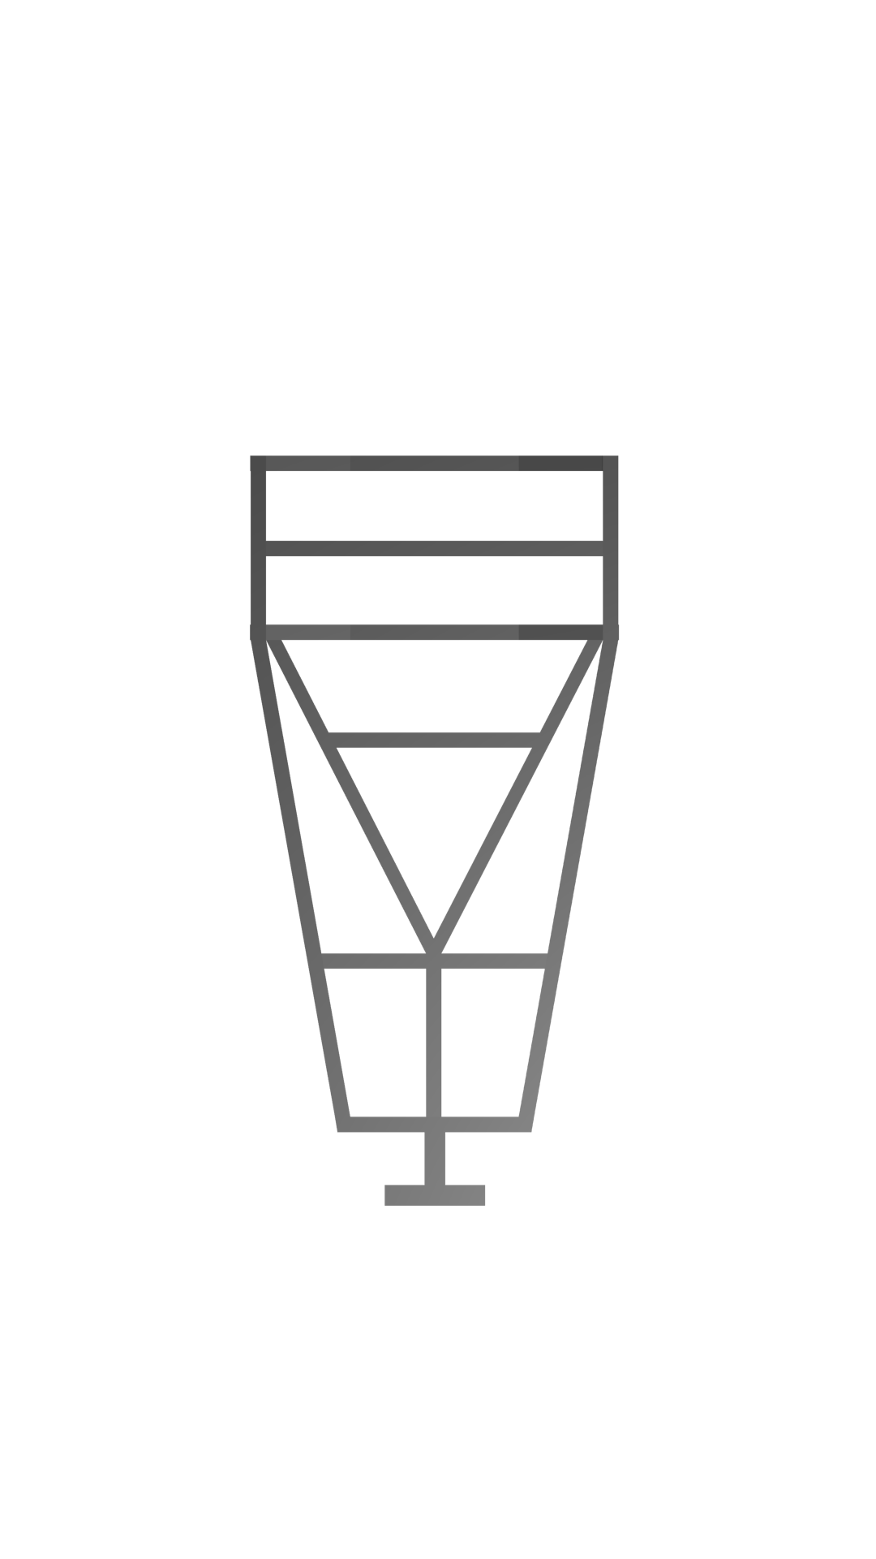20187954_854670941350345_818750075_n.jpg

**Wheel:** The rover has wheels with a diameter of 12 inch and a width of 5 inch. Considering the lightweight and high strength requirements custom made wheels made from molded aluminum have been used. The design of the custom made aluminum motor housing is so modular for connecting the wheels and motors with the body, for that wheels or motors can be replace from the main rover body any time. The motor is placed inside the wheel for avoiding collision with rocks. An efficient rubber grip has been incorporated on the wheel. For cost reduction the rubber grip was made from the timing belt traditionally used in car engine. The orientation of the grip will help the rover to rotate 360 degrees, climbing rock and deal with the vertical drops. Choosing molded aluminum as the raw material for the rover’s wheel was the contribution of the team mongol tori and they are having benefits on field for that decision.

**Suspension:** Considering the rough terrain and the vertical drops a six wheeled rover has been designed. The design is inspired from the popular rocker bogie suspension system. The rover design consists of 1 bogie and 1 rear suspension in each side of the rover. In our design the bogies are mounted on to the front part of chassis and the rear suspension is supported by a high performance shock absorber with double spring. The bogie can freely move up to 80 degrees both directions. The rear suspension is placed angularly for absorbing the shock perfectly. Generally, in the rocker bogie system the distance between every wheel is identical, but in this semi – rocker bogie system the distance between the front two wheels of a bogie is 40 inch and the distance between the middle and the back wheel is 20 inch. For that decision this rover can deal with the vertical drops perfectly. This rover successfully overcome 0.71-meter vertical drop.

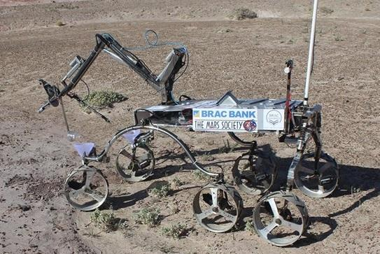

**Steering: :** For the semi rocker bogie structure an intelligent steering system has been used. In this system the front two wheels are working as the steering. Two linear actuator has been incorporated for controlling the steering system. This steering system is totally unique and only used by team mongol tori. This system is the best contribution from the team, that’s why the rover can rotate 360 degree without dragging.

**Robotic Arm:** A very strong and efficient robotic arm with six degrees of freedom (base, shoulder, elbow, wrist, two degrees of freedom in the end effector) is designed our rover. The arm consists of three linear actuator and three dc motor. A gear mechanism has been incorporated at the base of the arm for 360 degree rotation. The three fingered end effector with hard rubber in the fingers can grab small stuff perfectly. An intelligent rotational gear based system has been comprised on the claw for 360 degree rotation without wire twisting. This gear based system is the contribution in the Arm by the team. The claw can hold and the arm can lift 5 kg of weight at any circumstances.

19904680_854665024684270_1989314005_n.jpg

**Evolution:**

**Suspension:** Firstly the team mongol tori used the rocker bogie suspension system without steering mechanism and the bogie was made from square stainless steel box pipe. But after some experiment the team has seen that while 360 degree rotation the rover dragged a lot and the bogie was not stable. That’s why the team include steering system for smooth 360 degree rotation and stable the semi rocker bogie the team used inch round stainless steel pipe which makes the rover more stable.

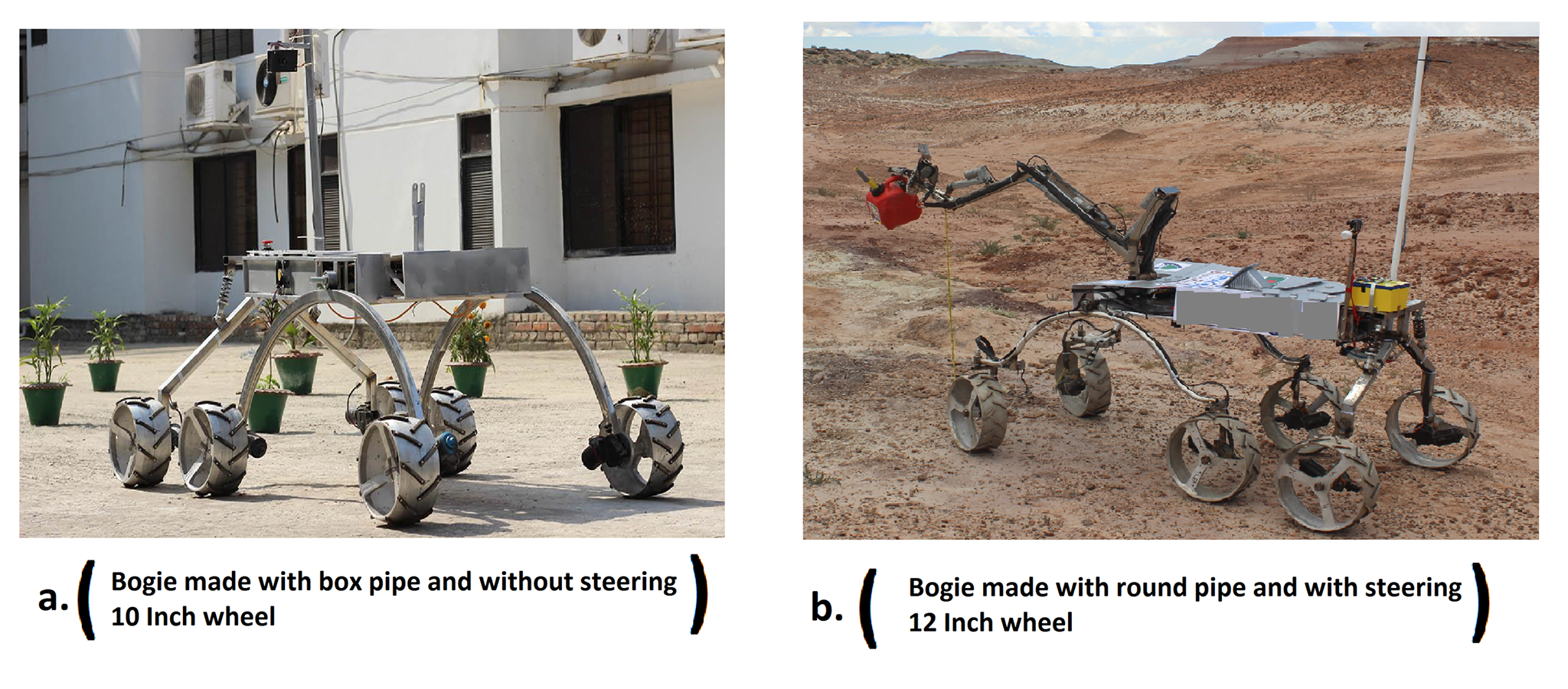

**Robotic Arm:** In the robotic arm the placement of the actuator was not perfect for working. The weight distribution was not accurate also. That’s why the mechanical sub team redesign the robotic arm and places the actuators perfectly that’s how the team has gain the accurate weight distribution. In the end effector there was a problem, while 360 degree rotation of the rover claw it cannot avoid wire twisting. Then the mechanical sub team developed an intelligent gear based mechanism to avoid the wire twisting. Firstly the claw was two fingered, with the two fingered end effector the team has faced some problem while grabbing small stuff. Then the mechanical sub team has developed a new three fingered mechanism which helps the team to grab small stuff more perfectly.

**20227652_854665001350939_1860822765_o.jpg**

**Wheel:** First of all wheels with the diameter of 10 inch has been used. While driving the rover on the rough terrain the rover cannot overcome the large rocks and the motor housed outside the wheel have collision with the rocks. Then team go for a larger version of the wheel which has 12 inch diameter. Then the rover can easily overcome the large rocks and mechanical sub team placed the motor inside the wheel that’s why there was not any collision between motor and rocks. The rubber grip orientation on the wheel which has been used was not working properly. Then the team placed the rubber grip with a new proper orientation which worked properly and helps the wheels to grab the surface superbly.

**III. ROVER SOFTWARE**

The rover software we made established a central control system from a remote distance which consists of control interface (Base Station) and central rover controller. Each system is responsible for controlling different aspects of rover. The base station is responsible for interpreting data from the controller, processing data received from the rover and sent data to the Rover. This system’s main requirement is to provide reliable, easy-to-use control of the rover and accurate, up-to-date, clearly presented information on the rover’s status. All the software has been written in Java which requires Java RunTime Environment (jre 1.8.0\_73). The rover control is based on a Microsoft windows based mini-computer Intel NUC and ATmega2560 based microcontroller board Arduino Mega.

**Control GUI:**

For controlling the rover movement, the base station software takes command from the keyboard according to movement, process the command and send instruction to rover side software which runs on the NUC pc. The rover side software interprets the command and run the rover accordingly.

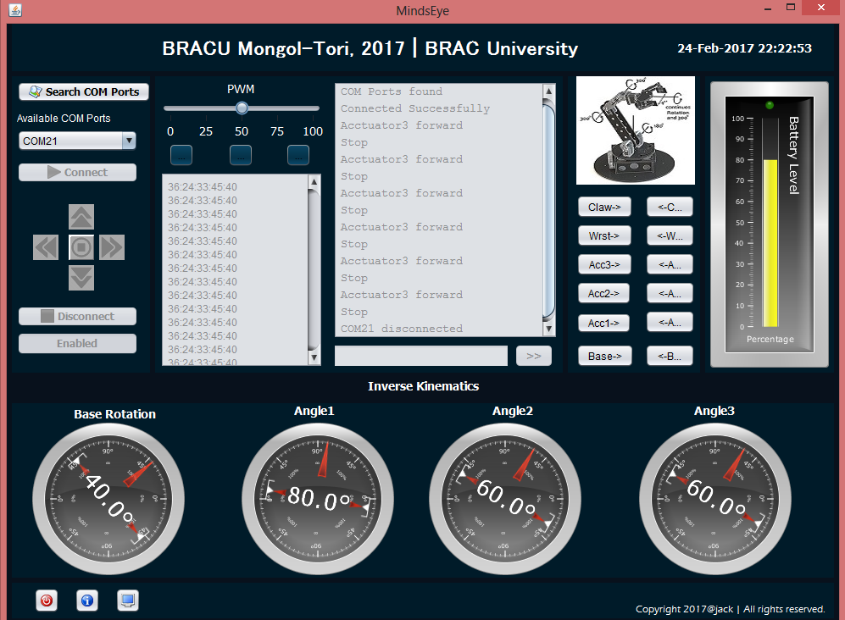

**Sensor GUI:**

The rover side software takes reading from the sensors and transmits the data over the network. The base software receives the data as a string and shows the data in a reliable, accurate, up-to-date and clearly presented way as there are dials, meters, gauges in the software GUI.

**Offline Map:**

To locate and plot the rover’s position, Grove GPS module is being used which features 22 tracking / 66 acquisition channel GPS receiver. GPS data is received in NMEA format and every received string is sent to the base station. The software in the base station is developed in python 2.7 which processes the raw GPS data and extracts the latitude and longitude of the rover position and continuously plots them in the cropped picture of the static map using matplotlib and pynmea.

**Stability GUI:**

An MPU-92/65 sensor is used which is a single chip package containing a 3 axis accelerometer, a 3 axis gyroscope, a 3 axis compass sensor. The sensor is connected with ATmega328P based microcontroller Arduino Uno which communicate with the base station GUI to provide a clear and accurate orientation of the rover. The stability GUI is developed using Arduino and processing.

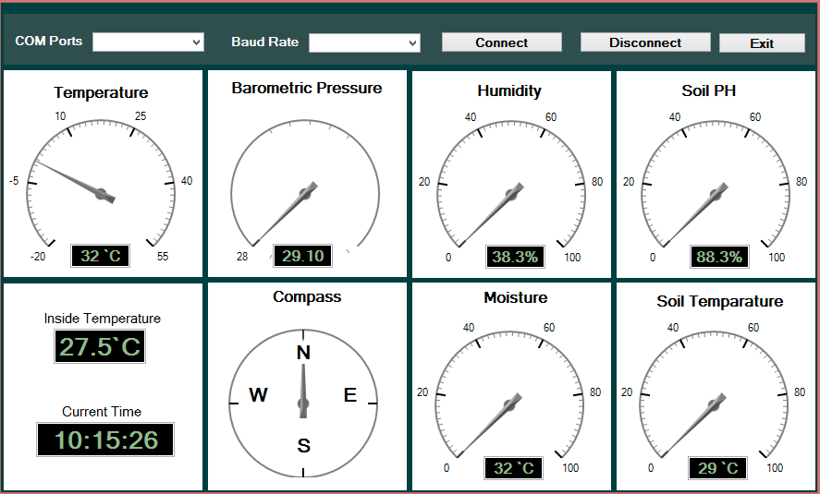

Fig: Sensors GUI

**IV. SCIENCE TASK**

Mars is fourth plane of this solar system located around 142 million [1] miles away from sun. It is one of the four rocky planets that have almost same duration of night and day like earth but it has only 37.5% gravity of earth so the atmosphere of mars is thin and mostly contains carbon dioxide and some water vapor [1]. Due to this thin atmosphere and lack of magnetic field the planet is defenseless against radiation. The surface of this planet is exposed by solar energetic particles and galactic cosmic rays at the rate of 0.67 millisieverts per day [2]. Unlike Earth most of the Martian surface is covered by mantle.

The inspiration of series of mars lander like Pathfinder, Phoenix and Curiosity we have built “Mongol Tori”. On this rover “Mongol Tori “, it used instruments on board to examine the environmental condition to support life and design some quick lab testing fig[2] to get the condition of soil. Firstly, it has digital temperature and humidity sensor on board for measuring air condition which contain a capacitive humidity sensor and a thermistor. High Humidity with the combination of aerosols (small particulates) helps the formation of droplet and increase the possibility of raining and water cycle [3]. On the other hand life can exist only if liquid water is available. So, air temperature is another important factor to support life. However, to [4] is the temperature range where water can be found as liquid in certain conditions. We have also used gas sensor to measure carbon dioxide and carbon mono oxide concentration in ppm which is also indicate the survivability of life forms. However, We have designed a sophisticated drill mechanism to collect subsurface soil from more than 10 cm deep [fig : 1]. This drill is not just only creating 10 cm deep hole but also collect soil layer by layer so that we can use it for later lab test.

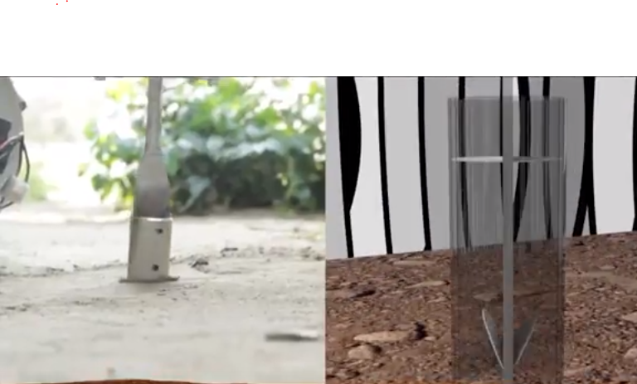

|  |  |
| --- | --- |
| *Fig 1: Soil Drill* |  |

This rover also has Grove moisture sensor and Waterproof Digital Temperature sensor to measure the moisture of the soil and temperature. As the air pressure of Mars is much lower, the possibility of finding water is high in subsurface than top surface. Secondly, after collecting the soil from drill cylinder we can take the layer from five cm to ten cm range and operate some quick lab test. We will start with our analog pH meter to measure the pH of the soil. Most of the life form on earth found within the pH range of 6.5-9.0 [5]. On the other hand mars have 8-9. Another Important two tests the team has conducted is biomass test and water capillary test.

In the biomass test they have heated up the soil for few minutes and calculate the mass difference to get the idea of water and other liquid bio substance present in the soil. After that the water capillary test indicates the water absorbing capacity of the soil. This is important because if the water holding capacity is low the rain water goes down deep under the ground and surface remains dry. So, the sample collecting system and series of lab test will give a clear idea of the environment there to support life within the short amount of time.

*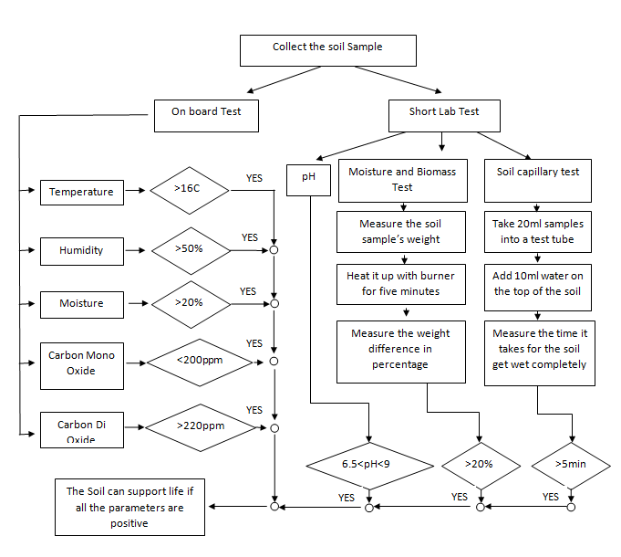*

*fig 2: procedure of science task*

**IV. ROVER ELECTRONICS**

We are using 6 high torque dc wiper motors which draw not more than 10 Amp in rough terrain and in normal mode it draws 4 or 5-amp parallel. As our arm is modular so we have made another printed circuit board for 3 linear actuators and 3 dc motor for grabbing function of the claw as well as science task module. Linear actuators consume little amount of current when it carries load, it like 700mah or 1 amp, since we have to grab minimum load 5 kg through our claw it can draw 6 amps because we are using brushed dc motor. For operating our wheel’s motor, we are using 6 BTS7960 motor driver module. BTS7960 is a fully high current half bridge motor driver. It can be operated 24 volt and current rating is max 43 amps. It contains one p-channel high side Mosfet and one n-channel low side Mosfet and both can create an integrated driver IC which fully integrated high current half bridge. It has PWM features which can be operated up to 25 kHz. This motor driver has over voltage lock out, under voltage shut down, over temperature protection, current limitation short circuit protection. Moreover we are using another motor driver 13Amp Cytron motor driver, its basic feature is Bi-directional control for 1 brushed DC motor , Support motor voltage ranges from   5V to 30V , Maximum current up to 13A continuous and  30A peak (10 seconds) , 3.3V and 5V logic level input , solid state components provide faster response time and eliminate the wear and tear of mechanical relay , fully NMOS H-Bridge for better efficiency and no heat sink is required , speed control PWM frequency up to 20KHz . For reducing weight of our rover we are using 22V 14Amp Lithium ion battery for powering motor of wheel and arm. On the other hand, we have also lead acid battery as a backup which rating is 12 volts 7 amps. Our connection like two lead acid battery connected parallel for increasing ampere such as 7+7=14 amp and one series for increasing voltage from 12 to 24 volt. Also we have our own custom power distribution board on rover where we used two 22V 14Amp lithium ion batteries. From our power distribution board we are distributing power to the main board of rover which consist of 12V Intel NUC pc, 24V communication router and 12V IP camera module and for converting voltage from 22 volts to 12 we are using XL6009 dc-dc converter which input voltage 3V ~ 32V, output voltage range is 5 ~ 32V, Built-4A efficient MOSFET switch, so that the efficiency up to 94%; (LM2577 current is only 3A). Each of the six motors requires 24V, each of the three actuators and three DC motors need 12V which have been managed directly from the battery source through motor drivers. Although our motor drivers have some built in protection but for keeping our circuit cool we have designed cooling system by two DC fan and heatsink on the regulator IC. Instead of all these safeties we have also integrated a kill switch for any emergency situation.

**V. ROVER COMMUNICATION**

**Base Setup**:For Base station 2.4 GHz Ubiquiti AirMax Rocket M2 is used which was attached with a 120 degree directional Sector antenna with 15dbi gain.Rocket M2 has 64 MB OF SDRAM and 8 MB Flash.It operates in 24 volt 1 Amp.

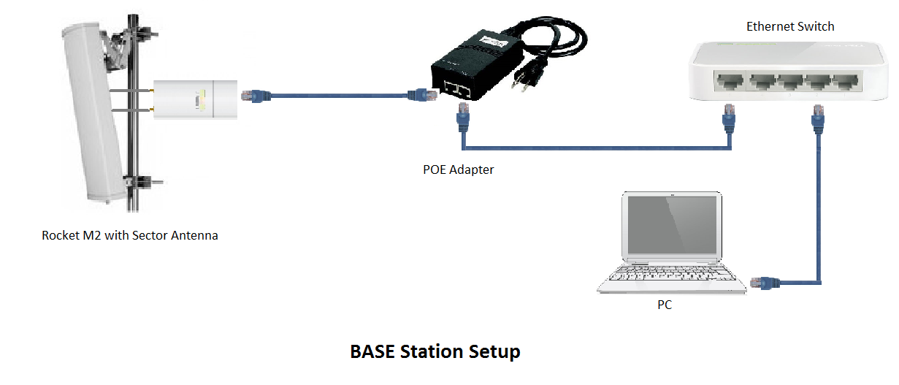

Rocket M2 used in base station used as a Access point Bride mode in 2447 MHz frequency.The Channel width was 20 MHz.

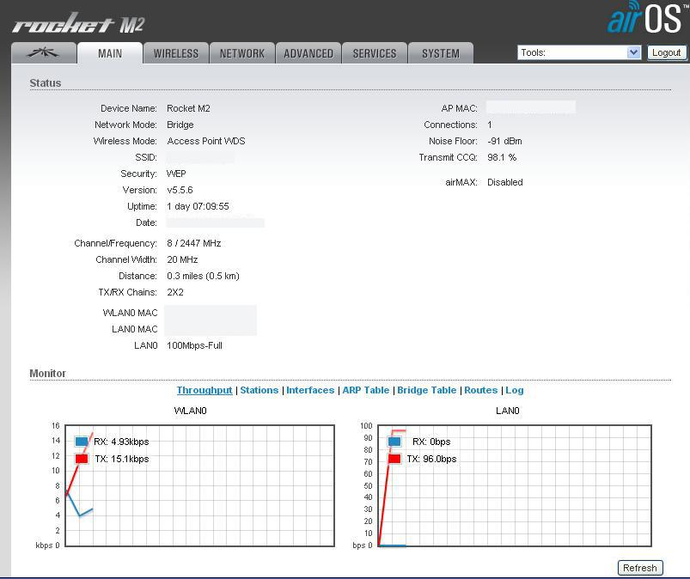

**Rover Setup:**For Rover 2.4 GHz Ubiquiti Bullet M2 is used which was attached with TP-Link TL-ANT2412D 12 dBi omni-directional antenna with N female connector.Bullet M2 operates with 24 volt 1 Amp thourgh Power over Ethernet(PoE)

connectivity.Bullet M2 has 32MB SDRAM ,8MB Flash. Its maximum power consumption is 7 Watts.

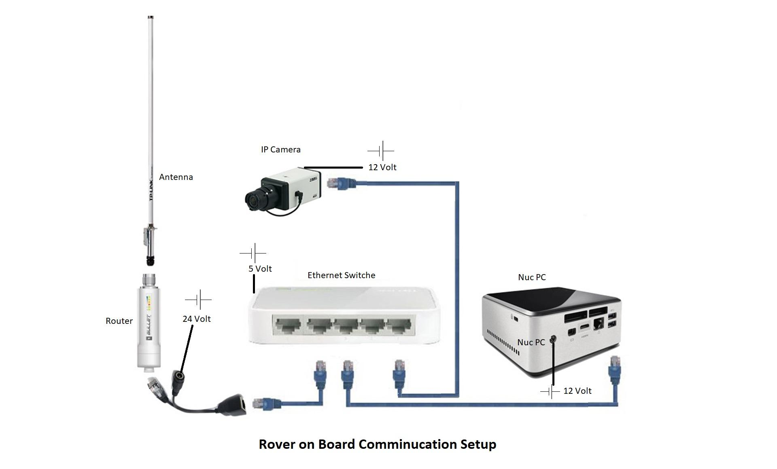

Bullet M2 is used in Station mode with 20/40 MHz channel width.Bullet M2 was used in MCS7 – 65[150] Maximum TX Rate in Mbps.

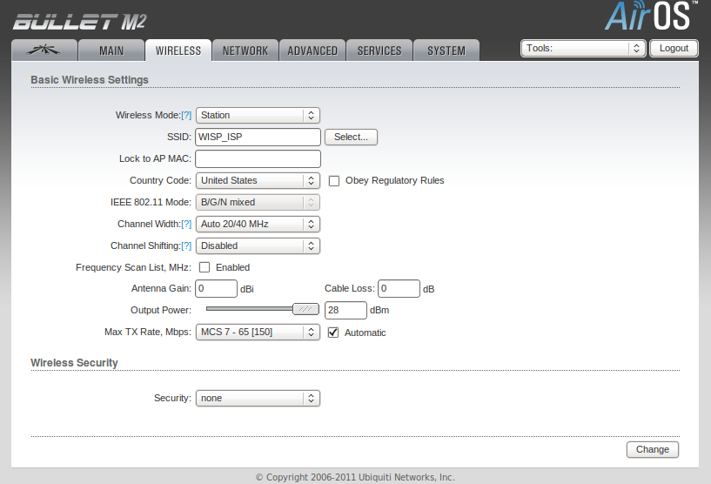

**Camera Setup:** Two 720p First Person view(FPV) Camera is used with viewing angle of 165 Degree.

For wireless transmission 5.8GHz 48 Channel TS832 is used which operating voltage is 7.4 to 16 volt.Its transmitting power is 600 milliampere.

5.8 GHz 48 Channel RC832 is used as a receiver.It operates with 12 volt and it operates drawing maximum 200 milliampere current.

**Science Task Reference :**

**1.**  Mars Facts | Mars Exploration Program. (n.d.). Retrieved May 10, 2017, from<https://mars.nasa.gov/allaboutmars/facts/#?c=inspace&s=distance>

**2.** SwRI scientists publish first radiation measurements from the surface of Mars. (n.d.). Retrieved May 10, 2017, from<http://www.swri.org/node/9079>

**3.** At what humidity does it start to rain? (n.d.). Retrieved May 02, 2017, from https://earthscience.stackexchange.com/questions/5047/at-what-humidity-does-it-start-to-rain

**4.** Welcome to Explore! Our Place in Space. (n.d.). Retrieved May 1, 2017, from http://www.lpi.usra.edu/education/explore/our\_place

**5.** PH of Water. (n.d.). Retrieved April 25, 2017, from http://www.fondriest.com/environmental-measurements/parameters/water-quality/ph

**6.** Mckay, C. P., Friedmann, E. I., Gómez-Silva, B., Cáceres-Villanueva, L., Andersen, D. T., & Landheim, R. (2003). Temperature and Moisture Conditions for Life in the Extreme Arid Region of the Atacama Desert: Four Years of Observations Including the El Niño of 1997–1998. Astrobiology, 3(2), 393-406. doi:10.1089/153110703769016460

**7.** Quirk, J., Johnson, D., Leake, J., & Beerling, D. (n.d.). Ecosystem CO2 starvation and Earth's minimum CO2 concentration: an experimental assessment - Beerling Lab Website. Retrieved July 22, 2017, from https://sites.google.com/a/sheffield.ac.uk/djb-group/ecosystem-co2-starvation/joe-quirk