***Base Station:***

In order to establish a strong communication link between base station and rover, we required establishing P2P(point-to-point) connection. We tested different outdoor router pairs and   
there ranges for long distance communication. Maximum coverage distance was tested from one PC to the other using ping command. Variation of directionality and SNR were observed for different distant location. Based on which Mongol tori team finalized 2.4GHz Ubiquiti Airmax Rocket M2[1] which has both compatible omnidirectional and sector antenna. It was set as Access point bridge mode at the base station. We needed to ensure clear line of sight (LOS) communication, where signal distortion can be kept minimum. To serve our purpose, focused narrow beam signal having significant directionality must be transmitted from the transmission side. This made our point to choose airMax sector antenna [2] of 120 degree directional coverage. Control data requires better reliability hence we used TCP protocol for data transmission.

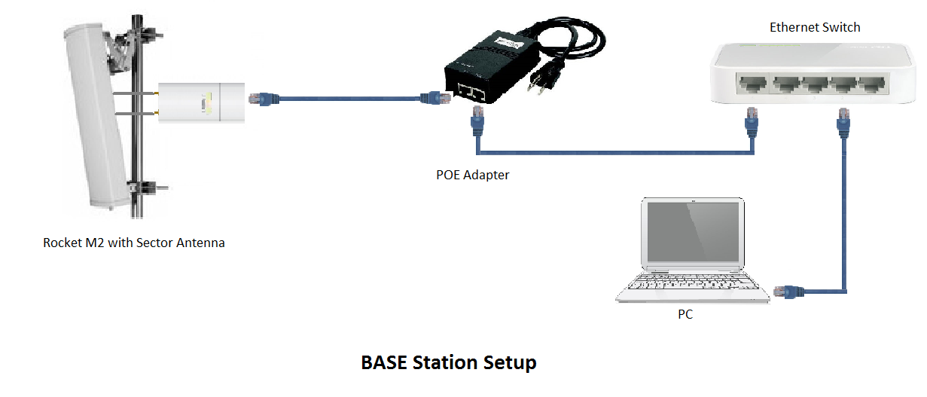  
  
  
**Fig 1:** Base station setup  
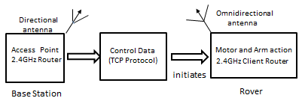 **Fig2**: Base station signal flow  
  
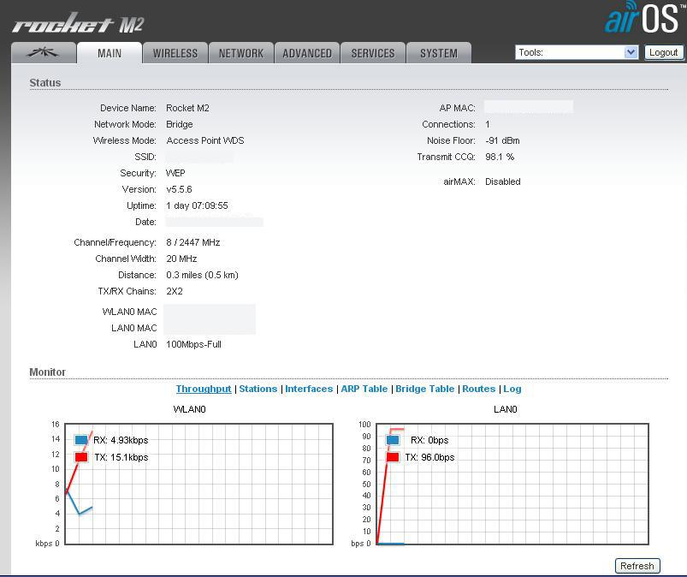  
**Fig3**: Parameters set at AP-Bridge router  
 **Rover Setup**:   
At rover 2.4GHz Ubiquiti Bullet M2 was used which was set as station mode. To extend horizontal beam pattern coverage, external omnidirectional antenna, TL-ANT2412D [3] was connected to the router. Angular coverage needs to be maximum at the rover. Since it is subjected to motion and need to carry out task in any direction assigned to. It is required to manipulate control data received at any instantaneous position. Separate wireless device, 5.8GHz 48 channel TS832 and RC832 [4] for transmission and reception respectively was enhanced for video transmission captured at the rover. Mongol Tori team decided to use two different wireless channels, as it results in no interference between the control signal and video stream. UDP protocol allows faster transmission, with delays as minimal as possible, to capture video stream this particular protocol have been handy for us. FPV camera pair having 720P resolution and viewing angle of 165 degrees have been used in the rover, to send captured video stream.

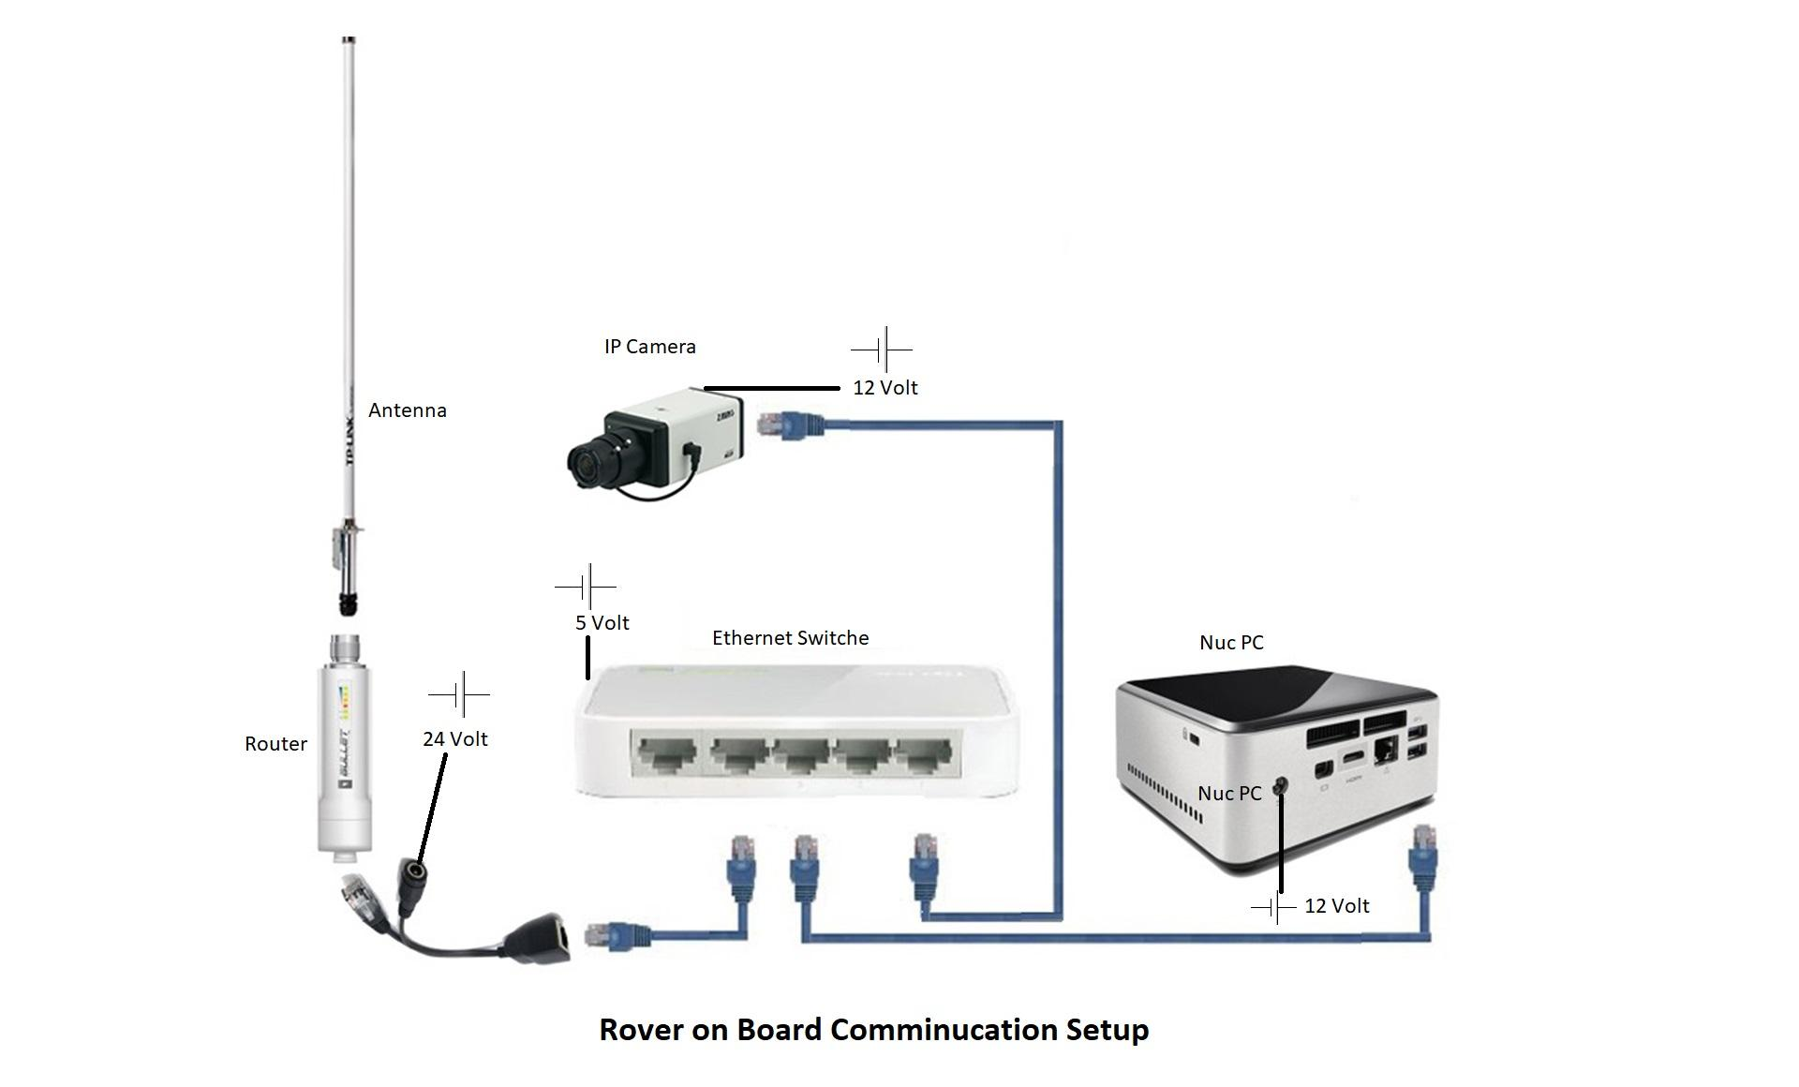  
**Fig4:** Rover on board communication setup

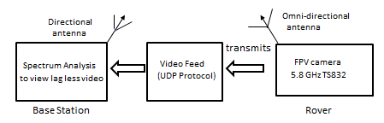  
**Fig5:** Rover signal flow  
  
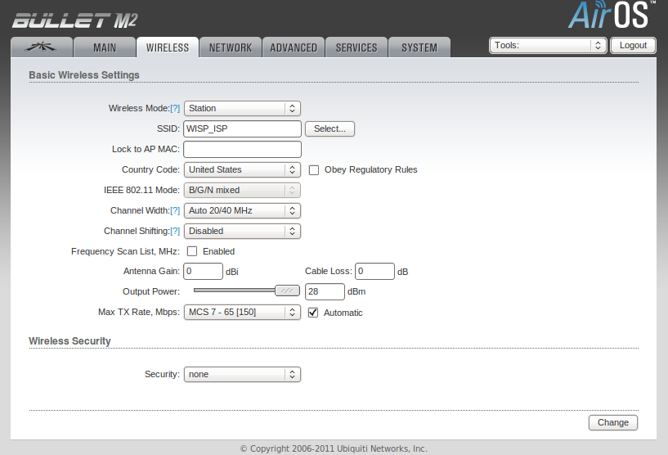  
**Fig6:** Parameters set at station router  
  
***Communication References:***   
  
  
1. Anon, (n.d.). [ebook] UBIQUITI NETWORKS, pp.2-6  
 Available at: https://dl.ubnt.com/datasheets/rocketm/RocketM_DS.pdf [Accessed 12 Jan. 2018].   
  
2.airMAX Sector 5GHz 2x2 MIMO BaseStation Sector Antenna. (2018). [ebook] UBIQUITI NETWORKS, p.10. Available at: https://dl.ubnt.com/guides/sector/airMAX_Sector_AM-5G16-120_AM-5G17-90_QSG.pdf [Accessed 12 Jan. 2018].

3.Tp-link.com. (n.d.). *TL-ANT2412D | 2.4GHz 12dBi Outdoor Omni-directional Antenna | TP-Link*. [online] Available at: http://www.tp-link.com/us/products/details/cat-5067_TL-ANT2412D.html#specifications [Accessed 12 Jan. 2018].

4 http://www.personal-drones.net/wp-content/uploads/2013/08/RC832_English.pdf. (n.d.). *RC832 Instruction Manual*. [online] Available at: http://www.personal-drones.net/wp-content/uploads/2013/08/RC832_English.pdf [Accessed 12 Jan. 2018].