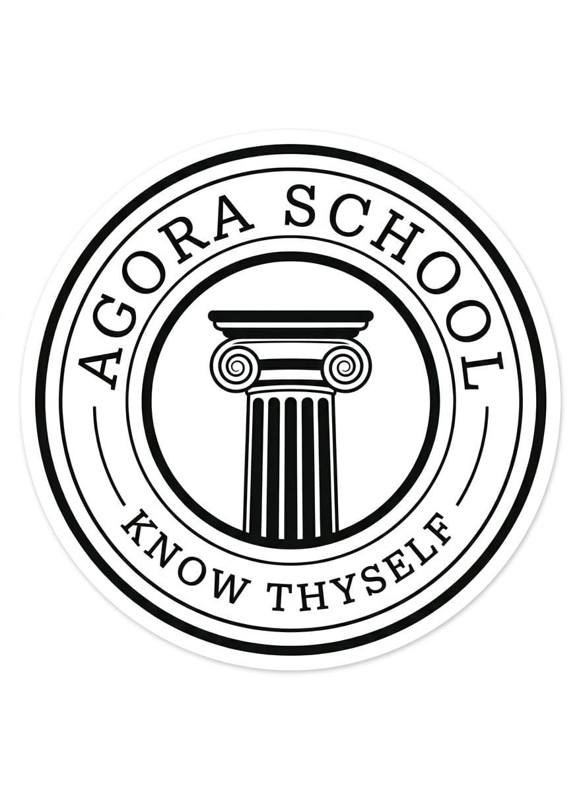

AGORA SCHOOL,DERA ISMAIL KHAN
Final Term Examination 2026

Name :______________ Subject :Math Class:3rd Roll NO:______

Date:_______________ Test Marks:75 Obtained marks:____ Teacher Sign:
Objective
Q1: Choose the correct answer. (10)
- Complete the pattern:
______ , ______ , ______ , ________

- Which shape is this ?
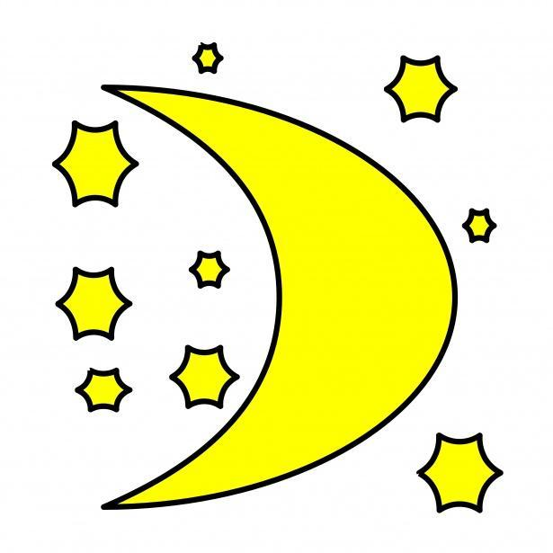
a) Triangle b) Circle c) Rectangle d) Square
- Which picture shows night time?
a) sun in sky b) Moon & stars c) children playing d) doing school homework

- Which one is a triangle?
a) Ball b) Pizza slice c) window d) Clock
- Which number comes after 8?
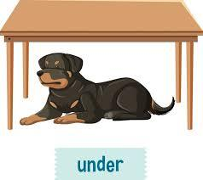
a) 9 b) 6 c) 10 d) 7
- Which object is under the table?
a) Cat on table b) cat behind table c) bird in front of table d) dog under table
- Which shape has four equal sides?
a) triangle b) Circle c) Oval d) Square
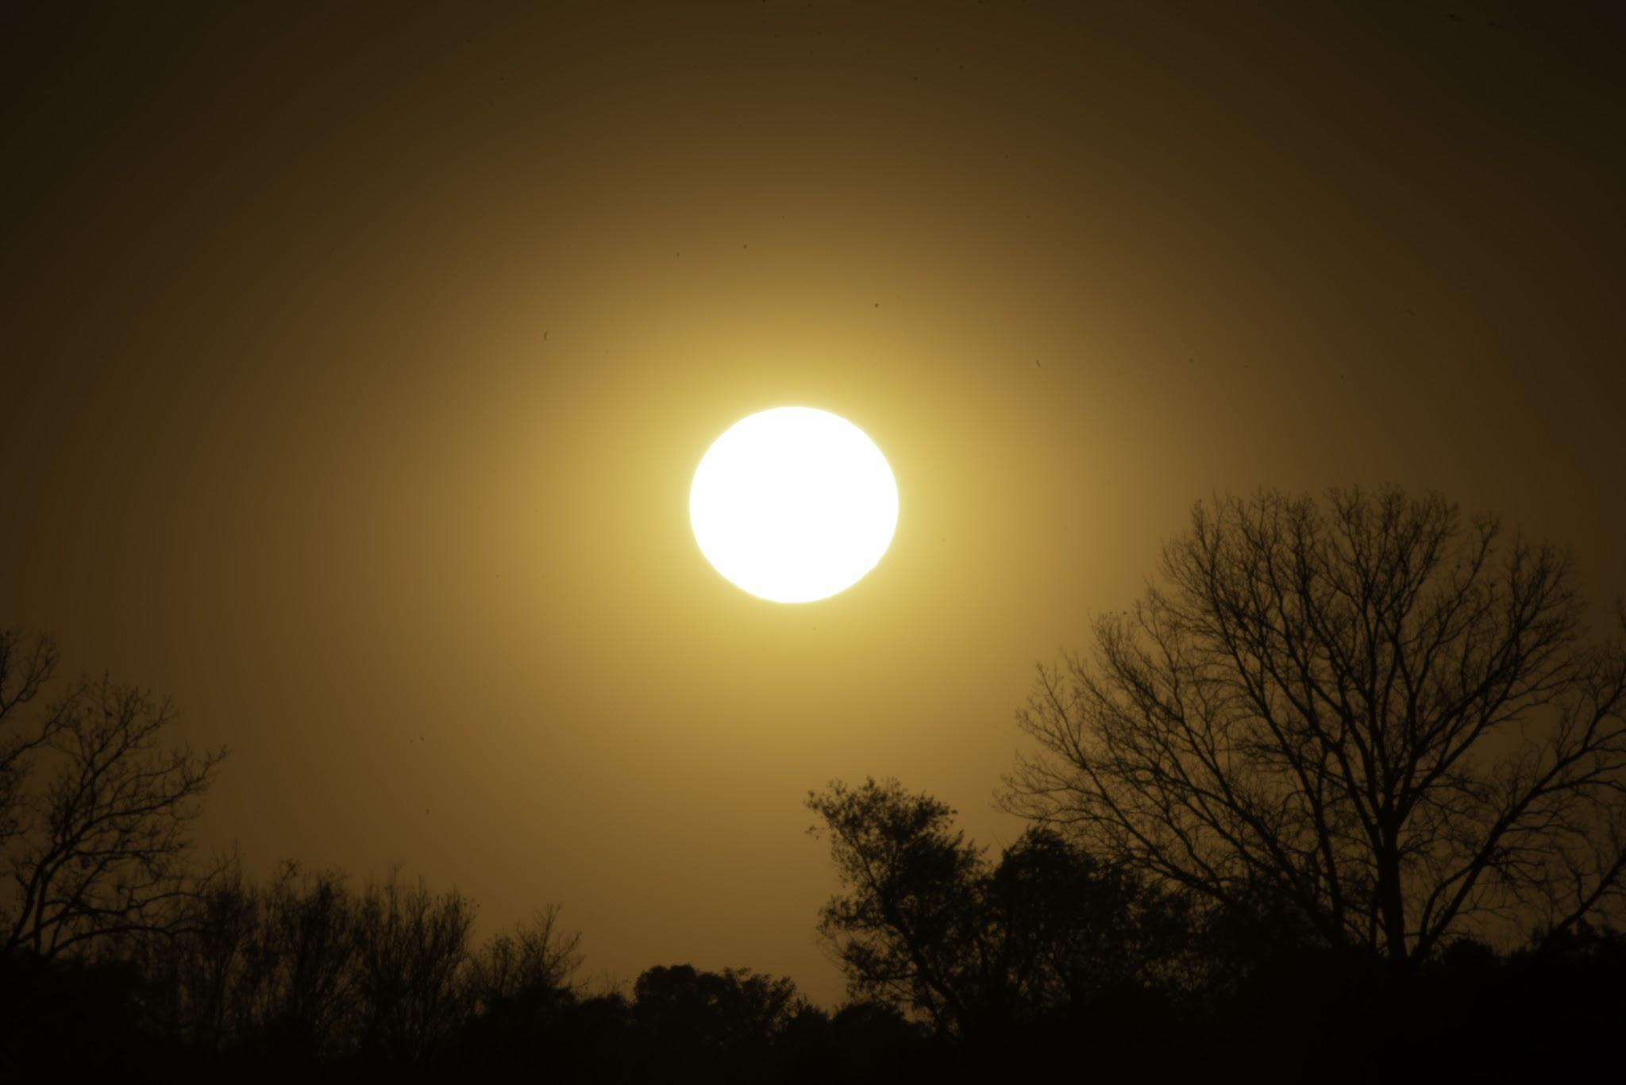
- Which number comes before 10?
a) 8 b) 9 c) 11 d) 12
- Which picture shows the afternoon?
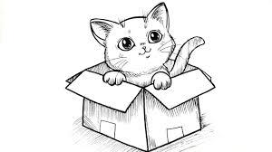
a) Children sleeping b) Bright sun in the sky c) Moon & stars d) Dark sky
10.Where is the cat?
a) On the box b) Under the box C) In the box d) Behind the box

Q2:Fill in the blanks (10)

1. A door is _______ in shape.
2. We sleep at _______.
3. 9 comes before _______.
4. _____ comes between 4 and 6?
5. Which _____is the odd one out?
a)🍎 b) 🥭 c) 🍌 d)🚓
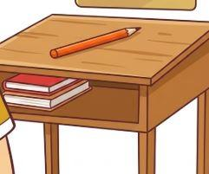
6.The shape of the object is _______.

7. The pencil is _______ the table.
8. The shape of a ball is _______.
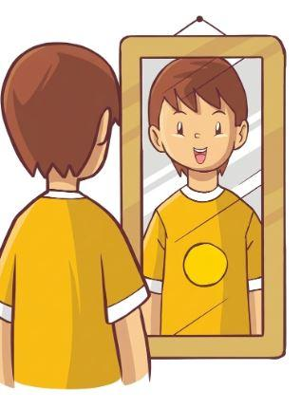
9. The number that comes after 4 is _______.
10. The boy is _______ the curtain.

Q3 :- Tick the right option. (10)
- There are 4 balls in the picture. ◯ ◯ ◯ ◯ [True] [False]

- These are the same. 🍎 🍎 🍎 [True] [False]
- The dog is under the table. [True] [False]
- Spoon is an odd one out. 🥄 🍴 🍴 🍴 [True] [False]
- The shape of the ball is a circle. ◯ [True] [False]
- This is a square. △ [True] [False]
- The number after 2 is 3. [True] [False]
- This is a circle. △ [True] [False]
- The time of day is morning. (boy sleeping) [True] [False]
- There are 3 stars in the box. ★ ★ [True] [False]

Q4 :- Colour the shape that matches (5)
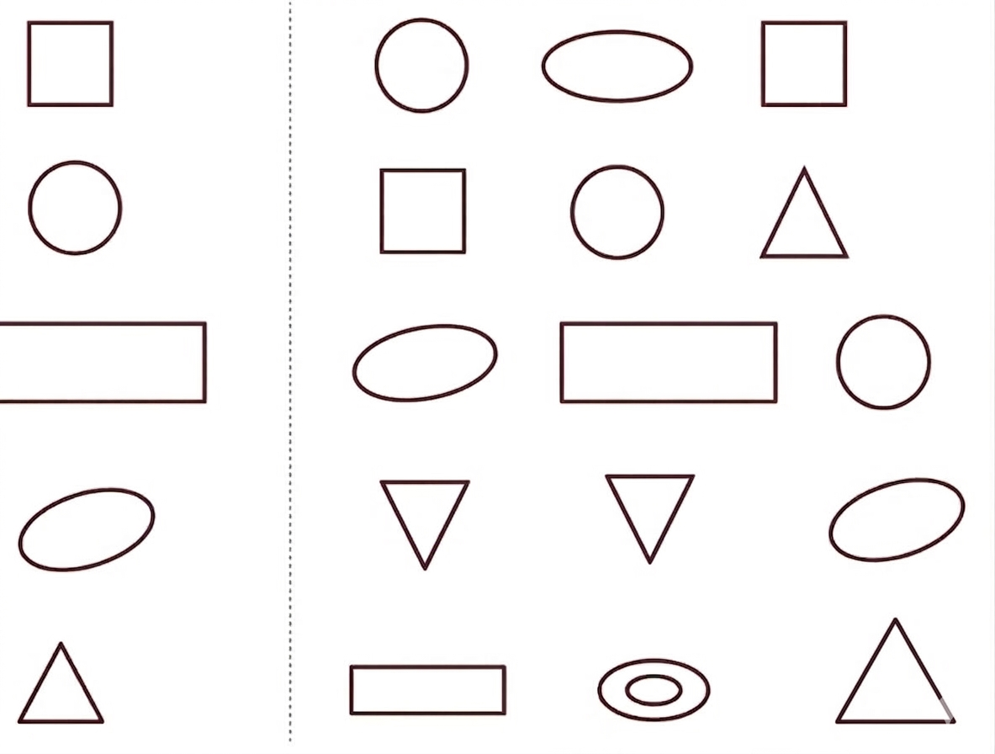 (8)
Q5:Observe each activity and circle the box showing the correct time of the day?
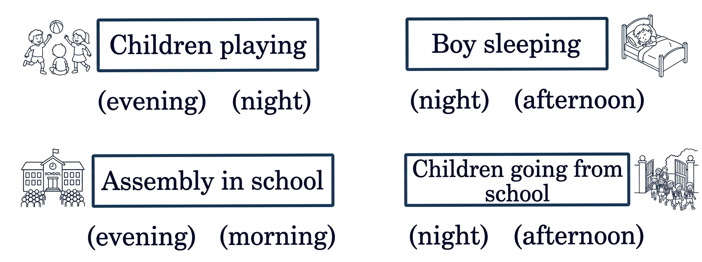
Q6: add the following. (6)
5 + 1 =_____ 9 + 1 =______ 3 + 5 =____
4 + 2 =_____ 2 + 2 =______ 6 + 3 =____
Q7:Subtract the following. (6)
5 - 3 =______ 7 - 4 =_______ 6 - 2 =_______
8 - 5=______ 9 - 6 =_______ 4 - 2 =_______

(5) (10)
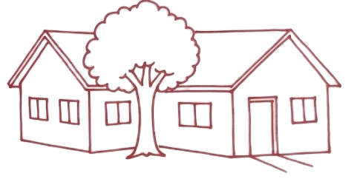
Q8:Colour the house that is behind the tree ? Q9:Write the table of 2 ?
1 | x | 2 | =
2 | x | 2 | =
3 | x | 2 | =
4 | x | 2 | =
5 | x | 2 | =
6 | x | 2 | =
7 | x | 2 | =
8 | x | 2 | =
9 | x | 2 | =
10 | x | 2 | =

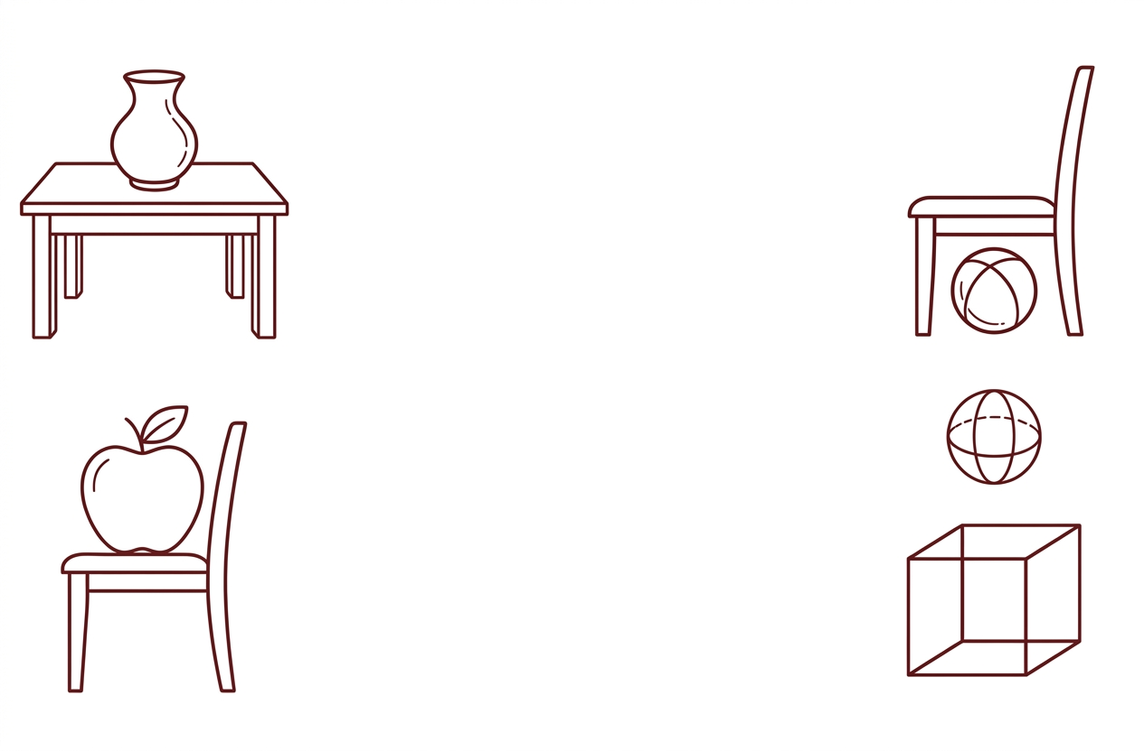
Q10:Circle the picture in which an object is on something ? (5)

