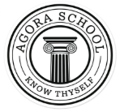
AGORA SCHOOL, DERA ISMAIL KHAN
Final Term Examination 2026

Name: ________________ Subject :English Class: Nursery Roll NO: ___________
Date : _________________Paper Marks: 75 Obtained marks: ____ Teacher Sign: ___________
Section A (Subjective Marks: 30)
Q1.Writes Alphabets Aa-Zz (10) --------------------------------------------------------------------------------------------------------------------------------------------------------------------------------------------------------------------------------------------------------------------------------------------------------------------------------------------------------------------------------------------------------------------
Q2.Write vowels. (5)
______ , ______ , ______ , _______ , ______
Q3. Write the letter which comes before the given letter. (5)
1) ___ e 2)___ l 3)___ f 4) ___ x 5)___ t
Q4. Match the object with its correct shape? (5)
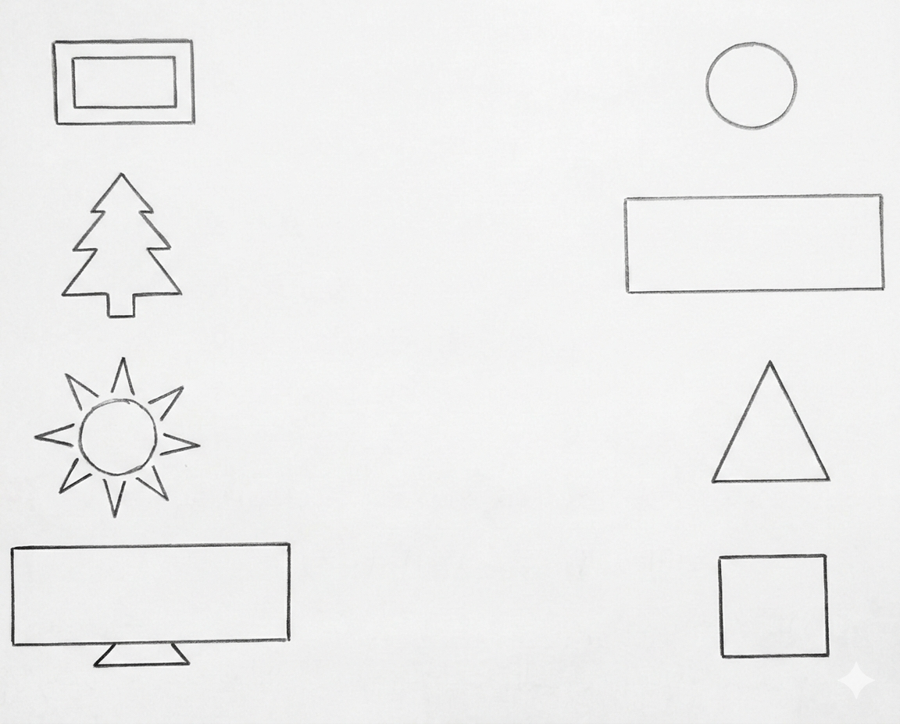
Q5. Arrange letters to make three letter words? (5)
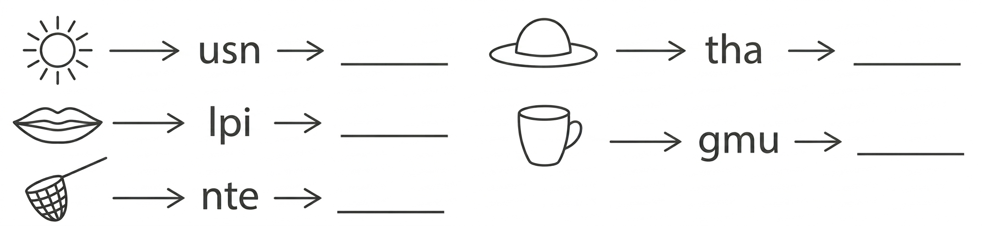
Section B (Objective Marks:45)
Q1: Choose the correct answer . (10)
- The ending sound of the picture is __🐔
  - a) T b) N c) H d) D
- The picture begins with the sound __🖊️__
  - a) B b) T c) P d) L
- The capital letter of 'g' is?
  - a) Q b) G c) J d) C
- This is an __🍎___:
  - a) Banana b) Apple c) Mango d) Strawberry
- The vowel letter in the word 'pen' is _____:
  - a) e b) T c) P d) N
- Which letter is a vowel
  - a) B b) C c) A d) D
- The picture begins with the letter '___🌞__'
  - a) T b) S c) N d) U
- Which word starts with the letter 'L'?:
  - a) Dog b) Lion c) Cat d) Hen
- Which one is correct three-letter word?:
  - a) Book b) Pen c) Apple d) Mango
- The last letter of the word 'bus' is _____:
  - a) U b) S c) A d) B
Q2: Fill in the blanks (10)
- The three-letter word is _________ (hat / late).
- The letter comes before F is ______?
- The small letter of 'Y' is ______?
- The picture begins with a vowel letter 🐘____ ?
- The letter comes after T is _____.
- The capital letter of s is _____
- The picture begins with the letter _____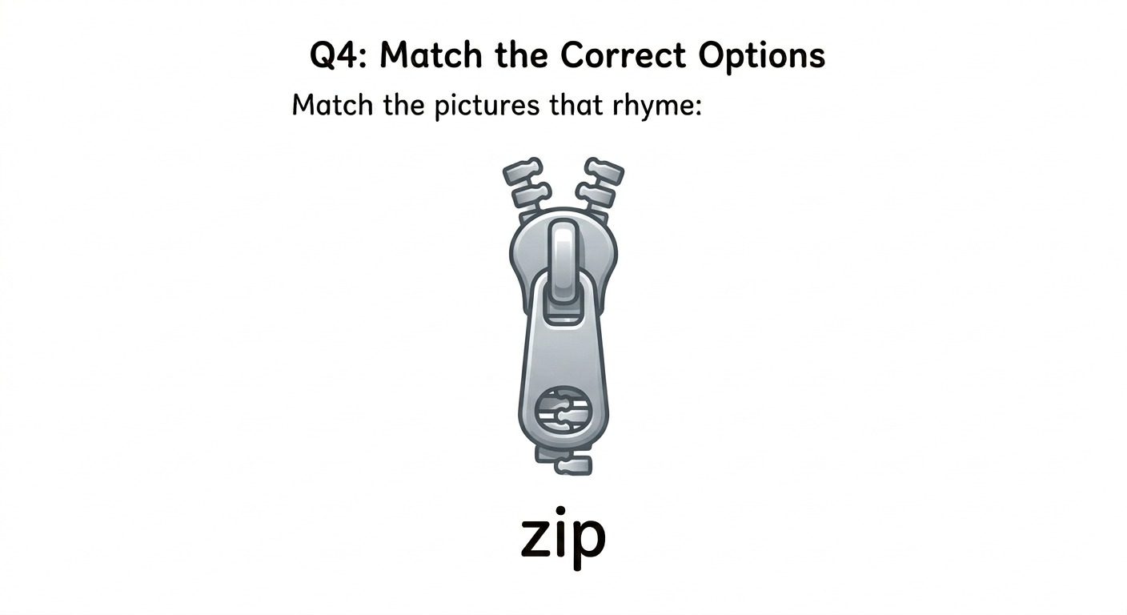
- The picture ends on the letter _____🐌
- The word 'Ant' begins with the vowel letter _____?
- Complete the spelling of C____t 🐈?
Q3: Tick the right option (10)
- 'B' comes before 'A'. [True / False]
- The small letter of 'M' is 'n'. [True / False]
- The picture begins with the letter 'N' 🥭 [True / False]
- The given picture is of a doctor. __👨‍🏫 [True / False]
- The picture begins with the vowel letter 'e'__🥚_ [True / False]
- The colour of Apple is red ? [True / False]
- 7. The letter 'B' is for 'cat' ? [True / False]
- 8. The word 'fish' starts with the letter f ? [True / False]
-  begins with letter 'q' ? [True / False]
- 'B' comes between A and C ? [True / False]
(5)
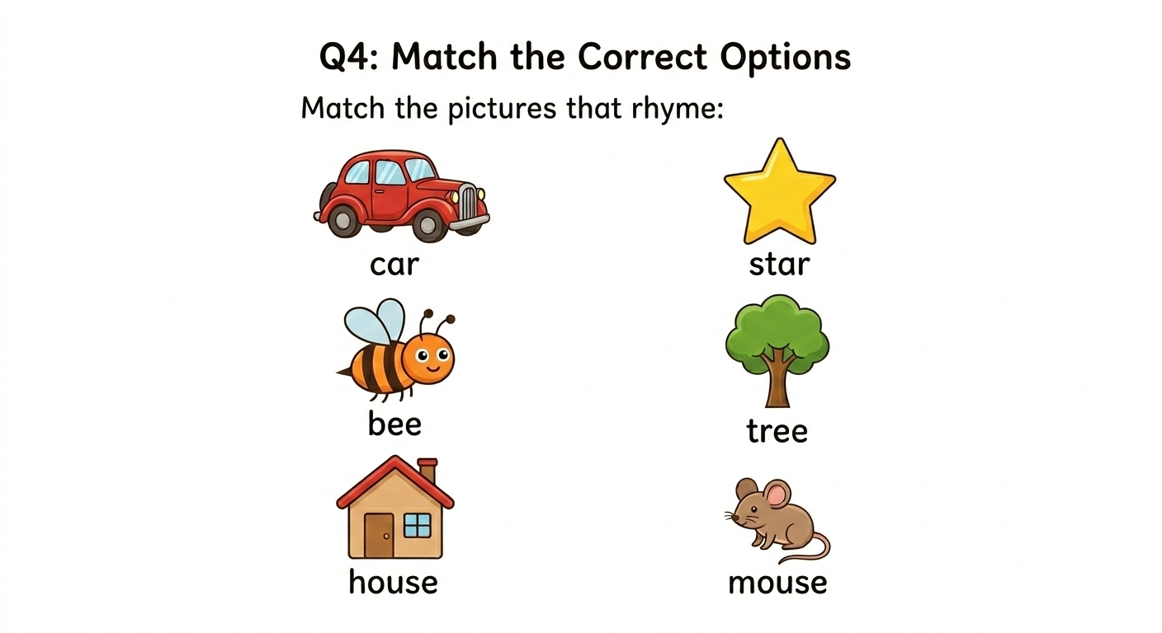
Q5: Match capital letters with small letters. (10)
U b
A s
B u
T a
S t

